743/2
BUILDING CONSTRUCTION
(Project)
PAPER 2
July/August 2018
6 hours
ASSHU – RWENZORI REGION ACADEMIC BOARD MOCK 2018

ASSHU - RWENZORI REGION ACADEMIC BOARD (ARRAB)
Uganda Certificate of Education
MOCK EXAMINATIONS
BUILDING CONSTRUCTION
(Project)
Paper 2
6 hours

INSTRUCTIONS TO CANDIDATES:
This paper consists of three assignments
Answer assignment 1 and either assignment 2 or 3.

Turn Over
© ASSHU – Rwenzori Region Academic Board Mock 2018
- Figure 1 shows an outline of floor plan of a DOMESTIC HOUSE, not draw to scale.

SPECIFICATIONS:
FOUNDATIONS: | 690 mm by 150 mm concrete strip, 1000mm deep from ground level.
WALLS: | All walls are 225 mm thick and 3000 mm high from floor level to the underside of wall plate.
FLOOR: | Cement sand screed 25 mm thick laid on 100 mm thick site concrete with a blinding layer 25 m laid on 150mm thick hard core.
DOORS: | D₁ 1200mm wide by 2100mm high glazed metallic casement  double shutters.
 | D₂ 2400mm wide by 2100mm high metallic double shutters.
D₃ 900mm wide by 2100mm high framed, ledged braced and
battened doors.
D₄ 800mm by 2100mm framed, ledged, braced and battened
doors.
WINDOWS: | W₁ steel glazed casement, 1200mm wide by 1200mm high  with concrete window sills.
 | W₂ steel grazed casement, 600mm x 600mm.
ROOF: | Double pitched at 30o and gabled, with closed eave 60mm projection and covered with iron sheets.
 | Purlins 75mm x 50mm
 | Rafters 100mm x 50mm
 | Tie beam 150mm x 50mm
 | Struts /ties 100mm x 50mm
 | Wall plate 100mm x 75mm
 | Fascia board 225mm x 25mm.

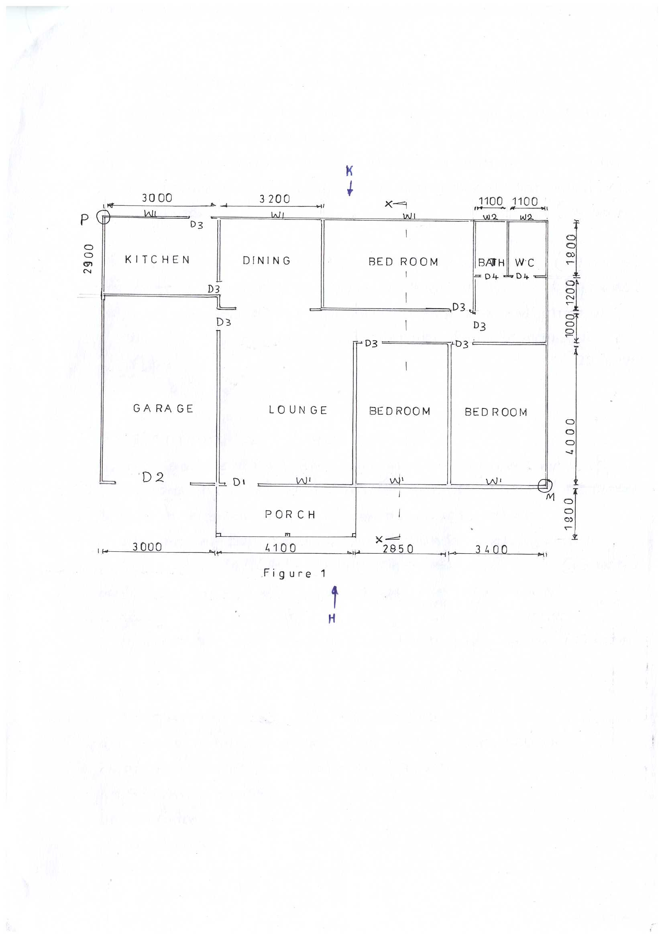

Assignment 1: (60 MARKS)
Using the specifications and drawing shown in figure 1, draw to a scale of 1:100, the:
- Plan of the house using related symbols to show all the doors, windows, sanitary fittings, ward robes in their appropriate positions. (20 marks)
- Front elevation in the direction of arrow H. (09 marks)
- Rear elevation in the direction of arrow K. (09 marks)
- Vertical section through cutting plane X –X and show all the constructional details from foundation to ridge. (22 marks)

ASSIGNMENT 2: (40 MARKS)
- To a scale of 1:10, draw the plan of course 1 and 2 of the wall in circled P in Flemish bond (4 bricks long) (10 marks)
- Draw to a scale 1:10 in isometric projection elevation of five courses in English bond at a junction marked M (4 bricks long both sides) (13 marks)
- Assume the house in figure 1 was erected on loose ground. To a scale of 1:10, draw in isometric view a suitable limbering to trenches used in this soil conditions. Name the members. (17 marks)

ASSIGNMENT 3: (40 MARKS)
- Draw to 1:10 a three centered ARCH of rise 400mm at D1 in figure 1 and label the following; (20 marks)
- Striking points
- Intrados
- Key brick
- Poussoirs
- Extrades
- Springe
- Skew back
on one side show the construction details.
- Draw to a scale 1:10 a two paneled window, 1000mm wide by 1200mm high.
(10 marks)
- (i) Sketch a cross section of an open eave. Name the members. (05 marks)
(ii) Use appropriate sketch to illustrate tiled flooring. (05 marks)

END

