GEOGRAPHY
PAPER 312/2
MARKING SCHEME.
SECTION A
1. (a) (i) Three positive effects of Tourism in Kenya.
- Foreign exchange earnings / Gov. revenue
- Promotes world peace.
- Provide higher and stable market
- Conservation of wildlife enhanced.
- Creates employment. Any 1x3=3mrks.
(ii) Three factions threatening Tourism in Kenya.
- Pouching
- Pests & diseases
- Pollution.
- Negative publicity.
- Insecurity in the parks and banditry.
- Terrorism.
- Human – wildlife conflict. Any 1x3=3mrks.
(b) (i) How minerals are obtained through dredging.
- Trona dug out lake bed by use of bucket dredger.
- Trona crashed into small pieces.
- Trona mixed with Lake water and pampered to factory & lake share.
- Trona washed off impurities e.g. mud and silt.
- Trona dried and put in desicaliar which removes any remaining moisture and hydrogen
-The end product in a greyish white substance called Soda ash.
(ii) Three factors influencing exploitation of minerals.
- Availability of market.
- Occurrence.
- Quantity and quality..
- Mining cost.
- Government policy. 1x3=3mrks.
2. (a) Energy crisis – is a situation in the economy when the demand for crude outstripped the
Supply.
(b) Effects of energy crisis.
- Closing down of industries.
- Unemployment.
- Industries operating below capacity.
- Inflation – rise in price.
- Negatively affects agricultural production. 1x3=3mrks
3. (a) Definition of wildlife.
A combination of undomesticated animals and plants found in their natural habitant and
Forming part of the natural resources. 1x2=2mrks
(b) Causes of Human – wildlife conflict.
- Scarcity of agricultural land.
- Culture of the neighbouring pastoralist communities.
- Encroachment by wildlife into human / destruction of property. 1x3=3mrks.
4. Limitations of centralization.
- Goods transported is limited.
- Requires sophisticated machines to handle.
- Size and weight of confirmers leads to road dilapidation. (Any 1x2=2mrks)
5. Two advantages of Road transport over Railway transport.
- Road transport.
- Door to door delivery is possible.
- Flexibility – widespread.
- Most people use them. (Any 1x2=2mrks)

SECTION B
TOTAL
Crop | 1999 | 2000 | 2001 | 2002 | 2003
Horticulture | 17641 | 21216 | 19846 | 28334 | 36485 | 123522 | 351
Tea | 33065 | 35150 | 34485 | 34376 | 33005 | 190081 | 412
Coffee | 12029 | 11707 | 7460 | 6541 | 6286 | 44023 | 210
6.

(a) Proportional circles to represent total exports per crop between 1999 – 2003.
Scale : 1cm : 100 Units.
Horticulture Radius
1cm =100
? = 351 = 3.51
Tea : 412 = 4.12
100
Coffee 210 = 2.1
100
 | 1999 | 2000 | 2001 | 2002 | 2003 | TOTAL
Horticulture | 51.4⁰ | 61.8⁰ | 57.8⁰ | 82.5⁰ | 106.3⁰
Tea | 69.9⁰ | 74.4⁰ | 72.9⁰ | 72.8⁰ | 69.9⁰
Coffee | 98.4⁰ | 95.7⁰ | 61⁰ | 53.5⁰ | 51.4⁰

HORTICULTURE.
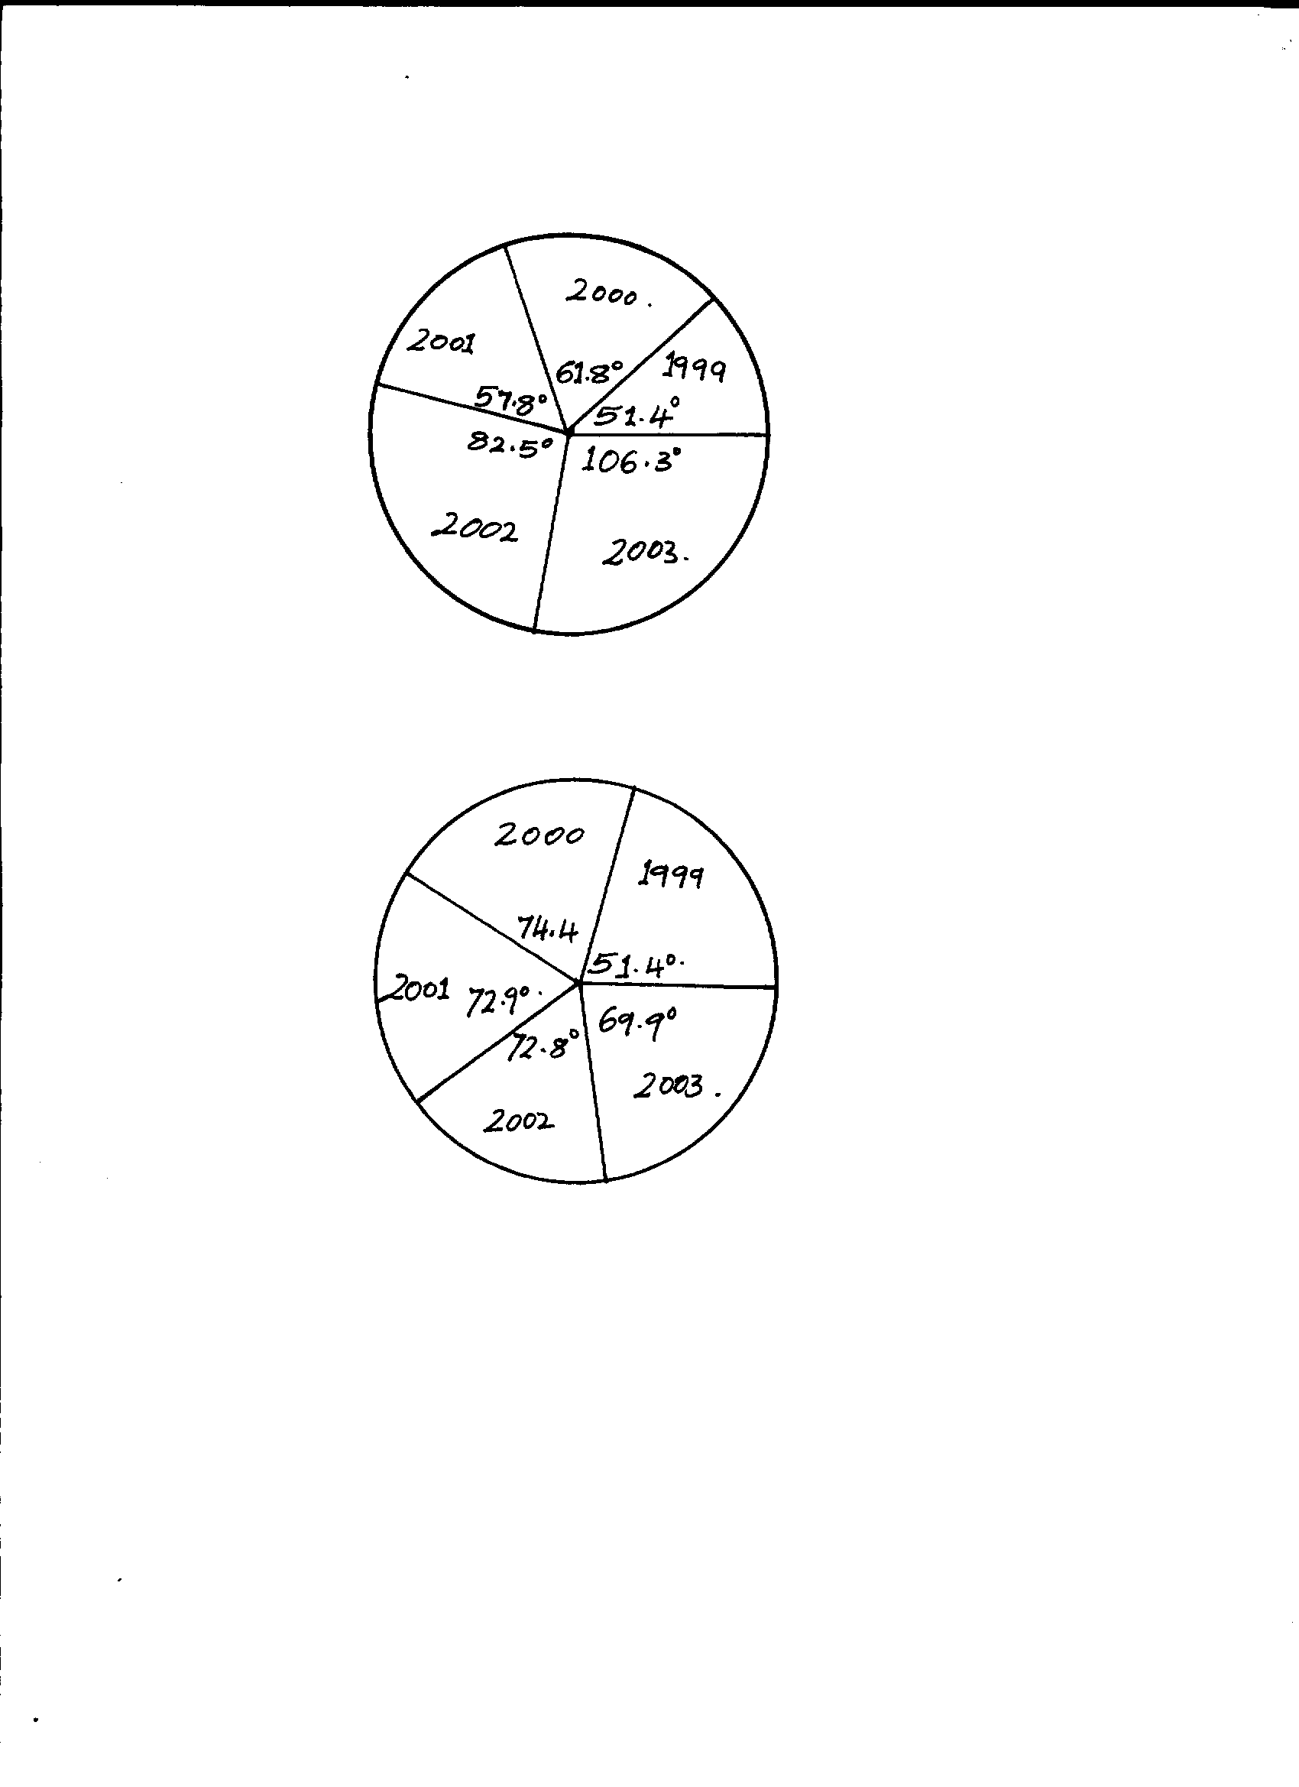

TEA

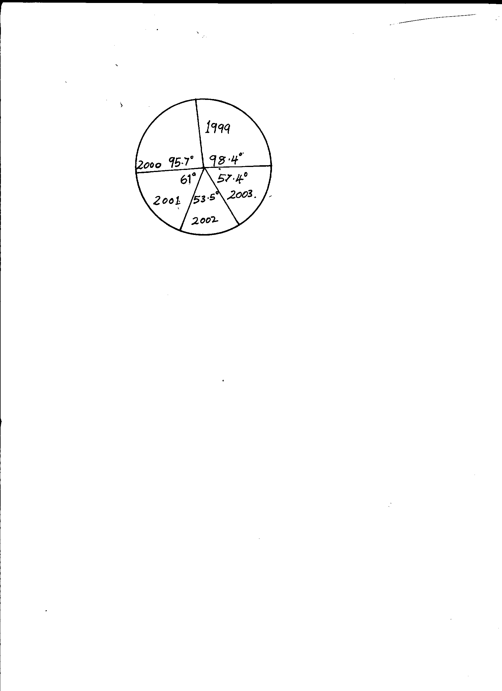

COFFEE

(b) (i) Trend in coffee earnings
- Coffee earnings has shown a steady decline.
- Highest decline registered between 2600 – 2001. 2x1=2mrks
(ii) Four possible reasons for the trend observed.
- A decline in world demand
- Lowered production due to diseases / drought.
- Competition with other crops especially horticulture.
- Low morals among farmers
- Leading to uprooting / neglect of coffee bushes. 4x1=4mrks
(c) (i) Identify THREE counties producing coffee in Kenya
- Nyeri
- Kiambu
- Muranga
- Kirinyaga
- Kisumu. Any 1x3=3mrks
(ii) Four importance of coffee farming to Kenya economy of Kenya.
- Coffee is exported – leading exchange earlier.
- Improvement of infrastructure for incomes
- Improvement of living standard by individual farmers.
- Source of employment as people work as farmers. Any 1x4=4mrks
(d) Four physical problems facing sugarcane farmers in Kenya.
- Impossible roads during wet / rainy seasons perpetuated by Elnino factor.
- Drought perpetuated by Elnino factor.
- Over used soils which have become infertile.
- Soil pollution from the liquid waste from sugarcane.
7. (a) (i) Name of fishing grounds marked A.B and C.
√ A - North East Pacific.
√ B - North East Atlantic.
√ C - North West Pacific. 1x3=3mrks
(ii) Two methods used in commercial fishing.
- Trawling √
- Selling √
- Lining √
- Drifting √ Any 1x2 =2mrks
(b) (i) Explain three reasons why fresh water fishing is more popular in E. Africa that Marine
Fishing.
- Pressure of more inland fishing grounds such as Lakes.
- Inadequate capital for buying modern equipment required for marine fishing.
- Presence of regular coastline especially in Tanzania.
- Now demand for see fish compared to fresh water fish.
- Presence of narrow continental shelf which limits the growth of plantation.
- Poor technology in deep sea fishing.
(ii) Two physical factors that favour fish farming in Kenya.
- Gently sloping land – to allow granty flow of water.
- Constant source of fresh water for fish.
7b. Contd.
- Availability of land for dam construction.
- an inlet or outlet for water.
(iii) Four problems encountered by fishermen on L. Victoria.
- Heavy presence of hyacinth which hinders fishing.
- Piracy from neigbouring – Uganda fisher men e.g. around Migingo Island.
- Heavy waves and storms leading to boat capsizing. Any 1x4 =4mrks.
(c) (i) Similarities (3) between fishing in Kenya and Japan.
- In both countries Marine and fresh water are carried out.
- There is a problem of overfishing in both countries.
- In both coutries inshore fishing is done. Any 1x3 =3mrks
(ii) Two measures the Kenya Government should undertake to conserve her fisheries.
- Establish of fish hatcheries.
- Prevent water pollution.
- Ban fishing for some period in the year.
- Research on fish breads.
- Discouraged overfishing
- Restocking of overfished species.
- Control the harvesting of young fish. Any 1x2=2mrks
8. (a) (i) Primary Industry - Involves exploitation of natural resources to provide raw material.
Secondary Industry – Involves changing of raw materials into finished goods.
(ii) Two examples of Agricultural non – good processing Industries in Kenya.
- Cotton ginnery – Sisal fibre making
- Bata shoe company – Pyrethrum processing.
- British America tobacco etc. – pawpaw paper
(b) (i) Five characteristics of cottage Industry in India.
- Owned by individual families /groups.
- Rural based
- Work is carried out manually.
- Industries operate in home / small shops.
- Found almost throughout the country.
(ii) Four ways through which Kenya benefits four assembling motor tor vehicles locally.
- Foreign exchange into expectation e.g. locally assembled vehicles.
- Kenya saves foreign exchange by importing vehicle parts instead of complete units.
- Employment opportunities.
- Acquisition of skills of this Kenyans marking there.
- Investment of capital in the country by with companies.
- Kenya establishes trade links with neibgbours
- Growth of related industries e.g. tyres, paints etc.
(c) (i) Three factors that led to development of Iron and steel Industry in Ruho Region of
Germany.
- Availability of large Iron deposits just adjacent to cool fields.
- Availability of abundant source of power e.g. coal.
- Availability of raw material (lime)
- Presence of a well developed transport –network (navigable rivers and canals)
- Traditional industries, provided skilled labour.
- Availability of capital, rich population companies.
- Large market in Central and Western Europe as well as home.
- Central location in Europe.
(ii) Three contribution of industrialization to the development of Kenya.
- Employment opportunities.
- Income to workers, raising living standards.
- Foreign exchange when produced are expected.
- Diversification of economy.
- Infrastructural development.
- Market to agriculturalist products.
- Utilization of natural resources.
- Improves a contrip balance of trade.
- Industrial and technical skills.
- Society amenities.
- Urbanization.
9. (a) 5 differences in population structure below Kenya and Sweden

KENYA SWEDEN
- Broad base - Narrow base
- Narrow top. - Broad top
- More people in rural areas. - Pop. Evenly distributed.
- More male than females. - Male and female
- Economically active pop engaged almost the same.
in wealth generation. - The active pop. 1x5=5mks

(b) Explained 3 problems that results from high pop. growth rate.
- High unemployment.
- Strain on social amenities.
- High dependency ratio.
- High crime rate due to unemployment.
- Low economic investment.
- Land subdivision fragmentation. (2x3=6mrks)
(c) Describe 3 measure taken in Kenya reduce infant mortality.
- Pre- natal / post natal services.
- Feeding programme
- Sensitization on safe delivery and motherhood.
- Org. immunization programes on deadly disease.
- Provision of mosquitoes nets. (2x3=6mrks)
(d) Explain 4 factors for high population density in L. Victoria Basin.
- Fertility soils (Loaming / Blank cotton)
- Reliable rainfall.
- Water supply
- Foodstuff ( vegetation/ fruits / fish. 2x4=8mrks
10. (a) (i) Environmental hazard.
- Danger or disaster within the surrounding due is natural or human cause. 2x1=2mrks
(ii) 4 man induced Environment hazards.
- Pollution
- Aridity / Desertification
- Floods
- Soil Erosion (1x4=4mrks)
(b) (i) 3 causes of flooding.
- Blocking water channels.
- Reforestation along river banks.
- Ploughing along the rivers 1x3=3mrks
(ii) Explain 4 ways in which floods affects pple
- Loss life / destruction of property.
- Water borne diseases.
- Crops being washed away.
- Areas become inaccessibility.
- Forced evictions , relocation 4x2=8mmrks
(c) Discuss 4 ways of controlling floods.
- Planting trees/ veg. along river banks.
- Building embankments.
- Resilling bases of the river
- Clearing and opening water channels. 4x2=8mrks

