535/3 PHYSICS
- In this experiment you will determine the acceleration due to gravity using a simple
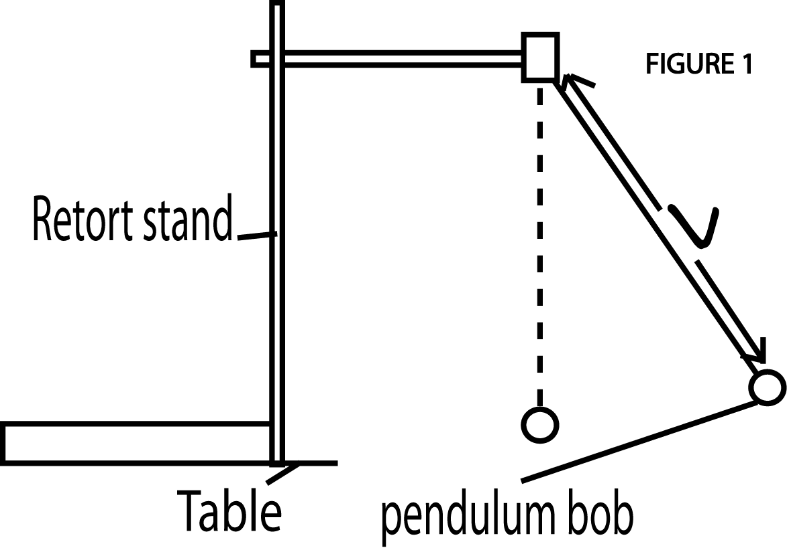
- pendulum.

- Suspend the pendulum bob from a retort stand as shown in figure1.
- Starting with a length $ι$= 0.30m, displace the bob through a small angle and release it.
- Determine the time for 20 oscillations
- Determine the periodic time T for the one oscillation.
- Repeat procedures (b) to (d) for the values of $ι$= 0.40, 0.50, 0.60, 0.70 and 0.80m.
- Record your results in a suitable table including values of T².
- Plot a graph of T² against $ι$
- Find the slope s of the graph.
- Calculate the acceleration due to gravity (g) from the expression
S = $\frac{4π^{2}}{g}$
(cm) | t(s) | T(s) | T²(S²)
0.30 | 22.0 | 1.10 | 1.21
0.40 | 27.0 | 1.35 | 1.82
0.50 | 29.0 | 1.45 | 2.10
0.60 | 32.0 | 1.60 | 2.56
0.70 | 34.0 | 1.70 | 2.89
0.80 | 35.0 | 1.78 | 3.16

s=$\frac{3.26-1.18}{0.83-0.21}$
s=3.36
g=$\frac{{4π}^{2}}{s}$ = $\frac{{4π}^{2}}{3.36}$
g=11.7ms⁻²
- In this experiment, you will determine the refractive index n of the material of the glass block provided
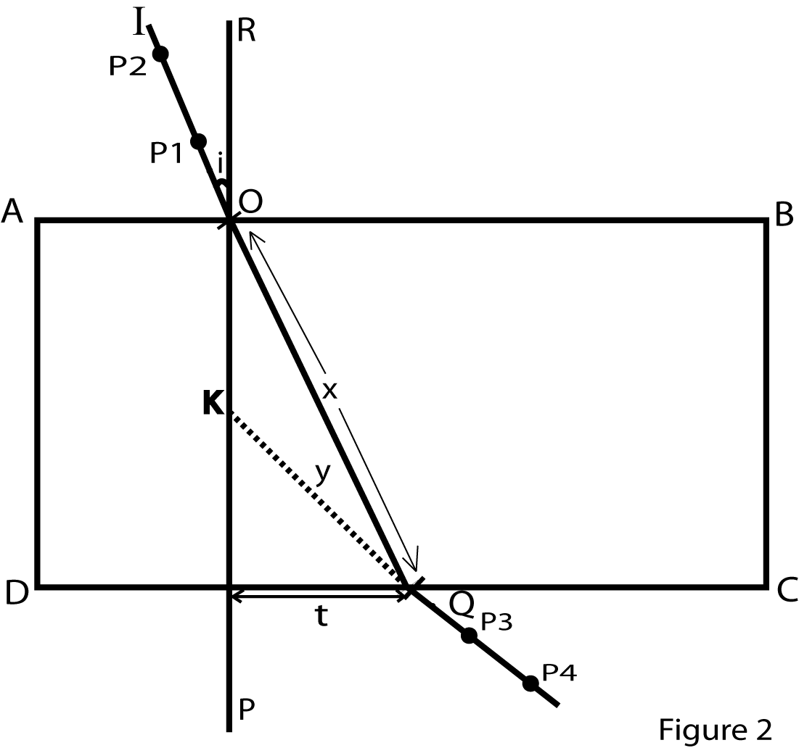

- Fix a white sheet of paper on a soft board using drawing pins.
- Place a glass block on a white sheet of paper with its broad face upwards and trace its outline ABCD.
- Remove the glass block
- Draw a normal PR at 0, 2m from AD
- Draw a line IO such that angle i= 10⁰
- Fix pins P₁, and P₂ vertically along I O
- Replace the glass block on its outline
- Looking through side DC fix pins P₃ and P₄ such that they appear to be in a straight line with the images of P₁ and P₂ as shown in figure 2
- Remove the glass block and the pins and draw a straight line, through P3 and P4 to meet DC at Q.
- Join Q to O and measure distance Q call it x
- Produce the line through pin marks P3 and P4 to meet the normal at K
- Measure distances t and y
- Repeat procedures (e) to (l) for values of i = ${20}^{0}$,${30}^{0}$,${40}^{0}$,${50}^{0}$ and ${60}^{0}$
- Record your results in a suitable table including values of $\frac{t}{y}$ and $\frac{t}{x}$
- Plot a graph of $\frac{t}{y}$ against $\frac{t}{x}$
- Find the slope n of the graph
I(⁰) | T(cm) | Y(cm) | $x$(cm) | $$t/y$$ | $$t/e$$
10 | 0.9 | 5.0 | 6.7 | 0.180 | 0.134
20 | 1.5 | 4.5 | 6.8 | 0.333 | 0.221
30 | 2.3 | 4.3 | 7.0 | 0.545 | 0.329
40 | 3.1 | 4.6 | 7.4 | 0.674 | 0.419
50 | 4.2 | 5.3 | 7.8 | 0.792 | 0.538
60 | 5.2 | 5.8 | 8.4 | 0.897 | 0.619

n=$\frac{1.040-0.100}{0.700-0.70}$
n =$\frac{0.94}{0.63}$
n = 1.49
HAND IN YOUR TRACING PAPER TOGETHER WITH OTHER ANSWER SHEETS
- In this experiment you will determine the resistivity$ρ$of the bare wire provided
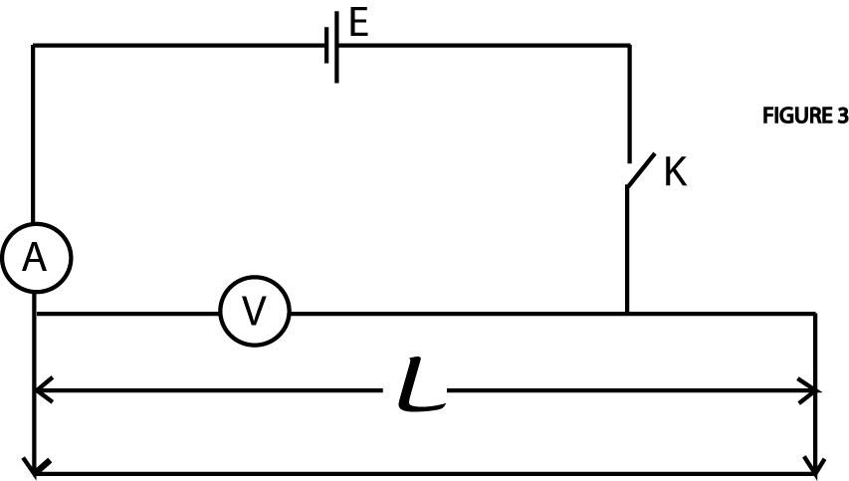

- Connect the cell, ammeter, voltmeter, switch and the bare wire as shown in figure 3
- Adjust the length $ι$ of the bare wire equal to 10.0cm.
- Close the switch K
- Read and record the voltmeter reading V and the ammeter reading A
- Open the switch K
- Repeat procedures (b) to (e) for values of l= 20,30, 40, 50, 60 and 70 cm
- Record your results in a suitable table including values of $V/I$
- Plot a graph of $V/{I }$against$ι$.
- Find the slope s of the graph.
- Calculate the resistivity $ρ$ of the wire from the expression $ρ$ = 5.4106 x 10⁻⁵ s
$$ι(cm)$$ | V(v) | I (A) | $\frac{V}{I}$ (Ω)
10 | 0.55 | 0.56 | 0.98
20 | 0.75 | 0.42 | 1.79
30 | 0.85 | 0.36 | 2.36
40 | 0.95 | 0.30 | 3.17
50 | 1.05 | 0.26 | 4.04
60 | 1.10 | 0.24 | 4.58
70 | 1.15 | 0.22 | 5.23

s=$\frac{5.5-0.51}{74-30}$
s=0.0703

$$\int{=5.4106x{10}^{-5} s}$$
$$\int{5.4106 x{10}^{-5}} x 0.0703$$
$\int{=3.803 x{10}^{-6}}$Ωm

END

