P615/4
STUDY OF ART
Study of Art
Paper 4
Jul/ Aug 2019
2 ½ hours

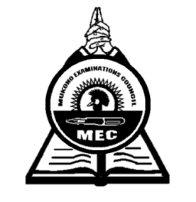

MUKONO EXAMINATION COUNCIL
Uganda Advanced Certificate of Education
ART STUDIO TECHNOLOGY
Paper 4
2 hours 30 minutes

INSTRUCTIONS TO CANDIDATES:
This paper contains ten questions
Answer all the ten questions.
Drawings and diagrams should be used where necessary.

- (a) Define the principle of Balance as applied in Art and craft (02 marks)
(b) Give reasons for the importance of the above principle in art (03 marks)

2. Explain any three properties of colour. (06 marks)

3. (a) Define the term fabric decoration (01mark)
(b) Explain any three methods of decorating a fabric. (06 marks)

4. Explain the following techniques used in tie and Dye.
(a) Pleating (03 marks)
(b) Crumpling (03 marks)
(c). Circles (03 marks)
(d) Running stitch (03 marks)

5. (a) Mention six local materials used in basketry (03 marks)
(b) Differentiate between coiling and twinning (04 marks)

6. Mention any six materials that are used in the making of collage (03 marks)

7. Define the following terms in relation to clay:
(a) Wedging (03 marks)
(b) Slip (03 marks)
(c). Bisque (03 marks)
(d) Glaze (03 marks)

8. (a) Define marionette (02 marks)
(b) Mention any four types of puppets (04marks)
(c) Give any two materials and two tools used in producing puppets (02 marks)

9. Using a well labeled illustration, construct a single-point linear perspective
(06 marks)

10. (a) What is a sketch? (01 mark)
(b) Give the importance of sketching for any work of art (03 marks)

End -

