TRANSPORT IN ORGANISMS
Transport refers to the movement of materials from one part of the organism to another. This is also known as Translocation in plants. The major processes involved in. the transport of materials in organisms are diffusion, osmosis, active transport in simple
and small organisms, circulatory systems in complex and large animals and vascular
systems in complex plants.
The necessity for transport systems in large complex multicellular organisms is based
on the following facts:
- That neither the organism nor its cells can live in total independence of their environments for they need metabolites for their metabolism and have to eliminate the resulting metabolic wastes.
- The fact that diffusion alone can no longer suffice in large organisms to move such materials (wastes and metabolites) to and from the cells let alone at a rate commensurate-to (as fast as) body needs.
- That in large multicellular organisms most of the cells are detouched from the environment and the great distance between them and the environment is certainly a hindrance to diffusion and other means of movement in and out of cells.
- That quicker movement of materials in the organism can only be achieved if the materials in transit are separated from other materials within the organism.
- That a large part of the external body surface must often be kept impermeable to conserve water particularly in terrestrial organisms.
This is exactly what vascular systems and circulatory systems have been evolved to do and thus they share the following similarities.

Similarities between vascular systems in plants and circulatory systems in animals
(i) In both among the materials to be transported are inorganic materials like respiratory
gases, water and mineral elements and organic materials like nutritive molecules and
hormones.
ii) In both the medium of transport is either water or largely composed of water.
iii) In both the channels of transport constitute mainly of tubular ... system with various modifications to suit particular needs.
iv) In both movement of materials requires and depends on energy. In higher animals most of this energy is spent pumping action of the heart to keep blood circulating. While in higher plants there is great dependence on the transpiration stream whose operation greatly depends on solar energy.
Differences between transport systems of higher plants and animals
Plants | animals
Medium of transport is water | Medium of transport is blood and lymph-
Conducting vessels are xylem and  phloem. The xylem is non living while  the phloem is living. | Conducting vessels are arteries, veins,  capillaries and lymphatics and all are living
No valves involved and therefore  capillaries a two way transport is possible therefore (in the phloem). | With the exception of arteries all the rest have valves and blood flow in one way.
Xylem transports water and salts  while phloem transports  manufactured food and  hormones | All types of vessels can transport the s~  materials
The medium does not circulate. | The medium actually circulates
Water as a medium of transport in flowering plants and animals
Apart from being essential to their continued existence as a major constituent of the protoplasm, and a medium of metabolic reactions it is an important constituent of all transporting media in organisms i.e. blood, lymph and plant sap. This is by means a coincidence but a result of the fact that water has specific and unique properties that enable it to serve as an efficient transport medium.
These are: -
- Being neutral and inactive it does not affect the substances being transported so they reach their destinations unaltered.
- Being a universal solvent it can dissolve all the substances that are to be transported making their transport in solution easier than if they were solid.
- By having a high surface tension it influences activities at interfaces of cell inclusions and the protoplast in general. This affects physiological processes like cell membrane permeability, adsorption, and imbibition of water by colloids, capillarity and protoplasmic streaming all important in transpiration.
- By having a low viscosity this allows rapid movement of water and hence transporting materials easily.
- By having a high thermal conductivity, it allows the transfer of heat to where it is
required in the organism which is essential in temperature regulation especially in
endotherms.
- By having a high specific heat capacity, it is not subject to rapid fluctuations of
temperature which is essential for keeping normal temperatures in organisms
fluctuations of which would affect enzymatic reactions and hence metabolism in
general.

VASCULAR SYSTEMS IN ANIMALS
Vascular systems in animals share the following basic features
- A circulatory fluid: most common one is blood though higher organisms contain lymph as an addition
- A pump organ: the heart
- A system of tubes through which the circulatory fluid can move
Functions of circulatory system
The circulatory system may differ in various animals but carries out the same basic functions.
- Transport of nutrients. It transports all soluble food compounds from the area of absorption to different parts of the body for storage, assimilation or synthesis of new components.
- Transport of waste products: it transports all the excretory products produced as a result of cellular activities from all over the body to the organs of excretion (like kidney in man)
- Transport of intermediate metabolites: it transports all the byproducts or intermediate products from the tissues they are produced to the organs where they can be metabolized (like lactic acid produced in muscles is transported to the live for oxidation.
- Transport of hormones: since hormones are produced by ductless glands, they are transported through the circulatory fluid to their target organs.
- Uniform distribution of heat: since circulatory fluid connects to all parts of the body it picks up heat from one part and dissipates it on the surface bringing about the uniform distribution.
- Transport of water, inorganic ions and various chemicals is also done by the circulatory fluid so as to maintain a uniform distribution
- Defense against diseases: the circulating fluid contains blood cells responsible for body defense
- Transport of respiratory gases: in some animals the circulatory fluid contains respiratory pigments which may be dissolved in plasma like in snails, crustaceans or cephalopods or present in cells like in all vertebrates including man. The oxygen is transported from respiratory organs to respiring tissues while carbon dioxide is carried from tissues to respiratory organs. Some animals like insects have tracheal system for respiration and circulatory system is not directly associated with respiration. More so it lacks any respiratory pigment

BLOOD
This is a highly specialized fluid tissue which consists of different types of cells suspended in a pale yellow fluid known as the blood plasma

BLOOD PLASMA
This is a pale yellow fluid component of blood composed of the plasma proteins and blood serum where the blood cells are suspended. Blood plasma carries the biggest percentage of blood and consists of a colourless fluid known as serum and also plasma proteins. It is the blood serum that all the different soluble materials are dissolved e.g. urea, hormones, soluble food substances, bicarbonate ions e.t.c.
The plasma proteins are manufactured by the liver and include the following;
- Fibrinogen. This protein is important for normal blood clotting by changing into fibrin in the presence of thrombin enzyme.

Fibrinogen (soluble) Fibrin (insoluble)

- Prothrombin. This is the inactive form of the proteolytic enzyme, thrombin, used in converting fibrinogen to fibrin during the clotting of blood.
- Globulin. Both Prothrombin and globulin play important roles in the homeostasis. All the plasma proteins maintain pH of the body fluids constant by acting as buffers.
- Blood cells. There are three main types of blood cells which include;
  - Erythrocytes (Red blood cells)
  - Leucocytes (White blood cells)
  - Platelets

ERYTHROCYTES
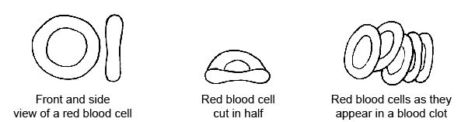

These are small numerous bi-concave disc shaped cells mainly important in transportation of oxygen as oxyhaemoglobin from the respiratory surfaces e.g. lungs and gives it to the tissues. Erythrocytes are manufactured by the bone marrow in adult and by the liver in the foetus.
Adaptations of erythrocytes
- They have a bi-concave disc shape which provides a large surface area that enhances maximum diffusion of enough oxygen into them.
- They have a flexible membrane which can enable them change their original shape and squeeze themselves into the blood capillaries in order to allow the exchange of respiratory gases.
- They lack a nucleus so as to provide enough space for haemoglobin in order to carry a lot of oxygen in form of oxyhaemoglobin.
- They have a red pigment called haemoglobin in their cytoplasm which has a high affinity for oxygen and therefore rapidly transports oxygen.
- They have a thin and permeable membrane which enables faster diffusion of oxygen and carbon dioxide into them.
- They have an enzyme known as carbonic anhydrase within their cytoplasm which enables most of the carbon dioxide to be transported in form of bicarbonate ions (HCO₃⁻), by catalyzing the reactions between carbon dioxide and water to from carbonic acid.

CO₂ + H₂O H₂CO₃ Carbonic anhydrase

LEUCOCYTES (white blood cells)
They are amoeboid cells having a nucleus and a colourless cytoplasm important for defense of the body against infections.
They are fewer than erythrocytes i.e. they are about 7000/m³ of blood. They are mainly manufactured by the bone marrow.
They are classified into two main types which include;
- Granulocytes (polymorphonuclear leucocytes)
These are leucocytes with granules in there cytoplasm and a lobed nucleus. They originate in bone marrow. There are three types of granular leucocytes which include;
- Basophils (0.5%)
- Eosinophils (1.5%) iii. Neutrophils (70%)
Basophils (0.5%) produce heparin and histamine. Heparin is an anticoagulant which prevents blood clotting in blood vessels. Histamine is a substance that is released during allergic reactions e.g. hay fever. Histamine brings about allergic reactions by causing dilation (widening) and increased permeability of small blood vessels which results in such symptoms as itching,, localized swellings, sneezing, running nose, red eyes e.t.c.
Eosinophils (1.5%) possess anti-histamine properties and their number increases in people with allergic reactions such as high fever, asthma e.t.c. so as to combat the effects of histamine.
Neutrophils (phagocytes) (70%) engulf pathogens phagocytotically and digest them actively inside to defend the body against diseases.

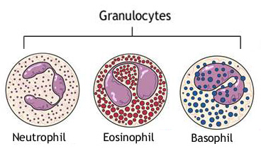
- Agranulocytes (mononuclear leucocytes)
These are leucocytes with no granules in there cytoplasm usually with a spherical or bean shaped nucleus. They originate in bone marrow and lymph nodes. They are divided into two types;
i. Monocytes (4%) ii. Lymphocytes (24%)
Monocytes (4%) are leucocytes which enter the tissues from which they develop into macrophages which carry out Phagocytosis to defend the body against pathogens.
They have a bean shaped nucleus.
Lymphocytes (24%) they are produced in the thymus gland and lymph nodes. The precursor cells of lymphocytes in the bone marrow form a tissue which is called the lymphoid tissue. Lymphocytes are usually round and they possess a small quantity of the cytoplasm. Lymphocytes produce antibodies, agglutins, lysins, opsonins and antitoxins.
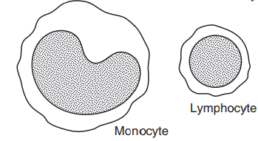

Adaptations of white blood cells to their function
- They do not have a fixed shape and hence the amoebic movements used to engulf pathogens.
- They are larger than the pathogens
- They are numerous
- Some lymphocytes produce antibodies which attack pathogens
- They have an irregular shaped nucleus which allows them to squeeze through the narrow capillaries
- They have a sensitive cell surface membrane that detects micro organisms
- They have enzymes in their cytoplasm to digest the engulfed micro organisms
- In adults they are produced and develop in the bone marrow
- They have a large nucleus which contains lymph glands while in embryos they are many genes for the control of antibody produced in the thymus gland, liver and spleen.
NB: WBC have a life span of 21 days

BLOOD PLATELETS (thrombocytes)
These are irregularly shaped, membrane bound cell fragments lacking the nuclei and are formed from the bone marrow cells. They are responsible for starting up the process of blood clotting. There are abound 250,000 blood platelets per mm³ of blood.

DEFENCE AGAINST DISEASES
Every mammal is equipped with a complex system of defensive mechanisms which are designed to enable it prevent the entry of microbes into it, to withstand attacks by pathogens (disease causing micro-organisms) and to remove foreign materials from the system.
The defensive mechanisms of blood include the following;
- Clotting of blood
- Phagocytosis
- Immune response to infection

Clotting of blood
When a tissue is wounded, blood flows from it and eventually coagulates to form a blood clot which covers the entire wound. This prevents further blood loss and entry of pathogens. The process of blood clotting is described below.
When blood platelets and damaged tissues are exposed to air, the platelets disintegrate and release an enzyme called thrombokinase, which in the presence of plasma proteins and calcium ions catalyses the conversion of a plasma protein derived from vitamin K called Prothrombin into thrombin enzymes.
Thrombin is a proteolytic enzyme that hydrolyses a plasma protein called fibrinogen into an insoluble protein called fibrin. Fibrin forms fibres at the wounded area. Within the fibrous network of fibrin blood cells become trapped, thereby forming a fibrin clot or a blood clot.
The clot not only prevents further blood loss, but also prevents the entry of bacteria and other microbes which might otherwise cause infection.
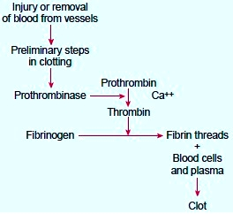

Why blood does not clot in the vessels
- Connective tissue plus the liver produce chemical, heparin, which prevents the conversion of prothrombin to thrombin, and fibrinogen to fibrin.
- Blood vessels are smooth to the flow of blood. Damage to the vessel’s endothelium can lead to platelets breakdown which leads to clotting of blood.

BLOOD GROUPS AND TRANSFUSION
This is the transfer of compatible blood from the donor to the recipient.

Blood transfusion based on the ABO system of grouping blood
Blood group A has antigen A on the surface of its red blood cells and antibody b in the blood plasma of that person. Blood group B has antigen B on the surface of its red blood cells and antibody a in the blood plasma of that person. Blood group AB has antigen B and A on the surface of its red blood cells and no antibody in the blood plasma of that person. Blood group O has no antigen on the surface of its red blood cells and both antibody b and a in the blood plasma of that person.
Blood group | Antigen on the red blood cell membrane | Antibody on plasma
A | A | b
B | B | a
AB | A and B | Lacks antibodies
O | No antigens | a and b
Blood plasma permanently contains antibodies depending on a particular blood group. However these antibodies do not correspond to a specific antigen, if they correspond then agglutination occurs (precipitation of blood). That is why an individual with blood A having antigen A cannot donate blood to an individual with blood group B having antibody a in the plasma which corresponds to antigen A to cause agglutination. Similarly, blood groups A and B cannot donate blood to an individual of blood group O because antigen A will be attacked by antibody a in blood group O and antigen B will be attacked by antibody b in blood group O to precipitate the recipient’s blood. The table below summarizes the possible blood transfusions and the impossible ones.
Blood group compatibilities
Individuals with blood group AB posses
Recipient |  |  |  | Donor’s blood group
Blood group |  |  | Antibody in plasma | A | B | AB | O
A |  |  | B |  | X | X
B |  |  | A | X |  | X
AB |  |  | None
O |  |  | a and b | X | X | X
 |  | = compatible with recipients blood
antigen B which stimulates blood group B of the recipient to produce antibody a that reacts with antigen A in the donor’s blood to cause agglutination and therefore this transfusion from AB to B is impossible. Similarly blood group O individuals can donate blood to blood group A because the donor’s blood has no antigens which would react with antigen A in the recipient’s blood and therefore agglutination is impossible.
X = Incompatible with recipient i.e. agglutination occurs
Individuals with blood group O are called universal donors because they lack antigens which would react with the corresponding antibodies in the recipient’s blood.

Individuals with blood group AB are called universal recipients because they lack antibodies in their blood plasma which would have reacted with the corresponding antigens in the donor’s blood.
NOTE; the recipient’s antibody is the one expected to attack and react with the corresponding antigen in the donor’s blood. Whenever the antigen of the donor corresponds with the antibody of the recipient’s blood group, an antibody-antigen reaction occurs, leading to agglutination (precipitation or clotting of blood)

RHESUS FACTOR (D-Antigens)
These are antigens which were first observed in the bodies of the Rhesus monkeys. These antigens are also carried on the surface of the erythrocytes of some human beings. Those people with D-antigens on the surface of their red blood cells are called Rhesus positive (Rh⁺) while individuals missing such D-antigens are called Rhesus negative (Rh⁻).
The bodies of individuals do not have already manufactured antibodies against the D-antigens. When an expectant mother who is Rh⁻ bears the foetus with which is Rh⁺, some foetal erythrocytes with D-antigens will cross the placenta and enter into the blood circulation of the Rh⁻ mother towards the end of the gestation period (pregnancy). It is also possible for the blood of the foetus to mix with that of the mother during birth so that the mother gets Rh⁺ by getting the D-antigens from the child.
The D-antigens that have entered the mother’s blood circulation stimulate the maternal body to manufacture corresponding antibodies (antibody-d or anti-D antibodies) which attack and react with the D-antigens in the mother. Some formed antibodies-d can also pass via the placenta and enter the foetal blood circulation where they attack and react with the Dantigens which results into clumping together and bursting of the foetal red blood cells, a condition called erythroblastosisfoetalis (Haemolytic disease of the new born). This disease results into acute anaemia which can lead to death of the feotus.
The first born rarely dies because the time is too short for the mother to produce enough antibodies that can pass to the foetus to cause death but subsequent Rh⁺ foetus can die due to the many antibodies of the mother entering its circulation to cause agglutination.
To prevent this disease, pregnant mothers are always given anti-D chemicals 72hours to delivery, to render her immune system insensitive towards the D-antigen i.e. the mother may be infected with antibody-d within 70-72hours to delivery or within 72 hours after her first born. Also the blood of the foetus can be transfused with normal blood to dilute antibody-D so as to save the child.
NOTE: if a rhesus negative mother of blood group O is carrying a rhesus positive child of any blood group other than O, the problem will not arise. This is because if fetal cells enter the mother’s circulation, the mother’s a andb antibodies will destroy the blood cells before the mother has time to manufacture anti-rhesus antibodies.

Types of circulatory systems in animals
The higher invertebrates and vertebrates have two types of circulatory systems
- Open circulatory system and
- (ii) closed circulatory system

The open circulatory system: this is a system where blood is not confined to blood vessels through the course of its circulation in the body. It fills in open spaces known as the haemocoel. The blood is pumped at relatively low pressure from the heart into the main body cavity called the haemocoel. The blood bathes the cells directly and only slowly percolates through the tissues

The open vascular system of an insect
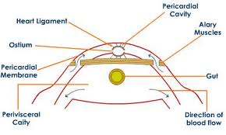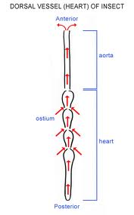

As shown above the only blood vessel is the heart which is tubular and is perforated by tiny holes called Ostia. It is suspended by slender ligaments attached to the pericardial membranes on the lower side and body wall on the upper. It extends from the abdomen to the thorax and it is expanded to form a small chamber in each segment.
At positions corresponding to these chambers of the heart in the pericardial membrane are muscles known as alary muscles. These muscles are responsible for aiding expansion of the heart after its contraction.

During systole (contraction),
- The alary muscles are relaxed
- The ostia and the valves close,
- Waves of contraction take place in the heart from the posterior towards the anterior chambers.
- This propels blood forward in the heart and
- When it reaches the anterior, blood flows out of the heart through the aorta to the haemocoel.
During diastole (relaxation),
- The alary muscles contract.
- This causes the ligaments to stretch the heart,
- The pericardial membrane is depressed,
- Leads to reduction in volume in the perivisceral cavity
- Pressure in the perivisceral cavity increases.
- Fluid then flows from the pervisceral cavity to the pericardial cavity and it enters the heart through the ostea.
- When the heart is full of blood, it contracts and the cycle continues.

Functions of the circulatory system of insects;
- Transport of nutrients
- To transport nitrogenous wastes to organs of elimination i.e. the malphigian tubules
- To defend the body against disease causing organisms using phagocytes they contain.
Note: blood in insects does not transport respiratory gases. O2 is supplied directly to the tissues by the tracheal system.

Closed circulatory system
A closed circulatory system is one where blood is confined to blood vessels throughout its course of circulation in the body.
This is present in vertebrates and higher invertebrates like annelids.
There are two types of closed circulatory systems;
i) The single circulatory system: in this case the blood flows through the heart once in each complete circulation.
ii) The double circulatory system. In this case the blood flows through the heart twice in each complete circulation.
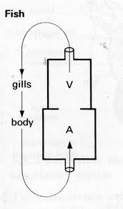
Single circulation in fish
Deoxygenated blood flows from the heart to a capillary network in the gills then to the tissues of the body and finally back to the heart. The heart in fish has a single atrium and ventricle.
The functions of the circulatory system in fish are similar to those of earthworms.

The single circulation of the earthworm
In the earthworm the circulatory fluid blood consists mainly of water in which are dissolved gases, sugars, amino acids, salts and many other molecules and ions taking part in metabolism. The blood also has haemoglobin and this makes it able to carry oxygen. However this haemoglobin is not confined in blood cells but is dispersed in the blood.
The circulatory system here consists of a system of large longitudinal blood vessels on both the dorsal and ventral parts of the body which end in capillaries where exchange of materials between the blood and organs like the skin, intestines, nephridia and other tissues takes place. In addition to these blood vessels there is a “heart” which in essence consists of five pairs of aortic loops whose walls are capable of muscular contraction.
Blood is propelled from the aortic loops when muscles contract. Blood flows through vessels to organs and tissues where they terminate into capillaries. Once through the capillaries the blood is collected by a branching network of blood vessels leading into the dorsal blood vessel. This vessel contracts rhythmically forcing blood to flow forward to the anterior of the animal until it reaches the aortic loops and the cycle is repeated.
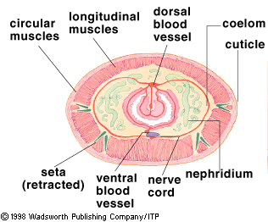

The functions of blood circulatory system of earthworm are;
i) Transport of; nutritive molecules, respiratory gases and nitrogenous wastes
ii) Defense against diseases. The blood has amoebocytes which engulf any disease causing organisms in the blood.

Double circulatory system
This is one where blood passes through the heart twice in one complete circulation. This is a characteristic of all members of the vertebrata with the exception of the fish.
Blood entering the heart first flows to the lungs and back to the heart which is known as pulmonary circulation after which it is then pumped to the rest of the body. This is known as systemic circulation. For this reason higher blood pressure can be attained than in single circulation.

Double circulation in amphibians
The heart is three chambered with two atria and a single ventricle. The mixing of blood which would otherwise have occurred in the ventricle is prevented by the presence of spiral valve in the conus arteriosus.
The extensive blood supply to the lungs and the skin via pulmocutanous blood vessels greatly increases the efficiency in transporting gases in addition to the presence of haemoglobin in the RBC. Again this is greatly enhanced by the structural arrangement of the circulatory system which ensures that blood is pumped to the skin and lungs where gas exchange occurs from the ventricles at the same pressure with that to the rest of the body.

Double circulation in octopus
High blood pressure is maintained by branchial hearts. The blood is pumped at a high pressure by the main heart to the body, then taken up by the branchial heart, to the gills then back to the main heart.
Note: check BS page 470.

Double circulation in mammals
Mammals have a complete double circulation. The heart is divided into a left and right section there ensuring complete separation of deoxygenated and oxygenated blood. The heart is therefore two pumps in one and this is why it is able to send out different volumes of blood to different organs at different pressure. Both these pumps work simultaneously.
Advantages of a double closed circulatory system over open one
- Relatively high pressure required for fast flow of blood is acquired than in open circulation
- Since the blood is returned rapidly to the heart for pumping, more rapid circulation can be attained
- The separation of oxygenated and deoxygenated blood in it improves efficiency of oxygen distribution and therefore sustain the high metabolic rate required by such animals
- The blood is piped directly to where it is needed
- The amount flowing to certain organ can be regulated by changing the diameter of the blood vessels.
- blood cells and large molecules remain within vessels
- can support higher levels of metabolic activity

Differences between open d closed circulatory system

Open circulatory system | Closed circulatory system
- blood flows through large open spaces and channels called lacunae and sinuses among the tissues | - blood flows through a system of closed chambers and tubes called the heart and blood vessels
- tissues are in direct contact with the blood | ii)..there is no direct communication with any tissue, open body cavity or space
- blood flows under very low pressure and moves slowly through the tissues | iii). By strong pumping action of the heart blood flows with great pressure in the arteries
- heart pumps oxygenated blood into an aorta which branches into number of arteries, which open into series of blood spaces and lacunae collectively known as haemocoel | iv). Heart pumps oxygenated blood to aorta which branches into a number of arteries, then to arterioles and finally to a network of capillaries all over the body.
- Blood takes comparatively longer time to circulate through the whole body | v). blood takes a much shorter time to circulate through the body.
- Blood seeps out of the sinuses and is poured back into the heart through the open ended vein. | vi). Blood is collected by veins and is poured back into the heart through a tissue or organ can be regulated by contraction and relaxation of the smooth muscles of the arteries.
- Exchange of gases takes place directly between blood and tissues | vii). Nutrients and gases pass through the capillary wall to the tissues
- Volume of blood flowing through a tissue can not be controlled as blood flows out in open spaces | viii). Volume of blood flowing through a tissue or organ can be regulated by contraction and relaxation of the smooth muscles of the ateries
- It is present in higher invertebrates like most arthropods, prawns, insects | ix). It is present in echinoderms, some molluks, annelids and all vertebrates

MAMMALIAN BLOOD CIRCULATION
The mammalian blood circulation is a double blood circulation which is mainly based on the heart and blood vessels,

BLOOD VESSELS
There are three major types of blood vessels: arteries, capillaries, and veins. As the heart contracts, it forces blood into the large arteries leaving the ventricles. Blood then moves into smaller arteries successively, until finally reaching the smallest branches, the arterioles, which feed into the capillary beds of organs and tissues. Blood drains from the capillaries into venules, the smallest veins, and then into larger veins that merge and ultimately empty into the heart. If you stretched out all of the blood vessels in the human body, they would be 100,00 km (60,000 miles) long!
Arteries carry blood away from the heart, so they are said to “branch” as they form smaller and smaller divisions. In contrast, veins carry blood toward the heart and are said to “merge” into larger and larger vessels approaching the heart. In the systemic circulation, arteries always carry oxygenated blood and veins always carry oxygen-poor blood. In the pulmonary circulation, the opposite is true. The arteries, still defined as the vessels leading away from the heart, carry oxygen-poor blood to the lungs, and the pulmonary veins carry oxygen-rich blood from the lungs to the heart.
The only blood vessels that have contact with tissue cells in the human body are capillaries. In this way, they serve cellular needs. Exchanges between the blood and tissue cells occur primarily through the thin capillary walls.
Task:
- Give a comparison between arteries and veins
- How are the three blood vessels adapted to their functions
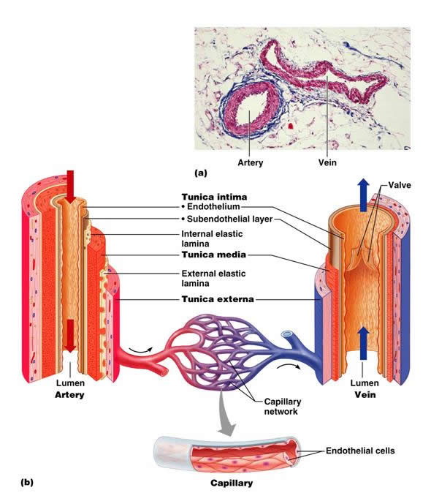
Anatomy of a blood vessel wall. The tunica intima, tunica media, and tunica externa.
The walls of these blood vessels occur in three layers, namely;
- Tunica externa (outer most layer)
- Tunica media (middle layer)
- Tunica intima (inner most layer)
Tunica externa, this is the outermost layer which is tough and made up of thick collagen fibres which provide strength and prevents extensive stretching.  Tunica media is the middle layer which consists of smooth muscles, collagen and elastic fibres. The structural proteins allow for the stretching of the walls of blood vessels during vaso-dilation. The smooth muscles allow for the distension and constriction of the walls of the blood vessels.  Tunica intima is the innermost layer composed of a single layer of squamous en dothelium. It is found in all walls of blood vessels. Capillaries have only the tunica interna. | 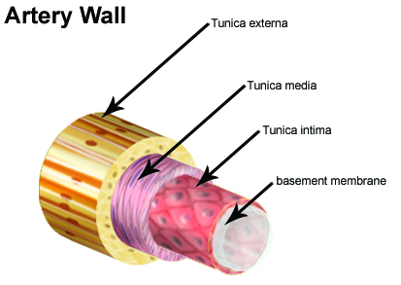

INTERNAL STRUCTURE OF THE MAMMALIAN HEART
The internal structure of the heart shows that the heart has two sides, the left side and right side. These are separated by a muscular wall known as septum.
The heart has the artria which collects blood from the body and pumps it to the lower chambers known as ventricles. The ventricles pump blood to the arteries and this is the reason why they have thick walls. The left ventricle which pumps blood to the rest of the body has a thicker and stronger wall than the right ventricle which pumps blood to the lungs which are a shorter distance away. The atria and ventricles are separated by valves. The valve on left side consists of two flaps and is known as bicuspid valve (mitral valve) while that on the right is known as tricuspid but collectively both are known as atrio ventricular valves. These valves are supported by strands of strong inelastic tissues known as tenderone chords or chordate tendinae. These prevent the valves from being turned inside out by the high pressure generated when ventricles contract. The bases of the arteries in the heart also have valves shaped like crescents and are commonly known as the semi lunar valves. However to be more specific the valves at the base of the aorta are known as aortic valves while those at the base of the pulmonary artery are known as pulmonary valves. All valves serve to prevent blood flowing in the wrong direction.

CARDIAC CYCLE
Rhythmic contraction and relaxation of the cardiac chambers i.e. the auricles and the ventricles in a specific manner during one heart beat constitutes a cardiac cycle.
Heart beats continuously without pause in life. Auricles and ventricles show rhythmic contractions and relaxations. On average heart beats 72 times per minute. Heart pumps about 5 litres of blood per minute.
Both auricles contract simultaneously and the blood flows into the ventricles and both ventricles contract together forcing the blood into pulmonary artery and aorta.

Terms
Systole. Refers to the contraction of the cardiac chambers and as a result the heart contracts forcing the blood into the pulmonary artery and the aorta.
Diastole. This refers to the relaxation of the cardiac chambers hence enabling the heart to refill
Joint diastole. This refers to the relaxed state of both atria and ventricles

Sequence of changes in cardiac chambers during one cardiac cycle
Atrial filling and joint diastole
- Atrial filling and joint diastole.
- Filling of right atrium (RA) with deoxygenated blood from the great veins and left atrium (LA) with oxygenated blood from pulmonary vein.
- As the pressure increases in the atria, the bicuspid and tricuspid valves open and blood flows into the respective relaxed ventricles
- The semilunar valves remain closed because of the low pressure and blood does not flow out of the ventricles.
- Atrial systole and ventricular diastole
- At the end of joint diastole, next heart beat begins.
- The two atria contract, forcing most of the blood into the ventricles
- Simultaneous closing of great great vein roots ( superior and inferior vena cava) by compression occurs
- Bicuspid and tricuspid valves are open
- It lasts for about 0.15 seconds

- Ventricular systole (VS) and atrial diastole (AD)
- Sharp closing of A.V valves to stop backflow of blood to ventricles. this produces the first heart sound lubb.
- Rise of the ventricular pressure but it is still lower than the pressure in the great arteries- the pulmonary artery and aorta and hence the semi lunar valves are still closed.
- Ventricles contract as closed chambers and then the ventricular pressure exceeds the pressure in the pulmonary artery and aorta forcing the opening of valves.
- Blood flows from ventricles to great arteries
- It lasts for about 0.25 seconds
- Ventricular diastole and atrial diastole (beginning of joint diastole)
- Ventricles relax and the pressure falls below to that in the great arteries
- Closing of the semilunar in the pulmonary artery and aorta produces the second heart sound- dub.
- This prevents backflow of blood into ventricles.
- As the low ventricular pressure is still greater than the atrial pressure , the AV valves remain closed
- Continued ventricular diastole decreases the pressure tremendously and now both atria and ventricles are in joint diastole.
- This lasts for about 0.4 seconds
One complete systole and diastole (described above) forms a cardiac cycle which takes about 0.8 seconds. The new cardiac cycle begins with the atrial systole.
In each cardiac cycle there is a louder lub heart sound during ventricular systole and a fainter dub sound during ventricular diastole.

(Check in functional approach for cardiac cycle drawings)
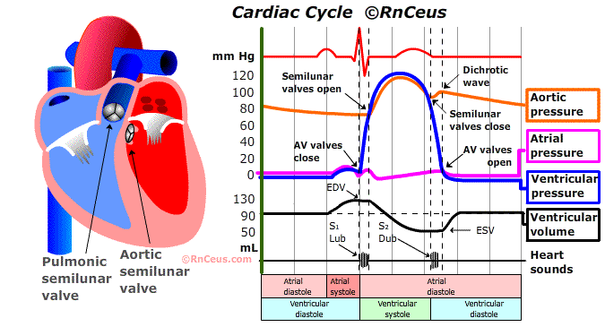

Comparison of atrial and ventricular systole
Atrial systole | Ventricular systole
- Contraction of atria and relaxation of ventricles | Contraction of ventricles and relaxation of atria
- Bicuspid and tricuspid valves open | Bicuspid and tricuspid valve are closed
- Closing of great vein roots and no sound is produced. AV valves are open | Closing of AV valves produces the first heat sound lubb
- Blood is poured into ventricles | Blood is pumped out in great arteries
- Lasts for about 0.15 seconds | Lasts for about 0.25 seconds

 | Mitral valve |  |  |  |  | Semilunar valve
- (i) | Also referred as bicuspid valve |  | since | it | (i) | Valves consist of 3 flaps.
 | consists of 2 flaps.
(ii) Guards the opening |  | of left auriculo- |  |  | (ii) | Present at the base of pulmonary artery
 | ventricular aperture. |  |  |  |  | and aorta and at regular intervals in
 |  |  |  |  |  | veins.
(iii) | Allows the blood to move from left atrium |  |  |  | (iii) | In the heart they allow the blood to flow
 | to left ventricle. |  |  |  |  | from ventricles to great arteries and in
 |  |  |  |  |  | the veins allow the blood to flow towards
 |  |  |  |  |  | the heart.
(iv) | Valves are attached to chordae tendinae |  |  |  | (iv) | Valves are attached to the wall of the
 | which prevent them from being everted |  |  |  |  | blood vessel. No chordae tendinae are
 | out. |  |  |  |  | present.

Control of the heart beat
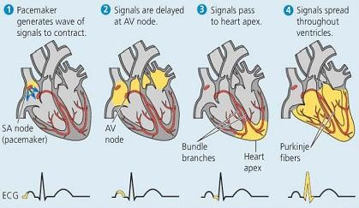
All vertebrate hearts are myogenic in nature, meaning their heart beat is initiated from within the heart muscles. In insects it is initiated by the nerves outside the heart and is known as neurogenic.
The initial stimulus for a heartbeat originates from a group of cardiac muscles known as the Sino Atrial node (SAN). This is located in the wall of the right atrium near where the vena cava enters the heart. The SAN determines the basic rate of heart beat and is therefore known as the pacemaker.
A wave of excitation spreads out from the SAN across the atria, causing them to contract more or less at the same time. The wave of excitation reaches a similar group of cells known as the Atrio-ventricular node (AVN) which lies between the two atria. To allow blood to be forced upwards into the arteries, the ventricles need to contract from the apex upwards. To achieve this, the new wave of excitation from the AV node is conducted along purkinje fibres, which collectively make a bundle of His. These fibres lead along the intra-ventricular septum to the apex of the ventricles, from where they radiate upwards.

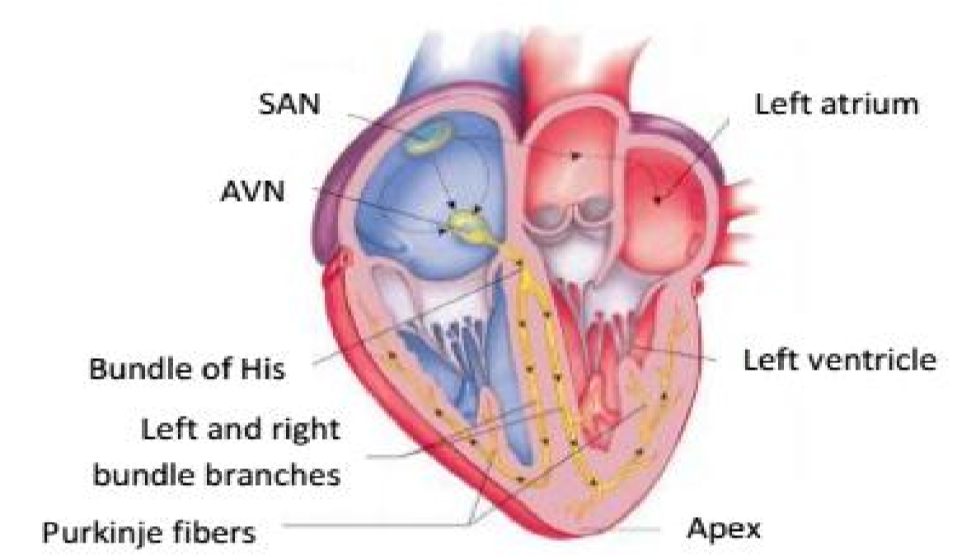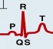

The spreading of excitations through the heart
chambers
can
be
monitored
using
an
electrocardiogram. It shows characteristic waves as the
excitation spreads through the heart.

P
-
atrial
shows
which
wave
depolarization over the atrial m
uscle
and spread of excitation from SAN
during atrial systole.

QRS
-
wave shows spreading of excitation through the
ventricles. (Ventricular systole).

T
-
wave shows recovery/ the be
ginning of ventricular
diastole

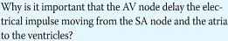
Heart Rate, Arterial Pulse and Blood Pressure
Heart rate:
It refers to the number of times the heart beats per minute. Heart rate of humans is 68-72 times/min. at rest, Heart rate of elephant is 25 times/min and Heart rate of rat 300 times/min.
As is clear from the figures given above, heart rate varies in animals. The smaller animals have high metabolic rates and hence need greater action of heart to pump more oxygen and nutrients to tissues. This is the reason why smaller animals have much higher heart beat rate than the larger animals.
Trachycardia: It refers to the abnormal increase in heart beat rate. It could be due to many factors like emotional stress, anxiety, anger, excitement, etc. It can also be due to over activity of thyroid gland.
Bradycardia: It refers to the abnormal decrease in heart beat rate. Athletes who generally have a high heart rate may suffer low heart rates during rest. It can also be due to under activity of thyroid gland. ii) Arterial Pulse or Pulse wave:
It is a wave of distension followed by constriction experienced in the arteries as a result of ventricular systole and diastole.
Pulse rate per minute = Heart beat rate/minute.
As the ventricles contract, blood is pumped out into arteries with force. It causes distension of the elastic wall of arteries and is felt as a pulse when a finger is placed on an artery near the wrist. This pulse becomes fainter and fainter as the blood moves further away and becomes so low in capillaries that it cannot be felt.
As the ventricles relax, there is a drop in the pressure in the arteries and the distended portion comes back to normal. iii) Blood Pressure:
It is the pressure or the force exerted by the blood against the walls of the arteries.
As the arteries already contain blood, the pressure in them increases due to sudden flow of blood during ventricular systole and falls slightly as the ventricles relax. The blood pressure is measured as two values, for example for a normal healthy man, it is equal to 120 by 80 mmHg. It means that the person has a systolic pressure of 120 mmHg and diastolic pressure of 80 mmHg.
Systolic pressure: It is the pressure experienced in the arteries as a result of contractions in the ventricles. It is equal to 120 mmHg for a normal healthy person.
Diastolic pressure: It is the pressure in the arteries when the ventricles relax.
It is equivalent to 90 mmHg for a normal healthy person.
The values of blood pressure change with age, sex or health of a person.
A Sphygmomanometer is an instrument used for the measurement of blood pressure in the brachial artery.
The blood pressure can also be affected by other conditions like arteriosclerosis where due to hardening of arteries, their lumens become narrower and so the blood pressure increases.

Factors that affect the heart rate
- Size of the organism: small organisms have high rate than large organisms due to high metabolic rate.
- Age: young mammals have higher rate of heart beat than old ones due to high metabolic rate since young ones are actively growing.
- Health state: high heart rate in diseased organisms is due to response to increased levels of temperature and carbon dioxide.
- Activity: increased muscular activities result in accumulation of carbon dioxide in the body and this results in a higher heart rate.
- Temperature: if the body temperature increases, the heart beat rate increases.
- Presence of drugs such as epinephrine increases heart beat rate.

Maintenance and control of blood pressure.
Blood pressure can be controlled and maintained via varying the activities of the SAN. This can be done form within the heart itself by increasing or reducing in the rate of excitation from the SAN which affects the heart beat rate. This determines the cardiac output which affects blood pressure. It can also be controlled via external factors which include;
1. Temperature:
An increase of only 1ºC raises the heart rate by about 10 beats per minutes. This is the reason your heart beats faster when you have fever.
2. Hormonal activity:
Hormones like adrenaline, epinephrine, thyroxin, insulin and other sex hormones directly affect the SAN to increase its activity. When released in the body they increase blood pressure.
3. Nervous system:
Via the cardiovascular regulatory center in the medulla oblongata, the nervous system can regulate blood pressure by varying the activities of SAN via the vagus nerve which decelerates the heart beat and via the sympathetic nerve which accelerates the activities of the SAN.
At the back of the aorta, there are sensory cells sensitive to stretching and concentration of CO₂. These are carotid and aortic bodies. When they are stimulated, they send impulses to the cardiac regulatory center which in turn affects the SAN
e.g. when blood pressure is low or when CO₂ is high, the carotid bodies are stimulated, send impulses to cardiac accelerating center which responds by sending impulses via the sympathetic nerve to the SAN. This causes an increase in the cardiac output hence blood pressure.
Within the cells of the arteries, there are bare receptors, those are sensitive to pressure changes in the arteries. When the blood pressure in the arteries reduces, they are stimulated and they send impulses to the vasomotor center in the medulla. This responds by sending impulses through the sympathetic nerve to the smooth muscles of arteries which contract to increase the blood pressure.

Transport of oxygen
Since oxygen is not very soluble in water under normal atmospheric conditions, most of it is carried by red blood cells. Red blood cells contain a complex protein hemoglobin which on combination with oxygen forms a reversible compound oxyhemoglobin.
A hemoglobin molecule is made up of four polypeptide -chains and four heme groups, each containing an iron atom to which an oxygen can attach. A molecule of hemoglobin can carry 1-4 oxygen molecules (one with each heme group) according to its degree of saturation which depends upon (i) P0₂ in alveolus and (ii) PC0₂ in the blood.
Hemoglobin molecule on combining with oxygen forms oxyhemoglobin in the lungs. These oxygen molecules are quickly released in the tissues.
Hb + 4O₂ Hb(4O₂)

Hemoglobin has high affinity for oxygen and this affinity is enhanced by fall in PC0₂ of blood. At the alveolus in lungs, venous blood has low oxygen and it is exposed to high PC0₂ of alveolus and so oxygen diffuses into red blood cells and forms oxyhemoglobin. As carbon dioxide diffuses from blood to alveolus, blood PC0₂ falls enhancing further uptake of oxygen.
Oxyhemoglobin remains unchanged till it reaches the tissues where it dissociates readily to release
its oxygen.

Question: Describe the structure of haemoglobin and discuss how it is suited to its functions

OXYGEN DISSOCIATION CURVE
The amount of oxygen hemoglobin takes up at a particular time is called its percentage saturation which depends on the P0₂ of air in contact
The graph in which percentage saturation of blood is plotted against P0₂ is called the oxygen dissociation curve which is an S-shaped curvy. It indicates that the blood has a high affinity for oxygen.
In man the arterial blood has P0₂ of about 95 m.m of Hg and so hemoglobin is about 95% saturated. In the venous blood, P0₂ is about 40 mm of Hg and so blood is about 70% saturated.
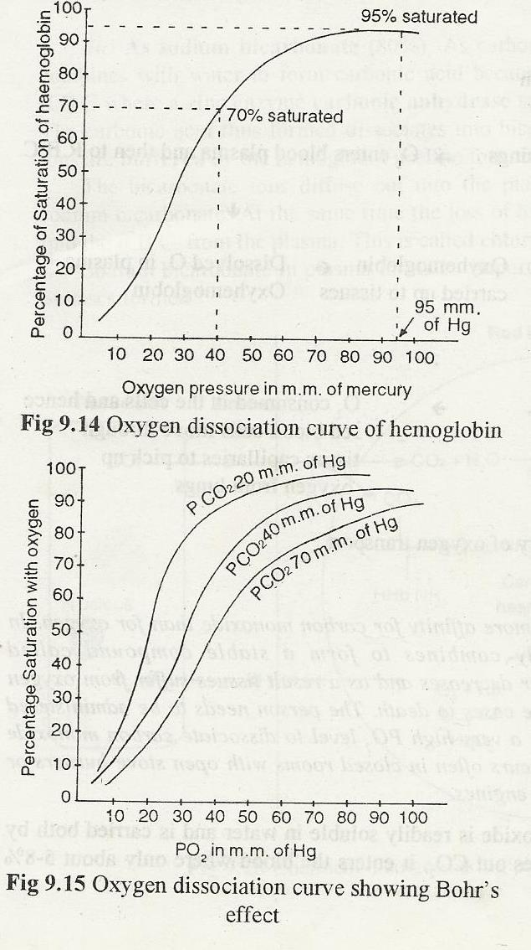

Bohr Effect
Figure below shows that increase in PC0₂ shifts the oxygen dissociation curve downwards. This is called as Bohr effect (named on the scientist) which has biological advantages. Since PCO₂ is lower in lungs than in tissues, hemoglobin has higher affinity for oxygen. In the tissues, P0₂ is between 10 and 40 m.m of Hg and PC0₂ is comparatively very high around 46 m.m of Hg. An active tissue has a relatively high PC0₂, low pH and raised temperature and all these changes lead to more dissociation of oxygen. Oxygenated blood passing through inactive cells does not give up oxygen even if its P0₂ is low but in active cells it readily gives oxygen as PC0₂ is very high.

Factors affecting Disassociation
- Blood temperature
- increased blood temperature reduces haemoglobin affinity for O₂ hence more O₂ is delivered to warmed-up tissue as shown below

- BLOOD pH
Lowering of blood pH (making blood more acidic) caused by presence of H⁺ ions from lactic acid or carbonic acid reduces affinity of Hb for O₂ and more O₂ is delivered to acidic sites which are working harder

- Carbon dioxide concentration
The higher CO₂ concentration in tissue the less the affinity of Hb for O₂so the harder the tissue is working, the more O₂ is released (explain)

Comparison between the oxygen dissociation curves of different sized mammals
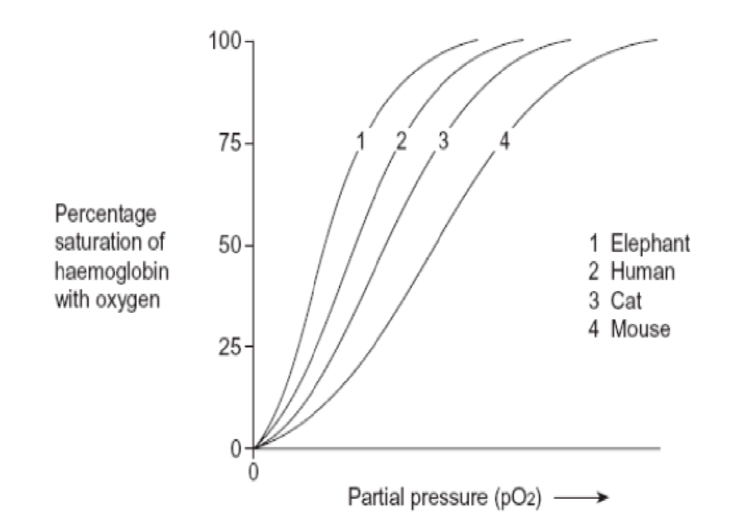
Small animals have higher metabolic rates and so need more oxygen per gram of tissue than larger animals. Therefore they have blood that gives up oxygen more readily i.e. their dissociation curves are on the right of the larger animals

Comparison between the oxygen dissociation curves at rest and during exercise
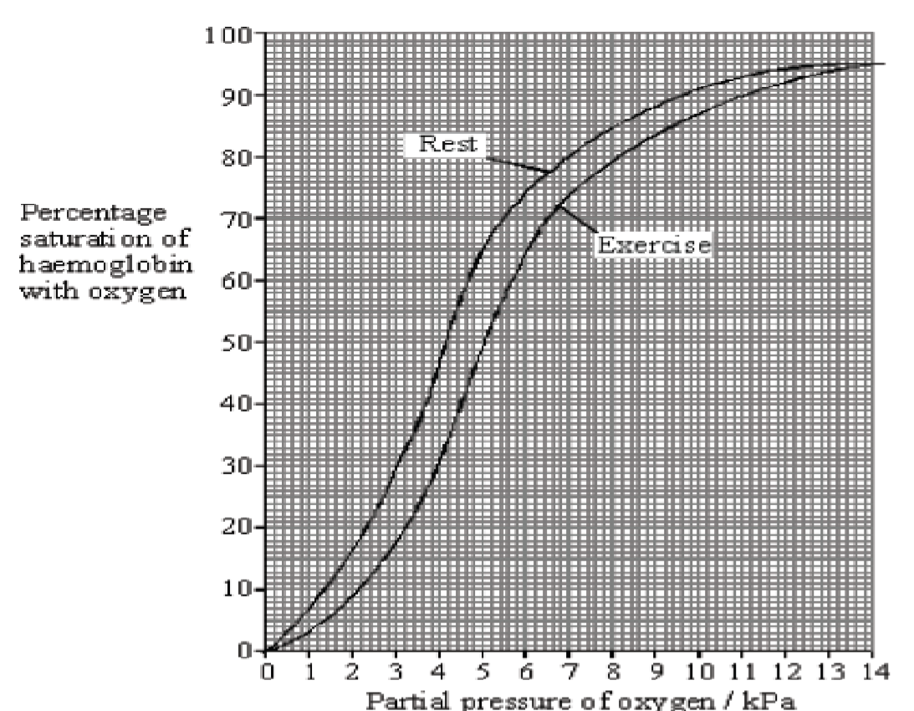

During exercise, the oxyhaemoglobin releases oxygen more readily hence the oxygen dissociation curve during exercise is to the right of that when the individual is at the right of the curve when at rest.

Comparison between the oxygen dissociation curve of maternal haemoglobin and that of the foetal haemoglobin
The oxygen dissociation curve of foetal haemoglobin lies to the left of maternal haemoglobin (check in Biological sciences) ;
This indicates that the foetal hemoglobin has a higher affinity for oxygen than that of the mother. This enables the foetal haemoglobin to pick sufficient oxygen from the mother via the placenta and also increases on the oxygen carrying capacity to the tissues, especially when the foetus needs a lot of energy.
It also increases on the oxygen carrying capacity to the tissues of the foetus in the situation whereby deoxygenated and oxygenated blood are mixed due to the bypasses of ductus arteriosus and foramen ovale in the foetus.

Myoglobin and other respiratory pigments
Myoglobin is a respiratory pigment which also contains iron containing haem groups mostly found in the muscles where it remains fully saturated at partial pressures below that required for haemoglobin to give up its oxygen. Myoglobin has a higher affinity for oxygen than haemoglobin in a way that it combines readily with haemoglobin and it becomes fully saturated with oxygen at a lower partial pressure of oxygen.
Myoglobin acts as a store of oxygen in resting muscles in form of oxymyoglobin and only releases the oxygen it stores only when oxyhaemoglobin has been exhausted i.e. many vigorous activities because myoglobin has a higher affinity for oxygen than haemoglobin. The oxygen dissociation curves for myoglobin lies to the left of that of haemoglobin as shown in the graph
Oxygen dissociation curves of haemoglobin and myoglobin
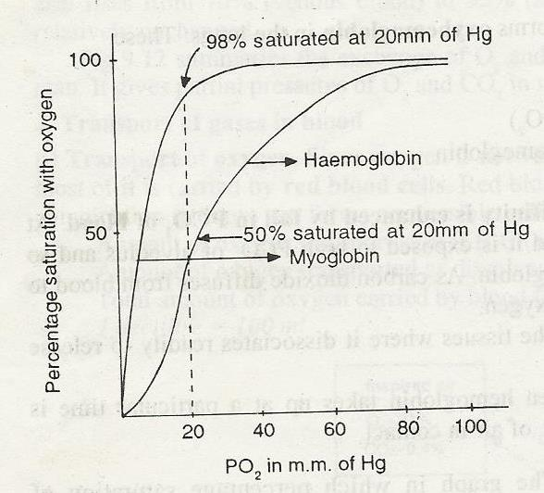

Note;
- High affinity refers to low rate of dissociation to release oxygen and a higher rate of association of haemoglobin with oxygen.
- Low affinity refers to higher rate of dissociation to release oxygen and a lower rate of association of haemoglobin with oxygen.
- There are other respiratory pigments mostly found in the lower animals which include haemocyanin which consists of copper and mostly found in some snails and crustaceans
- Other pigments include haemocrythrin which contains iron and is also found in some in annelids
- Chlorocruorin which also contains iron is also found in some annelids.

Carbon monoxide poisoning
Hemoglobin has much more about 250 times more affinity for carbon monoxide than for oxygen. In the presence of carbon monoxide, it readily combines to form a stable compound called carboxyhemoglobin. The oxygen combining power decreases and as a result tissues suffer from oxygen starvation. It leads to asphyxiation and in extreme cases to death. The person needs to be administered with pure oxygen-carbon dioxide mixture to have a very high PO₂ level to dissociate carbon monoxide from hemoglobin. Carbon monoxide poisoning occurs often in closed rooms with open stove burners or furnaces or in garages having running automobile engines.
Transport of carbon dioxide.
Carbon dioxide is readily soluble in water and is carried both by plasma and red blood cells. As an active cell gives out CO₂, it enters the blood where only about 5-8% forms the solution in the blood plasma and the rest 92-95% enters the red blood cells where it is transported by two means. In all carbon dioxide is carried by three different means.
- By plasma in solution form (5-8%). Carbon dioxide combines with water to form carbonic acid
H₂CO₃. It is a very slow process and hence a very small amount is carried this way.

CO₂ + H₂O H₂CO₃

- By the R.B.C as compounds with proteins of haemoglobin (l5 %.). Some carbon dioxide that enters the R. B. C forms a reversible compound with amino (-NH₂) group of the globin (protein) part of reduced haemoglobin. The reaction is similar to that with oxygen but is not with the heme part but is with the protein part of the haemoglobin. The compound formed is called as carbamino-haemoglobin.

HHbNH₂ + CO₂ Hb NHCOOH + H⁺
Reduced haemoglobin Carbamino haemoglobin

- As sodium bicarbonate (80%). As carbon dioxide diffuses into the blood plasma, only a part combines with water to form carbonic acid because it is a very slow reaction.
A large part enters the R.B.C where a zinc enzyme carbonic anhydrase speeds up the formation of carbonic acid tremendously.
The carbonic acid thus formed dissociates into bicarbonate HC0₃⁻ and hydrogen ions H⁺. The hydrogen ions are buffered by the hemoglobin itself to form HHb as shown in figure below.
The bicarbonate ions diffuse out into the plasma where they combine with sodium ions to form sodium bicarbonate. At the same time the loss of bicarbonate ions is balanced by chloride ions diffusing into the R. B.C. from the plasma. This is called chloride shift.
Sodium bicarbonate in plasma forms an important buffering system and helps to neutralise any acids or bases formed.

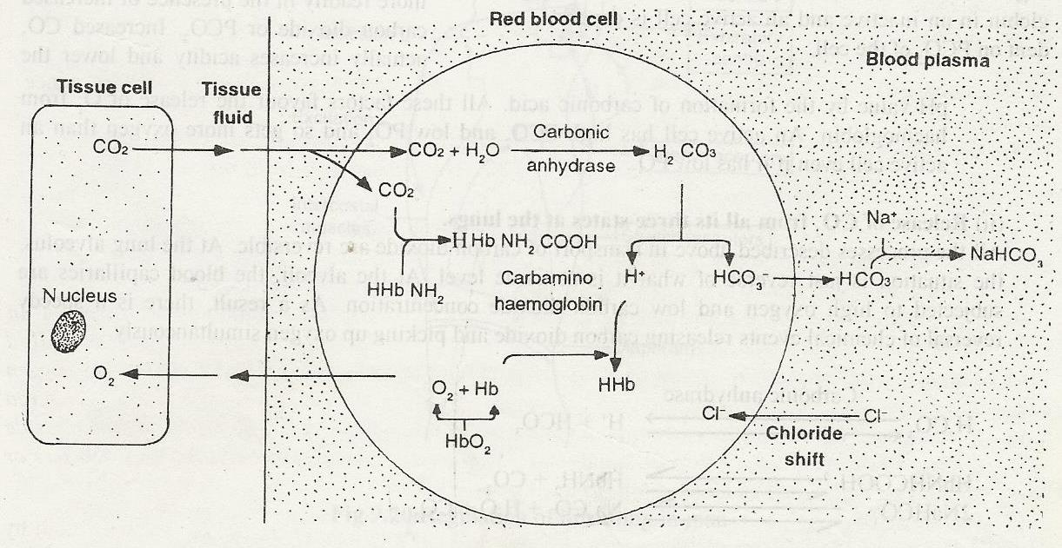
Release of gases at the tissue and at the lung level
At the tissue level, oxygen is released from oxyhaemoglobin and carbon dioxide is picked by plasma and red blood cells. At the lung level, carbon dioxide is released from its three states so as to expire it out from blood to the alveoli and oxygen is picked up by haemoglobin.
Release of 0₂ from oxyhaemoglobin at the tissue level

HbO₂ Hb + O₂

The dissociation of oxyhaemoglobin depends on PO₂ and PCO₂ of the cell. Oxyhaemoglobin gives off its oxygen more readily in the presence of increased carbon dioxide or PCO₂. Increased CO₂ actually increases acidity and lower the pH value by the formation of carbonic acid. All these factors favour the release of oxygen from haemoglobin.

Release of CO₂ from all its three states at the lungs.
All the processes described above in transport of carbon dioxide are reversible. At the lung alveolus the situation is just reverse of what it is at tissue level. At the alveoli. the blood capillaries are subjected to high oxygen and low carbon dioxide concentration. As a result there is a speedy reversal of chemical events releasing carbon dioxide and picking up oxygen simultaneously.

Carbonic anhydrase also rapidly converts carbonic acid back to carbon dioxide and water when blood reaches the lungs.

IMMUNITY
Immunity is defined as the capacity to recognize the entry of foreign materials in the body and to mobilize cells to help and remove the foreign particles immediately it enters the body or before they enter the body.

Antigen:
Molecule that stimulates an immune response. Usually proteins (polysaccharides, nucleic acid, lipids can also act as antigens) and other inorganic molecules important for self-recognition.
Self-antigen: Only found on the host's own cells and does not trigger an immune response. There is only 1:4 change that siblings will possess an identical antigen.
Non-self-antigen: Found on cells entering the body (e.g. bacteria, viruses, and another person's cell) and can cause an immune response.

Antibody (immunoglobin protein):
Secreted by B-lymphocytes and produced in response to a specific (foreign) non-self-antigen. B-lymphocyte's receptor site matches the non-self-antigen.
Each antibody is produced by one type of B-lymphocyte for only one type of antigen
An antibody is Y-shaped
- The two ends of the Y are called the Fab fragments
- The other end is called the Fc fragment
- Fab fragment is responsible for the antigen-binding properties
- Fc fragment is the effector component and triggers the immune response B cells divide and form memory cells and antibody-secreting plasma cells:
- Agglutination makes pathogens clump together.
- Antitoxins neutralize toxins produced by bacteria.
- Lysis digests bacterial membrane, killing the bacterium.
- Opsonisation coats pathogen in protein that identifies them as foreign cells.

Types of Immune Response
The immune system defends the body in the following ways:
Non-specific way This works by attacking anything foreign. It involves:
- First line of defense: this is a barrier that helps prevent pathogens from entering the body. The body has several different types of barriers:
Tears = wash germs away, kill germs
Skin = Germs can only enter skin when you have a cut, burn or Scrape.
Mucous Membranes = in your nose, mouth, and throat secrete a fluid called mucus that traps germs.
Saliva = washes germs from your teeth and helps keep your mouth clean. Gastric juice = destroys germs that enter through food or drink.

- Second line of defense: microbes that get into the body encounter the second line of non-specific defense. It is meant to limit the spread of invaders in advance of specific immune responses. There are 3 types: i) Inflammatory response: works in two ways;
  - Histamine triggers vasodilation which increase blood supply to that area, bringing more phagocytes to engulf germs. Histamine is also responsible for the symptoms of the common cold, sneezing, coughing, redness and itching and runny nose and eyes - all attempt to rid the body of invaders.
  - Increased body temperature speeds up the immune system and makes it more difficult for microbes to function.

Inflammation:
This is a localized reaction which occurs at the site where a wound has been formed. It causes swelling and a lot of pain. The site appears red due to increased blood flow. Capillary network dilate and become more permeable to lymph and release lymphocytes. Chemical substances called histamines are released to bind the pathogens (agglutination) for easy recognition by lymphocytes. Fibrinogen also present to assist blood clotting if necessary. ii) Phagocytes iii) Interferon: chemicals released by the immune system to block against viral infections.

B-Lymphocytes: The Humoral Response
Response for pathogens not entering our cells i.e. antibodies defend against infection in body fluids. (E.g. bacterium).
Each B-lymphocyte recognizes only one specific antigen or need T-helper cell to be activated.
Mature B-cells develop to give many different variants of specific immune system responding to any type of pathogen entering the body.
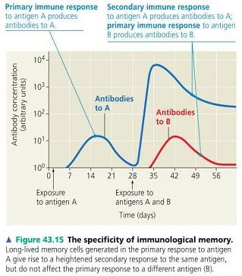
- Primary response:
Pathogen is ingested by macrophages / macrophage displays the pathogens surface non-self-antigen on its surface (antigen presentation).
It then joins with specific T-helper cells and B lymphocytes that have membrane receptors and are complementary in shape to the non-self-antigen. T-helper cells will release cytokines to activate selected B-cell/lymphocyte:
  - Secretes antibodies of the same type into the blood
  - Divided by mitosis to produce a clone iii) Cells grow to form plasma cells producing masses of free antibodies
Some of the cells remain in the blood as memory cells.
- Secondary response: this occurs if an individual is exposed again to the same antigen. There is immediate recognition and distraction - faster, larger response usually prevents harm. Antibodies are produced more rapidly and in larger amounts.

T-Lymphocytes: Cell-Mediated Response
Cytotoxic lymphocytes defend against infection in body cells. This occurs when a Virus enters a cell thus more difficult to remove.
No antibodies involved / work directly on the infected cell by destroying it.
Special proteins called Major Histocompability Complex (MHC) are present on all human cells. Non-self-antigen interacts with MHC as human cell becomes infected by a pathogen.
✓ Specific T-lymphocyte recognizes specific non-self-antigen only with a chemical marker next to it (MHC) ✓ Activated T-lymphocytes multiply by mitosis and enter circulation ✓ Cells differentiate into different types of cell.
- Cytotoxic T-Cells: destroy pathogens and infected cells by enzyme action, and secrete chemicals which attract and stimulate phagocytes.
- Helper T-Cells: stimulate the activity of the cytotoxic T-Cells and B-lymphocytes by releasing chemicals (cytokines and interleukins). It’s the one destroyed by HIV.
- Suppressor T-Cells: switch off the T and B cell responses when infection clears
- Memory T-Cells: Some activated T-Cells remain in the circulation and can respond quickly when same pathogen enters body again.

Different types of immunity
 | Active (Antibodies made by the human immune system, long term acting due to memory cells) | Passive (Given-Antibodies, short term acting)
Natural | - Response to disease  - Rejecting transplant | - Acquired antibodies (via placenta, breast milk)
Artificial  (immunization) | - Vaccination (Injection of the antigen in a weakened form) | - Injection of antibodies from an artificial source, e.g.  anti-venom against snake bite
Differences | - Antibody in response to antigen  - Production of memory cells  - Long lasting | - Antibodies provided  - No memory cells  - Short lasting

How vaccines produce responses by the immune system (Artificial active immunity)

Types of vaccine
- Vaccine containing dead pathogens. Antigen is still recognized and an immune response made o Salk polio vaccine (Polio vaccine is injected) o Influenza o Whooping cough
- Vaccine containing a toxin o Diphtheria o Tetanus
- Vaccine containing an attenuated (modified or weakened) organism which is alive but has been modified so that it is not harmful o Sabin polio vaccine (Taken orally, often sugar pumps)
- Purified antigen - genetically engineered vaccine. o Hepatitis B (A gene coding for a surface protein of the hepatitis B virus has been inserted into yeast cells which produce the protein when grown in fermenters)

Transplantation
This is the replacement of diseased tissue or organs by healthy ones through a surgery. It’s less successful than blood transfusion because the organ contains more antigens than blood so they are likely to be rejected by the body’s immune system. Tissue rejection has been perfectly overcome by:
- Careful tissue typing i.e. using tissue which meets the donor and recipient antigens as exactly as possible.
- Use of immune suppressive drugs which suppress the recipient’s immunity in order to increase the chances of transplant success.
Tissue typing can be effected through the following ways;
i) Autograft; the tissue is grafted from one area to another on the same individual. E.g. skin. Rejection is not a problem. ii) Isograft; a graft between two genetically identical individuals’ e.g. identical twins. Rejection is not a problem.
- Allograft; a tissue from individual to individual but the two must be closely attached or related though of different genetic constitution. In case of rejection, immune suppressive drugs can be used.
- Xenograft; a graft between individuals of different species such as from sheep to human.

WATER UPTAKE BY THE ROOTS

Internal structure of the root
The root consists of various tissues which occur in concentric layers. The cells at the surface of the young root forming the peliferous layer are so called because it is by the root hairs. As the roots get older, they increase in girth (thickness or diameter) and the peliferous layer (breaks) raptures and peels off leaving the outer most layer of cells known as epiblem, to become the functional outer layer.
Next to the epiblem is the thicker layer of loosely packed parenchyma cells, known as cortex. Adjacent to the cortex is a layer of cells known as endodermis.
The endodermal cells have their radial and horizontal walls coated with a corky band called casparian strip. This strip is made up of a substance called suberin. The Casparian strip is impermeable to water and solutes due to the suberin that it contains and therefore prevents water and solutes to pass through the cell walls to the endodermis. The endodermis also contains starch grains.
Next to the endodermis is another layer of cells known as pericycle from which lateral roots develop. The pericycle, that is made up of parenchyma cells which encloses the vascular bundles (xylem and phloem) in the centre of the root.

Diagram showing the internal structure of the root
(Toole fig 22.13a pg 462)
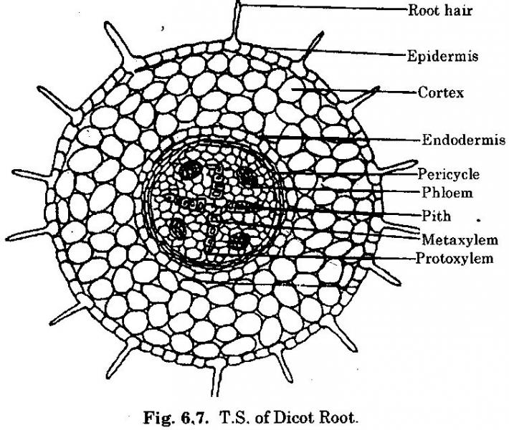

(Toole fig 22.13b pg 462)

Longitudinal section through a root
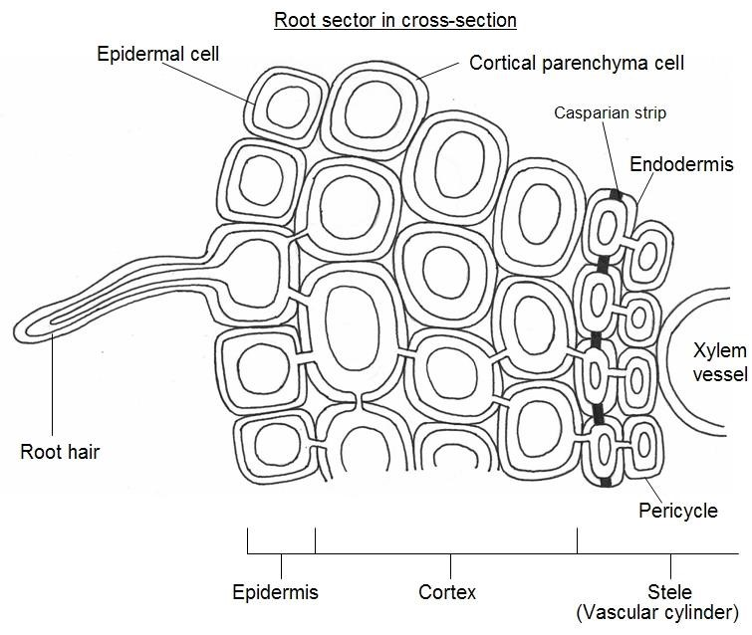

Mechanism of water uptake by the roots
For water to be transported up to the leaves through the stem, it must be absorbed from the soil by the tiny root hairs. Water absorption into the root hairs occurs by osmosis. This is due to the water potential of the cell sap of the root hairs being lower than that of the soil solution (water content).
When the root hair absorbs water, its water potential increases and becomes higher than that of the adjacent cells of the root. This facilitates the flow of water from the root hairs to the endodermal cells across a water potential gradient.
The water flow is also due to the root pressure developed by the cell cortex and endodermis which ensures that water flows from the root hairs to the xylem vessels and upwards to the leaves.
Water flows by osmosis form the root hairs to the endodermal cells using three pathways, namely;
a) Apoplast (cell wall) pathway
- Symplast (cytoplasm) pathway
- Vacuolar pathway

Apoplast pathway
This is the pathway in which water moves through the spaces between the cellulose fibres in the cell wall of one cell to the cell wall of the adjacent cells.
However, this movement does not occur within the endodermal cells because they possess the impermeable casparian strip which prevents water and solutes flow through the cell walls of the endodermal cells. This means that water and solutes flow through the cell walls of the endodermal cells via the Symplast and the vacuolar pathways only.
The significance of this casparian strip is to actively pump salts (ions) from the cytoplasm to the endodermal cells into the xylem vessels which creates a high solute concentration in the xylem, thereby greatly lowering the water potential in the xylem than in the endodermis. This makes the water potential of the xylem vessels more negative (very low) and results into rapid osmotic flow of water from the endodermal cells to the xylem vessels, due to the steep water potential gradient between the endodermal cells and the xylem vessels.
The casparian strip facilitates the pushing of water upwards through the xylem vessels by root pressure up to the leaves due to its active pumping of the salts. In addition, this active pumping of the salts into the xylem vessels prevents leakage of slats (ions) out of the xylem vessels so as to maintain a low water potential in this vessel.

Symplast pathway
This is the movement of water through the cytoplasm of one cell to the cytoplasm of the adjacent cell via plasmodesmata.
Water leaving the pericycle cells to enter the xylem causes the water potential of these cells to become more negative (more dilute). This facilitates the flow of water by osmosis from the adjacent cells into these cells. In this way the water potential gradient from the root hairs to the xylem is established and maintained across the root. This pathway offers a significant resistance to the flow of water unlike the apoplast pathway.

Vacuolar pathway
This is the movement of water from the sap vacuole of one cell to the sap vacuole of the adjacent cell following a water potential gradient.
This is achieved by maintaining a steep water potential gradient. However, this also offers a reasonable level of resistance towards water flow in comparison to the Symplast pathway.
Note; the apoplast is the most appropriate pathway in plants because it provides less resistance to water flow in the plant.

Diagram showing the three pathways of water in the root
(Soper fig 13.18a pg 448)

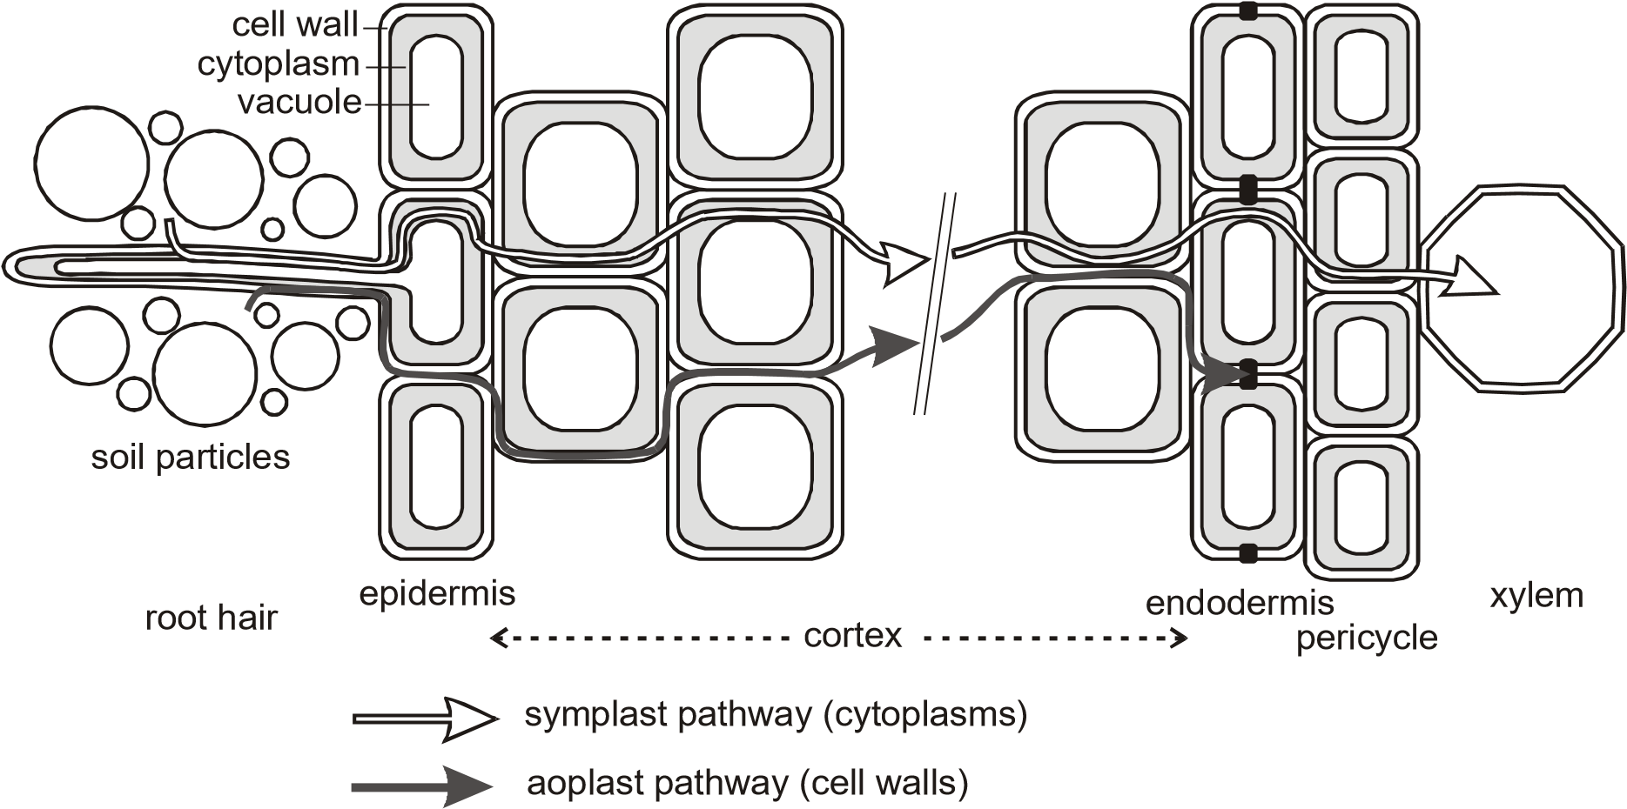

To ensure maximum absorption of water, the root hairs have the following adaptations
- They are numerous in number so as to provide a large surface area for the maximum absorption of water by osmosis.
- They are slender and flexible for easy penetration between the soil particles so as to absorb water.
- The lack a cuticle and this enhances the passive osmotic absorption of water without any resistance
- They have a thin and permeable membrane which allows the absorption of water by osmosis.
- They have a water potential lower than that of the soil solution which facilitates a net osmotic flow of water from the soil

ROOT PRESSURE
Root pressure is the force developed by cells of the roots which forces water from the endodermal cells into the xylem vessels of the root and constantly forces water upwards through the stem to leaves. This process is active and involves utilization of many ATP molecules. Root pressure occurs as a result of endodermal cells actively secreting salts into the xylem sap from their cytoplasm, which greatly lowers the water potential in the xylem.
In some plants, root pressure maybe large enough to force liquid water through pores called hydathodes of the leaves in a process called guttation

The following is the evidence to support the mechanism of water uptake from the endodermis into the xylem vessel as an active process
- There are numerous starch grains in endodermal cells which could act as an energy source for active transport.
- Lowering the temperature reduces the rate of water exudation (given out) from the cut stem as it prevents root pressure, an active process.
- Treating the roots with metabolic poisons e.g. potassium cyanide also prevents water from being exuded from the cut stems. This is because the poisons kill the cells thereby preventing aerobic respiration, a source of ATP molecules.
- Depriving roots of oxygen prevents water from being exuded from the cut stems. This shows that water was being pushed upwards in the cut stem by root pressure, an active pressure.

The following is the evidence to show that water moves by pressure in a plant.
When the stem of a plant is cut water continues to exude from the xylem vessels of the plant stem. The continuous exudation of water from the xylem vessels of the cut stem is due to root pressure because the leafy shoot is cut off, meaning that water not only moves upwards by transpiration pull, but also due to pressure and other forces.

Root pressure can be measured using a mercury manometer whose diagram is shown below
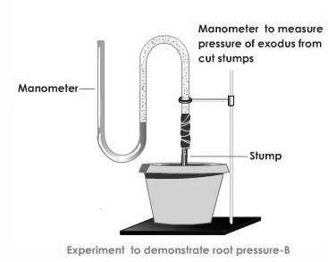
Though it is true that water moves from the roots through the stem to the leaves by transpiration pull, root pressure partly contributes towards the movement of water from the parenchyma cells to the xylem of the root, to the stem and eventually up to the leaves.

THE UPTAKE OF WATER FROM THE ROOTS TO THE LEAVES
The movement of water from the roots to the leaves is by combination of different forces which include the following;
- Root pressure
- Transpiration pull(cohesion force)
- Capillarity

Root pressure
This enables movement of water from the parenchyma cells of the main root into the xylem tissue due to the active pumping of cells from endodermal cells into the xylem tissue.
Root pressure also ensures upward movement of water through the xylem tissues to the leaves.

Transpiration pull (cohesive force/cohesion-tension theory of water uptake)
This offers an explanation for the continuous flow of water upwards through the xylem of the plant i.e. from the root xylem to the stem xylem and finally to the leaf xylem. Water is removed from the plant leaves by transpiration which creates a tension within the leaf xylem vessels that pulls water in the xylem tubes upwards in a single unbroken column or string held together by the cohesive forces of attraction between water molecules.
According to the cohesion-tension theory, evaporation of water from the mesophyll cells of the leaf to the sub-stomatal air chamber and eventually to the atmosphere via the stomata by transpiration, is responsible for the rising of water from the roots to the leaves. This is because the evaporated water molecules get replaced by neighbouring water molecules which in turn attract their other neighbours and this attraction continues until the root is reached.
Evaporation of water results in a reduced water potential in the cells next to the leaf xylem. Water therefore enters these mesophyll cells by osmosis from the xylem sap which has the higher water potential. Once in the mesophyll cells water moves using the three pathways namely; apoplast, Symplast and vacuolar pathways from one cell to another by osmosis across a water gradient.
When water leaves the leaf xylem to the mesophyll cells by osmosis, a tension is developed within the xylem tubes of water which is transmitted to the roots by cohesive forces of water molecules. The tension develops in the xylem vessels and builds up to a force capable of pulling the whole column of water molecules upwards by means of mass flow and water enters the base of these columns from neighbouring root cells. Because such a force is due to water loss by osmosis by transpiration, it is referred to as transpiration pull.
The upward movement of water through the xylem tissue from the roots to leaves is also facilitated by the cohesive forces of attraction which holds the water molecules firmly together, due to the hydrogen bonds which exist between them. This enables water to have a high tensile strength which enables it to move upwards in a continuous stream without breaking. In addition, the upward movement of water from roots to leaves is also facilitated by cohesive forces which hold the water molecules on the xylem walls so that it continues moving upwards.

Capillarity
Since the water rises upwards through narrow leaves, it is also facilitated by capillarity through the stem. This is because the xylem vessels are too narrow and the flow of water is maintained without breaking by both the cohesive and adhesive forces.

NOTE
- The continuous mass flow of water through the xylem vessels from the roots to the leaves in a stream without breaking, due to the transpiration pull is called the transpiration string
- Adhesion is the force of attraction between molecules of different substances while cohesion is the force of attraction between molecules of the same substance

The diagram below shows the upward movement of water from the soil up to the leaves.
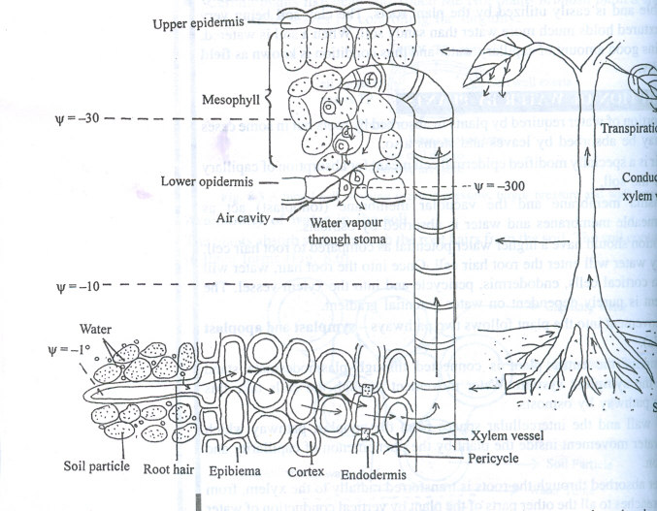

UPTAKE AND TRANSLOCATION OF MINERAL IONS
Translocation is the movement of mineral salts and chemical compounds within a plant.
There are two main processes of translocation which include;
- The uptake of soluble minerals from the soil and their passage upwards from the roots to the various organs via the xylem tubes.
- The transfer of organic compounds synthesized by the leaves both upwards and downwards to various organs via the phloem tubes

Mechanism of mineral ion uptake
Minerals such as nitrates, phosphates, sulphates e.t.c. may be absorbed either actively or passively.

1. Active absorption of minerals
Most minerals are absorbed from the soil solution having the less mineral concentration into the root hairs with the higher mineral concentration, selectively by using active transport which uses a lot of energy.
The rate of active absorption of minerals into the root hairs depends on the rate of root respiration. Factors such as oxygen supply and temperature will affect the rate of ion uptake. The addition of respiratory poison has shown to inhibit uptake of mineral ions.

2. Passive absorption
If the concentration of a mineral in a soil solution is greater than its concentration in the root hair cell, the mineral may enter the root hair cell by diffusion.

Mass flow or diffusion occurs once the minerals are absorbed by the root hairs so that they move along cell walls (apoplast pathway). In mass flow, the mineral ions are carried along in solution by water being pulled upwards in the plant in the transpiration stream, due to the transpiration pull i.e. the mineral ions dissolve in water and move within the water columns being pulled upwards.

The mineral ions can also move from one cell of the root to another against the concentration gradient by using energy inform of ATP.
The mineral ions can also move through the Symplast pathway i.e. from one cell cytoplasm to another. When the minerals reach the endodermis of the root, the Casparian strip prevents their further movement along the cell walls (apoplast pathway). Instead the mineral ions enter the cytoplasm of the cell (Symplast pathway) where they are mainly pumped by active transport into the xylem tissues and also by diffusion to the xylem tissues.
Once in the xylem, the minerals are carried up the plant by means of mass flow of the transpiration stream. From the xylem tissues, minerals reach the places where they are utilised called sinks by diffusion and active transport i.e. the minerals move laterally (sideways) through pits in the xylem tissue to the sinks by diffusion and active transport.

NOTE;

1. The following is the evidence to show that most mineral ions are absorbed actively by the root hairs
- Increase in temperature around the plant increases the rate of mineral ion uptake from the soil as it increases respiration that can provide energy for active transport
- Treating the root with respiratory inhibitors such as potassium cyanide prevents active mineral ion uptake leaving only absorption by diffusion. This is because the rate of mineral ion uptake greatly reduces when potassium cyanide is applied to the plant.
- Depriving the root hairs of oxygen prevents active uptake of minerals by the roots and as a result very few ions enter the plant by diffusion.

2. The following is the evidence for supporting the role of the xylem in transporting minerals
- The presence of mineral ions in the xylem sap i.e. many mineral ions have been found to be present in the xylem sap.
- There’s a similarity between the rate of mineral ion transport and the rate of transpiration i.e. if there’s no transpiration, then there’s no mineral ion transport and if transpiration increases, the rate of mineral ion transport also increases.
- There’s evidence that other solutes e.g. the dye, eosin, when applied to the plant roots, it is carried in the xylem vessels
- By using radioactive tracers e.g. phosphorous-32. When a plant is grown into a culture solution containing radioactive phosphorous-32, phosphorous -32 is found to have reached all the xylem vessels but not the phloem tubes.
(The interpretation of these elements is that where lateral transfer of minerals can take place minerals pass from the xylem to the phloem and where lateral transfer is prevented, the transport of minerals takes place in the xylem)

NOTE; Some plants absorb mineral salts by using mutualistic associations between their roots and other organisms e.g. the association between the fungus and the higher plant roots called mycorrrhiza.

TRASLOCATION OF ORGANIC MOLECULES

(Food molecules in the phloem)
The organic materials produced as a result of photosynthesis; need to be transported to other regions of the plant where they are used for growth or storage. This movement takes place in the phloem tissue particularly in the sieve tubes.

Evidence to support that organic molecules of photosynthesis are transported in the phloem
- When the phloem is cut, the sap which exudes out of it is rich in organic food materials especially sucrose and amino acids.
- The sugar content of the phloem varies in relation to environmental conditions. When the conditions favor photosynthesis, the concentration of the sugar in the phloem increases and when they not favor photosynthesis and concentration of the

sugar in the phloem reduces.
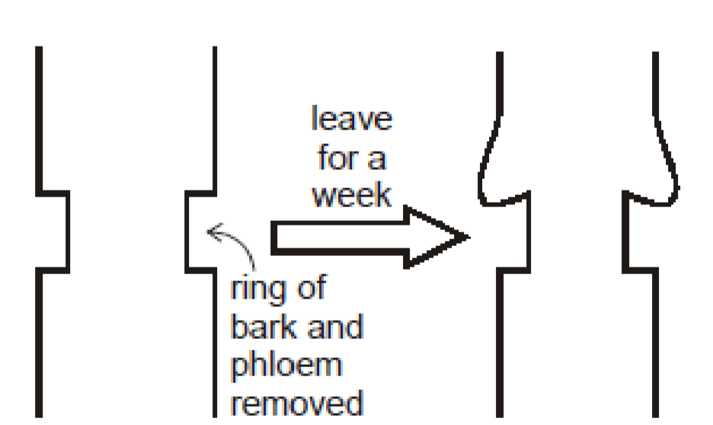
- Removal of a complete ring of phloem around the phloem causes an accumulation of sugar around the ring, which results into the swelling of the stem above the ring. This indicates that the downward movement of the sugars has been interrupted and results into the part below the ring failing to grow and may dry out.
This is called the ringing experiment.

- The use of radioactive tracers. If radioactive carbon dioxide-14 is given to plants as a photosynthetic substrate, the sugars later found in the phloem contain carbon-14. When the phloem and the xylem are separated by waxed paper, the carbon-14 is found to be almost entirely in the phloem.
- Aphids have needle like proboscis with which they penetrate the phloem so as to suck the sugars. If a feeding aphid is anaesthetized using carbon dioxide or any other chemical e.g. chloroform and then its mouth parts cut from the main body, some tiny tubes called the proboscis remain fixed within the phloem sieve tubes from which samples of the phloem content exudes.

When the contents of the phloem are analyzed, they are confirmed to be containing carbohydrates, amino acids, vitamins e.t.c. which further confirms that the phloem transports manufactured foods.
When small sections of the pierced stems are cut following the proboscis penetration, the tips of the proboscis are found within the phloem sieve tubes.

There are several hypotheses put forward to explain movement of materials through the phloem. The most widely accepted is the mass flow hypothesis, however, the other mechanisms are cytoplasmic streaming, electro-osmosis, active transport and surface spreading.

1. Mass flow
Mass flow hypothesis explains translocation as a result of photosynthetic products moving through the phloem tissue from the leaves to the roots due to the turgor pressure gradient.
In the leaves, turgor pressure is high due to manufacture of food substances and materials produced e.g. sucrose increases the osmotic pressure of mesophyll cells which when absorbed would result into increase in turgor pressure.
In the roots, turgor pressure is very low because food substances respired to release energy.
The difference in turgor pressure enables food substances to flow from the source to the sinks. Any area of a plant from which sucrose is loaded into the phloem is called a source. An area that takes sucrose out of the phloem is called a sink.
There are several evidences to show that mass flow occurs in plants. These include;
❖ There is flow of food substances/solution; there is flow of sap from a cut stem.
- There is flow of sap from aphid stylets.
- There is a difference in the concentration of sucrose between the leaves and roots. Concentration of sucrose is higher in leaves than the roots therefore turgor pressure gradient occurs.
- Some viruses and growth substances applied to the leaves move through the phloem to the roots.
Munch demonstrated mass flow as a physical process as illustrated below;
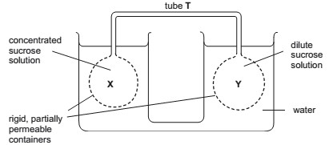
The model above illustrates mass flow i.e. bulk movement of food substances from higher turgor pressure to a lower turgor pressure.
Flask X contains a concentrated solution which in plants may stand for leaves. Flask Y contains a dilute solution which in plants may be roots. Fluid flows from flask X to flask Y through the delivery tube T. The delivery tube may represent phloem tissue which connects the source to the sink.

Shortcomings of the mass flow hypothesis
Although the mass flow hypothesis is widely accepted, there are some observation that regard translocation that it can’t explain.
- Different solutes have been observed to move at different speeds since the sieve tubes are not equally permeable to all solutes. The ratios of concentrations of various solutes changes as the solutes move along the sieve tube resulting in a change in their rate of flow.
- Materials have been observed to move up and down at the same time in the phloem tissue, mass flow can’t account for bi-directional flow.
- In some plants, gradients of turgor pressure are insufficient to overcome the resistance caused by the sieve pores and plates to move the food substances.

2. Cytoplasmic streaming
Within the phloem tissue, there are cytoplasmic strands or filaments which are proteins in nature and they are continuous from one sieve element to another via the pores. Food substances are able to move along these strands due to wave-like contractions generated by the filaments. The sieve elements use energy provided by the companion cells to carry out such contractions.
Cytoplasmic streaming enables some food substances to move upwards while others downwards. It therefore accounts for the bi-directional flow of substances observed in the phloem tissue.
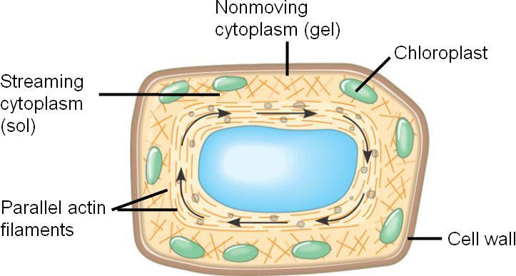

Shortcomings/criticisms:
Plants would require a lot of energy to transport the observed food units of food substances.

Evidence to support the fact that translocation of materials occurs via the phloem
- Ringing experiment:
In natural tree trunks, the phloem is confined to the bark. If a ring is cut round the bark and stripped off a tree trunk, the sucrose concentration increases above the ring and decreases below, indicating that downwards the movement of sucrose is blocked at that point.
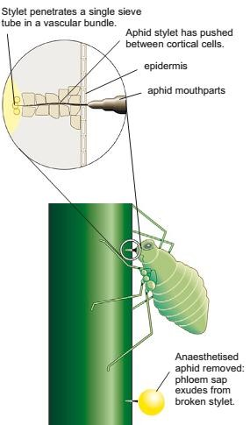
- Radioactive tracers:
If a plant is exposed to CO₂ labelled with radioactive ¹⁴C, the ¹⁴C becomes incorporated into the end products of photosynthesis which are subsequently detected in the stem. That these substances are confined to the phloem and can be shown by cutting sections of the stem, placing the sections in contact with photographic film and auto radiographing, it is found that the sites of radioactivity correspond precisely to the position of the phloem.
- Feeding aphid:
Aphids are a good way of collecting sap. Aphids, such as greenfly, feed by inserting their tubular mouthparts, called stylets, into the phloem of plant stems and leaves. Phloem sap flows through the stylet into the aphid. If the stylet is cut near the aphid’s head, the sap continues to flow.

TRANSPIRATION
This is the process of water loss inform of water vapour to the atmosphere from the plant mainly through the stomata pores.

Types of transpiration
There are three types of transpiration which include the following;
- Stomatal transpiration
- Cuticular transpiration
- Lenticular transpiration

Stomatal transpiration
This is the loss of water vapour to the atmosphere through the stomatal pores of the leaves. This contributes 90% of the total water loss from a leafy shoot. This is because leaves contain a large number of stomata for gaseous exchange where this water vapour can pass and also there’s little resistance to the movement of water vapour through the stomatal pores. In addition, leaves also have a large surface area over which water vapour can evaporate rapidly to the atmosphere.

Cuticular transpiration
This is the loss of water vapour to the atmosphere directly through the epidermis coated with a cuticle layer. It contributes 5% to the total water loss from the leafy shoot. This is because the cuticle is hard, waxy and less permeable to most diffusing molecules including water vapour molecules.

Lenticular transpiration
This is the loss of water vapour through a mass of loosely packed cells known as lenticels found scattered on the stems. It also contributes 5% of the total water loss to the atmosphere in a leafy shoot. It is because the lenticels are usually few in number and not directly exposed to environmental conditions. Lenticular transpiration is the main source of water loss from deciduous plants after shading off their leaves. Because there are more stomata on the leaves than elsewhere in the shoot system, it is evidence that most of the water vapour is lost from the leaves.
In order to establish that transpiration occurs mostly in the leaves, an experiment using absorptive paper, dipped Cobalt II Chloride solution or Cobalt II thiocynate solution is carried out. The paper is covered on the surface of both sides of the leaves and then clamped with glass slides. After some time, the blue cobalt thiocynate paper changes to pink, indicating the evaporation of water molecules from the leaf by transpiration. The rate of change from blue to pink is higher at the lower epidermis than the upper epidermis. This is because structurally there are more stomata on the lower epidermis to prevent excessive loss of water by transpiration due to direct solar radiation

Measuring the rate of transpiration
The rate of transpiration can be measured by either determining the rate of transpiration at which the plant loses mass due to water loss or the rate at which the plant takes in water (water uptake), using an instrument called a potometer.
Determining the rate of transpiration using

a) Weighing method
The rate of mass loss by the plant can be determined by using the potted plant placed on an automatic weighing balance whereby the change in mass is noted over a given period of time. Using this method, it is assumed that the mass loss is only due to water loss by transpiration. However, the whole pot must be enclosed in a polythene bag to prevent water from evaporating from the soil. In addition, the soil must be well watered before the beginning of the experiment so that the plant has enough water throughout the experiment. The rate of transpiration is then expressed in terms of mass lost per unit time
b) Potometer
The potometer is used to measure the rate of water uptake by the shoot of the leafy plant.
However, since most of the water taken up is lost by transpiration, it is assumed that water uptake ≈ water loss. The leafy shoot is cut under water to prevent the air bubbles from entering and blocking the xylem vessels. The cut leafy shoot is immediately fixed in the sealed vessel of connected to the capillary tube. The rate of water uptake is then measured by introducing an air bubble at the end of the graduated capillary tube and the distance moved by the air bubble per unit time is noted.
To drive the air bubble back to the original position, water is introduced into the capillary tube from the reservoir by opening the tap on the reservoir.
The leafy area is also established by tracing the outline of the leaves on a squared graph paper and then counting the number of complete and incomplete squares enclosed in the outline
The rate of transpiration is therefore expressed in terms of the volume of water taken up by the leafy shoot per unit time per unit leaf area. The structure of a potometer is shown in the diagram below.
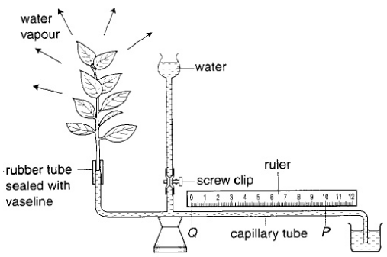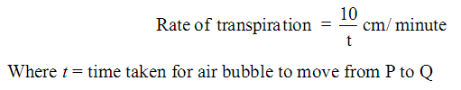

Precautions taken when using a potometer
- The leafy shoot used should have a significant water loss by having very many leaves
- The stem of the leaf shoot must be cut under water to prevent air from entering and blocking the xylem vessels 3. The setup must have plenty of water
- Ensure that only one bubble is present in the capillary tube
- A well graduated scale must be used e.g. a ruler, so that clear readings are taken
- The air bubble should always be reset to zero mark before the potometer is used again under different conditions
- The water reservoir should be filled with water when setting the air bubble at the zero mark
- The cut leafy shoot must be in contact with water in the sealed vessel

How to use a potometer
The leafy shoot is cut under water to prevent air bubbles from entering and blocking the xylem vessels. The cut leafy shoot is immediately fixed in the sealed vessel of water connected to a capillary tube. Allow time (5 minutes) for the apparatus to equilibrate. The rate of water uptake is measured by introducing the air bubble at the end of the graduated capillary tube and the distance moved by the air bubble per unit time is noted.
To drive the air bubble back to the original point, water is introduced into the capillary tube from the reservoir by opening the tap.
The leafy area is then established by tracing the outline of the leaves on squared papers and then counting the number of complete and incomplete squares in the outline of the leaves.
The rate of transpiration is therefore expressed in terms of the volume of water taken up by the leafy shoot per unit time per leafy area.

NOTE; since most of the water taken up by the potometer is lost by transpiration, it is assumed that water uptake = water loss.

Advantages of transpiration
- It allows the uptake of water from the roots to leaves in form of a transpiration stream. This is due to a transpiration pull created in the leaves. This ensures proper distribution of water throughout the plant to keep it alive.
- It facilitates the uptake of the absorbed mineral salts within the xylem vessels from roots to leaves
- It brings about the cooling of the plant since as water evaporates to the atmosphere, excessive heat is also lost as heat of vaporization, which results into the cooling of the plant
- It brings about mechanical support in non-woody or herbaceous plants, due to water uptake which provides turgidity to the parenchyma cells of the stem and leaves
- It is important for cloud formation via evapotranspiration hence resulting into rainfall

Disadvantages of transpiration
- It causes wilting of plants in case of excessive transpiration
- It may eventually cause death of the plant, when the plant looses water excessively due to excessive transpiration
NOTE: wilting is the loss of water from the plant cells. Evaporation occurs at rate greater than that at which it is absorbed, resulting into reduction in turgor pressure and dropping of the plant. It always takes place in hot and dry areas. Wilting also results into the closure of the stomata which cuts off gaseous exchange and therefore may cause death if it persists.

FACTORS AFFECTING TRANSPIRATION
The potometer may be used to investigate the effect of environmental factors on the rate of transpiration i.e. it can be moved to a windy place or a place which is dark. Transpiration is affected by both environmental and non-environmental factors.

ENVIRONMENTAL FACTORS

1. Humidity
The humidity of the atmosphere affects the gradient of water vapour between the sub-stomatal air chamber and the atmosphere around the leaf i.e. it affects the rate of diffusion of water vapour.
Low humidity (low water vapour pressure) outside the leaf increases the rate of transpiration because it makes the diffusion gradient of water vapour from the moist sub-stomatal air chamber to external atmosphere steeper.
When humidity is high in the atmosphere, the diffusion gradient or the water vapour pressure gradient is greatly reduced between the sub-stomatal air chamber and the atmosphere which results into reduction in the rate of transpiration.
In areas where humidity is too high, plants loose liquid water from their leaves via structures/glands on their leaf margins known as hydathodes, a process known as guttation. Guttation is the loss of liquid water from plant leaves through hydathodes due to excessive humidity in the atmosphere.

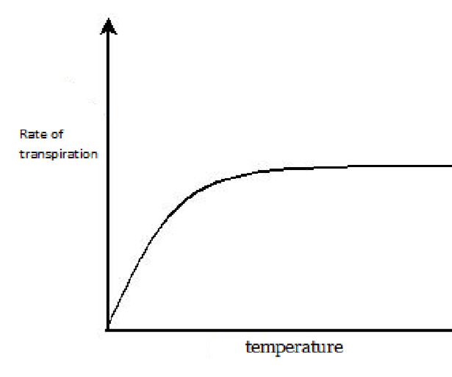
2. Temperature
Increase in temperature increases the rate of water loss by the leaves via transpiration. A decrease in temperature lowers the rate of water loss by the plant leaves via transpiration.
This is because increase in temperature increases the kinetic energy and movement of water molecules hence the water molecules evaporate rapidly to the sub-stomatal chambers and eventually to the atmosphere via the stomata.
Increase in temperature also lowers humidity outside the leaf which further increases the rate of transpiration. In extremely hot conditions, the stomata of some plants close, an adaptation to prevent water loss by transpiration.

3. Air movements
In still air (no wind), layers of highly saturated vapour build up around the stomatal pores of the leaf and reduces diffusion gradient between the stomatal air chamber and the external atmosphere, thereby reducing the rate of diffusion of water vapour from the leaf. The layers of highly saturated water vapour which build up around the stomatal pores of the leaf are called diffusion shells.
Windy conditions result in increased transpiration rates because the wind sweeps away the diffusion shells around the leaf, thereby maintaining a steep diffusion gradient which keeps the rate of transpiration high.

4. Atmospheric pressure
Water vapour and the atmospheric pressure decreases with increasing altitude.
The lower the atmospheric pressure the greater the rate of evaporation of water from the sub-stomatal air chamber. This implies that plants growing on a mountain have a higher rate of transpiration than those growing in low land areas.
However, when the atmospheric pressure is high e.g. in the lowland areas, the evaporation of water vapour from the substomatal air chamber to the atmosphere decreases, thereby increasing the rate of transpiration.

5. Water availability
For water vapour to diffuse out of the sub-stomatal air chamber to the atmosphere, the mesophyll cells must be thoroughly wet. Shortage of water in the soil or any mechanism which hinders the uptake of water by the plant leads to wilting of the plant hence the closure of the stomata.
When water is supplied in large amounts, too much water evaporates to the atmosphere and therefore a high rate of transpiration. However, when the water supply to the mesophyll cells is low, less water evaporates from the sub-stomatal to the atmosphere, hence a low rate of evaporation.

6. Light intensity
It affects transpiration indirectly by affecting the closure and opening of the stomata, which usually opens in bright sunlight to allow evaporation of water to the atmosphere. Therefore sunlight increases the rate of transpiration.
At night and in darkness, the stomata close and therefore there is no evaporation of water from the sub-stomatal air spaces to the atmosphere. This greatly lowers the rate of transpiration in the plant.
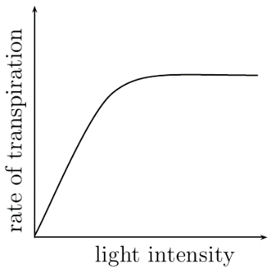

NON-ENVIRONMENTAL FACTORS

1. Leaf area
The larger the leaf surface area on the plant, the higher the rate of water loss by transpiration. In addition, broad leaves provide a large surface area over which water vapour diffuses to the atmosphere as compared to the narrow leaves.

2. Cuticle
The thinner the cuticle, the higher the rate of water loss by transpiration and the thicker the cuticle, the lower the rate of water loss from the plant to the atmosphere by transpiration. This is because this offers a significant resistance towards the diffusion of water vapour from the plant to the atmosphere.

3. Number of stomata
The larger the number of stomata on the plant, the higher rate of water loss by transpiration and the lower the number of stomata, the lower the rate of transpiration.
However, a very large number of stomata so close to each other may instead reduce the rate of transpiration especially in still air due to the accumulation of water vapour around the whole stomata pore.

STOMATA
In terrestrial plants, gaseous exchange takes place predominantly in the leaves. The epidermis of the leaves contains small pores called stomata (singular. stoma). Through stomata, gaseous exchange between the inside of the leaf and the outside air takes place by diffusion.
The broad leafed shape of the leaf offers a large surface for diffusion of gases, its thinness reduces the distances over which diffusion of gases from the atmosphere to the inner most cells.
In most terrestrial plants, stomata are more abundant on the lower side than the upper surface of the leaf. This reduces water loss through transpiration since the upper surface is exposed to direct sunlight.
The number of stomata in leaves vary from one plant species to another. They are normally absent in submerged leaves of water plants.

Structure of the stoma
Each stoma consists of a stomatal pore bordered by a pair of crescent or bean-shaped cells called guard cells. Unlike epidermal cells, guard cells contain chlorophyll. The inner cell wall of guard cells is thicker and less elastic than the outer wall. Microfibrils are radially orientated in the cell wall and the guard cells are joined at the ends. The epidermal cells surrounding the guard cells are subsidiary cells.

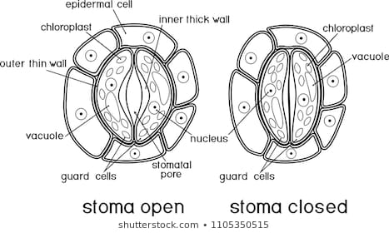

Ventilation (opening and closing of stomata)
The opening and closing of stomata occurs as a result of changes in the shape of the guard cells. When guard cells take in water by osmosis, they expand and become turgid. However, they do not expand uniformly in all directions. The thick inelastic inner wall makes the guard cells to curve away from each other, opening the stoma. When the guard cells lose water, they become flaccid and collapse, closing the stomata.
The closing and opening is controlled mainly by the intensity of light. They are normally open during daylight and closed during the night.

Several theories have been put forward to explain how the light intensity influences the opening and closing of stomata.

1. Photosynthetic product theory  Guard cells have chloroplast. During day light, they carry out photosynthesis producing sugar. The sugar increases the osmotic pressure of the cell sap. This causes water to move into the guard cells from nighbouring epidermal cells by osmosis. The result is an expansion and increase in turgidity of the guard cells containing the stomata to open.  In darkness, photosynthesis stops and the sugar in the guard cells is converted to starch. This lowers the osmotic pressure of guard cells causing them to lose water to neighboring cells by osmosis. The guard cells become flaccid and the stomata close.  Note; this theory does not explain how the low rate of glucose formation can account for the rapid opening of stomata | 2. Potassium ion (K⁺) mechanism (mineral ion concentration)  When guard cells are exposed to light, the light energy activates the ATPase enzyme, hence their chloroplasts manufacture ATP. The ATP drives a K⁺ - pump on the cell membrane of the guard cells. This causes an active uptake of K⁺ ions in the guard cells from the surrounding epidermal cells. Accumulation of K⁺ in the guard cells increases the osmotic pressure of their cell sap. This causes water to move into the guard cells from neighboring epidermal cells by osmosis. The result is an expansion and increase in turgidity of the guard cells causing the stomata to open because when they become turgid, they expend but not uniformly since the inner wall is inelastic, making the guard cells curve away from each other.  At the onset of darkness, ATP concentration in guard cells falls rapidly stopping the K⁺ pump. K⁺ migrates from the guard cells to neighboring epidermal cells by diffusion. This lowers the osmotic pressure of guard cells causing them to lose water to neighboring cells by osmosis. The guard cells become flaccid and the stomata close.

Note; the above theory is the most widely accepted theory today. It is supported by the fact that the opening of stomata is prevented by metabolic poisons which inhibit active transport.

The two above theories can be summarised into a single mechanism of stomata opening and closing as described below;

Stomata opening
- Stomata opening is promoted by high light intensity and low mesophyll carbon dioxide levels. Guard cells generate ATP by photophosphorylation during photosynthesis. .
- Blue light is absorbed by blue-light photoreceptors which activate a proton-pump (H⁺-ATPase) in the cell membrane of the guard cell
- ATPs generated by the light-dependent reaction of photosynthesis are hydrolysed to provide energy to drive the protonpump. As protons (H⁺) are pumped out of the guard cells, the cells become increasingly negatively charged. Potassium channels are activated and K⁺ ions diffuse from subsidiary cells through the channels down this electrochemical gradient into guard cells. Chloride ions (Cl⁻) then enter to balance the charge.
- In some plants the starch is converted to malate.
- The accumulation of K⁺ (and malate ions) causes the water potential in the guard cells to become more negative. Water enters by osmosis from the neighbouring subsidiary cells into the guard cells. The guard cells become turgid.
- The outer wall of the guard cells is t hinner and more elastic than the thicker inner wall. There are cellulose micro fibrils which are radially arranged around the cell wall and the ends of the two guard cells are joined
- The increased turgor pressure therefore causes the guard cells to curve outward and the stoma opens

Stomata closure
- Stomata closure can be triggered by water stress, high temperature, increasing carbon dioxide levels in the leaf mesophyll and low light intensity (night time)
- The hormone abscisic acid (ABA) is secreted by plant cells when transpiration rate is high and soil water is low.
- ABA binds to receptors at the cell membrane of the guard cells. This increase the permeability of calcium channels in the cell membrane. Calcium ions (Ca⁺) enter into the guard cell. The influx of calcium ions also triggers the release of Ca⁺ from the cell vacuole into the cytosol.
- Potassium ions (K⁺) move out of the guard cells into the subsidiary cells
- In some plants (Cl⁻)and certain organic ions e.g. malate ions also move out of the guard cells
- The water potential in the guard cells increase. Water diffuses out to neighbouring subsidiary cells by osmosis. The turgor pressure in the guard cells decreases, the cells become flaccid and the stoma closes.
- At night the chloroplasts in the guard cells do not photosynthesise, less ATP is produced and there’s no active uptake of K⁺ ions. Instead, the K⁺ ions diffuse out of the guard cells. The cells become flaccid and the stoma closes.

LENTICELS
A small amount of gaseous exchange takes place in the stem through structures called lenticels. The small gaps in the stem, usually circular or oval slightly raised on the bark surface. The cells in this area are thin walled and loosely parked, leaving air spaces which communicate with air spaces in the cortex. Here oxygen for respiration is taken up and carbon dioxide is given out.

Structure of the lenticel
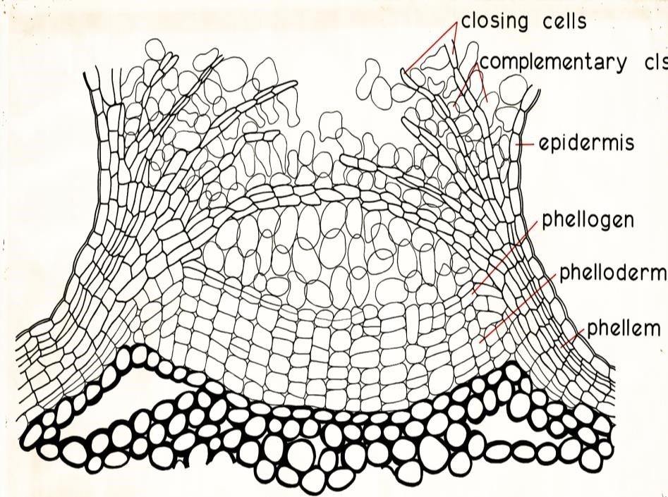

ROOT EPIDERMAL CELLS
Root cells can also take in oxygen for respiration and give out carbon dioxide. Gaseous exchange takes place by diffusion between the epidermal cells of roots and the air spaces in the soil. Most of the exchange takes place at the root hairs which provide a large surface area.
Water logged soils have their air spaces occupied by water, thereby reducing respiration in the roots which may subsequently die. This would obviously kill the whole plant.

Some aquatic plants, like pond weeds and multi cellular algae are completely submerged in water. These obtain their gaseous requirements by diffusion from the surrounding water. Epidermal cells of such plants have no cuticle and gasses diffuse directly across it.
Others like rice and water lilies are partially submerged in water. Their aerial parts obtain carbon dioxide and oxygen in the same manner as terrestrial plants. The submerged parts may face the problems of obtaining adequate oxygen for their respiratory requirement. However such plants have large air spaces in their stems and roots which store oxygen obtained from the aerial parts and that formed during photosynthesis. Floating leaves of such plants have stomata on the upper surfaces only.

In swampy environments, root systems give rise to breathing roots or pneumatophores. These grow out of the water and op into the air. Oxygen diffuses into them and aerates the submerged parts of the root system.

