HETEROTROPHIC NUTRITION
This is the type of nutrition in which organisms take in ready made organic food substances made by autotrophs (producers).

TYPES OF HETEROTROPHIC NUTRITION
- Holozoic nutrition
- Saprotrophic nutrition (Saprophytic nutrition)
- Symbiosis: (i) Parasitism (ii) Mutualism (iii) Commensalism

HOLOZOIC NUTRITION
This is the type of nutrition in which complex organic food is taken in and broken down inside the body of an organism into simple soluble molecules which are then absorbed and assimilated.

BASIC PROCESSES INVOLVED IN HOLOZOIC NUTRITION
- Obtaining food: May involve movements to capture or find new food sources from the environment.
- Ingestion: The intake of food into the body (feeding mechanisms).
- Digestion: Chemical breakdown (by enzymes) and physical breakdown (by teeth, gizzard, mandibles, radula) of large insoluble molecules of food into small soluble molecules.
- Absorption: The uptake of nutrient molecules into the cells of the digestive tract and, from there, into the bloodstream
- Defecation (Egestion): elimination of undigested residue.
- Assimilation: The utilization of the absorbed soluble food substances to form energy or materials which are incorporated into the body tissues.

FEEDING MECHANISMS OF ANIMALS
Nature of food | Mechanism | Organisms | Description
Small particles | filter feeding / microphagous  feeding; | Whales, sharks, flamingo, herring; | Body appendages (gills/beaks/keratinous plates) filter planktons/blue green algae suspended in water into body  cavity /mouth then digestion occurs.
Small particles | Pseudopodial feeding | Amoeba | Pseudopodia enclose the food particle to form food vacuoles which on associating with primary lysosomes form secondary lysosomes, and after digestion, soluble products simply/facilitatively diffuse /actively move into the cytoplasm while undigested wastes are egested by  exocytosis.
Small particles | Flagellate feeding | Euglena, sponges | Flagellar beating directs microscopic food particles to the  region of ingestion, then intracellular digestion occurs.
Small particles | Ciliary feeding | Paramecium, Amphioxus | Cilia beating directs microscopic food particles to the  region of ingestion, then intracellular digestion occurs.
Small particles | Tentacular  feeding | Sea cucumber | Mucus on tentacles traps food particles
Small particles | Setous feeding | Water flea (Daphnia), culex  mosquito larvae | Setae on appendages trap and direct small food particles  into the digestive system.
Small particles | Mucoid feeding | Some molluscs | Mucus layer traps food particles, later swallowed and new layer formed.
Fluids or soft tissues | Fluid feeding; | Aphids, leeches, fleas, lice, mosquitoes, housefly, vampire bats/  Tapeworm, Trypanosoma; | Nutrient-rich fluid from the living host; is sucked by modified mouth parts;  Already digested food is absorbed across the integument;
Large particles | Substrate feeding  / deposit feeding; | Insect larvae / earthworms; | Non-selective swallowing of mud, silt, sand, etc after  burrowing their way through the food / organic material;
Large particles | Bulk feeding / macrophagous feeding; | Land snail, caterpillar, termites, snakes, birds, seals, squids, many mammals, spiders, blowfly larvae, crabs, dragonfly, etc. | May involve scraping and boring (termites, snails) / Capturing and swallowing (snakes, birds, dogfish, seals) / Capturing, chewing and swallowing (squid, mammals) / Capturing, digesting externally and ingesting (spider, starfish, blowfly); using appendages like tentacles/pincers,  claws/ poisonous fangs and jaws/ mandibles;

THE HUMAN DIGESTIVE SYSTEM
The human digestive system consists of:
- Alimentary canal: Mouth, throat, oesophagus, stomach, small intestine (duodenum, jejunum and ileum), large intestine (colon, caecum and appendix), rectum and anus.
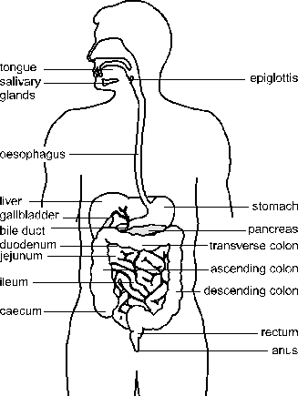
- Accessory structures: Teeth, tongue, salivary glands, liver, gall balder and pancreas. These are organs, glands, and tissues that enable digestive processes, e.g. by secreting fluids /chemicals, but the food does not actually pass through them.
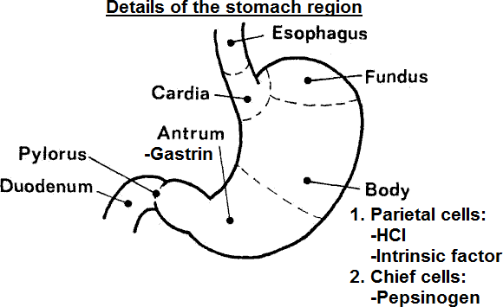
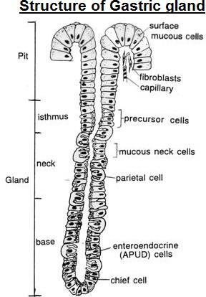
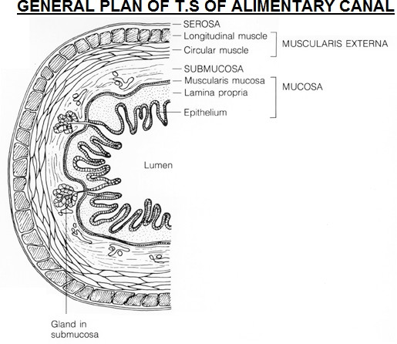
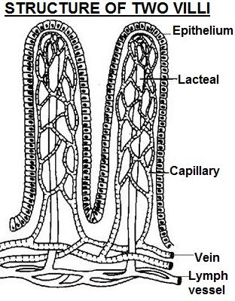

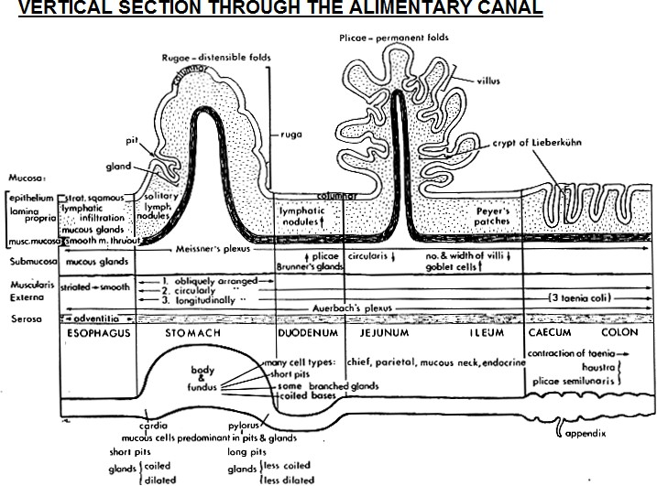

COMPARISON OF HISTOLOGY OF GASTROINTESTINAL TRACT REGIONS
WALL LAYER | STOMACH | DUODENUM | ILEUM | COLON
Serosa (Adventitia) | Areolar connective tissue, same composition as mesenteries  It is called serosa when the outermost layer lies adjacent to the peritoneal cavity.  It is called adventitia when the outermost layer is attached to surrounding tissue.
Muscularis externa | Consists of three muscle layers: (i) inner oblique layer (ii) middle circular layer (iii) outer longitudinal layer
Auerbach’s plexus  (Myenteric plexus) | Network of unmyelinated nerve fibers and ganglia between Muscularis externa longitudinal and circular muscles  Brings about peristalsis when stimulated by pressure of food in the gut.  Receives impulses from the vagus nerve  Control of nerve impulses is involuntary  Promotes secretion of intestinal juices  Causes sphincter muscles to open, thus permitting food to pass from one part of the digestive system to another
Submucosa | Consists of loose connective tissue, collagen, large arteries and veins, lymph vessels and nerves
Submucosa |  Brunner’s glands  absent.  No goblet cells | Brunner’s glands present  Brunner’s glands secrete alkaline mucus to neutralize acidic chyme from the stomach  Brunner’s glands are compound, tubular, mucous  Goblet cells present |  Brunner’s glands  absent.  Goblet cells  present |  Brunner’s glands  absent.
Meissner’s plexus  (Submucosal plexus) | Nerve network of unmyelinated nerve fibres and associated ganglia located with the submucosa  It is believed to work against the myenteric plexus to control the muscular contractions more finely.  In intestines, it works with Auerbach’s plexus in producing peristaltic waves and increasing digestive secretions.

WALL LAYER | STOMACH | DUODENUM | ILEUM | COLON
Mucosa | 1. Muscularis mucosa:  Thin layer of smooth muscle at the boundary between mucosa and submucosa.  Contains both circular and longitudinal muscles  Functionally, the Muscularis mucosa presumably causes stirring at mucosal surface for increased secretion and nutrient absorption
Mucosa | 2. Lamina propria:  Formed by a very cell-rich loose connective tissue (fibroblasts, lymphocytes, plasma cells, macrophages, eosinophilic leucocytes and mast cells).  Lamina propria contains numerous cells with immune function to provide an effective secondary line of defense  e.g. Peyer’s patches which are lymphoid structures located in the ileum.  Lamina propria of villi includes lacteals (lymphatic capillaries).  Lamina propria of intestinal villi may include smooth muscle fibers.  In oral cavity and oesophagus, lamina propria is located immediately beneath a stratified squamous epithelium
Mucosa | 3. Surface epithelium:  Mucosal epithelium is highly differentiated along the several regions of the GI tract.  At the upper and lower ends of the tract, the epithelium is protective, stratified squamous.  Along the lining of the stomach, small intestine, and colon, the epithelium is simple columnar  In the stomach, surface epithelium contains mucous cells that secrete protective, alkaline mucus  - Plicae of the small intestine are permanent folds in the mucosa supported by a core of submucosa. Plicae increase the absorptive surface area of the mucosa.  - Gastric pits are shallow indentations in surface epithelium of stomach mucosa into which gastric glands open.  - Intestinal crypts (crypts of Lieberkühn) contain secretory Paneth cells at the deep end, which secrete lysosomal enzymes that contribute to protecting cells in the crypt lining.  - Villi are very small, typically densely-packed, invaginations of a mucosa that increase the surface area for absorption. In the stomach – no villi, duodenum – many, leaf-like villi, ileum – few, finger-like villi.  - Rugae are distensible folds in the gastric mucosa.

SECRETIONS FROM CELLS LOCATED IN THE GASTRIC WALL
The secretions of the mucous cells, chief cells, and parietal cells are known collectively as gastric juice, whose components include: mucus, pepsinogen, hydrochloric acid and intrinsic factor

Type of Cell | Secretion | Stimulus for secretion | Function
Mucous Cells  - Mucous surface cells  - Mucous neck cells | Mucus | Tonic secretion, with  irritation of mucosa | Physical barrier between lumen and stomach lining.
Mucous Cells  - Mucous surface cells  - Mucous neck cells | Bicarbonate | Secreted with mucus | Buffers gastric acid to prevent damage to epithelium
Chief / Peptic / zymogenic cells | Pepsinogen | Acetylcholine, acid secretion. | Pepsin digests protein, including collagen
Chief / Peptic / zymogenic cells | Gastric lipase | Acetylcholine, acid secretion. | Digests lipids
Chief / Peptic / zymogenic cells | Prochymosin  (Prorennin) | Acetylcholine, acid secretion. | Rennin curdles soluble Caseinogen (milk protein) into  insoluble casein whose slow flow enables digestion
Parietal / oxyntic cells | Hydrochloric acid | Acetylcholine, gastrin, histamine | - Activates pepsinogen to pepsin, Prorennin to rennin  - Kills bacteria. Only Helicobacter pylori, that cause  gastritis and gastric ulcers survive in the stomach
Parietal / oxyntic cells | Intrinsic factor | Acetylcholine, gastrin, histamine | Complexes with vitamin B12 to enable absorption of Vitamin B12 necessary for red blood cell formation  Vitamin B12 is a cofactor of enzymes which synthesise tetrahydrofolic acid, which, in turn, is needed for the synthesis of DNA components  Little intrinsic factor causes pernicious anemia
Enteroendocrine cells (APUD-cells: amine precursor uptake and decarboxylation cells)
(a) G cells  (Gastrin-producing cells) | Gastrin hormone | Acetylcholine, peptides, and amino acids | - Stimulates secretion of gastric juice  - Increases contractions of gastro-intestinal tract  - Relaxes the pyloric sphincter.
(b) D cells  (Somatostatin-producing cells ) | Somatostatin hormone | Acid in stomach | - Inhibits stomach secretion of gastrin and HCl  - Inhibits duodenal secretion of secretin and  cholecystokinin  - Inhibits pancreas secretion of glucagon
(c)VIP-producing cells (vasoactive intestinal peptide) | Vasoactive intestinal peptide | Distension of the stomach wall | - Induces smooth muscle relaxation  - Inhibits gastric acid secretion  - Stimulates pepsinogen secretion by chief cells
(d) Enterochromaffin cells (Serotonin-containing cells) | Histamine | Acetylcholine, gastrin | Stimulates gastric acid secretion

DIGESTION
Digestion is the process by which large food molecules are broken down into small soluble molecules which can be absorbed and assimilated into the tissues of the body.
Digestion includes two types of processes:
Mechanical processes: which include the chewing and grinding of food by the teeth and also the churning and mixing of the contents of the stomach to expose more surface area to the enzymes that finish the digestive process.
Chemical processes: which include hydrolysis action of digestive enzymes, bile, acids.

DIGESTION IN THE MOUTH
It starts with chewing (mastication), which breaks food into pieces small enough to be swallowed and also increases the surface area of food to digestive enzymes.
The sight, taste, smell and thought of food induces salivary glands to secrete saliva, a watery fluid with PH of 6.8 to 7.0. During chewing, saliva mixes with food and the different saliva components perform different functions:
- Salivary amylase (ptyalin) enzyme catalyses the breakdown of amylose of cooked starch into maltose.
- Water moistens food and binding it together for swallowing
- Mucin binds and lubricates food; to enable swallowing.
- Chloride ions activate salivary amylase
- Lysozymes kill bacteria in the buccal cavity.

NOTE:
Amount of amylase secreted in saliva depends on amount of starch the animal regularly feeds on in diet.
- Amylase is usually absent in the saliva of carnivores because of absence of cooked starch in the diet.
- In separate human groups, the relative amounts of amylase (in arbitrary units) produced in saliva were as follows:
Tswana: 248, Bushmen 22, European: 101. Which human group’s diet is largely made of flesh?
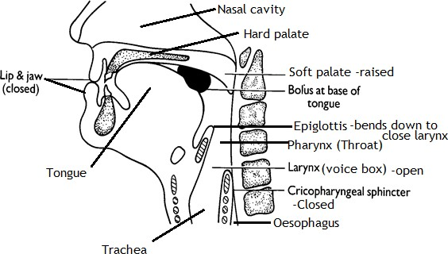
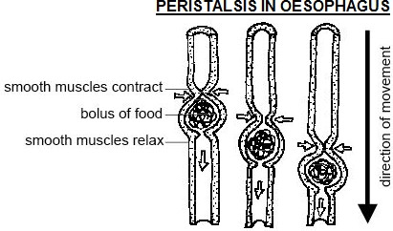
SWALLOWING
This is a reflex action, which lasts less than 10 seconds.
STAGES OF SWALLOWING
Tongue contracts to push the bolus towards the throat, forcing the soft palate upwards to close the nasopharynx
Larynx and hyoid bone move anteriorly and upwards.
Epiglottis bends downwards to close larynx (trachea entrance) to prevent food from entering the trachea.
NB: Any food that enters into trachea is expelled out by coughing reflex.
Breathing briefly stops due to closure of
glottis.
Pharynx shortens.
Upper oesophageal sphincter (Cricopharyngeal sphincter) relaxes, to allow the bolus enter into oesophagus
In oesophagus the food bolus moves by peristalsis, a sequence of wave-like contractions that squeeze food down the oesophagus.
Lower oesophageal sphincter (cardiac sphincter) relaxes to allow food into stomach.

TYPICAL EXAMINATION QUESTION
- Describe the process of swallowing food in humans. (10 marks)
- Explain the role of gastric juice during food digestion in adult humans (10 marks)

DIGESTION IN THE STOMACH
Arrival of food in the stomach stimulates secretion of gastrin hormone from G-cells into the blood stream, which stimulates the gastric glands to secrete gastric juice, whose components include: mucus, pepsinogen, hydrochloric acid and intrinsic factor.
The components of gastric juice are secreted by different cells and perform different roles as follows:

Type of Cell | Secretion | Function
Mucous cells  - Mucous surface cells  - Mucous neck cells | Mucus | Forms a barrier at the stomach lining, to prevent tissue digestion.
Mucous cells  - Mucous surface cells  - Mucous neck cells | Bicarbonate | Buffers gastric acid to prevent damage to epithelium
Chief / Peptic / zymogenic  cells | Pepsinogen | Pepsinogen on activation to pepsin digests protein to polypeptides
Chief / Peptic / zymogenic  cells | Gastric lipase | Digests lipids to fatty acids and glycerol
Chief / Peptic / zymogenic  cells | Prochymosin  (Prorennin) | Rennin coagulates soluble milk protein Caseinogen into insoluble  casein in babies, whose slowed flow enables digestion by pepsin.
Chief / Peptic / zymogenic  cells | Gastric lipase | Gastric lipase weakly hydrolyses fats to fatty acids and glycerol
Parietal / oxyntic cells | Hydrochloric acid | - Activates pepsinogen to pepsin, Prorennin to rennin  - Kills most bacteria in the stomach.  - Provides optimum acidic pH for pepsin to hydrolyse proteins into polypeptides.  (v) Stops the working of salivary amylase enzyme
Parietal / oxyntic cells | Intrinsic factor | Forms a complex which enables absorption of vitamin B12 that is necessary in red blood cell formation  Little intrinsic factor causes pernicious anemia

MECHANISM OF HYDROCHLORIC ACID SECRETION IN PARIETAL CELLS
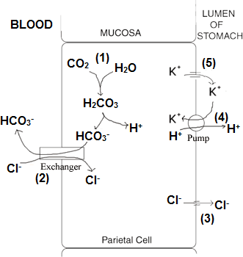
Hydrochloric acid is produced by parietal cells through a complex series of reactions.
Catalysed by the enzyme carbonic anhydrase, carbon dioxide (which diffused from capillaries) reacts with water to form carbonic acid, which dissociates into bicarbonate ion and hydrogen ion.
Bicarbonate ion is transported into the blood stream by an ion exchange molecule in plasma membrane which exchanges bicarbonate ions exiting parietal cells for chloride ions entering.
Hydrogen ions are actively pumped into the duct of gastric gland and the negatively charged chloride ions diffuse with the positively charged hydrogen ions.
Potassium ions are counter pumped into the parietal cell in exchange for hydrogen ions.
The net result is production of hydrochloric acid in the parietal cells and its secretion into the duct of gastric gland.

Due to churning by the stomach wall (alternate contractions and relaxations), VIP-producing cells are stimulated to secrete the hormone called vasoactive intestinal peptide, which causes relaxation of pyloric sphincter muscle to allow the semi solid chyme flow from the stomach into the duodenum, after a maximum of about four hours.

DIGESTION IN THE DUODENUM
Arrival of partially digested, acid food mixture in the duodenum stimulates endocrine cells in duodenal walls to secrete the hormones: Secretin, Enterogastrone, Cholecystokinin (CCK) formerly Cholecystokinin-Pancreozymin (CCK-PZ), Villikinin and Enterocrinin. These hormones coordinate activities of the stomach, pancreas, gall bladder and ileum as follows:
Hormone | Stimulus for secretion | Effect
Secretin hormone | Acid chyme in duodenum | Stimulates the liver to secrete bile into the gall bladder.  Stimulates pancreatic secretion of non-enzymatic substances (hydrogen carbonate ions) from acinar cells. HCO - neutralise the acid from the  3  stomach to provide an alkaline pH optimum for pancreatic enzymes.  Inhibits secretion of HCl by oxyntic cells as chyme leaves the stomach.
Enterogastrone hormone | Acid and fat in the duodenum | Reduces stomach motility  Inhibits oxyntic cells from secreting hydrochloric acid in order to provide an optimum pH for pancreatic enzymes.  Signals the stomach to empty slowly when fat is present, allowing much time for digestion of fat already emptied.  NOTE: High fat diets stimulate enterogastrone production, which prolongs food stay in the stomach, and is therefore useful in treating duodenal ulcer.
Cholecystokinin  hormone (CCK) formerly called  Cholecystokinin | Partially digested fat and protein in the duodenum | Stimulates contraction of gall bladder to release bile into duodenum.  (i) Bile salts (sodium glycocholate) emulsify fats i.e. fats physically break into droplets due to reduced surface tension, which increases their surface area  Stimulates the pancreas to secrete pancreatic enzymes:  - Pancreatic amylase which catalyses the hydrolysis of starch into maltose  - Enterokinase, a non-digestive enzyme which activates Trypsinogen to  Trypsin.  - Trypsinogen, which is activated by enterokinase to Trypsin. Trypsin:  - Catalyses hydrolysis of polypeptides to peptides.  - Activates chymotrypsinogen to chymotrypsin.  (iii) Chymotrypsinogen, which is activated to chymotrypsin by Trypsin. Chymotrypsin catalyses hydrolysis of casein / polypeptides into peptides.
Villikinin  (Motilin) | Alkaline pH in the  duodenum | Increases peristalsis in the small intestine and ileum villi movements, in  preparation for incoming food.

NOTE:
- Some sources indicate that enterogastrone refers to any of the hormones secreted by the mucosa of the duodenum in the lower gastrointestinal tract in response to dietary lipids to inhibit churning e.g. (i) Secretin (ii) Cholecystokinin
- All proteolytic (protein digesting) enzymes along the gut are secreted in inactive (precursor) form to prevent autolysis
(self-digestion) of gut tissues, which are protein in nature.

The churning action of duodenal walls turns the semi-solid Chyme into a thin, milky-looking alkaline fluid called Chyle.

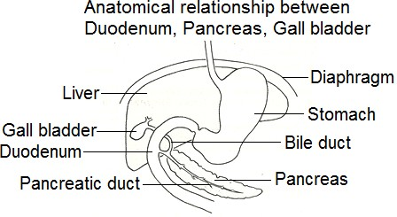
DIGESTION IN THE ILEUM
Distention of the small intestine by food / tactile stimulus / irritating stimulus stimulates the secretion of intestinal juice (Succus entericus), which consists of a mixture of substances from crypts of Lieberkühn and Brunner’s glands. Some of the components of Succus entericus include the following enzymes:
Peptidases: catalyse hydrolysis of peptides into amino acids, thereby completing the digestion of proteins.
Nucleotidases: catalyse hydrolysis of nucleotides into
phosphoric acid, nitrogenous bases and pentose sugars.
Maltase: catalyses hydrolysis of maltose into glucose molecules, thereby completing starch digestion.
Sucrase (invertase): catalyses hydrolysis of sucrose into glucose
and fructose molecules.
Lactase: catalyses hydrolysis of lactose into glucose and
galactose molecules.
Intestinal lipase: catalyses hydrolysis of lipids into fatty acids
and glycerol.
Intestinal amylase: catalyses hydrolysis of starch into maltose.

FOOD ABSORPTION
It is the process by which soluble food substances are absorbed across the gut epithelium into blood circulatory system or
lymphatic system to be carried to all body cells.

During absorption, substances move as follows:
- From intestinal lumen across the free end / apical end / mucosal end of the absorbing cell.
- Across the base / basilar end / serosal end of absorbing cell into the subcellular space, and finally into blood circulatory system or lymphatic system.

NOTE: Substances entering at the apical surface may be metabolized or within the cell or may appear at the basilar surface when changed into another form.

MAIN SITES OF NUTRIENT ABSORPTION
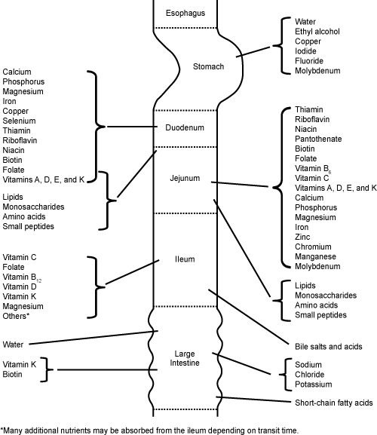

PROCESSES INVOLVED IN ABSORBING DIGESTED FOOD
  - Simple diffusion (2) Facilitated diffusion (3) Active transport: Direct active transport and Secondary active transport

SECONDARY ACTIVE TRANSPORT
A form of active transport across a biological membrane in which a transporter protein couples the movement of an ion (e.g. Na+ or H+) down its electrochemical gradient to the uphill movement of another molecule or ion against a concentration/electrochemical gradient. Thus, energy stored in the electrochemical gradient of an ion is used to drive the transport of another solute against a concentration or electrochemical gradient.

TYPES OF SECONDARY ACTIVE TRANSPORT
1. Cotransport (also known as Symport) 2. Exchange (also known as Antiport)
1. COTRANSPORT: The direction of transport is the same for both the driving ion and driven ion/molecule.  Examples:  - The Na+/glucose cotransporter in enterocytes (small intestine epithelial cell) and kidney proximal tubule epithelial cells simultaneously transports 2 Na+ ions and 1 glucose molecule into the cell across the plasma membrane.  - The H+/dipeptide or tripeptide cotransporter in epithelial cells of small intestine couples the downhill movement of H+ across the plasma membrane to the uphill transport of dipeptides and tripeptides into the cell against a concentration gradient. | 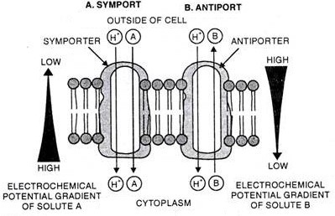
2. EXCHANGE: The driving ion and driven ion/molecule move in opposite directions.
Example:
The Na+/Ca2+ exchanger in cardiac muscle cells transports 3 Na+ ions into the cell in exchange for 1 Ca2+ ion transported out of the cell.

MECHANISMS OF ABSORBING DIGESTED FOOD IN THE ILEUM

Digested food | Mechanism | Description of the mechanism
Glucose and galactose | Secondary active transport with Na+  (Cotransport with Na+) | Glucose and galactose are cotransported into epithelial cells of villi with Na+ ions, then exported into blood capillaries by  facilitated diffusion.
Fructose | Facilitated diffusion | Fructose moves into epithelial cells of villi by facilitated  diffusion, then exported into blood capillaries by facilitated diffusion.
Amino acids | Secondary active transport with Na+  (Cotransport with Na+) | Amino acids are cotransported from intestinal lumen into small intestinal epithelial cells with Na+ ions, then exported to  capillaries by facilitated diffusion.
Dipeptides and Tripeptides (Oligopeptides) | Secondary active transport with H+ (Cotransport with H+) | Oligopeptides (dipeptides and tripeptides) are cotransported from intestinal lumen into villi epithelial cells with protons (H+) Oligopeptides are then hydrolysed by cytoplasmic peptidases into amino acids, which are exported from the villi epithelial  cells into blood capillaries by facilitated diffusion.
Short chain fatty acids | Simple diffusion | Short chain fatty acids move into epithelial cells of villi by  simple diffusion, then are exported into blood capillaries by  simple diffusion.
Monoglycerides and Long chain fatty acids | Simple diffusion | Monoglycerides and long chain fatty acids diffuse into columnar epithelia of villi, recombine to form lipids, then combine with proteins to form water soluble lipoproteins called  chylomicrons, which are exported by exocytosis to lacteals.

NOTE:
- Absorption of whole proteins occurs only in a few circumstances e.g. newborns when suckling absorb antibodies
(immunoglobulins) from the mother’s milk (colostral milk) to acquire passive immunity.
- In adults, absorption of whole protein can cause allergic reaction due to presence of foreign protein in blood.

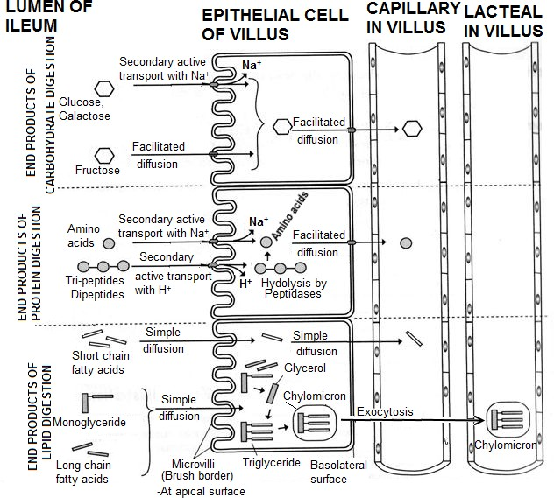

ILEUM – THE MAJOR SITE FOR ABSORPTION
Adaptations of the ileum to absorption of food
- Ileum is long and highly folded for increased surface area in absorption of soluble food substances.
- Ileum has numerous finger-like projections called villi which increase the surface area for absorption of soluble food.
- Ileum epithelial cells have microvilli which further increase the surface area for efficient food absorption.
- Ileum epithelium is thin to reduce diffusion distance for soluble food substances to allow fast rate of diffusion.
- Ileum epithelium is permeable to allow movement of soluble food substances across with minimum resistance.
- Ileum villi have dense network of blood capillaries to rapidly carry away digested food from the absorption area which maintains a steep diffusion gradient.
- Ileum villi have permeable lacteal, a branch of the lymphatic system for carrying away fats
- Ileum epithelial cells have numerous mitochondria to generate ATP energy for active transport of some ions.
- Ileum inner surface is lined with a lot of mucus to prevent autolysis (self-digestion) by proteolytic enzymes.

TYPICAL EXAMINATION QUESTIONS
  - (a) Explain how the structure of villi in the small intestine is related to absorption of digested food.
Large surface area by microvilli / protrusion of exposed parts for fast uptake of soluble substances.
Epithelium only one layer thick to reduce diffusion distance.
Protein channels allow facilitated diffusion and active transport.
Numerous mitochondria provide much ATP for active uptake of some nutrients like glucose and salts.
Blood capillaries close to epithelium/ surface to reduce diffusion distance during absorption of glucose/ amino acids
Lacteal / lymphatic vessel is permeable/has large surface area at centre to absorb fatty acids and glycerol.
Tight junctions between adjacent villi enable controlling absorption of substances

- The table below shows experimental results of the rate of absorption of hexose sugars (Glucose, galactose and fructose), and pentose sugars (xylose and arabinose) by pieces of living intestine and by pieces of intestine poisoned with cyanide. The results are shown as relative to the rate for glucose.
 | Rate of absorption
 | By living  intestine | By poisoned  intestine
Glucose | 1.00 | 0.33
Galactose | 1.10 | 0.53
Fructose | 0.43 | 0.37
Xylose | 0.31 | 0.31
Arabinose | 0.29 | 0.29

  - Explain the observed rates of sugar absorption shown by the two tissues.
The rate of absorption of glucose and galactose is faster in living intestine; but much slower in poisoned intestine; because absorption of these sugars is active transport requiring ATP whose formation depends on enzymes; which are inhibited by respiratory inhibitor cyanide; To a small extent, the two sugars are absorbed passively;
Rate of absorption of fructose, xylose and arabinose is the same or relatively the same in living intestine and in poisoned intestine; because absorption of these sugars is facilitated diffusion which does not require ATP; therefore not inhibited by respiratory poison cyanide;

The graph below shows how an injection of secretin affects the secretion of pancreatic juice by the pancreas.
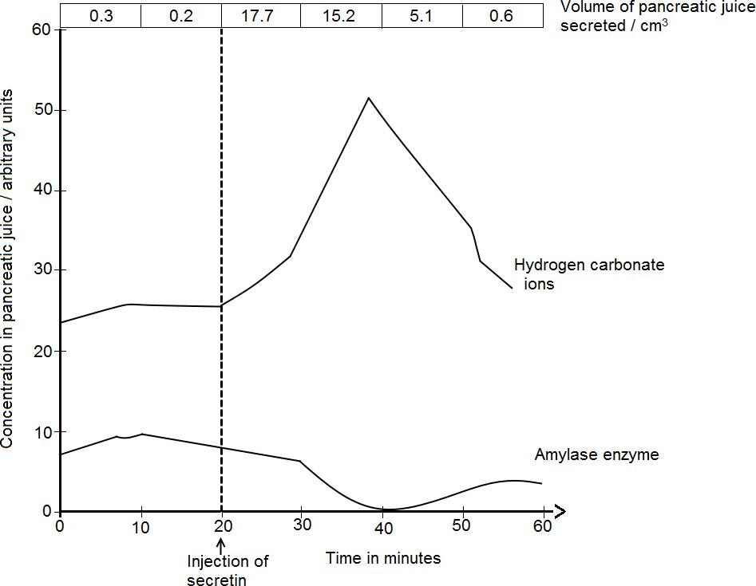

- Use the graph to explain the effect of secretin on pancreatic secretion.
- (i) From the graph, comment on the composition of pancreatic juice.
(ii) State any other digestive secretion stimulated by secretin.
(c) Certain types of ulcers are thought of to be made worse by the production of too much acid from the stomach. Medical doctors have used several methods to treat such ulcers.
Suggest how each of the following treatments might reduce the amount of acid secreted by the stomach:
- Cutting the gastric vagus nerve.
- Blocking the action of acetylcholine by giving the patient atrophine.
PROBABLE SOLUTIONS
- Secretin injection causes a rapid increase in the volume of pancreatic juice from 20 minutes to 30 minutes; followed by gradual decrease to 40 minutes; then a rapid decrease to 60 minutes;
Secretin injection causes gradual increase in the concentration of bicarbonate ions from 20 minutes to 30 minutes; followed by rapid increase to a peak at 40 minutes; then rapid decrease until 60 minutes;
Secretin injection causes gradual decrease in concentration of amylase from 20 minutes to 30 minutes; followed by rapid decrease to a minimum at 40 minutes; then gradual increase until 55 minutes and thereafter remains constant until 60 minutes;
Upon injection into blood, secretin hormone circulates to reach the pancreas and liver, first in low concentration from 20 minutes to 30 minutes; gradually stimulating pancreatic secretion of watery hydrogen carbonate ions from acinar cells and gradually stimulating secretion of somatostatin hormone which gradually inhibits secretion of pancreatic amylase enzyme.
From 30 minutes to 40 minutes, there is now much secretin concentration in blood circulation; which rapidly stimulates pancreatic acinar cells to rapidly secrete hydrogen carbonate ions and also greatly stimulates secretion of somatostatin hormone which rapidly inhibits secretion of pancreatic amylase enzyme;
From 40 minutes to 60 minutes, high PH (alkalinity) due to hydrogen carbonate ions inhibits the working of secretin hormone; causing less stimulation of acinar cells hence rapid decrease in secretion of hydrogen carbonate ions. Somatostatin hormone secretion decreases hence decreasing the inhibition of pancreatic exocrine cells causing increased amylase enzyme secretion;
- (i) Pancreatic juice is mainly composed of substances (like water), hydrogen carbonate ions, and small amounts of enzymes like amylase.
  - Secretion of bile in liver cells, stored in the gall bladder which when released in the duodenum emulsifies fats into droplets, which is physical digestion.
- (i) Conditioned reflexes from vagal centre in the brain fail to stimulate secretion of acetylcholine, no secretion of gastrin hormone, no secretion of gastric juice (HCl) during the cephalic phase (before food reaches the stomach) hence the stomach wall will be less irritated.
(ii) Blocking the action of acetylcholine using atrophine inhibits the secretion of gastrin hormone; hence secretion of gastric juice (HCl) is inhibited.

COLON
In the colon, there is mainly absorption of:
- Water into the blood capillaries by osmosis.
- Vitamins Biotin (B7) and K, which is synthesised by Escherichia coli bacteria that live in the colon.
- Na+, Cl- and K+

NOTE: The colon wall contains mucus secreting cells for lubricating the movement of undigested food through the colon.

APPENDIX AND CAECUM
In ruminants like cattle and in non-ruminants like rabbits, mutualistic bacteria secrete cellulase enzyme which digests cellulose to glucose, which is lost along with faeces. In the process described as coprophagy (coprophagia), rabbits eat own faecal pellets while dung beetles feed on cow dung to enable absorption of glucose at the ileum.
In humans, appendix and caecum have no obvious role.

RECTUM
In the rectum, food is stored temporarily to enable osmotic absorption of water into blood capillaries.

CONTROL OF DIGESTION IN HUMANS
A combination of hormonal and nervous stimulations and inhibitions of the gut that regulate the secretion of digestive juices in the gut.

IMPORTANCE OF CONTROL OF DIGESTION
- Secretion of digestive juices depends on respiratory energy, therefore unnecessary secretion must be prevented to avoid wastage of respiratory substrates.
- Secretion of proteolytic enzymes in inactive form prevents autolysis (self-digestion of tissues).

MECHANISMS OF CONTROLLING DIGESTION IN HUMANS
Involves a combination of hormonal and nervous; stimulations and inhibitions of the gut; that regulate the secretion of digestive juices in the gut;
The digestive juices secreted include saliva in the buccal cavity; gastric juice in the stomach; pancreatic juice and bile in the duodenum; intestinal juice in the ileum;

CONTROL IN THE MOUTH
Sight / smell / thought of food stimulate conditioned reflexes involving the cerebral cortex, hypothalamus and medulla oblongata; which stimulate salivary glands to secrete saliva.
Contact of food with tongue taste receptors stimulates nerve impulses via sensory neurons to the hypothalamus and
medulla oblongata; relayed along motor neurons to stimulate salivary glands to secrete saliva.
-Salivary amylase in saliva causes hydrolysis of starch to maltose.
Loss of appetite / depression inhibit cerebral cortex; parasympathetic centre is not stimulated, no secretion of saliva;

CONTROL IN THE STOMACH
Occurs in 3 phases: cephalic; gastric; and intestinal phases;

Cephalic phase / Nervous phase:
It occurs before food enters the stomach;
Sight / smell / thought of food stimulate conditioned and unconditioned reflexes; involving the cerebral cortex, hypothalamus and medulla oblongata; which stimulate the vagus nerve causing the release of acetylcholine; which stimulates the secretion of the hormone gastrin; whose effects are:
- Stimulates secretion of gastric juice.
- Increases contractions of gastro-intestinal tract
- Relaxes the pyloric sphincter to let in bolus of food from the gullet;
Loss of appetite / depression inhibit cerebral cortex; parasympathetic centre is not stimulated, no gastric secretion;

NOTE:
Secretion of nervous phase lasts for about one hour during which gastric juice secretion reaches a maximum, after which there is a rapid decrease from 1 hour to 1.5 hours.
Therefore, nervous secretion is: (i) short lasting and (ii) rapid as compared to the hormonal phase.

Gastric phase:
Arrival of food bolus distends / stretches the stomach wall which activates stretch receptors to fire impulses to the
Meissner’s plexus in the stomach wall to cause the following effects:
- Stimulate local secretory reflexes in the stomach wall to activate gastric glands secrete pepsinogen and HCl;
- Stimulate reflexes in the medulla, via the vagus nerve to activate gastric glands wall to secrete pepsinogen and HCl;
- Stimulate enteroendocrine cells / G-cells to secrete gastrin hormone; which stimulates secretion of gastric juice;
- Stimulate enteroendocrine /enterochromaffin cells to secrete histamine; which activates secretion of gastric juice;
Partially digested proteins especially peptides / decrease in pH activates chemoreceptors, which stimulate G-cells to secrete gastrin hormone; which stimulates secretion of gastric juice;
Excessive acidity (PH of less than 2) inhibits G-cells hence gastric juice secretion reduces;
Emotional upset activates sympathetic nervous system whose effects override the parasympathetic nervous system;

NOTE:
The gastric glands are stimulated by hormones to secrete gastric juice for about four hours.
Therefore, hormonal secretion is: (i) longer lasting and (ii) gradual as compared to the cephalic phase.

Intestinal phase:
Distension of duodenum / presence of acid chyme / partially digested food stimulates the secretion of intestinal (enteric)
gastrin hormone; which stimulates secretion of gastric juice in the stomach;
Distension of duodenum / presence of acid chyme / fatty acids / irritants / in the duodenum stimulates the secretion of Intestinal hormones:
- Secretin; which stimulates the release of bile from the liver and hydrogen bicarbonate ions in pancreatic juice;
- Cholecystokinin; which stimulates the pancreas to secrete its enzymes;
- Enterogastrone; which inhibits/suppresses gastric activity (any further secretion of acid by the stomach);
- Vasoactive intestinal peptide inhibits gastric acid secretion.
Distension of duodenum / presence of acid chyme / fatty acids / irritants / in the duodenum initiates gastric-inhibitory impulses in the enterogastric reflex causing suppression of gastric activity; and emptying of stomach;

CONTROL IN THE ILEUM
Contact of food with intestinal lining stimulates the intestinal glands; to secrete intestinal juice composed of enzymes responsible for completion of digestion of food substrates;

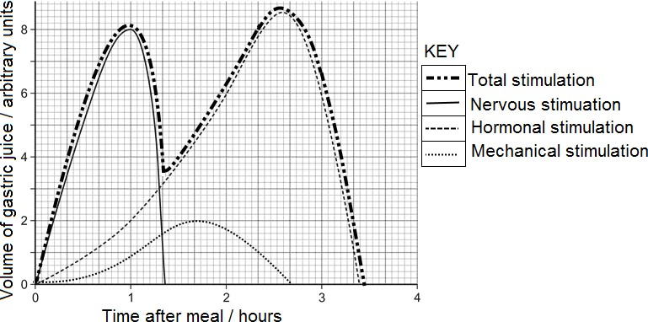
Variations in volume of gastric juice produced by nervous, hormonal and mechanical stimulations with time after eating food

NOTE:
The maximum volume of gastric juice produced as a result of the different stimulations varies in different mammals.

OBSERVATIONS / DESCRIPTION
- Volume of gastric juice produced during nervous stimulation increases rapidly from 0 hour to a maximum at 1 hour, then decreases rapidly and ceases at 1.5 hours. Nervous secretion is: (i) shorter lasting (ii) instantly rapid as compared to hormonal and mechanical phases.
- Volume of gastric juice produced during hormonal stimulation increases gradually from 0 hour to 1 hour, then increases rapidly to a maximum at about 2.5 hours, then decreases rapidly and ceases at about 3.3 hours.
Therefore, hormonal secretion is: (i) longer lasting and (ii) initially gradual as compared to the cephalic phase.
- Volume of gastric juice produced during mechanical stimulation (food stretching stomach and duodenal wall) increases gradually from 0 hour to 0.7 hour, then increases rapidly to a maximum at about 1.6 hours, then decreases rapidly and ceases at about 2.6 hours

TYPICAL EXAMINATION QUESTION
The graph below shows the amount of gastric juice produced by the stomach of an individual who had just chewed some food. The food was spat out after being chewed, and none was swallowed.

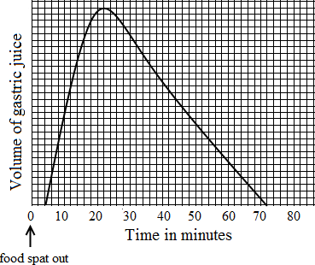
  - Name two constituents of gastric juice
  - Assuming that no traces of food got down into the stomach, explain how the secretion of gastric juice was brought about.
  - (i) How much time elapsed between the moment the food was spat out and the moment gastric juice started to be produced?
(ii) Account for the delay in (c) (i) above.
  - If the stomach of an adult person is surgically removed through an operation, suggest with reasons, the more suitable diet for such a person after recovery from the operation.

ASSIMLIATION OF FOOD
Assimilation: The process by which simple soluble food substances are absorbed and used by body cells in the various ways. The products of digestion are brought directly through the hepatic portal vein to liver, which controls the amount of nutrients released into the mainstream blood circulatory system.
Assimilation supports growth, development, body renewal, and storing up of reserves used as a source of energy.
Metabolism: Chemical processes within cells of an organism. It involves:
- Catabolism: Break down of complex molecules into simpler molecules, with release of energy.
- Anabolism: Assembly / building up of complex molecules from simple molecules using energy.

FOOD | HOW ABSORBED FOOD IS USED IN THE BODY | HOW BODY DEALS WITH EXCESS
Glucose | ATP synthesis in respiration  Formation of glycoproteins involved in cell to cell recognition mechanisms.  For production of mucus  Excess carbohydrates are stored in the form of glycogen in the liver and muscles. | Stored in the liver as glycogen.  Excess carbohydrates may be converted into fats for storage.
Amino acids | Formation of protoplasm of cells during growth  Production of enzymes and antibodies  Formation of body structures such as hairs, nails, hooves, cell membranes  Oxidised to release ATP energy during severe starvation i.e. in the absence of glucose and fats.  Formation of hormones e.g. insulin  Formation of plasma membrane components e.g. glycoproteins, channel proteins | Deaminated in the liver to form urea, which is expelled by kidneys.  Some amino acids are transaminated  to produce a different amino acid
Fatty acids and glycerol | The long chain fatty acids are desaturated in the liver and are then broken down to carbon dioxide and water by successive oxidations.  Some of it can be converted into glucose  Some used to form various structures which are components of cells e.g. phospholipids | Stored as fat under the skin

TYPICAL EAMINATION QUESTION
- What roles do the liver and pancreas play in: (i) food digestion (ii) metabolism of absorbed products
- How can the diet of raw liver prevent the disease pernicious anaemia?
 | Digestion | Metabolism of absorbed products
Pancreas | On stimulation by cholecystokinin hormone, the pancreas secretes enzymes whose effects are as follows:  - Amylase catalyses hydrolysis of starch into maltose  - Enterokinase enzyme which activates Trypsinogen to Trypsin.  - Trypsin:  - Catalyses hydrolysis of polypeptides to peptides.  - Activates chymotrypsinogen to chymotrypsin.  - Chymotrypsin catalyses hydrolysis of casein / polypeptides into peptides.  - Lipase hydrolyses fats to fatty acids and glycerol  - Nuclease hydrolyses nucleic acids to nucleotides  - Polypeptidase hydrolyses polypeptides to amino acids.  On stimulation by secretin hormone, the pancreas secretes hydrogen carbonate ions from acinar cells, which neutralise the acid chyme from the stomach to provide an alkaline pH optimum for pancreatic  enzymes. | - If in excess (above 90mg/100cm3), the pancreas is stimulated to secrete insulin hormone which causes conversion of glucose to glycogen for storage, fat or metabolizing it to energy and CO2.  - If little (below 90mg/100cm3), the pancreas is stimulated to secrete glucagon hormone which causes conversion of glucagon to glucose hence increasing the blood glucose level.
Liver | On stimulation by secretin hormone, the liver secretes  bile into the gall bladder.  On stimulation by CCK hormone, gall bladder contracts to release bile salts which emulsify fats i.e. fats physically break into droplets due to reduced surface tension, which increases their surface area | 1. The Liver regulates blood glucose:  - If in excess (above 90mg/100cm3), glucose is converted into glycogen for storage.  - If little (below 90mg/100cm3), glycogen is converted into glucose for use.  - The liver regulates amino acids in the body: Excess amino acids are not stored in the body, but undergo deamination process. i.e. the amino group (- NH2) from the amino acid is removed to form ammonia, which later forms urea that is carried in blood to kidneys for excretion.  - The liver regulates lipids (fats) in the body: It synthesizes and degrades phospholipids and cholesterol.  - The liver forms red blood cells in foetus and breaks down worn out red blood cells in adults.  - The liver forms plasma proteins from amino acids  - The liver stores fat soluble vitamins A, D, E, K and water soluble vitamins B12 and C  - The liver stores minerals like Iron, potassium, copper, zinc and trace elements.  - The liver detoxifies poisonous substances i.e. toxic  substances are turned harmless by the liver cells e.g. alcohol, cholesterol and hydrogen peroxide.

- Raw liver is rich in vitamin B12 which is essential for formation of red blood cells (erythrocytes), whose absence causes pernicious anaemia characterised by paleness, slowness and death.

FOOD AND DIET IN HUMANS
Food: Any substance taken in to nourish the body and sustain life. Food provides energy and nutrients.
Nutrient: is a substance which is needed for growth, repair and metabolism.
The three main nutrients are: (1) carbohydrates (2) proteins (3) lipids (fats and oils)

MEASURING FOOD ENERGY CONTENT
The energy content in a food sample can be measured by simple calorimetry.
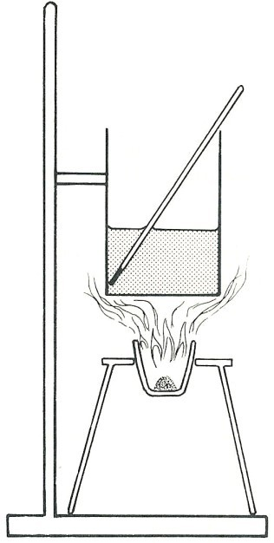
Calorimetry: Measuring the amount of heat given out or taken in by a process, such as the combustion of a fuel.

PROCEDURE OF CALORIMETRY  - Pour cold water into a boiling tube / small beaker / metal can  - Record the starting temperature of the water  - Measure accurately the mass of the food sample in a crucible  - Heat the food until it catches fire.  - Heat the water using the flame from the burning food  - Record the final temperature of the water and calculate the temperature difference.  NB: The experiment above can be done more accurately using a  food calorimeter, though it costs more money to purchase.  Calculations  Work out the energy transferred to the water in joules or in calories  Energy transferred (J) =  Mass of water (g) × 4.2 (J/g°C) × temperature increase (°C)  Note: 4.2kJ (1 cal.) of energy are required to raise the temperature of 1 kg of water through 10C  Worked example  When 0.5 g of food is burned, 10 cm3 of water warms up by 20°C. What is the energy content of the food in J/g?  Solution  1 cm3 of water has a mass of 1 g  Energy transferred to water = 10 × 4.2 × 20 = 840 J Energy content of food = 840 ÷ 0.5 = 1680 J/g  To find the energy value of sugar, 1g of sugar is burnt in a crucible, the flame produced is used to heat 100 g water in a metal can and the rise in temperature of the water measured. | Thermometer  Boiling tube or small can  Water  Food sample in crucible  COMPARISON OF ENERGY VALUES  Carbohydrate: 1 gram contains 17 kJ  Fat: 1 gram contains 39 kJ  Protein: 1 gram contains 18 Kj  ENERGY UNITS  Energy units are joules, no longer calories  4.18 joules = 1 calorie  1000 calories = 1 kilocalorie (kcal.) = 1 Cal  1000 joule = 1 kJ (kilojoule) = 1 joule 1000 kJ = MJ (megajoule)

PRECAUTIONS
When comparing different foods, it is important to carry out a fair test by keeping other variables constant:
  - Starting temperature of water (2) temperature increase (3) distance of the flame from the boiling tube
More reliable results can be obtained by repeating the experiment.

SOURCES OF ERROR IN CALORIMETRY
    - Inaccurate weighing of sugar
    - Incomplete combustion of the sugar
    - Inability to measure the temperature difference accurately enough
    - Heat from the burning sugar escaping without heating the water.

ENERGY-FOOD INTAKE AND CONSUMPTION
The body needs energy for three main reasons:
- Maintain the basal metabolic rate (BMR) – minimum energy a body requires at rest to perform vital functions like beating of the heart, breathing, peristalsis, impulse transmission, synthesis of biological molecules like proteins, etc.
- Sustain body activities like muscle contraction during movement, locomotion, etc.
- Generation of heat to maintain body temperature at about 370C

NOTE: BMR accounts for about 65% of the energy used in the body each day.

FACTORS WHICH DETERMINE BASAL METABOLIC RATE
Age, Sex, Body mass, Nature of physical activity engaged in, Muscle mass, Diet, Drugs, Environmental factors e.g. temperature, Hormonal factors e.g. during pregnancy and lactation, Genetics.

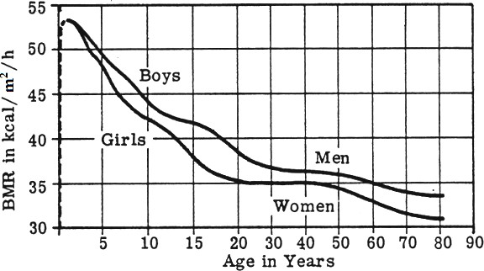
(i) Factors shown in the graph, which affect BMR: Age and sex

(ii) Other factors not shown in the graph, which affect BMR:
Muscle mass, Body size, level of physical activity, and Pregnancy and lactation, Diet, Drugs, Environmental factors e.g. temperature, Hormonal factors e.g. during pregnancy and lactation, Genetics

Explanation of variation in BMR with the factors in (a) (i) above.
Variation in BMR with sex
At about 2.5 years and below, BMR in males is equivalent to BMR in females because infants have basically identical composition of carbohydrates, fats and protein.
From about 2.5 years throughout life, BMR is slightly higher in males than in females because males usually have more body muscle than females while females usually have more fat than males per unit body mass and surface area. The more muscle tissue in the body, the more energy the body needs just to function e.g. to conduct impulses and biosynthesis compared to fat cells that largely store fat, with little biosynthesis.

Variation in BMR with age
Infants and children have relatively high BMR than old-aged adults because at infancy and childhood much of the energy consumed is used in biosynthesis of cellular components required for growth. At adulthood, biosynthesis is greatly reduced since growth has stopped.
From the age BMR was first determined to about 20 years of age, BMR decreases rapidly, then remains constant up to about 50 years of age and thereafter decreases slowly.
From infancy to maturity at 20 years of age, biosynthesis of cellular components required for growth decreases rapidly, then remains constant by middle age until 50 years of age and thereafter decreases slowly, partly because of loss of muscle tissue, and also because of hormonal and neurological changes. Only repair and replacement of worn out cells occurs at slow rate by adulthood.
.
Explanation of variation in BMR with the factors in (a) (ii) above.
Muscle mass (amount of muscle tissue in the body). Muscle requires more energy to function than fat. The more muscle tissue in the body, the more energy the body needs just to exist.
Body size: Larger bodies tend to have a higher BMR because they usually have larger internal organs and fluid volume to maintain. Taller people have a larger skin surface, therefore have higher metabolism to maintain a constant temperature.
Genetics: Genotypes and genetic disorders determine the rate of BMR.
Physical activity: Regular exercise increases muscle mass and causes the body to burn kilojoules at a faster rate, even when at rest.
Hormonal factors (e.g. during pregnancy and lactation): Hormonal imbalances caused by certain conditions, including hypo- and hyperthyroidism, can affect the metabolism. Expectant and lactating mothers require more energy to support foetal and baby growth respectively.
Environmental factors (e.g. temperature): Weather can also have an effect on body metabolism; if it is very cold or very hot, the body works harder to maintain its normal temperature and that increases the metabolic rate.
Drug content in the body: Caffeine and nicotine can increase your metabolic rate, while medications including some antidepressants and anabolic steroids can contribute to weight gain regardless of what you eat.
Diet: Certain aspects of one’s diet can also affect metabolism e.g. inadequate intake of iodine for optimal thyroid function can slow down body metabolism.

BALANCED DIET
Balanced diet is one which contains the correct proportions and quantity of protein, carbohydrate, lipids, vitamins, mineral salts, water and dietary fibre/roughage required to maintain health.
Mainly, carbohydrates and lipids are for energy production, proteins are for growth and repair, vitamins and mineral salts are for protection of good health, water is a solvent while roughage stimulates peristalsis to prevent constipation.
An unbalanced diet can lead to deficiency diseases.

EFFECTS OF UNDERFEEDING AND OVERFEEDING
If energy output exceeds energy input, carbohydrate reserves (glycogen) and fat reserves (adipose tissue) are respired and the person’s body mass decreases. When carbohydrate and fat reserves exhaust, tissue protein is respired and the body wastes away.
If energy intake exceeds energy usage over a period of time, carbohydrate is turned into fat and the person’s body mass increases leading to obesity (overweight).
Disadvantages of obesity: (1) the extra mass causes a person to get tired quickly (2) increases chances of stroke/heart attack.
How an obese person can lose weight: (1) Eating less energy food (2) Taking more exercises to increase energy output

BODY MASS INDEX (BMI)
This is one of the ways of determining whether a person is underweight or overweight. BMI can be calculated using the formula:
BMI = Mass in kg
(Height in m)2

Qn. Calculate the BMI of a female of mass 69 kg and height of 1.67m
Another way of determining whether a person is underweight or overweight is to use a graph showing the relationship between height and body mass.
CHANGES IN M ETABOLIC RAT E AND ENER GY RESER VE UTILISATION DURIN G STAR VAT ION

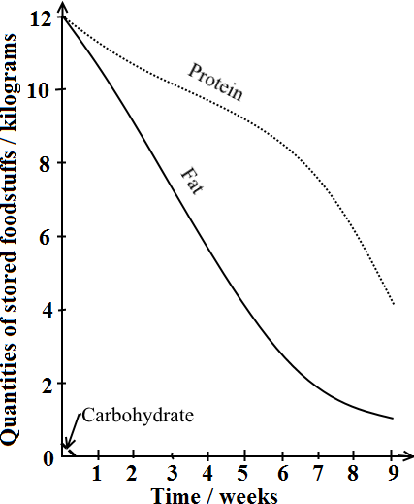
CHANGES IN BODY ENERGY RESERVES DURING STARVATION
Starvation results from the inadequate intake of nutrients or the inability to metabolize or absorb nutrients.

CAUSES OF STARVATION
Prolonged fasting, anorexia, deprivation, or disease
SYMPTOMS OF STARVATION
Weight loss, dehydration, apathy, listlessness, withdrawal, increased susceptibility to infectious disease, discoloured hair color, flaky skin, and massive edema in abdomen and lower limbs causing the abdomen to appear bloated.

ADVERSE EFFECTS OF STARVATION
- Marasmus: occurs on account of extreme energy deficiency, typically from inadequate amounts of protein and calories.
- Kwashiorkor: is related to marasmus, affects children who are protein-energy deficient, and can result in edema (fluidic inflammation)
and an enlarged fatty liver — resulting in the counterintuitive distending of bellies, giving the illusory impression that starving children are well fed.

INTERVENTIONS AGAINST STARVATION
Rehydration and feeding the starving person low-bulk food with much proteins, much energy and fortified with vitamins and minerals. Avoid foods high in bulk but low in protein content

DESCRIPTION OF CHANGES IN ENERGY RESERVES
Glycogen, proteins, and fats are all metabolized during starvation.
Exhaustion of blood glucose stimulates glucagon secretion and insulin
secretion is inhibited.
Within the first 24 hours, the very low glycogen amount stored in the liver and muscles decreases rapidly to depletion because glycogen is broken down into glucose for oxidation to release energy, while the amounts of fats and protein remain high.
Anaerobic breakdown of glycogen in skeletal muscle is also stimulated.

Within week 1, a few hours after depletion of carbohydrate/glycogen, the amount of fats decreases rapidly while the amount of protein decreases gradually until about 6 weeks of starvation.

This is because fats are hydrolysed rapidly into fatty acids and glycerol while oxidation of amino acids releases energy.
 The liver metabolizes fatty acids into ketone bodies that are degraded to release energy. Accumulation of ketones causes
ketosis, by condition characterised by blood becoming acidic
Fatty acids in skeletal muscles are broken down to release energy, thus decreasing the use of glucose by tissues other than the brain.
Glycerol is converted into small amount of glucose, but most of the glucose is formed from the amino acids of proteins.
The brain begins to use ketone bodies, as wells as glucose, for energy.
Dependency on fats for energy release decreases the demand for glucose, protein breakdown reduces but does not stop.
The liver degrades non-essential proteins into glucose for the brain in a process called gluconeogenesis, which involves converting carbon skeletons into pyruvate or Krebs’ cycle intermediates and excreting amino groups from the body as urea.

From 6 weeks to 8 weeks, amount of fat decreases slowly to very low levels, while amount of protein decreases rapidly.
This is because as fat reserves / stores are getting depleted, metabolism of fats to release energy occurs gradually and the body begins to rapidly break down essential proteins, leading to loss of liver and heart function as these organs are broken down for fuel metabolizing proteins as the major energy source.
Muscles, the largest source of protein in the body, are rapidly depleted.

TYPICAL EXAMINATION QUESTIONS
A group of rats were encouraged to over eat by feeding them with unlimited supplies of processed foods such as chocolate and cakes over a three week period. These rats were called cafetarian rats. Over the same period, another group of control rats fed on unlimited supplies of

their natural food.
- What was the effect of feeding the rats on food other than their natural food? (1½ marks)
They gained more body mass, fat and energy
 | AVERAGE OVER 21 DAYS
 | Cafetarian rats | Control rats
Energy content of food eaten (kj) | 11670 | 6480
Gain in the body mass (g) | 131 | 103
Gain in body fat (g) | 66 | 40
Energy used (kj) | 9440 | 4690

- Determine the average gain in mass of the cafetarian rats over the control rats during the 21 days Average gain in mass = gain in body mass of cafeterian – gain in body mass of control rats = 131 – 103 = 28g

- State three features of the two groups of rats which should be kept the same: Age, sex, species (1½ marks)
- Which chemical of life in the rats would have been responsible for most of the gain in mass? Body fat (½ marks)
- Explain the observation that some people eat enormous amounts of foods without putting on weight where as others become over-weight on quite small food intake: Weight gain does not only depend on food intake, but on other factors like genetic makeup.
- Using evidence from the data, explain why cafetarian rats were able to gain more weight than control rats. (2 marks)
The difference between the energy content of food and energy used is higher in cafetarian rats; so unused food had to be converted to fat
- Why were control rats necessary in this experiment? For comparison of results (1 mark)

FEEDING EXPERIMENTS ILLUSTRATING THE IMPORTANCE OF VITAMINS IN NORMAL DIETARIES
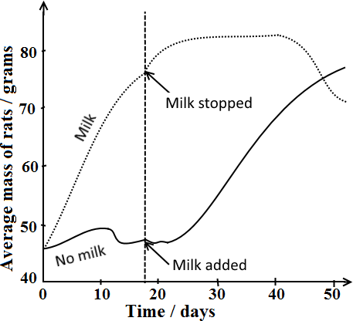
In his investigations exploring the relationship between diet and growth in rats, Frederick Gowland Hopkins found that a diet consisting of protein, salts, fats, and carbohydrates could not alone support growth.

EXPERIMENT
Two groups of young rats were used.
Group A were fed on a diet of purified casein, starch, glucose, lard, minerals and water only for the first 18 days.
Group B were fed on a diet of purified casein, starch, glucose, lard, minerals and water plus an extra of 3cm3 of milk daily for the first 18 days.
After 18 days milk was given to group A rats and removed from group B’s diet.

OBSERVATIONS
Group A rats increased in mass gradually from 0 day to 10 days, mass decreased gradually until about 12 days, mass remained relatively constant up to 22 days, then mass increased rapidly from about 22 days to 50 days

Group B rats increased rapidly in mass from 0 day to 18 days, then gradually increased in mass from 18 days to about 23 days, stopped growing from about 23 days to 40 days and gradually decreased in mass/lost weight thereafter.

CONCLUSION: Hopkins’s experiments revealed that, to grow, animals needed small amounts of other substances he called
“accessory food factors”- now known as vitamins.

EXPLANATION
Group A rats resumed growth and increased in weight after 18 days while group B rats stopped growing and lost weight after 18 days. While the 3cm3 of milk had an insignificant food value in terms of carbohydrate, fat, protein and minerals, the milk contains an extra nutrient which the rats needed to be able to grow and develop.

Why it was necessary to transfer milk from group B to group A half way through the experiment?
To ensure that all groups of rats are subjected to identical conditions e.g. feeding them on identical food so as to establish the effect of milk on growth while eliminating the possibility of other factors being responsible the observed differences in results e.g. choice of rats in one group (group A) may have been more sickly than those in group B etc.

Why feeding rats on one type of protein (casein), not a variety is ruled out as a possible cause of growth stoppage and weight loss?
Although proteins are essential for growth and there are different types, proteins are hydrolysed in the body into different amino acids, and the body is able to make some amino acids for itself. Therefore even though the rats were only getting casein this was enough to not have an effect on growth.

Why while a diet of protein alone is sufficient for young animals, it is inadequate for adults?
Much as milk contains all the nutritional requirements like protein, carbohydrates (lactose), lipids, mineral salts, vitamins and water, some amounts may be nutritionally insufficient to meet the metabolic demands of adults.
Some people who are lactose intolerant can’t digest the main sugar (lactose) in milk. In normal humans, production of lactase enzyme that digests lactose stops between ages of two and five years, which would result in insufficient ATP production.

NUTRITION IN CARNIVORES AND HERBIVORES
- Carnivorous animals: are either predators or scavengers whose diet consists of mainly flesh obtained from preys.
- Predator: An animal that hunts and kills animals for food.
- Prey: An animal that is hunted and killed for food.
- Scavenger: An animal that eats dead animals, but doesn’t kill them.
- Herbivore: An animal whose diet is mainly vegetation
- Grazers: Mainly feed on grass
- Browsers: Mainly feed on leaves of shrubs and trees

 | Carnivore | Herbivore
Adaptations for finding and capturing prey (carnivores) or grazing / browsing (herbivores) | Well-developed sense of smell for locating prey  Fast moving to outpace and capture prey  Well-built body to manipulate and capture prey.  Very sharp claws for gripping and killing prey.  Keen eye sight for locating prey from a distance  Foot pads enable stealth movement to ambush prey.  Long, sticky tongue for reaching distant prey e.g. toads.  Elongated canines for digging up prey e.g. walrus | Upper jaw lacks incisors to provide a hard pad against which lower incisors press and cut grass.  Tongue is highly muscular for manipulating food during chewing.
Adaptations for ingesting the food | Sharp pointed canines for tearing the fresh of prey  Flat molars to crush prey  Incisors pointed for nipping and biting.  Carnassial teeth present for shearing flesh.  Upper jaw wider than lower jaw to facilitate shearing.  Up-and-down jaw action only prevents lateral movement hence reducing the danger of dislocation  Powerful jaw muscles provide much force for chewing | Molars and premolars are ridged for maximum grinding of hard cellulose materials.  Molars and premolars have large surface area for maximum grinding of the hard cellulose materials.  Articulation of lower jaw permits lateral movement to enable maximum grinding of food.  Well-developed jaw muscles provide much grinding power for crushing cellulose materials.  Between the front and cheek teeth, there’s a gap called diastema for separating crushed grass from uncrushed grass for effective chewing.
Adaptations for digesting the food | No cellulose in diet hence less developed caecum and appendix to reduce on body weight to enable fast running.  Relatively short alimentary canal reduces weight, since diet is entirely protein. | Ruminant stomachs are four chambered to derive maximum nourishment from grass.  Mutualistic bacteria in caecum and appendix enable chemical digestion of cellulose into glucose.  Relatively long alimentary canal to digest vegetation

DIFFERENCES BETWEEN CARNIVORES AND HERBIVORES RELATED TO NUTRITION
Carnivores | Herbivores
Closed pulp cavity in teeth  Upper jaw incisors present  Canines present and well developed  Carnassial teeth present  Cheek teeth pointed  Articulation of lower jaw prevents lateral movement  Relatively short alimentary canal  No cellulose digestion | Open pulp cavity in teeth  Upper jaw incisors absent in most herbivores  Canines small or absent to create a diastema  Carnassial teeth absent  Cheek teeth flattened with enamel ridges and dentine grooves  Articulation of lower jaw permits lateral movement  Relatively long alimentary canal  Cellulose digestion occurs in caecum

EXAMPLES OF SYMBIOTIC ASSOCIATIONS IN ANIMALS
Symbiosis: Ecological relationship between two or more organisms living together with some form of feeding relationship.
Mutualism: Close relationship where two organisms of different species depend on each other for reciprocal benefit, without any harm e.g. pollination flowers by insects, Trichonympha and termites, cellulase producing bacteria and herbivores, etc.
Commensalism: Loose relationship in which two organisms of different species live together, only one organism benefits while the other remains unharmed e.g. sea anemone and clown fish.
Parasitism: Close relationship between organisms of different species in which one organism called parasite obtains nutrients from and harms a larger living organism called host.

DIGESTION IN RUMINANT MAMMALS
Ruminants: are the mammals, which have a 4-chambered stomach for the digestion of plant based food.
Rumination involves regurgitation of fermented grass known as cud, chewing and re-chewing it again to further break down plant matter and stimulate digestion.
Ruminating mammals include cattle, goats, sheep, giraffes, deer, camels, antelope, etc.

Four-chambered stomach showing food movement during feeding
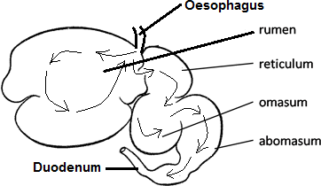
  - Rumen (Paunch): Bacteria and protozoa in the rumen secrete cellulase enzyme which breaks down cellulose into glucose which undergoes fermentation to form organic acids, carbon dioxide and ethane. The fermentation process produces heat that keeps ruminants warm.

  - Reticulum (Honeycomb bag): Here any foreign objects that may have been accidentally swallowed with food settle out in the honeycomb structure of the reticulum’s walls. Reticulum is sometimes called “hardware stomach”.

  - Omasum (Psalterium / Manyplies): Absorbs water from food and also absorbs more nutrients called volatile fatty acids that supply ruminants with energy.

  - Abomasum (Reed / True stomach): Here, the food particles are digested by hydrochloric acid in the same way it occurs in human stomachs. The remaining particles are then passed on to the small intestine where most of the nutrients are absorbed by the body and made available to the ruminant.

CELLULOSE DIGESTION IN TERMITES
Guts of wood-eating termites contain a micro-organism called Trichonympha, which secretes cellulase enzyme to digest cellulose in wood. The termite absorbs some of the products of digestion (glucose), while Trichonympha gets sheltered.

CELLULOSE DIGESTION IN RABBITS (NON RUMINANTS)
The caecum and appendix of a rabbit contain bacteria that secrete cellulase enzyme for digesting cellulose into glucose. The herbivore gains glucose while the bacteria get shelter.
In the process described as coprophagy (coprophagia), rabbits eat own faecal pellets while dung beetles feed on cow dung to enable absorption of glucose at the ileum.

PARASITISM
Close relationship between organisms of different species in which one organism called parasite obtains nutrients from and harms a larger living organism called host.

Challenges / Dangers faced by ectoparasites | Challenges / Dangers faced by endoparasites
Failure to cling on the host to avoid being dislodged.  Failure to obtain nutritive molecules from the host.  Failure to find the right host for dispersal to their final host | Failure to penetrate the host  Failure to obtain nutritive molecules from the host.  Destruction by the digestive enzymes and immune responses of the hosts.  Complete elimination or extinction.  Fluctuating environment e.g. low oxygen tensions, excess heat, solute concentration, darkness etc.  Failure to find the right host for dispersal to their final host

GENERAL ADAPTATIONS OF PARASITES
Structural adaptations | Physiological adaptations | Reproductive adaptations
Possession of penetrative devices for host entry e.g. fungal haustoria, cutting teeth in hook worms Ancylostoma duodenale)  Possession of nutrient suckers e.g. leech  Development of digestive-resistant outer covering to avoid host’s enzyme attack e.g. Ascaris and Taenia etc.  Camouflaging morphology to increase survival chances e.g. brown ticks on brown cattle.  Possession of specialised mouth parts in some ecto-parasites to suck hosts e.g. sharp stylets in aphids and tsetse flies.  Possession of specialised haustorial structures in Cuscuta (Dodder plants) for obtaining nutrients from the host  Degeneration of non-essential organs e.g. no feeding organs, no locomotory organs, no alimentary canal to reduce body size and fit in intestines /blood vessels and for reducing energy expenditure on such organs for example Fasciola hepatica (liver fluke), tape worm, hook worm etc. | Production of enzymes to digest the host’s tissues during penetration into the host e.g. fungi and plasmodium  Production of anticoagulants by blood feeding parasitic animals such as mosquitoes and ticks to avoid blood clotting during feeding.  Highly tolerant to fluctuating environment e.g. anaerobic respiration in areas of low oxygen tensions, high temperatures, darkness and pH changes in places where they live e.g. most endoparasites.  Rapid means of escape which increases their chances of survival e.g. fleas and mosquitoes.  Production of much mucus for resisting digestion by host’s enzymes.  Some endoparasites produce chemicals to protect themselves against the immune response of the host. | Some are hermaphrodites with the ability to carry out self fertilisation to increase the rate of reproduction e.g. Fasciola, Taenia.  Some asexually reproduce for high rate of reproduction to avoid extinction.  Release of sexually mature forms of the parasites as free living organisms e.g. in some parasitic animals such as the horse hair worms  Production of large number of infective agents such as eggs, cysts, and spores which increase survival chances to avoid extinction e.g. tape worms.  Development of reproductive bodies that are highly resistant when out of the host to survive adverse conditions e.g. cysts in amoeba, fungal spores, etc.  Use of intermediate host (vector) for their transfer to primary host e.g. plasmodium in female anopheles mosquito to man.  Some parasites localise the strategic points for propagation to the next host e.g. HIV which causes AIDS is localised in the sex organs.  Some use hereditary transmission for increased spreading i.e. some parasites infect the ovary of primary host which lays  parasite infected eggs.

COMMON PARASITES
Definitive host (final host / primary host): a host in which a parasite attains sexual maturity.
Intermediate host (secondary host): a host in which a parasite passes one or more of its asexual stages; usually designated first and second, if there is more than one.

PrimaryHost Secondary
Phylum/division | Parasite |  |  | Effect on primary host
Platyhelminthes | Fasciola hepatica (liver Fluke) | Sheep, cattle | Pond snails | Liver rot
Platyhelminthes | Schistosoma mansoni (blood fluke) | Humans | Pigs | Schistosomiasis (Bilharzia)
Platyhelminthes | Taenia solium (Pork tape worm) | Humans | Pigs | Taeniasis; Anaemia, Weight loss Abdominal (intestinal) pain
Platyhelminthes | Taenia saginata (Cattle tapeworm) | Humans | Cattle | Taeniasis; Anaemia, Weight loss Abdominal (intestinal) pain
Nematoda | Ascaris lumbricoides (roundworm) | Humans | None | Ascariasis, Intestinal obstruction
Spermatophyta  (Seed plants) | Dodder plant (Cuscuta) | Nettle, clover,  tomato, potato | None | Damages tissues causing  secondary infections
Spermatophyta  (Seed plants) | Striga sp. (witch weeds) | Maize, millet, groundnut, etc. | None | Stunted growth, wilting, and  chlorosis
Heterokontophyta | Phytophthora infestans | Tomato leaves | None | Late blight of potato and tomato  (Black leaf spots, tuber rot)
Arthropoda | Plasmodiun | Female Anopheles | Humans | Malaria fever

LIFECYCLES OF SELECTED PARASITES
Lifecycle of Ascaris lumbricoides (roundworm) | Adaptations of Ascaris to parasitic life
Adult female in lumen of ileum lays about 200,000 eggs daily, which are passed out in faeces.  Fertile eggs embryonate and become infective after about three  weeks, (optimum conditions: moist, warm, shaded soil).  On being swallowed by humans, eggs hatch into larvae, which invade intestinal wall, and are carried via the portal, then systemic circulation to lungs.  Larvae mature further in lungs (10 to 14 days), penetrate alveolar walls, ascend the bronchi to the throat, and are swallowed into gut.  Upon reaching the ileum, they develop into adult worms.  Between 2 and 3 months are required from ingestion of the infective eggs to oviposition by the adult female.  Adult worms can live 1 to 2 years. | Degeneration of structures reduces space occupied.  Possession of digestive-resistant cuticle resists destruction by the host’s enzymes.  Ability to position itself in a habitat where it gains maximum nourishment.  Eggs have protective/resistant shell which is their main ineffective and resistant stage.  Tolerance to oxygen deficient environment  Ability to copulate within the intestines followed by the laying of very many eggs increases survival chances.

Lifecycle of Taenia sp. (Tapeworm) | Adaptations of Taenia to parasitism
Humans are the definitive hosts for T. saginata and T. solium.  Eggs or gravid proglottids are passed out in faeces;  Cattle (T. saginata) and pigs (T. solium) become infected by ingesting vegetation contaminated with eggs or gravid proglottids.  In the animal’s intestine, the oncospheres hatch, invade the intestinal wall, and migrate to striated muscles, where they develop into cysticerci. A cysticercus can survive for several years in the animal. Humans become infected by ingesting raw or undercooked infected meat.  In the human intestine, the cysticercus develops over 2 months into an adult tapeworm, which can survive for years.  Adult tapeworms attach and stay in small intestine by their scolex.  The adults produce proglottids which mature, become gravid, detach from the tapeworm, and migrate to the anus or are passed in the stool (approx 6 per day).  The eggs contained in the gravid proglottids are released after the proglottids are passed with the feces. | Has hooks and suckers for holding tightly onto ileum wall.  Flattened body increases surface area for absorbing its host’s digested food  Degeneration of structures reduces on space occupied.  Lays many eggs to increase survival chances.  Hooks for boring through the gut of the host  Eggs have a thick shell for resisting enzyme destruction.  Being hermaphrodite increases reproductive rate

Hygienic practices for controlling endoparasites
Avoid eating infected under cooked meat
Through proper disposal of sewage which prevents these worms from spreading
Through cooking meat thoroughly for example prolonged heating destroys the tapeworm bladders
Regular deworming to flush the worm out of the wall of the intestines in faeces.
Through regular meat inspection before it is consumed by man.
By prohibition of the discharge of raw sewage into inland waters and seas.

PLASMODIUM – THE MALARIA CAUSING PARASITE
There are approximately 156 named species of Plasmodium which infect various species of vertebrates. Four species are considered true parasites of humans, as they utilize humans almost exclusively as a natural intermediate host: P. falciparum,
- vivax, P. ovale and P. malariae.

LIFE CYCLE OF PLASMODIUM
Malaria parasite life cycle involves humans as intermediate host and adult female anopheles mosquito as definitive host.
During a blood meal, a malaria-infected female Anopheles mosquito releases sporozoites into human blood.
On reaching the liver, sporozoites infect liver cells and mature into schizonts, which rupture and release merozoites.
After this initial replication in the liver (exo-erythrocytic schizogony), the parasites undergo asexual multiplication in the erythrocytes (erythrocytic schizogony).
Merozoites infect red blood cells, the ring stage trophozoites mature into schizonts, which rupture releasing merozoites.
Some parasites differentiate into sexual erythrocytic stages (gametocytes).
Blood stage parasites are responsible for the clinical manifestations of the disease.
The gametocytes, male (microgametocytes) and female (macrogametocytes), are ingested by an Anopheles mosquito during a blood meal.
The parasites’ multiplication in the mosquito is known as the sporogonic cycle.

While in the mosquito’s stomach, the microgametes penetrate the macrogametes-generating zygotes.
Zygotes become motile and elongated (ookinetes), invade the midgut wall of the mosquito to develop into oocysts.
Oocysts grow, rupture, and release sporozoites, which enter the mosquito’s salivary glands.
Inoculation of the sporozoites into a new human host perpetuates the malaria life cycle.

LIFE CYCLE OF PHYTOPHTHORA INFESTANS
Phytophthora produce two kinds of spore i.e. diploid oospores, formed sexually from fusion of haploid antheridia and
oogonia, and chlamydospores formed asexually. Both types of spore have thick cell walls for surviving harsh conditions.
Under cool wet conditions, Phytophthora spores (oospores or chlamydospores) germinate to form hyphae or directly produce sporangia.
Sporangia release free swimming biflagellated zoospores, which travel in moisture at the surface of leaves, and in soil.
On reaching plant root or leaf surface a zoospore forms a cyst.
The encysted zoospore then germinates to form hyphae on the host surface, which penetrates plant leaf or root tissues to absorb nutrients.
After Phytophthora infects the plant, it produces sporangia and zoospores which further infect other tissues of the same plant or nearby plants.
Sexual reproduction occurs when positive and negative mating types are present.
Haploid nuclei of antheridium and oogonium fuse together when the antheridium enters the oogonium to form a
diploid oospore, which develops into a sporangium and the cycle will continue as is would asexually.

TYPICAL EXAMINATION QUESTION
  - The blood fluke, Schistosoma mansoni is an important helminth parasite that resides within the mesenteric veins of its definite host. Experiments were done and the graphs in figures 1, 2 and 3 below show the effect of temperature, light and salinity on the hatching of the eggs of Schistosoma mansoni. At hourly intervals, the number of eggs hatching was determined and expressed as a percentage of total hatch.
Figure 1 shows the effect of temperature on hatching. After 4 hours of treatment at the temperatures shown, the samples were incubated for a further two hours at 280C at constant light and salinity.
Figure 2 shows the effect of light on hatching. One sample was kept in light for 6 hours while a second sample was first kept in the dark for 3 hours, then transferred to light for 3 hours at constant temperature and salinity.
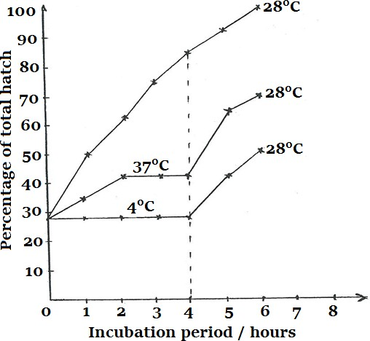
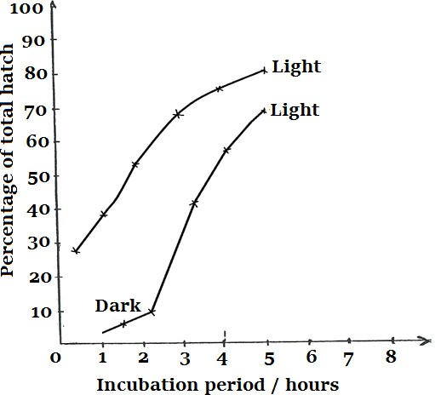
Figure 3 shows the effect of salinity on hatching after treatment for 6 hours at constant temperature and light (percentage of total hatch is expressed as a % of number of eggs hatching in 0% saline).
Figure 1
Figure 2

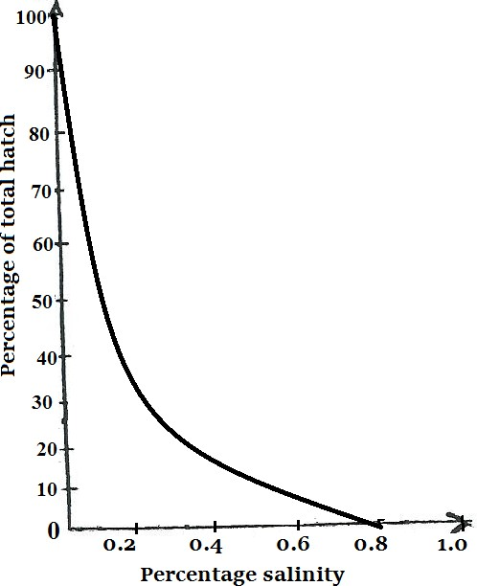
The eggs kept in 0.8% saline for 6 hours as in figure 3 above were removed, divided equally into four lots and placed in a range of saline solutions for a further 6 hours. The results are as shown in table 1 below:
Figure 3
Table 1
- Comment on the effect of temperature on hatching of Schistosoma mansoni eggs. (7 marks)
- Explain the effect of light on percentage hatch of eggs. (6 marks)
- What is the effect of salinity on percentage hatch of the eggs? (4 marks)
- From the data presented and restricting yourself to egg stage only, discuss adaptations of S. mansoni to its mode of life. (10 marks)
- (i) Name the disease caused by this blood fluke to man (1 mark)
(ii) Explain how the spread of disease can be controlled (4 marks)
(f)(i)Explain the physiological challenges facing human endo-parasites and how they are overcome (6 marks)
(ii) What are the benefits of parasitic nutrition to organisms that exhibit it? (2 marks)

Salinity (%) | Total hatch after 6 hours (%)
0.0 | 100
0.2 | 40
0.4 | 20
0.6 | 8

PROBABLE SOLUTIONS
- Comment on the effect of temperature on the hatching of the eggs of Schistosoma mansoni. (7 marks)
- At constant light, salinity and temperature of 280C; ✓ eggs hatched rapidly; ✓ to completion; ✓
- At higher temperature of 370C and lower temperature of 40C; ✓hatching is just slightly stimulated (greatly inhibited); ✓
- Restoring temperature from 370C and 40C to 280C; ✓stimulates rapid hatching; ✓

Explain the effect of light on the percentage of the total hatch of the eggs. (6 marks)
- The lot of eggs exposed to light hatch rapidly to completion; ✓ because light stimulates / activates a hatching substance/enzyme; ✓ which digests/breaks down the egg membranes to enable emergence of larvae; ✓
- Darkness generally inhibits hatching; ✓ because the hatching substance is inactive; ✓ however in this case a little hatching occurred in the dark probably due to experimental errors which resulted in some illumination of eggs;✓

What is the effect of salinity on the percentage of total hatch of the eggs? (4 marks)
- In fresh water (at 0% salinity) all eggs hatched; ✓ at 0.8% salinity no eggs hatched (hatching was inhibited); ✓ increase in salinity; ✓ causes a rapid decrease in hatching; ✓
- From the data presented and restricting yourself to the egg stage only, discuss the adaptation of S. mansoni (For more information, see MBV Roberts; functional approach, pg. 552-553)
- In the mesenteric veins of the main host of Schistosoma mansoni; ✓ there is total darkness and temperature is about 370C;
✓both of which prevent hatching of eggs into miracidia (larvae) in man; ✓because they would die; ✓
- When faeces with eggs reach fresh water bodies; ✓where there is much illumination (light), lower temperature and very low salinity; ✓ all of which favour rapid hatching of eggs; ✓ many larvae (miracidia) are formed; ✓ which infect water snails; ✓ (intermediate host) and form more larvae (cercariae) that infect man; ✓

(i) Name the disease caused by this blood fluke to man (1 mark)
Bilharzia (Schistosomiasis); ✓

(ii) Explain how the spread of the disease can be controlled (method and its purpose = 01 mark x 4)
- Disposal of faeces in latrines/toilets to avoid their contact with fresh water bodies; ✓
- Deworming to kill adult worms in humans; ✓
- Wearing gear (boots/shoes) that shield/protect feet from larvae (cercaria) infection; ✓
- Use molluscides to kill larvae’s (miracidia) intermediate hosts (adult snails) in water; ✓
- Biological control in which some fish and ducks are introduced in water to feed on larvae /snails; ✓

(f)(i) Explain the physiological challenges facing human endo-parasites and how they are overcome (Any 3, @ challenge – 1 mark, how overcome – 1 mark = 06 marks)
Challenge | How it is overcome
- Digestion by the host’s enzymes; ✓  - Osmotic changes in the habitat; ✓  - Inhibitory chemical environment; ✓  - Anaerobic conditions; ✓  - Attack by host’s immune system; ✓ | - Development of thick cuticle/secretion of inhibitory substances /mucus✓  - Increased chemosensitivity in order to equilibrate with host✓  - Secretion of anti-inhibitory substances; ✓  - Ability to respire anaerobically; ✓  - Development of protective structures against the host’s immune attack✓
(ii) Importance of parasitic nutrition (2 marks)
- A variety of nutrients required for growth, development and body maintenance may be obtained from one meal Less development of digestive system since most nutrients obtained are fully /partially digested.

SAPROTROPHISM (SAPROTROPHIC NUTRITION)
The process of obtaining soluble organic substances from extracellular digestion of dead or decayed organic matter.
Saprotroph: An organism that absorbs soluble nutrients from extracellular digestion of dead/decaying organic matter.

EXAMPLES OF SAPROTROPHS
- Saprobes: fungi like mushrooms, yeasts and moulds
- Saprophytes: saprotrophic plants e.g. sugar stick, gnome plant, Indian-pipe and putrefying bacteria which convert complex organic substances into simpler compounds e.g. Zygomonas bacterium ferments glucose producing alcohol, lactic acid and carbon dioxide, Clostridium aceto-butylicum forms butyl alcohol from carbohydrates, Lactobacillus converts sugars into lactic acid.
- Saprophages: Animal scavengers, such as dung beetles and vultures

DESCRIPTION OF SAPROTROPHISM IN FUNGAL MOULD LIKE MUCOR/RHIZOPUS
Under suitable conditions (moisture / water, oxygen, neutral / mildly acidic pH, temperature of about 25 °C) the saprotroph secretes different enzymes into the dead animal/plant body; proteases, lipases, carbohydrases e.g. amylase which break down insoluble complex organic substances into simple soluble substances as follows:
-Proteases break down proteins into amino acids
-Lipases break down lipids into fatty acids and glycerol
-Carbohydrases e.g. Amylases break down starch into maltose/simple disaccharides
The end products of extra-cellular digestion such as fatty acids and glycerol, glucose, amino acids plus other nutrients like vitamins e.g. thiamine and ions e.g. potassium, phosphorus, and magnesium are re-absorbed into the hypha through the cell wall by endocytosis / simple diffusion / facilitated diffusion / active transport and passed on throughout the mycelium complex to enable growth and repair.

COMPARISON OF SAPROPHYTES WITH PARASITES

Similarities
Both: (1) are heterotrophs (2) absorb soluble food (3) have simple digestive systems (4) have sexual and asexual phases in their reproduction (5) produce large numbers of offspring.

Differences
Parasites | Saprophytes |  | IMPORTANCE OF SAPROPHYTES
Energy derived from living organisms  Many stages in lifecycle  Very specific to their host  Nutritionally highly adapted  Most plant and animal groups have representatives  Most are aerobic | Energy derived from dead organisms  Usually a single adult stage, with spores inclusive  Use a variety of food sources  Simple methods of nutrition  Almost totally fungi and bacteria  Anaerobic and aerobic |  | Recycling of materials e.g. carbon, nitrogen, phosphorus  Brewing and baking e.g. yeast (Saccharomyces)  Making antibiotics e.g. Penicillin  Decomposition of wastes e.g. sewage  Production of yoghurt and cheese  Food source e.g. mushrooms  Industrial applications e.g. leather tanning, production of vitamins, etc.

