CHEMICALS OF LIFE
CARBOHYDRATES
They contain the elements carbon, hydrogen and oxygen. Their formula is C_{X}(H₂O)_{Y} where x and y vary, eg glucose has a formula C₆H₁₂O₆, sucrose C₁₂H₂₂O_{11.} The ratio of hydrogen to carbon is 2:1. The major function of carbohydrates is to supply and store energy.
VARIETY OF CARBOHYDRATES
Carbohydrates are put in three categories ie monosaccharides, disaccharides and polysaccharides.
General properties of sugars
- They are sweet.
- They can dissolve in water.
- They can be crystalline.
MONOSACCHARIDES
Monosaccharides like disaccharides are sugars. The number of carbon atoms in the molecule of monosaccharides ranges from 3 to 10.
CLASSIFICATION
They can be classified according to the number of carbon atoms present eg
- Triose- 3 carbon atoms eg phosphoglyceraldehyde (PGAL). This compound is involved in photosynthesis and respiration.
- Pentose- 5 carbon eg ribose in RNA, deoxyribose in DNA.
- Hexose- 6 carbon eg glucose, fructose and galactose.
VARIETIES (structural isomers)
The various atoms present within a particular group can be arranged in different ways giving rise to a number of isomers.
Consider glucose and fructose
Similarities
- They have a structural formula C₆H₁₂O₆.
- Presence of chemically reactive double boned oxygen atom (= O).
Differences
The chemically reactive double bonded oxygen atom is at different locations depending on the molecule. For glucose, it is located at the end of the chain of the hydrocarbon forming part of an aldehyde group. ( )
For fructose, the chemically reactive double bonded oxygen atom is attached to the second carbon atom forming a ketone group. (C = O)
Thus the first case gives rise to a series of monosaccharide sugars called aldose series (aldol series). They include: glyceraldehydes, ribose, glucose, galactose.
The second case gives rise to ketose series which include; fructose, dihydroxyacetone phosphate.
The two groups (ketone and aldose) have slightly different properties owed to the differences in location of the reactive group. Aldehydes and ketone groups both act as strong chemical reducing agents thus responsible for the reducing properties of monosaccharides and some few disaccaharides (maltose).
STRAIGHT CHAIN FORM OF MONOSACCHARIDES
Hexose and pentose sugars can exist in straight chain forms eg glucose and fructose in dry powder exist as straight chains.
Glucose (aldose sugar) fructose (ketose sugar)
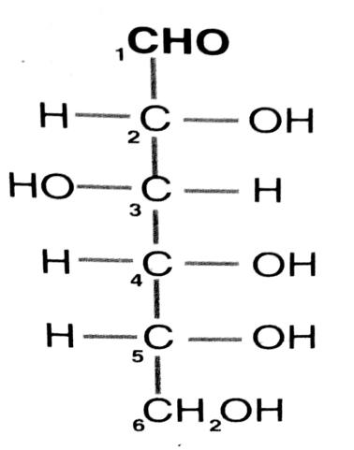
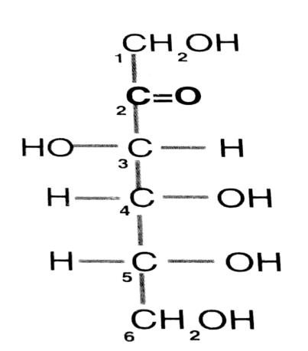
NB: In numbering, the carbon atoms are numbered from the end nearest the reactive group.
RING FORM OF MONOSACCHARIDES
In dissolved state, the straight chain of monosaccharides like glucose will change to a ring form.
Importance of the ring form
It is chemically more stable thus can
- Form subunits needed for building complex carbohydrates.
- Conserve energy in chemical forms.
- Used in DNA and other nucleic acid molecules which are relatively stable.
HEXOSE SUGARS (ring form)
GLUCOSE
Glucose exists in two isomers/forms ie alpha (α) and beta (β). The common features of a glucose molecule include:
- A ring formed by 5 carbon atoms and 1 oxygen atom.
- Side branches present (hydrogen atom)
- Hydroxyl group (OH).
- Alcohol group.
Structure of alpha glucose structure of beta glucose
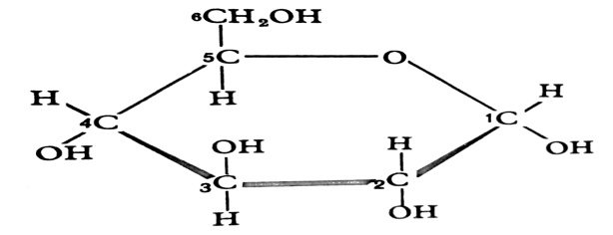
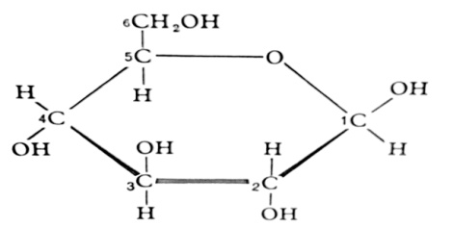
Differences (seen on carbon atom number 1)
Alpha glucose | Beta glucose
OH group is below the ring. | OH group is above the ring.
H atom above the ring. | H atom below the ring.

When powdered glucose which exists mainly in straight chain form is dissolved in water, the two ring structures of glucose are formed. These structures being more stable, an equilibrium is set such that both molecules are present as rings with a straight chain form being a relatively short lived intermediate.
Alpha and beta glucose have slightly different chemical properties owed to the above chemical structural difference. This simple variation in hydrogen atom and hydroxyl group on carbon atom 1 of the two molecules will significantly determine the marked difference in properties of complex carbohydrates synthesised from them.
In numbering carbon atoms in ringed monosaccharides, the carbon atoms are numbered starting with the one at the extreme end in a clockwise direction.
GALACTOSE
It differs from beta glucose by having the OH group and hydrogen atom on Carbon atom number 4 inverted.
Structure of galactose
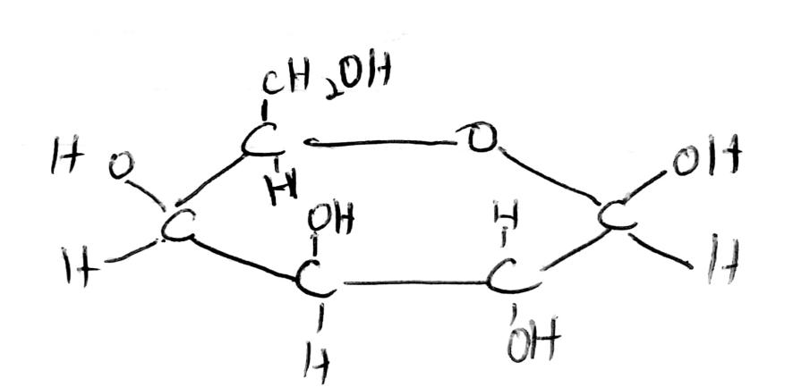
FRUCTOSE
It exists in two forms; the pyronose form (6 membered ring) and furanose form (5 membered). Furanose form exists only in disaccharides eg sucrose.
Pyronose form furanose form
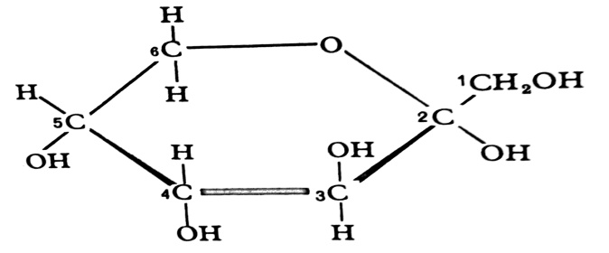
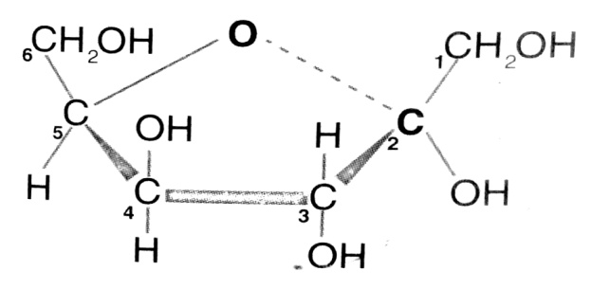
NB: Since the glucose molecule is reactive and readily dissolves in water, it serves as an ideal molecule to be used in respiration reactions to release energy required for immediate use by the body. Other hexose monosacharides like fructose can easily be converted to glucose and used for respiration reactions.
DISACCHARIDES
They are also sugars. They are formed when two molecules of monosaccharides are linked together. The reaction involves loss of a water molecule and it is known as condensation reaction. The bond formed linking the subunits is known as glycosidic bond (glycosidic linkage)
The type of disaccharides formed will depend on the type of monosaccharides linked.
MALTOSE
It is formed when two glucose molecules are bonded together.

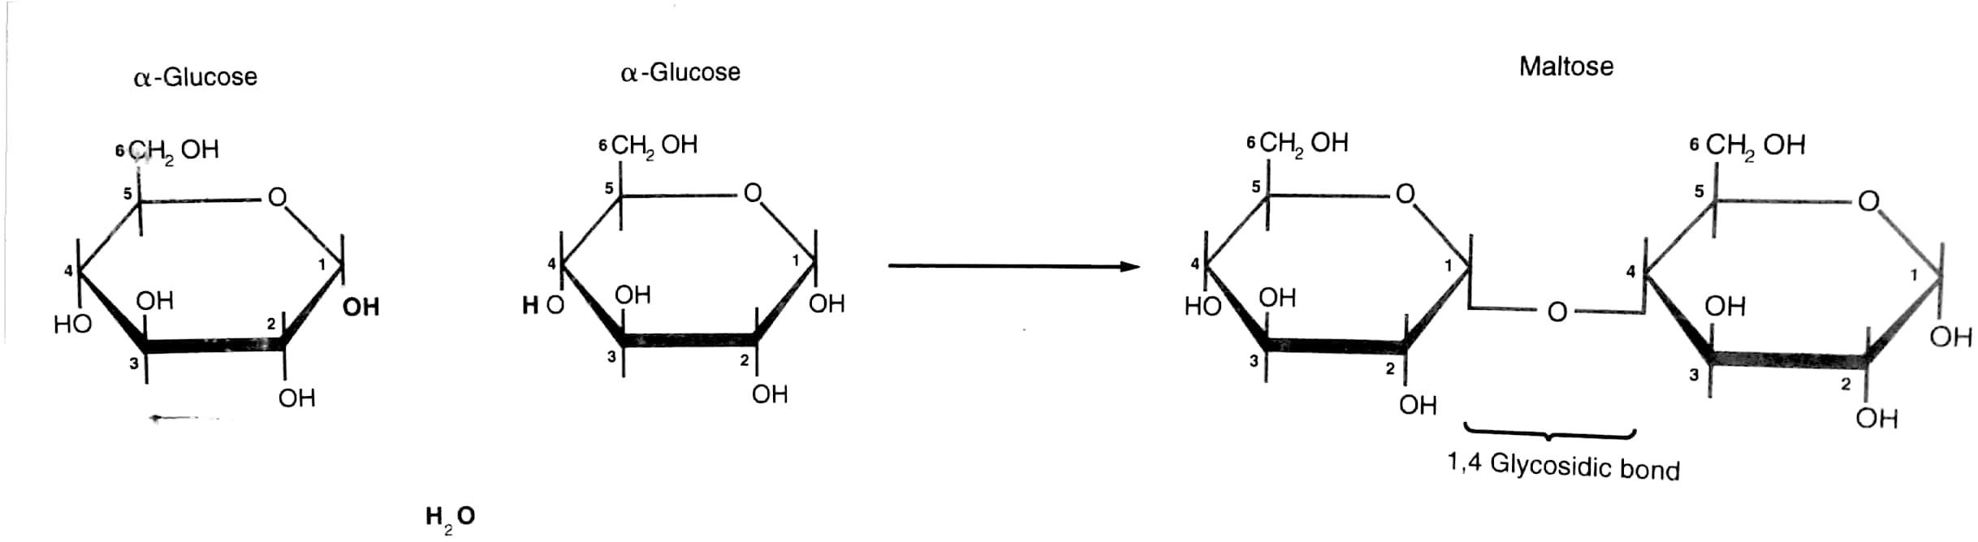
The reverse reaction can also occur when maltose breaks down back to glucose and the reaction involves breaking down of the glycosidic bond and a water molecule is consumed/used up in the reaction thus the reaction is known as hydrolysis reaction.
FORMATION OF LACTOSE
Lactose is formed between beta glucose and galactose. One of the molecules is inverted hence one head is down and the other is up.
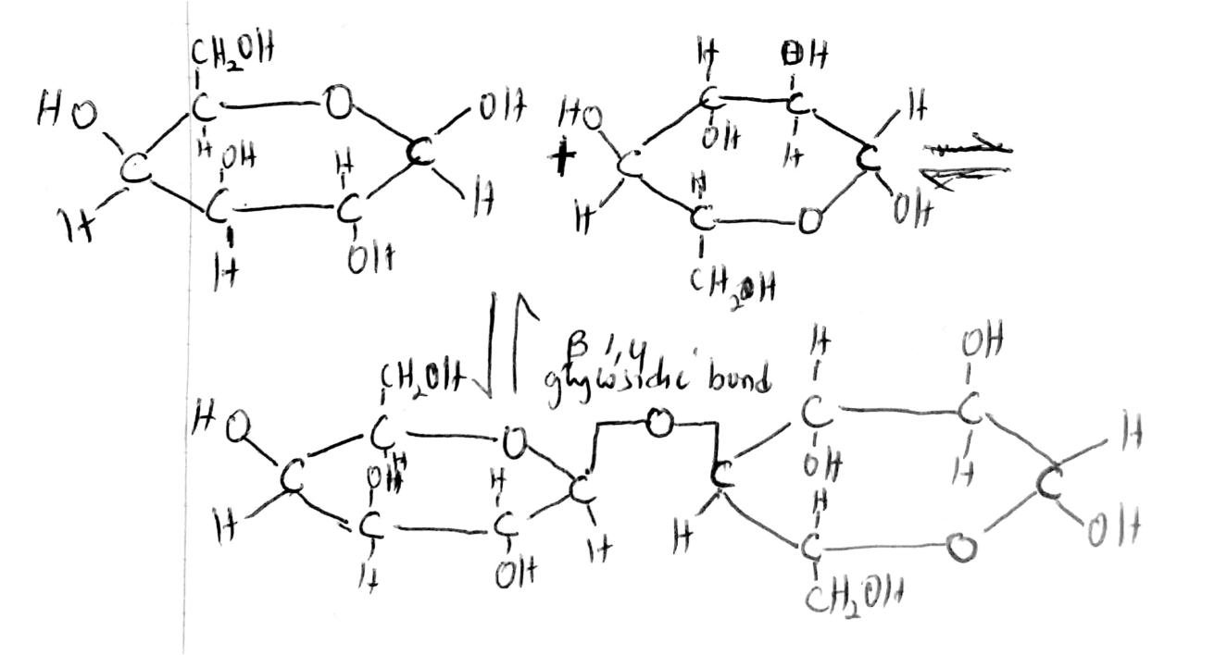
SUCROSE
It is formed by a condensation reaction between glucose and fructose.
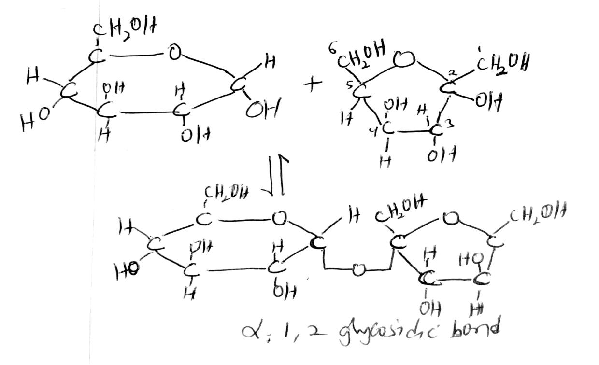

The alpha 1,2 glycosidic linkage formed between the sucrose subunits affects the chemical properties of the subunits hence their reducing properties are lost. This explains why sucrose is a non reducing sugar.
Sucrose is a high energy compound, non reactive and readily dissolves in water. These three properties make it an ideal molecule for transporting energy from one part of the plant (leaves) to other parts eg actively growing regions and storage organs of the plant.
POLYSACCHARIDES
They are complex molecules of carbohydrates consisting of monosaccharide units joined together by condensation. The general formula is (C₆H₁₀O₅)_{n}. The most important polysaccharides in living organisms are starch (plants), glycogen (animals), cellulose. Their major function is energy storage eg in starch and glycogen. Other functions include structural ones eg in cellulose.
General properties
- They are not sweet.
- They are relatively insoluble in water or form colloids.
- They can’t be crystallised.
- They are compact.
The compact nature of molecules like starch and glycogen plus their being insoluble in water makes these carbohydrate molecules suitable for conserving energy. It can be concentrated without escaping from the cells on lowering the water potential of the cell below the optimum which may affect normal metabolism of the cell.
STARCH
The main food energy storage material of many plants is starch. It consists of two types ie amylase and amylopectin ie the unbranched and branched forms of polysaccharides respectively.
Amylose
It is less abundant and it is made up of a chain of alpha glucose molecules. The monosaccharide subunits are in the ‘head up’ position. This configuration of molecules allows it to adopt a stable colloid structure called helix.
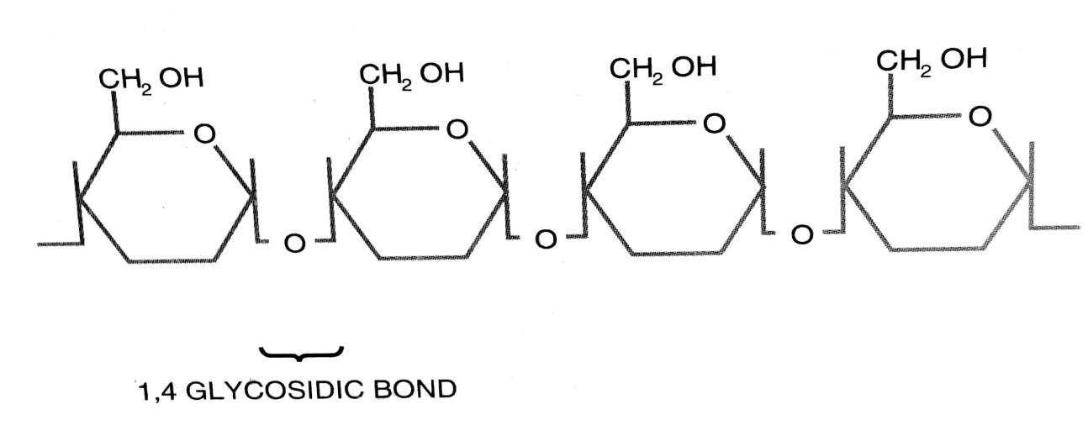
Long unbranched chains coiled into helix
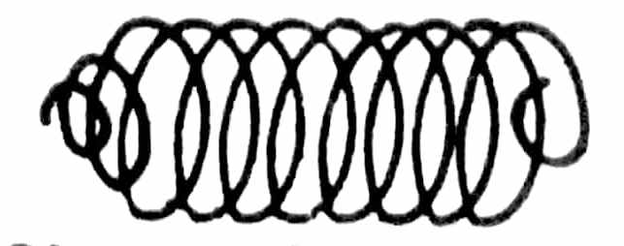
OH groups are inside making it insoluble/non polar. Hydrogen bonds also make it insoluble. This structure (helix) has 6 glucose units per turn and is held together by hydrogen bonds between adjacent turns.
Amylopectin
It forms up to 80% of starch. It differs from amylase by having a branched structure. Each branch starts with α 1,6 glycosidic linkage and branching occurs at intervals of about 24-30 glucose units. This greatly increases the number of forms where additional glucose units can be added or where enzyme breakdown can begin. Hence, it can be rapidly built up or degraded by amylase enzyme (diastase) to keep supply of simple sugars in the plant to correct levels.
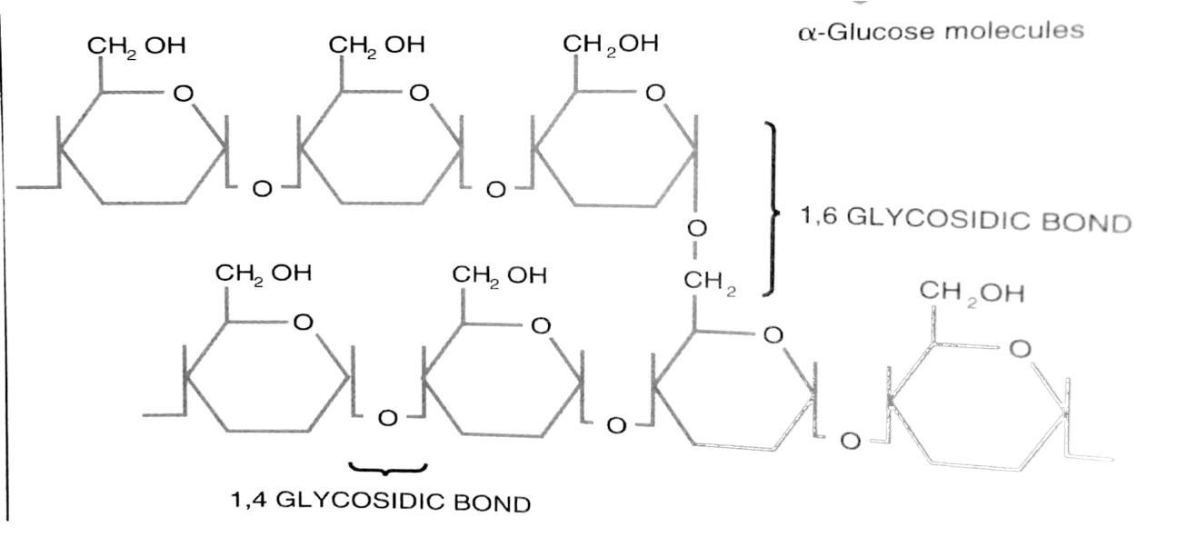
A suspension of amylose in water gives a blue black colour with iodine solution whereas a suspension of amylopectin gives a red violet colour. This is a basis of the test for starch.
Starch is stored in form of large aggregations of molecules called starch granules. These are found particularly in chloroplasts or spacious structures concerned with storage eg potato tubers or seeds.
GLYCOGEN
It is the most storage form of carbohydrates in animals. The molecular structure is very similar to that of starch (amylopectin) but branches are more often ie about 1 branch after every 8-12 glucose units.
The chains like amylopectins are of α glucose molecules and are linked by 1,4 or 1,6 glycosidic bonds.
CELLULOSE
This is the main structural material in plant cell walls. It is a polysaccharide with a long chain of beta glucose molecules linked with glycosidic bonds. Each chain may contain about 10000 glucose molecules.
The sugar molecules are oriented such that OH groups stick upwards and downwards from the chains in all directions. The OH groups can then form hydrogen bonds with neighbouring chains thereby forming a three dimensional lattice structure.
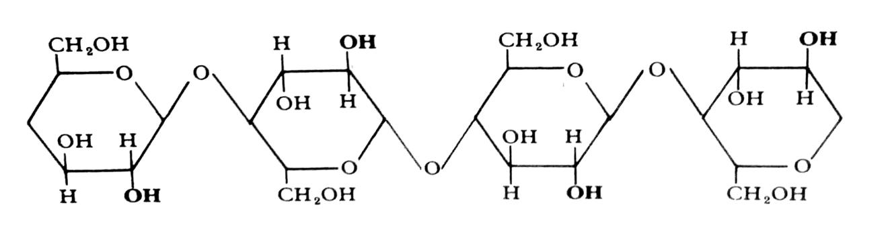
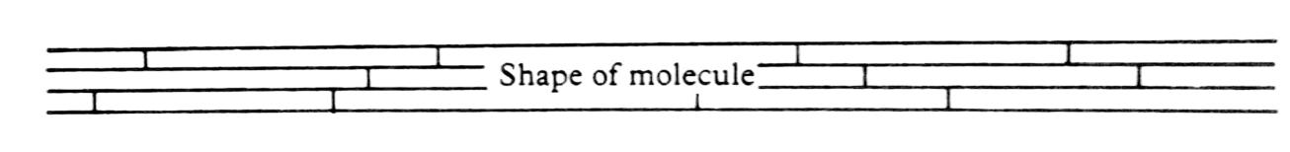
The strength of the glycosidic bonds plus that of cross links (hydrogen bonds) between adjacent chains make cellulose to be tough.
Groups of about 2000 cellulose chains are massed/brought together to form long threads each of diameter 10-30 nm called microfibrils. These are relatively insoluble as cellulose is insoluble and so ideal as structural components.
The microfibrils in the cell wall of a green plant cell are arranged in overlapping layers. This gives a particularly tough and rigid structure.
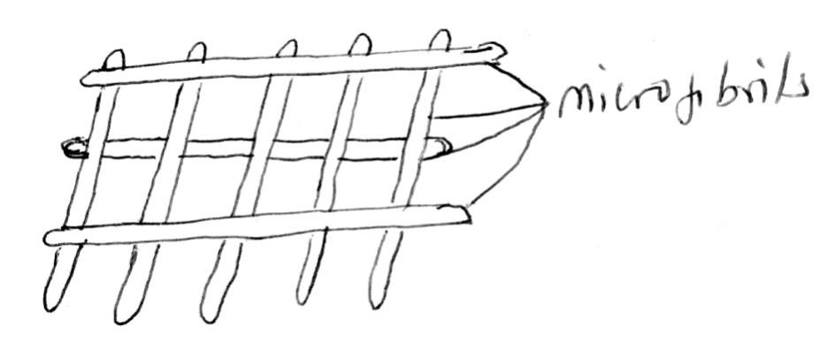
The space between microfibrils is filled with a gel like matrix containing a polysaccharide known as hemicellulose. These are short polysaccharides binding tightly to the microfibrils linking them together into a complex three dimension network. This results into even greater strength of the material or cell wall.
The cell wall is strong but permeable to water and solutes. The above property of permeability is achieved in two ways;
- The matrix molecules are hydrophilic (water loving) thus the cell wall is saturated with water.
- The matrix being perforated with small water filled channels where free diffusion of solutes can take place.
LIGNIN
It is a polymer of various sugars and amino acids. When deposited in spaces between the cellulose molecules, it makes the cell wall to be more rigid and permeable. Addition of lignin to cellulose is known as lignification and results into wood formation.
In a lignified cell, the protoplasm can no longer absorb materials from outside and hence the cell dies. A lignified tissue is thus dead with two main functions;
- Provides mechanical strength- lignol cellulose.
- Transportation - hollow tubes.
Mechanical strength is due to lignol cellulose composition and ability to transport is due to hollow tubes resulting from loss of protoplasm by the cell. The walls of the tubes are water proof since lignin acts as a water proof cement eg in tracheids and vessel elements.
AMINO SUGARS
These are sugars containing nitrogen. They are linked together by condensation to form polysaccharides eg mucopolysaccharides can be connected to proteins to form compounds like proteoglycan and glycoprotein.
Mucopolysaccharides are found in the matrix of connective tissues, basement membrane of the epithelium, synovial fluid in vertebrate joints, cell walls of prokaryotes and chitin. In chitin, the polymer subunits (monomers) differ from glucose by having one of their OH groups replaced by a more complex group (-NH-CO-CH₃) which is an acetylglucosamine unit. This gives more hydrogen bonds than in cellulose making chitin extremely tough.
Illustration of glucosamine, an amino sugar
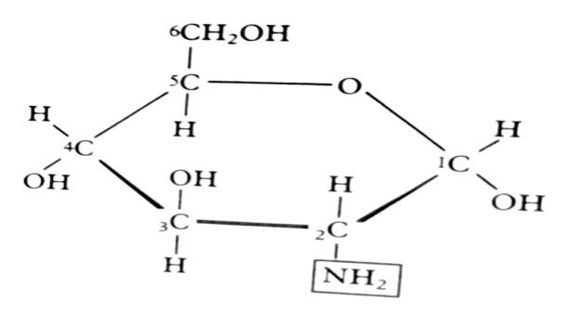
LIPIDS
These are a mixed collection of substances with a wide range of different functions. They have a high proportion of CH₂ groups which make them have a low solubility in water but high solubility in non polar solvents eg ethanol, chloroform. They include fats, oils waxes, phospholipids and steroids.
Fats, oils and waxes
Fats may be distinguished from oils by the fact that fats are solids at room temperature while liquids are in liquid state at room temperature. They have similar elements to those found in carbohydrates ie carbon, hydrogen and oxygen but different relative composition.
A fat molecule contains a much smaller portion of oxygen than a carbohydrate molecule and this explains their low solubility in water.
Fats and oils are complex molecules built up from two types of subunits called fatty acids and glycerol. Fatty acids can be categorised into saturated fatty acids and unsaturated fatty acids.
Saturated hydrocarbon chain eg stearic acid.
CH₃(CH₂)₁₆COOH
Unsaturated hydrocarbon chain eg oleic acid
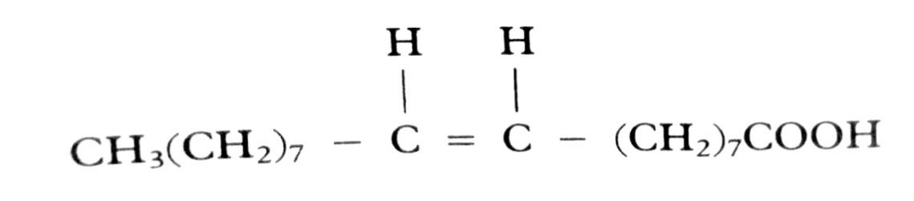
Saturated fatty acids have chains containing repeating CH₂ groups joined by a single bond. They have a general formula CH₃(CH2)_{n}COOH.
Structure of glycerol
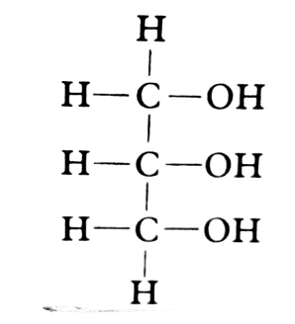
During fat or oil formation, a single glycerol molecule is joined to three fatty acid molecules when condensation reaction takes place between the OH group of the glycerol molecule and carbonyl groups of the three fatty acid molecules. The formed lipid is called triglyceride as it contains three fatty acid molecules. The bonds formed are known as ester bonds.
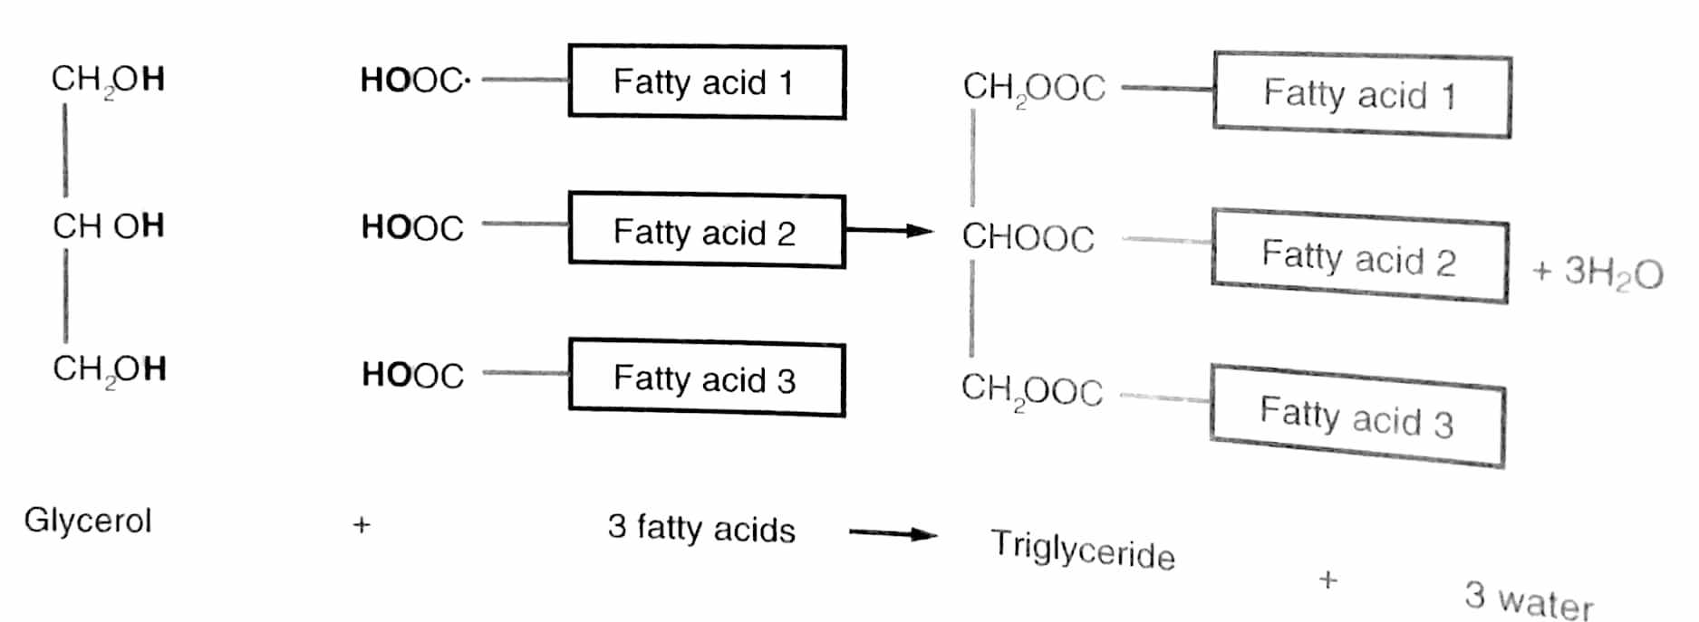
The variety and properties of the fats or oil will depend on the types of fatty acids that constitute it eg the three fatty acids in the molecule may be the same, different ie saturated or unsaturated.
In waxes, each molecule contains only one fatty acid subunit linked with a molecule of a long chained alcohol instead of glycerol.
Fats and oils too supply energy but function efficiently as storage materials. This is partly attributed to
- Their limited solubility in water.
- Their compact nature like starch and glycogen.
- Because of their numerous C-C and C-H bonds which characterise the structure.
These bonds represent a large reservoir of stored chemical energy that can be released and used by the cell when required as compared to carbohydrates. Fats and oils provide 38KJ/g. Carbohydrates provide 17KJ/g
In many organisms where their energy rich substances are rich in sulphur, they are converted into fats and deposited in some body fats like beneath the skin. This serves as a potential source of energy.
Fat deposits serve additional functions such as thermal insulation and mechanical protection of delicate organs.
Fats and oils and especially waxes are also used to make the external surfaces of plants and animals waterproof. This is attributed to water repelling properties of lipids.
PHOSPHOLIPIDS
They are important groups of lipids as they form part of certain structures in the cell eg the plasma membrane. A phospholipid is made up of two molecules of fatty acids linked to a molecule of glycerol in a condensation reaction. The third position of the glycerol molecule is occupied by a phosphate group.
They resemble triglyceride in structure except that one of the three fatty acids is replaced by a phosphate group.
The structure of a phospholipid
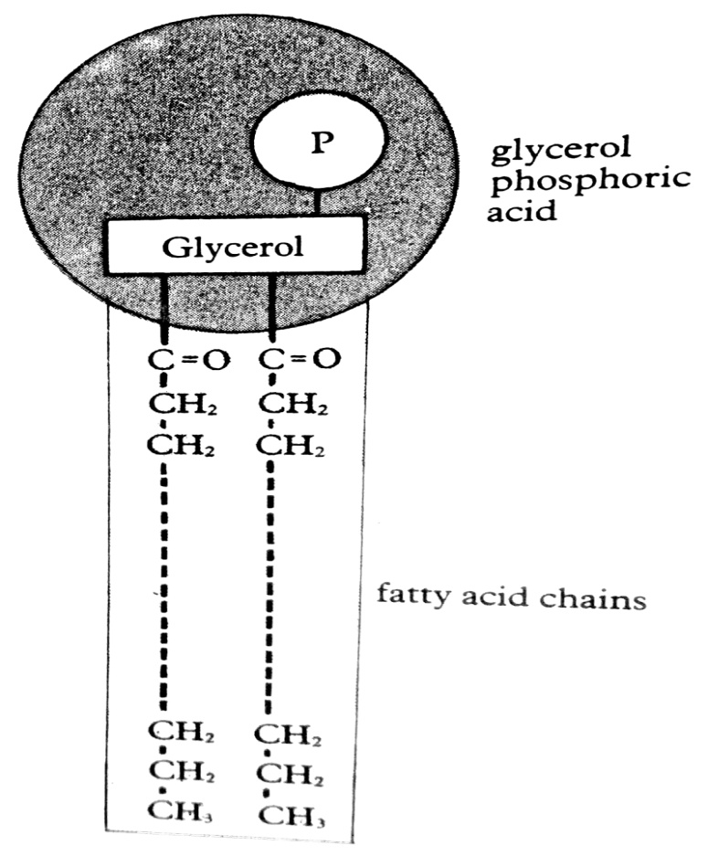
This gives a phospholipid molecule a different shape and different properties to that of a fat. One end of the phospholipid molecule which has the phosphate group is hydrophilic (polar and readily dissolves in water). The other end containing the fatty acids is said to be hydrophobic (non polar and not readily soluble in water).
When phospholipids are mixed with water, they can form bilayer structures. In the bilayer, the hydrophilic heads point upwards and form hydrogen bonds with the surrounding water molecules while the hydrophobic tails which have mutual attraction point inwards.
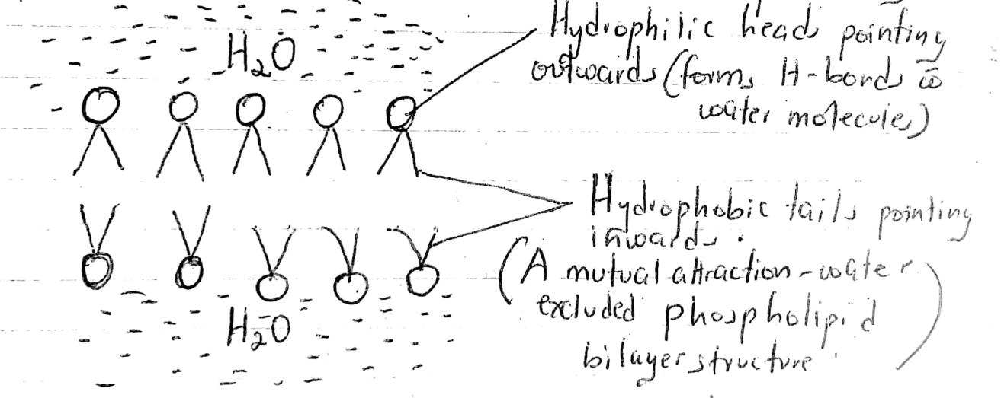
STEROIDS
They are biologically important groups of compounds which have properties similar to those of lipids eg being insoluble in water and yet soluble in organic solvents. Steroids contain a nucleus composed of 17 carbon atoms, methyl groups are usually attached at positions 18 and 19 and a side chain generally occupies position 17.
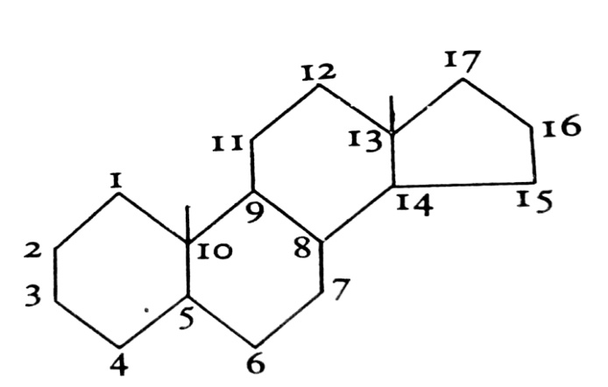
General structure of steroids
It is a system of rings, 3 six membered and 1 five membered condensed together. Examples include;
- Cholesterol which is a component of many cell membranes ie it is used as a structural component. Cholesterol mixes readily with lipids. The resulting mixture has the ability to absorb water.
- Other important steroids are present in small amounts and they include vitamin D, bile salts for emulsification of fats during fat digestion (sodium taurocholate and sodium glycocholate).
- Corticosteroids (hormones manufactured in the cortex region of adrenal gland eg cotisol (glucocorticoid), aldosterone (minerocorticoid)
- Sex hormones eg oestrogen, progesterone, testosterone.
Cholesterol
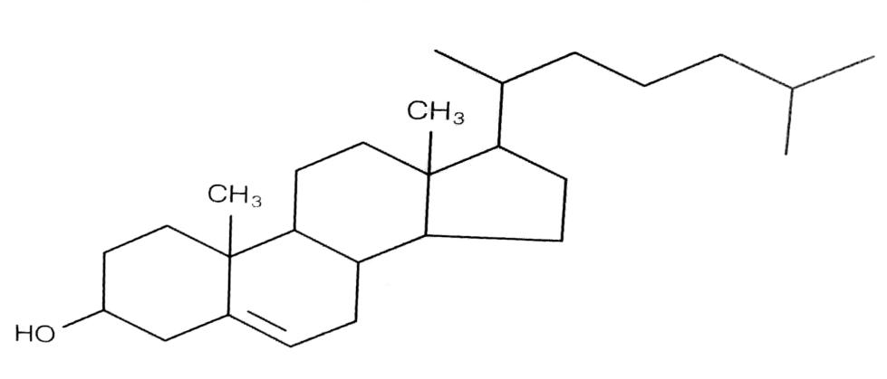
Functions of lipids
- They are an energy source upon breaking up the lipids’ chemical energy.
- Storage- Since they yield high energy upon breakdown, they make excellent energy stores. For an equivalent amount of energy stored, fats are less than half the mass of carbohydrates. This makes them especially useful for animals where locomotion requires mass to be kept at a minimum. In plants, they are useful in seeds where dispersal by wind or insects make small mass a necessity. Their insolubility is another advantage as they are not easily dissolved out of cells.
- Insulation- fats conduct heat only slowly and therefore they are useful insulators. In endotherms eg mammals, fats are stored beneath the skin (subcutaneous fat) where they help to retain heat.
- Protection- Lipids may act as a packing material around very delicate organs whereby they protect them from physical damage.
- Water proofing- Terrestrial plants and animals have a need to conserve water. Animal skin produces oil secretions eg from sebaceous glands in mammals and this water proofs the body. Oils also coat the fur and help to repel the water hence preventing it from getting wet. Birds spread oils over their feathers from a special gland near the cloaca for the same purpose. Insects have a waxy cuticle to prevent evaporative loss of water. In the same way, the plant leaves have cuticle to reduce transpiration.
- The phospholipids are major components of the cell membrane and contribute to many of its properties.
Other functions
- Many plant scents are fatty acids or their derivatives and therefore attract insects for pollination.
- Bees use wax to make honey combs which are important for their reproductive process. When fat is respired, water is one of its by-products. This water is called metabolic water, and it is an important source of water for many desert animals eg kangaroos.
- Fats are converted into steroids. These include sex hormones, cholesterol, adrenal cortex glands.
Advantages of lipids over carbohydrates as storage materials
- They are insoluble in water and so can be stored without being lost in solution.
- They have a high calorific value and therefore store a larger amount of energy in a small space than carbohydrates.
- They have a high hydrogen but low oxygen content and so can yield a lot of energy and water on oxidation.
- They are lighter in weight than carbohydrates and so keep the weight of the organism lower even with large energy deposits.
- They are relatively inert compared to carbohydrates so that they are kept unaltered over a long time.
- They are highly compacted and so store more energy in a relatively small space compared to carbohydrates.
- They serve other functions such as insulation of the body against heat loss, storage of vitamins A, D, E,K, used in water proofing, formation of cell membrane, aiding buoyancy, cushioning /shock absorber.
PROTEINS
Like carbohydrates and fats, proteins also contain carbon and hydrogen, but differ from them in than they contain nitrogen. In addition, some proteins may have sulphur, phosphorous and other elements.
The subunits of all proteins are the amino acids. Amino acids have the structure shown below.
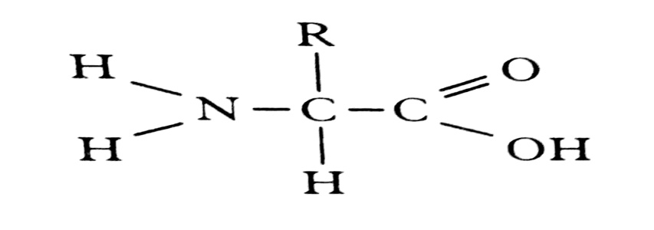
NB: The amino acid and carboxyl group are fixed parts of the molecule present in all the amino acids. The R-group is variable and determines the individual chemical properties of each of the 20 biologically important amino acids. Two amino acids of the 20 amino acids contain sulphur as part of the R group.
Classification of amino acids according to the R group
Amino acids with non polar R group | Amino acids with polar R group | Amino acids with acidic R groups | Amino acids with basic R groups
Alanine  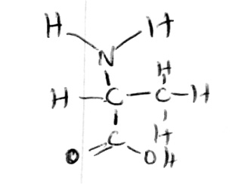  Others; valine, leucine, isoleucine, proline, tryptophan, phenylamine, methione | Serine  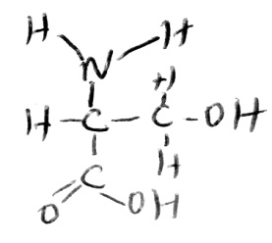  Others; threonine, tyrosine, cysteine, asparagines, glutmine. | Aspartic acid  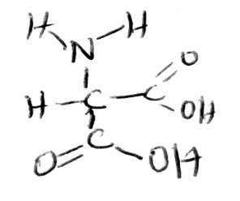  Others; glutaminc acid | Lysine  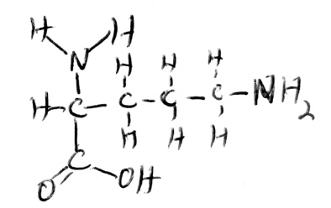  Others; arginine, Histidine

Non polar R-groups
A large proportion of these amino acids in the protein makes its molecules insoluble and unreactive thus they are common in structural proteins eg keratin.
Basic and acidic R-groups
These form positively and negatively charged ions and therefore strongly hydrophilic. Proteins which contain them are fairly soluble. The charged R groups are also important in forming bonds between different points of the molecules as globular proteins helping to hold its proper shape.
Polar R-groups
These groups develop partial charges which do not lose/gain electrons to form ions. They also increase protein solubility and allow hydrogen bonding between chains.
Amino acids are soluble in water and they form ions. These ions are formed by loss of hydrogen atoms from a carboxyl group making it negatively charged. The hydrogen atom then associates with the amino group making it positively charged.
The ion is therefore dipolar (having a positive charge and negative charge). Such ions are called Zwitterions.
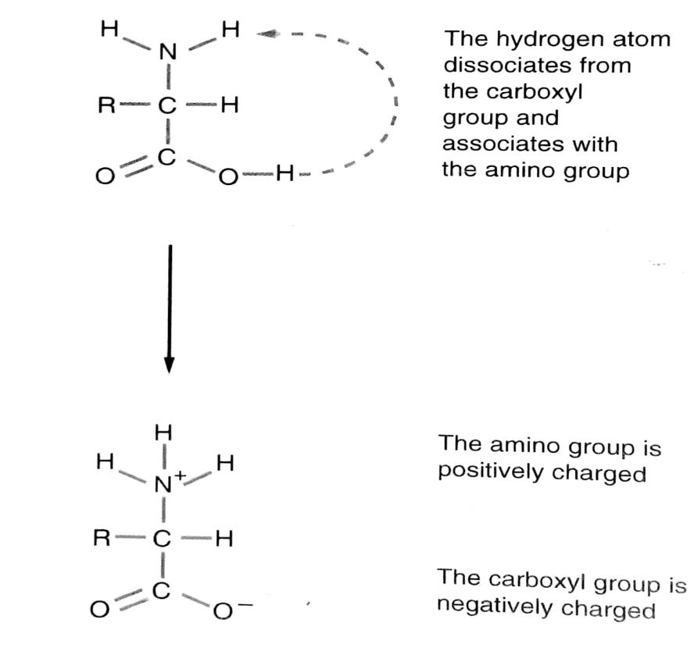
Amino acids therefore have both acidic and basic properties ie they are amphoteric, hence can act as buffers.
How amino acids resist changes in pH
The general formula for amino acids is

In neutral conditions of a cell ie when pH is approximately equal to 7, the amino acid exists as a zwitterion with it having a net charge of zero.
NB: The pH at which the net charge of an amino acid is zero is called isoelectric point
In acidic conditions, the concentration of protons (hydrogen ions) is high. Here, the amino acid takes up the proton attracting it to the negatively charged carboxyl group. In this way, the proton is removed from the solution which therefore becomes less acidic restoring the pH back to normal.
Acceptance of the H⁺ ions by the zwitterions buffers the solution and therefore restores the pH back to normal.
In basic conditions, there is an excess of hydroxyl ions, a proton is donated by the positively charged amino group of the zwitterions to react with OH to form water which is neutral. This restores the pH back to normal.
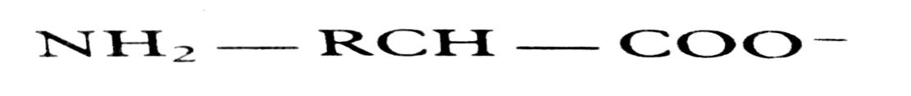
FORMATION OF A DIPEPTIDE AND POLYPEPTIDE
Through condensation reactions, amino acid carboxyl groups form linkages called peptide bonds which join amino acids together to form a long chain known as polypeptide.
Formation of a dipeptide
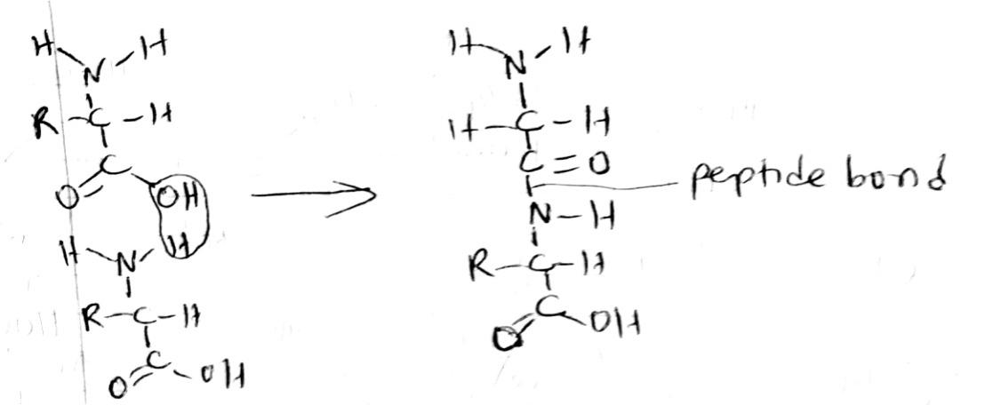
Illustration of a polypeptide
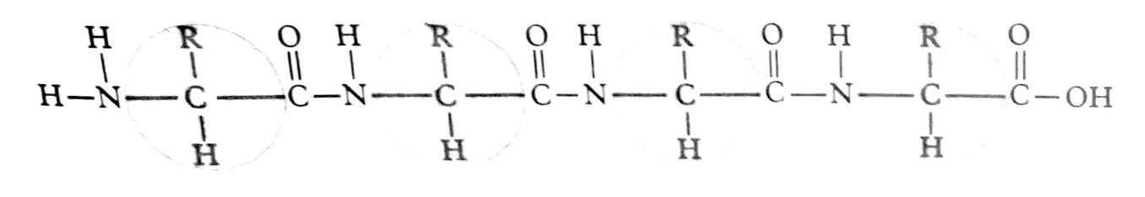
A polypeptide may contain 300 or more amino acids. There is limited potential of variation for the sequence of amino acids thus many different polypeptides are known
ORGANISATION OF PROTEIN STRUCTURE
Chemical nature
The individuality of a particular protein is determined by:
- Sequence of amino acids comprised in its polypeptide chain,
- pattern of branching
- folding and
- cross linkages
primary structure of a protein
It is the sequence of amino acids in a protein molecule.

The primary structure is important because it determines the 3 dimensional shape of the protein molecule on which its properties depend.
Many protein functions depend on the primary structure. For instance, it is the shape of the enzyme which determines whether the substrate molecule on which the enzyme acts would be able to fit in it and therefore whether or not the enzyme will work.
The primary structure will determine the secondary structure, tertiary and quaternary structures of a protein molecule.
Secondary structure of a protein
It refers to the arrangement of the polypeptide chains. The most common secondary structure is an extended spiral ring, the alpha helix whose structure is maintained by many hydrogen bonds which are formed between the hydrogen atom of the NH group and the oxygen atom of the CO group. The alpha helix is common in the protein keratin.
The weak hydrogen bonds allow the helix to be extended like a spiral when pulled at its end. Hydrogen bonds hold the alpha helix together increasing the stability of the structure. In many fibrous proteins, alpha helices are coiled together in a rope like arrangement giving a greater overall strength.
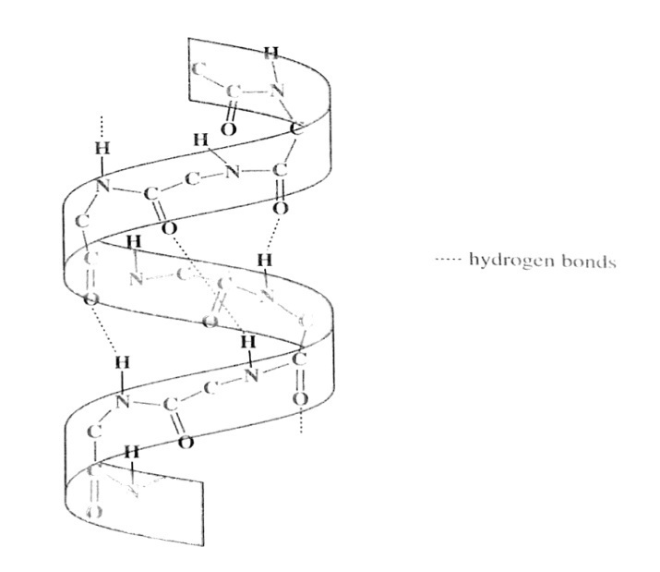
Another type of secondary structure is the beta pleated sheet. The protein that makes silk mainly fibroid is entirely in this form. Fibroid is used by silk worms when spinning their cacoon threads. It is made up of a number of adjacent chains which are more extended than the alpha helices.
These are arranged in a parallel fashion either running in the same direction or in the opposite direction. They are joined together by hydrogen bonds formed between the CO and NH groups of adjacent chains.
Illustration
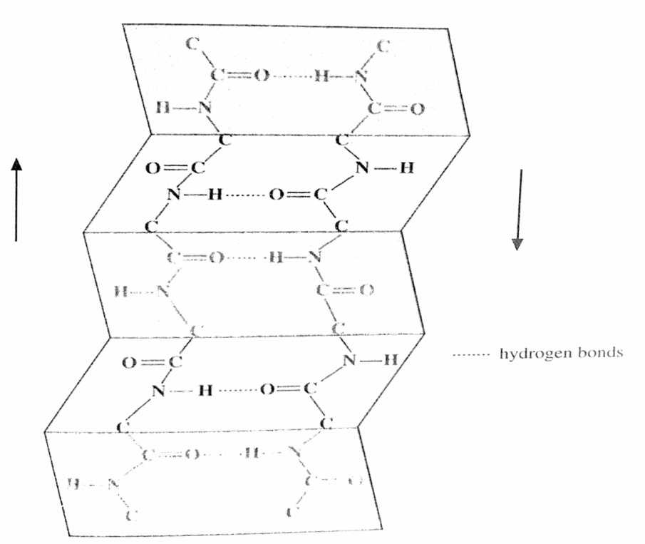
Tertiary structure
Usually, the polypeptide chains bend and fold extensively forming a precise compact globular shape. This is a protein’s tertiary structure. It is maintained by the interactions of four types of bonds namely ionic bonds, hydrogen bonds, disulphide bonds as well as hydrophobic interactions.
The latter are quantitatively the most important and occur when the protein folds so as to shield hydrophobic side groups from the aqueous surroundings at the same time exposing the hydrophilic side chains.
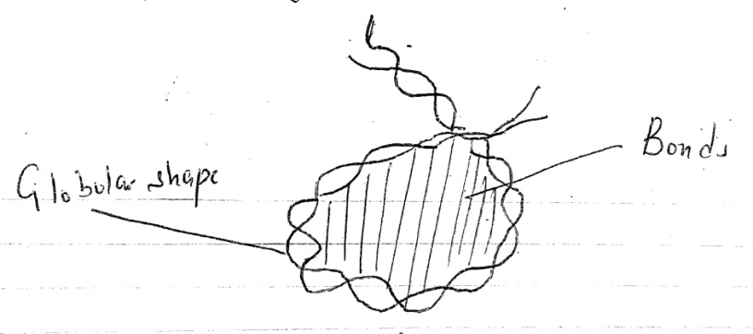
Quaternary structure
Most highly complex proteins consist of more than one polypeptide chain. The separate chains are held together by hydrophobic interactions, hydrogen and ionic bonds. This precise arrangement is known as the quaternary structure.
Haemoglobin shows such a structure. It is a red oxygen carrying pigment found in the red blood cells of vertebrates. It consists of four separate polypeptide chains of two types ie 2α and 2β polypeptide chains.
Each of the two alpha chains contains 141 amino acids while each of the two beta chains contains 146 amino acids.
Illustration
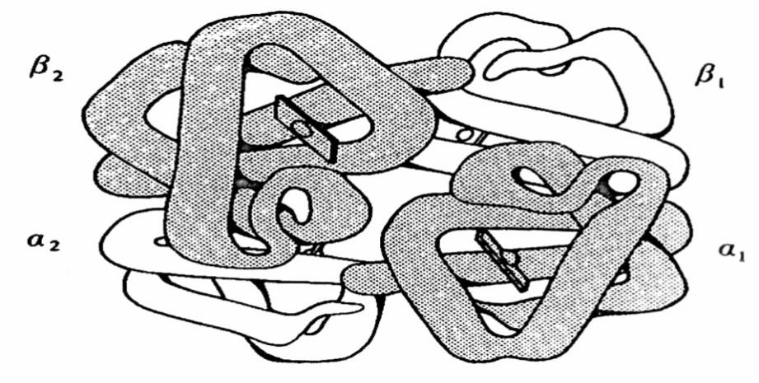
Structure of a polypeptide chain
The chains of amino acids which make up the polypeptides have a specific three dimensional shape. This shape is important in the functioning of proteins especially the enzymes.
The shape of the polypeptide molecules is due to four types of bonding which occur between various amino acids in the chain.
Disulphide bond
This arises from amino acids which contain sulphur and these bonds may arise with the same polypeptide chain or between molecules of different chains.
Ionic bond
It occurs between amino acids with basic R groups and amino acids with acidic R groups. Usually, basic R groups are positively charged and acidic R groups are negatively charged. So, there will be an attraction between the two creating an ionic bond.
Hydrogen bonds
These occur between hydrogen atoms of the amino group (NH group) and oxygen atom of the CO group. The hydrogen has a slightly positive charge (electropositive) and oxygen has a small negative charge (electronegative). Therefore, the two are attracted to each other and form hydrogen bonds. The bonds are weak and can easily be broken.
Hydrophobic interactions
These are interactions between non polar R groups.
Illustration of a polypeptide chain
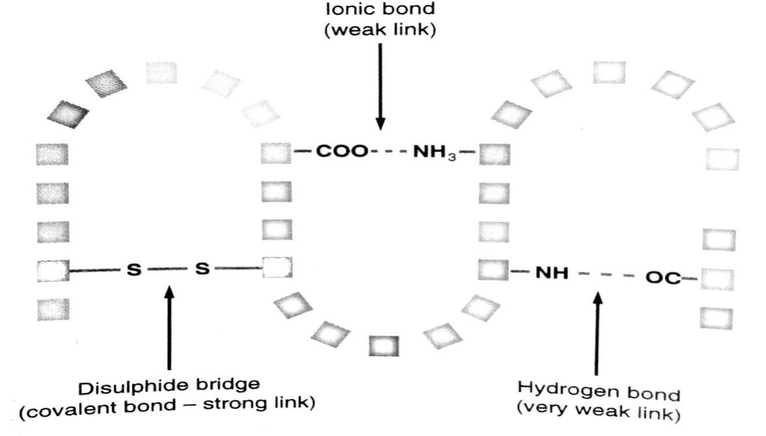
DENATURATION OF PROTEINS
Most proteins have a three dimension structure and this is maintained by fairy weak ionic and hydrogen bonds. Any agent which breaks these bonds will cause the globular protein to revert to a more fibrous form. This process is called denaturation.
The actual sequence of amino acids is not affected. However, it is the overall shape of the molecule that changes. Therefore, denaturation may be permanent or temporary due to a number of factors as stated below.
- Heat
This causes the atoms of the protein to vibrate more due to increased kinetic energy. The vibration break the hydrogen and ionic bonds which are weak eg coagulation of albumin. Boiling eggs therefore makes the egg white more fibrous and less soluble.
- Acids
Additional hydrogen ions in the acids combine with the COO⁻ group and forms COOH, ionic bonds are therefore broken as a result. For example, souring of milk by acid, the lactobacillus bacterium produces lactic acid which lowers the pH and denatures casein making it insoluble forming curds.
- Alkalis
Reduced number of hydrogen ions in solution causes ⁺NH₃ group of the zwitterions to lose the hydrogen ion and forms NH₂. Ionic bonds are therefore broken down.
- Inorganic compounds (chemicals)
The ions of heavy metals eg mercury and silver are highly electropositive. They therefore combine with the COO⁻ groups disrupting ionic bonds. Similarly, highly electronegative ions of cyanide (CN) combine with NH₃⁺ disrupting ionic bonds. For example, many enzymes are inhibited by being denatured in presence of certain ions eg enzyme cytochrome oxidase, a respiratory enzyme in the electron transport chain. This is inhibited by cyanide.
- Organic compounds
Organic solvents alter hydrogen bonds within the protein eg alcohol denatures certain bacterial proteins making them sterile.
- Mechanical stress/force.
Physical movements may break the hydrogen bonds and leads to denaturation eg stretching the hair breaks hydrogen bonds in keratin helix. The helix is extended and the hair stretches out. If released, the hair returns to its normal length. If however, it is wetted, the hair returns to its normal length. If however it is wetted and dried under tension, it keeps its original length.
RENATURATION
Sometimes, a protein will spontaneously refold into its original structure after denaturation provided conditions are suitable. This is called renaturation, and it is good evidence that the tertiary structures can be determined purely by primary structures and that biological structures can spontaneously assemble according to a few general principles.
TYPES OF PROTEINS
Proteins can be grouped into seven major classes based on their functions.
- Enzyme proteins- These are biological catalysts that control chemical reactions in the cells.
- Structural proteins- These form parts of the body of an organism eg keratin is a constituent of hair, collagen makes up tendons and ligaments.
- Signal proteins- These carry massages around the body eg insulin hormone which control the blood sugar level.
- Contractile proteins- Eg actin and myosin. These are involved in movements.
- Storage proteins- Eg albumin, which is a protein stored in egg white.
- Defence proteins- Eg antibodies in blood that fight infections. These are usually specific to diseases carrying agents.
- Transport proteins- Eg haemoglobin. This is responsible for oxygen transport in the body.
FUNCTIONS OF PROTEINS
Structural functions
- Serves as a component of the connective tissues like bones, tendons and ligaments.
- They play a protective function in the exoskeleton of insects by making them water proof.
- Proteins are important in formation of synovial fluids, mucus secretions eg mucus proteins.
- They are important in formation of skin hooves, horns and feathers eg keratin.
Globular proteins
They function as enzymes, antibodies and hormones. They consist of polypeptide chains tightly folded to form spherical shapes. They are soluble in water.
- Homeostatic role- Soluble proteins act as buffers stabilising the pH in case of any alterations.
- Transport- cell membrane proteins of cell involve transport of metabolites and ions across membranes ie haemoglobin for oxygen transport.
- Storage eg casein in milk, albumin in egg white.
- Protection- antibodies reacting with foreign particles and some other molecules. The colloidal suspension of proteins are important in holding molecules in position within the cell and maintaining molecular organisation in protoplasm because of their capability to absorb water.
CLASSIFICATION OF PROTEINS
Proteins are classified according to structure eg globular proteins, fibrous proteins.
Globular proteins
These are relatively soluble proteins in water but do not form a true solution, exist as a colloidal suspension. These proteins are composed of polypeptide chains tightly folded and twisted forming a spherical helix.
Examples are enzymes, antibodies, hormones eg insulin. They are also found in plasma membrane, protoplasm of the cell, microfilaments and microtubules.
Fibrous proteins
These are insoluble proteins in water consisting of long parallel polypeptide chains cross linked at many points due to hydrogen bonds and other bonds.
Because of the cross linkage between the parallel polypeptide chains, fibrous proteins are physically tough eg keratin found in hair, horns, feathers and hooves.
Also, elastin and collagen are fibrous connective tissue proteins which are important constituents in the muscles.
DIFFERENCES BETWEEN GLOBULAR AND FIBROUS PROTEINS
Fibrous proteins | Globular proteins
Have a repetitive sequence of amino acids. | Have irregular sequence of amino acids.
Polypeptide chains form long parallel strands. | The polypeptide chains fold into spherical shape.
Insoluble in water. | Form colloidal suspension.
Are very stable and do not easily change their shape. | A relatively unstable structure.
Are for support and structural functions. | Are for metabolic functions.
c) Intermediate proteins
These are fibrous but soluble eg fibrinogen. This forms insoluble fibrin when blood clots.
d) Conjugated proteins
These are formed when non protein components come together and join with a protein. The non protein component is called the prosthetic group. Examples of conjugated proteins include haemoglobin where the prosthetic group is a haem group, mucus where the prosthetic group is a carbohydrate, lipoprotein where the prosthetic group is a lipid, prosphoprotein where the prosthetic group is phosphoric acid, flavoprotein where the prosthetic group is FAD (flavine adenine dinucleoitide), nucleoprotein where the prosthetic group is nucleic acid.
PROTEINS IN THE DIET
In nature, there are 20 different amino acids and some of which are essential while others are non essential. Autotrophic organisms are able to synthesise all the amino acids but heterotrophic organisms have different abilities to synthesise. Man is able to synthesise only 10 out of the 20 amino acids existing in nature.
The ten amino acids that can be synthesised by man are called non essential amino acids. The remaining 10 amino acids that cannot be synthesised in the body of man are called essential amino acids. Essential amino acids can only be got from the diet.
Proteins can be classified into two groups according to their essential amino acid content.
- First class proteins- These are proteins that contain all the ten essential amino acids eg animal protein (meat) and some plant proteins eg soya beans
- Second class proteins- These are proteins that lack one or more of the essential amino acids and they include all plant proteins.
ENZYMES
Enzymes are organic compounds which are protein in nature produced by the body of living organisms specialised for altering the rate of metabolic reactions. They have two major functions
- Altering the rate of reaction (often speeding up).
- Regulating the rate of reaction.
Enzymes as catalysts
The general properties of catalysts also apply to enzymes. All vital activities of the cell are controlled by enzymes, such as muscle contraction, synthesis of proteins, transmission of proteins, impulse transmission in the nerve cell, photosynthesis, respiration, etc.
THE MECHANISM OF WORKING OF ENZYMES
There are two theories considered
- Lock and key hypothesis
- Induced fit hypothesis
LOCK AND KEY HYPOTHESIS
All enzymes have certain regions on the molecule called active sites. These areas are complementary to certain portions of the substrate molecule upon which the enzyme acts. In other words, the active site is shaped to fit exactly the parts of the substrate molecule.
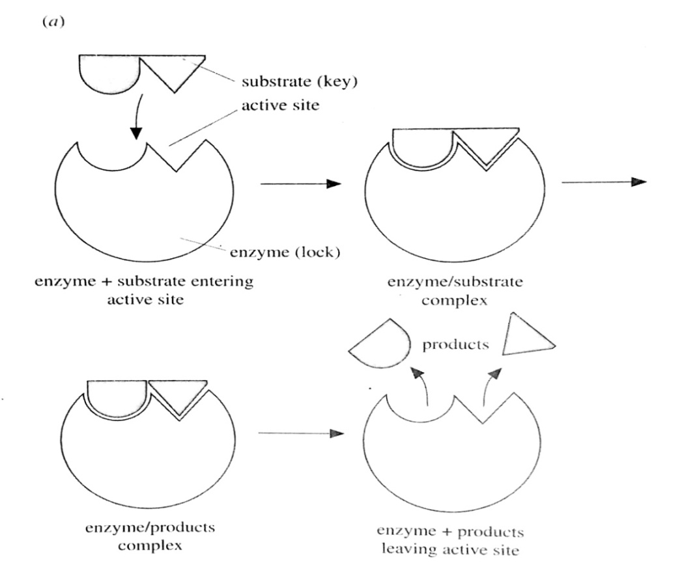
Using the complementary site, the enzyme and substrate molecules combine to form an enzyme substrate complex. This complex reacts with itself to give an enzyme product complex. The product detaches from the enzyme to join the surrounding medium leaving the enzyme free for another reaction.
The above reaction is reversible ie the product may fit in the active site of the enzyme and get converted back to the reactant. The side on which the equilibrium of the reaction uses depends on the
- Concentration of the substrate.
- Concentration of the product.
- Temperature.
Linking the enzyme and substrate resembles a lock and key relationship whereby the enzyme is the lock and the substrate is the key.
KOSHLAND’S INDUCED FIT HYPOTHESIS (s modification of the lock and key hypothesis)
There is evidence that enzymes and their active sites are flexible structures than before described. Interaction between the substrate enzyme molecules is facilitated by a conformational change of the active site of the enzyme, a phenomenon referred to as induced fit.
Note that before connection between the enzyme molecule and the substrate molecule, the shape of the enzyme’s active site is not compatible with the substrate ie the substrate does not fit in the enzyme’s active sites.
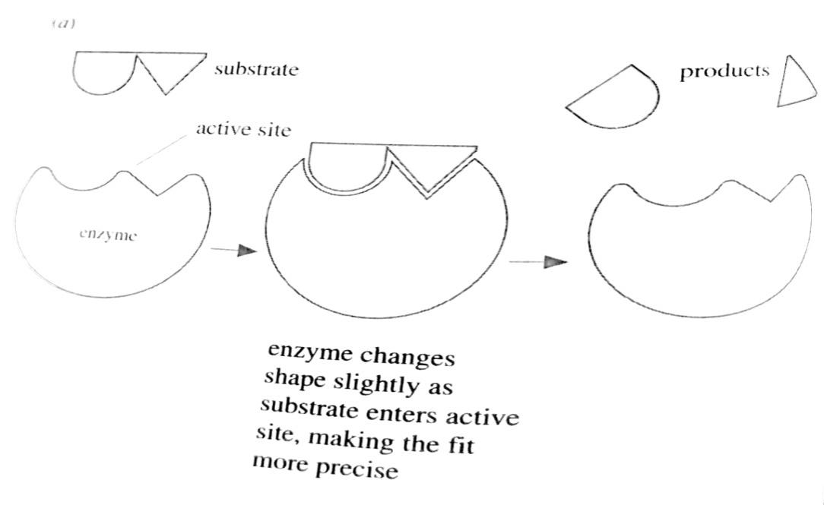
Properties of enzymes
- All enzymes are globular proteins.
- Being proteins, they are coded for by DNA.
- They are catalysts.
- Their presence does not alter the nature or properties of the end product(s) of the reaction.
- They are very efficient. In other words, every small amount of the enzyme brings about a change of a large amount of the substrate.
- They are highly specific that is an enzyme will catalyse only a specific reaction.
- The catalysed reaction is reversible.
- Their activity is affected by pH, temperature, substrate concentration.
- Enzymes lower the activation energy of the reactions they catalyse.
- Enzymes possess active sites where the reaction takes place. These sites have specific shapes.
FACTORS AFFECTING THE RATE OF ENZYME REACTIONS
- Temperature
The rate of an enzyme catalysed reaction increases with temperature up to a maximum called the optimum temperature. At suboptimal temperatures, increasing the temperature increases the kinetic energy of the reactants (substrate and enzyme). As they move faster, they are more likely to collide and interact with each other and with the enzyme thereby increasing the rate of reaction.
The change in the rate of reaction for each 10⁰C rise in temperature is called the temperature coefficient (Q₁₀).
Q₁₀ = rate of reaction at x + 10⁰C
Rate of reaction at x⁰C
At suboptimal temperatures, the Q₁₀ for enzyme catalysed reactions is approximately 2 (the rate doubles for each 10⁰C rise in temperature. The rate continues to rise until it reaches a peak at the optimal temperature.
Above the optimum temperature, the rate usually falls dramatically. This is because the increased energy causes the bonds that maintain the enzyme’s shape to break and the enzymes become denatured. The changed shape means that the substrate can no longer fit into the active site and the enzyme’s activity is lost.
The optimum temperature for an enzyme catalysed reaction is related to the enzyme’s usual thermal environment. In humans, many enzymes work best at a body temperature of about 37⁰C.
Effect of temperature on the rate of an enzyme controlled reaction
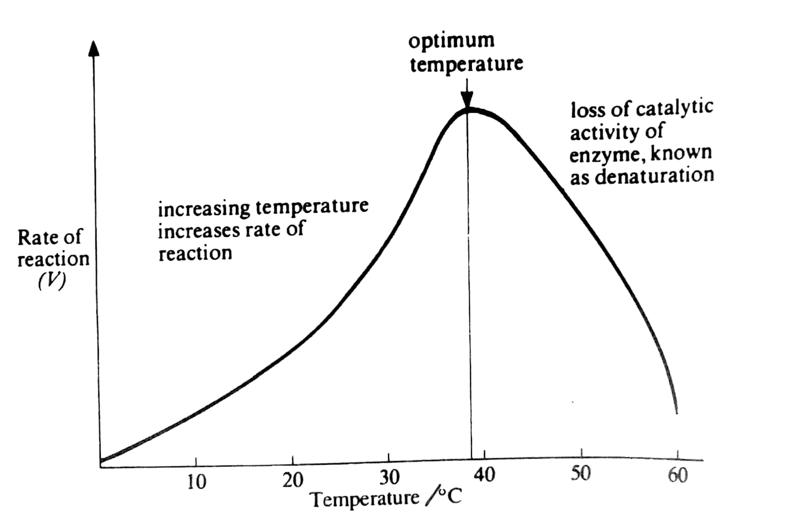
q. Study the figure below and comment on the shape of the curves given for the enzyme catalysed reaction at different temperatures.
Time course of an enzyme reaction at various temperatures
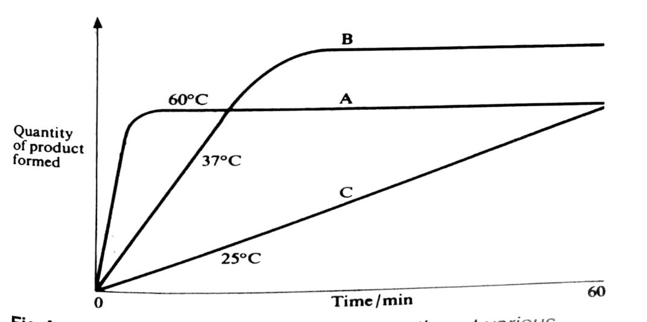
Initially, the reactions A and B are fast and a lot of product is formed. Later, product formation levels off and there is no further increase. This may be because of
- All substrate has been converted to product.
- The enzyme has been inactivated.
- The equilibrium point of a reversible reaction has been reached, and the substrate and product are present in balanced concentrations.
When the temperature is raised,
- Initial reaction rate is increased and
- The enzyme becomes more stable and is activated more rapidly.
Sensitivity to heat is an indication of the protein nature of the enzymes.
At lower temperatures (curve C), rate of formation of the product remains constant over 1 hour.
B. SUBSTRATE CONCENTRATION
At low substrate concentration, rate of enzyme controlled reaction increases with increase in concentration of the substrate. An increase in the concentration of the substrate means that there is more substrate molecules present and therefore, there will be an increase in the frequency of collisions of the substrate molecules with the enzyme molecules, thus more products formed.
Beyond a certain substrate concentration (saturation point), the rate remains constant with increase in substrate concentration.
Explanation
At the saturation point, all the enzyme molecules have reached their turnover number ie the maximum number of substrate molecules an enzyme can convert into products per unit time. This implies that all the active sites are occupied. Therefore, further increase in the number of substrate molecules will not have any effect. The limiting factor here is the enzyme concentration.
The law of limiting factors states that if a biochemical process is affected by more than one factor, its rate is limited by that factor closest to its minimum.
Rate of reaction
Substrate concentration

C. ENZYME CONCENTRATION
At low enzyme concentration, the rate of enzyme controlled reaction increases with increase in enzyme concentration. An increase in enzyme concentration means that there are more enzymes to act on the substrates and therefore more products formed. Beyond a certain point, further increase in enzyme concentration has no effect on the enzyme activity because the substrate concentration becomes a limiting factor ie there are many enzyme molecules which are redundant.

Enzyme concentration
Rate of reaction

D. PH
Under conditions of constant temperature, every enzyme functions most efficiently over a particular pH range. Often, this is a narrow range. The optimum pH is that at which the maximum rate of reaction occurs.
When the pH is altered above or below this value, the rate of enzyme activity diminishes. As pH decreases, acidity increases and the concentration of H⁺ ions increases. This increases the number of positive charges in the medium.
Changes in pH alter the ionic charge of the acidic and basic R groups and therefore disrupt the ionic bonding that helps to maintain the specific shape of the enzyme.
Thus the pH change leads to an alteration of enzyme shape, including its active site. if extreme of pH are encountered by an enzyme, then it will be denatured.
Effect of pH on the rate of an enzyme controlled reaction
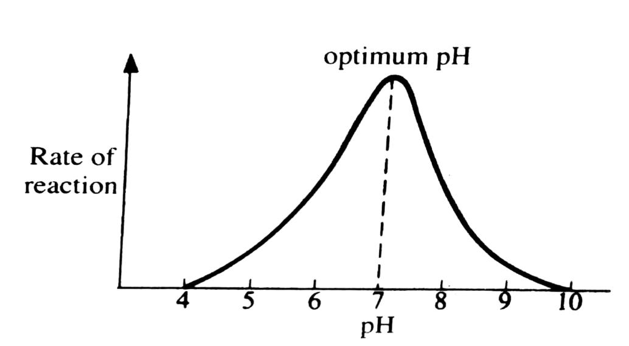
The effect of pH on the activity of three enzymes
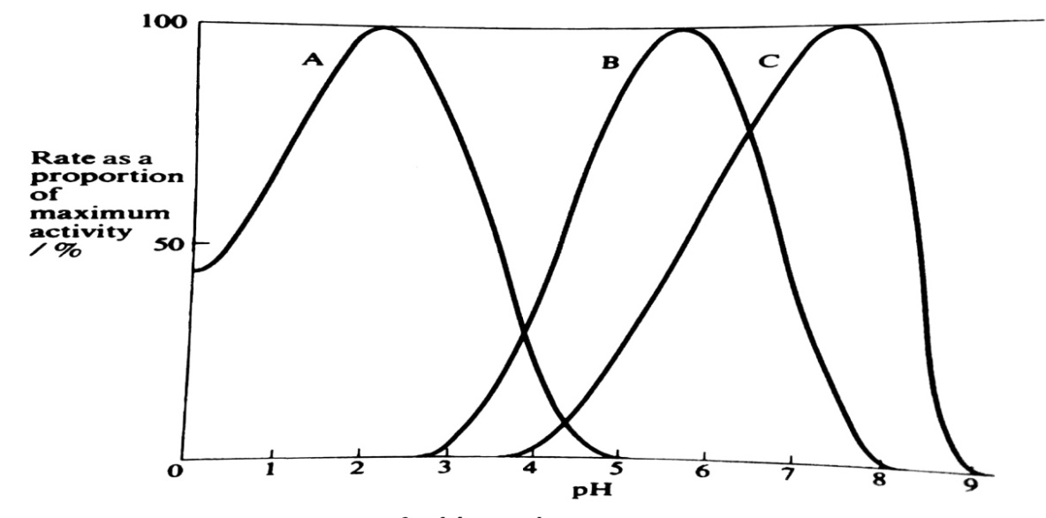
From the above graph, we can tell that enzymes A and C prefer acidic and alkaline pH respectively while B prefers almost neutral conditions. This is because their peaks (maximum activity) correspond to pH falling in their media.
COMPARISON BETWEEN ORGANIC AND INORGANIC CATALYSTS
- Enzymes are more efficient in lowering the activation energy than the inorganic catalysts. For example, in breaking of hydrogen peroxide to form oxygen and water.
H₂O₂ O₂ + H₂O
H₂O₂ O₂ + H₂O
H₂O₂ O₂ + H₂O
Catalyst | Activation energy | Relative rate of reaction (number of molecules of substrate formed per minute)
Catalase | 2000 | 6000000, very high
Platinum | 12000 | 10000, high
No catalyst | 18000 | 1, very low

- Enzymes are less stable ie they can easily be denatured in the course of reaction.
- Enzymes are more substrate specific.
- Enzymes are protein in nature.
- Enzymes are produced by living cells.
- Enzymes catalyse reversible reactions.
CLASSIFICATION OF ENZYMES
Enzymes are broadly classified into two major categories.
- Those which are produced in the cell but carry out their catalytic activity outside the cell, these are known as extracellular enzymes eg digestive enzymes like lipase, pepsin, trypsin.
- Those produced in the cell and catalyse reactions within the cell are known as intracellular enzymes eg catalase, peroxidise, ATPase, dehydrogenase.
The above mentioned classification is followed by a more definitive naming.
- Random naming eg ptylin, pepsin, rennin.
- By attaching a suffix ‘ase’ to the name of the substrate to be acted upon eg.
- Lipid lipase
- Maltose maltase
- Sucrose sucrase
- Peptide peptidase
Classification according to the type of reaction catalysed
There are six groups of enzymes recommended by the International Union of Biochemistry (IUB).
- Hydrolases
These enzymes catalyse reactions in which substrates are hydrolysed into simpler products. During hydrolysis, hydrogen atoms from water enter one of the products while the hydroxyl groups end up in the other product as shown below.
AB + HOH AH + BOH
Substrate water products
Examples include lipase, amylase, peptidase.
- Oxido-reductases (oxidation-reduction enzymes)
These catalyse reactions involving oxidation of substrates. They include the following categories.
- Dehydrogenases- these catalyse reactions involving transfer of hydrogen atoms from a substrate to a hydrogen acceptor eg NAD (nicotinamide adenine dinucleotide).
- Oxidases- These catalyse the transfer of hydrogen atoms to molecules of oxygen eg cytochrome oxidase enzyme which catalyses the transfer of hydrogen atoms to oxygen to form water during respiration.
- Peroxidases- Act on hydrogen peroxide or organic peroxides in the presence of a substrate which acts as an oxygen acceptor. Peroxidase enzymes are mostly found in the mammalian tissues eg liver and spleen. They also occur in higher plants eg irish potatoes.
- Catalase- It occurs in aerobic tissues to catalyse the breakdown of hydrogen peroxide into water and oxygen as the accumulation of hydrogen peroxide above a certain level is toxic to the protoplasm. Unlike for peroxidase, there is no oxygen acceptor.
- Transferases
These catalyse the transfer of a chemical group from one molecule to another. Examples include
- Transaminase- it catalyses the transfer of amino groups.
- Phosphorylase- it catalyses the transfer of phosphate groups.
- Lyases
These catalyse addition or removal of a chemical group without use of water. Eg
- Decarboxylase, catalyses the removal of carbon dioxide from a substrate.
- Carboxylases catalyse the addition of carbon dioxide to a substrate.
- Isomerases
They convert one isomer of a compound to another isomer of the same compound. Isomerases are involved in the conversion of sugar isomers in glycolysis.
- Ligases
These catalyse reactions in which new chemical bonds between two molecules are formed using energy from the hydrolysis of ATP. Examples are synthatases.
THE PRECURSOR/PROENZYME
The name of a proenzyme ends with a suffix ‘ogen’ eg pepsinogen, trypsinogen. In such a state, the enzyme is inactive. Trypsinogen becomes active trypsin when activated by enterokinase, pepsinogen is activated by a proton from hydrochloric acid to pepsin. It is necessary to be a precursor before reaching their destiny so that they do not digest organ cells.
ENZYME COFACTORS
A cofactor is a non protein substance which is essential for some enzymes to function efficiently. A cofactor is attached to the enzyme to form an enzyme-cofactor complex known as holoenzyme. An enzyme without its cofactor is known as apoenzyme.
Illustration
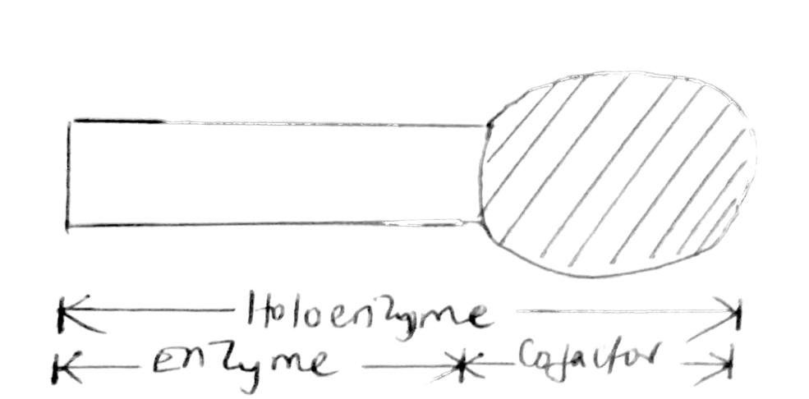
There are three types of cofactors which include; activators, coenzymes and prosthetic groups.
Activators
These are substances necessary for the functioning of certain enzymes eg the enzyme thrombokinase which converts prothrombin to thrombin during blood clotting is activated by calcium ion. In the same way, salivary amylase requires the presence of chloride ions before it will sufficiently convert starch to maltose.
Coenzymes
Coenzymes are non protein organic substances which are essential for the efficient functioning of some enzymes but are not themselves bound to the enzyme. Many coenzymes are derived from vitamins eg NAD is derived from nicotinic acid, a member of vitamin B complex. NAD acts as a coenzyme to dehydrogenases by acting as a hydrogen acceptor.
Prosthetic groups
Like coenzymes, prosthetic groups are organic molecules, but unlike coenzymes, they are bound to the enzyme itself. An example of a prosthetic group is the haem group. Haem is a ring shaped organic molecule with iron at its centre. Apart from its role as an oxygen carrier in haemoglobin, it is also the prosthetic group of the electron carrier cytochrome and of the enzyme catalase.
INHIBITION
The rate of enzyme controlled reactions may be inhibited by presence of inhibitors. There are two types ie reversible and non reversible inhibitors.
Reversible inhibitors
The effect of this type of inhibitor is temporary and causes no permanent damage to the enzyme because the association of the inhibitor with the enzyme is a lose one and it can easily be removed. Removal of the inhibitor restores the activity of the enzyme to normal. There are two types ie competitive inhibitors and non competitive inhibitors.
Competitive inhibition
In this type of inhibition, the inhibitor is closely related to the substrate in both chemical composition and molecular structure ie the inhibitor has the same shape with the substrate. The inhibitor competes with the substrate for the active sites of the enzyme thereby preventing the substrate molecule from occupying the active site and so reduce the rate of reaction.
An example of this inhibition is seen in cellular respiration where the enzyme succinate dehydrogenase that catalyses the oxidation of succinate to fumerate is competitively inhibited by malonate which is similar in both shape and chemical structure.
The degree of inhibition depends on the relative concentration of both the inhibitor and the substrate molecule. The greater the concentration of the inhibitor, the greater the intensity of the inhibition and vice versa. This type of inhibition can be reduced by increasing the substrate concentration.
Non competitive inhibition
Here, the inhibitors attach themselves not to the active site of the enzyme but elsewhere on the enzyme molecule. They alter the shape of the enzyme molecule in such a way that the active site can no longer properly accommodate the substrate (the substrate no longer fits in the active sites of the enzyme).
In this type of inhibition, increasing substrate concentration will not reduce the degree of inhibition. An example of a non competitive inhibitor is cyanide. It attaches itself to the copper prosthetic group of cytochrome oxidase, thereby inhibiting respiration.
Non-reversible inhibitors
These inhibitors leave the enzyme permanently damaged and so unable to carry out its catalytic activity. Heavy metal ions such as mercury (Hg⁺) and silver (Ag⁺) cause disulphide bonds to break. These bonds maintain the shape of the enzyme molecule.
Once broken, the enzyme’s molecular structure becomes irreversibly altered with the permanent loss of its catalytic properties.
CONTROL OF METABOLIC PATHWAYS
In metabolic pathways, successive enzymes lead to formation of an important metabolite (end product). Cells make use of enzymes’ own properties to exercise control over metabolic pathways. The end product of the pathway may inhibit the enzyme at the start (end product inhibition).
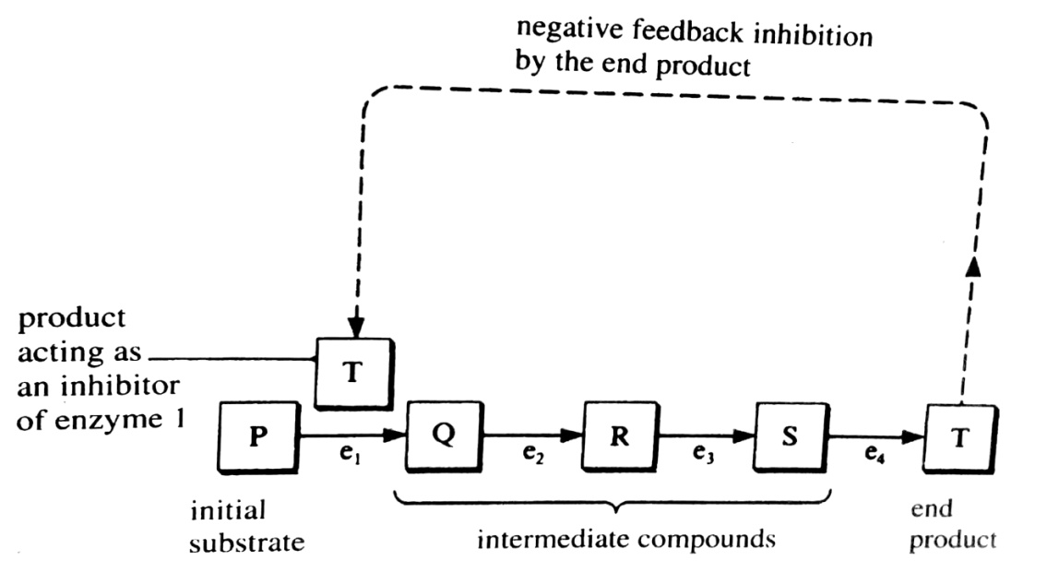
In the above example, the product E acts as inhibitor to enzyme a. If the level of the product E falls, this inhibition is removed/reduced and so more A is converted to B and subsequently more E is produced.
If the level of E rises above normal, inhibition of the enzyme a by the end product E increases and so the level of the product E is reduced.
ALLOSTERIC ENZYMES
Most enzymes which are regulated by end product inhibition are of the so called allosteric type. The word allosteric means ‘different shapes’ and it is characteristic of such enzymes that can exist in two different forms, one active and the other inactive.
The inactive form of the enzyme is shaped in such a way that the substrate will not fit into the active site. For the enzyme to work, it must be transformed into the active form, and this involves changing its shape so that the substrate will fit into the active site.
Allosteric enzymes can be inhibited by certain molecules which combine, not with the active site but with some other part of the enzyme (allosteric site). The inhibitor prevents the enzyme from changing into its active form. Substances which have this effect are known as allosteric inhibitors.
Other substances are known to combine with allosteric enzymes in such a way that they react more readily with their substrates.
Importance of enzyme inhibition
- Inhibition controls enzyme activity.
- Balances stimulation of a process in organisms e.g. in muscle contraction, the impulse will be accompanied by one to prevent muscle contraction of its antagonistic one.
- Regulates metabolism e.g. in allosteric enzymes where enzymes exist in different shapes.
- Helps in drug action in humans; e.g. antibiotics and sulphonamides are competitive inhibitors.
- Applied in respiratory poisons e.g, cyanides.
- Works by inactivating the enzyme cytochrome oxidase.
a) Explain why enzymes are essential in biotic systems? (4 marks)
- They are bio-catalysts, therefore, they increase biotic systems.
- They are highly specific biological catalysts therefore target specific reactions; which greatly speed up chemical reactions which otherwise be very slow;
- Provide a mechanism whereby individual chemical reactions can be controlled.
- Enzymes work reversibly, therefore are important in feedback mechanisms.
b) Giving examples, describe how control of enzyme activity in cells is achieved. (16 marks)
- Through enzyme cofactors which include coenzymes; activators; and prosthetic groups; for example, salivary amylase requires chloride ions; as activators thromboplastin requires calcium ions as activators dehydrogenases involved in respiratory reactions require NAD; as a coenzyme haemoglobin requires the haem group; as a prosthetic group
- Through genetic control; where the genes contained in the nucleus determine which enzymes are to be synthesised; and therefore determine the limits of the cell metabolising; accept any enzyme.
- End product inhibition; where the final product of a sequence of reactions inhibits the first enzyme; in the metabolic pathway if in excess and removes the inhibition if in short supply; by binding and unbinding at the allosteric site of the enzyme; respectively. For example ATPase enzyme is controlled by amount of ATP;
- Spatial arrangement; where enzymes control a series of chemical reactions in metabolic pathways; as in the mitochondrial and chloroplast membrane; in such an arrangement, the products are transferred to the enzyme catalysing the next reaction/step; eg RUBP carboxylase; PEP carboxylase, ATPases, etc
- Enclosing the enzymes inside small membrane bound structures called lysosomes; for potentially damaging enzymes that have to remain in the cell to prevent cell damage; lytic enzymes.
- Contain an inactive form; for those enzymes that are potentially damaging; if they are secreted in active form. For example; pepsinogen is secreted as pepsinogen which is activated by HCl in the stomach walls; protected from pepsin by mucus lining;
@ 1 mark, maximum 16 marks
NUCLEIC ACIDS
These are organic molecules whose role is to regulate cell Activities that is to say they are carriers of genetic information and they were first discovered by Ostwald in 1944. The main types of nucleic acids are deoxyribonucleic acid (DNA) and ribonucleic acid (RNA) . DNA is mainly found in the nucleus whereas RNA is found mainly but not exclusively in the cytoplasm. Other nucleic acids include AMP, ADP, ATP, NAD, FAD, NADP and coenzymes.
THE DNA STRUCTURE
The description of the double helical structure of DNA was first done by Watson and Crick in 1953. DNA is a double strand of polynucleotide chains; each strand has a helical (spiral) shape, so DNA forms a double helix.
Each DNA strand is a polymer made up of nucleotide subunits which join together to form a long unbranched polynucleotide chain. Each nucleotide consists of deoxyribose, a pentose sugar, an organic nitrogen containing base and phosphoric acid.
The sugar and organic base join together by a condensation reaction to form a nucleoside. Another condensation reaction joins the nucleoside with phosphoric acid to form a nucleotide. This bond between carbon 5 of the sugar and a phosphate is called a phosphoester bond.
The organic bases present in DNA are either purines or pyrimidines. Purines have a double ring structure comprising a six sided and a five sided ring. Purines are guanine (G) and adenine (A). Pyrimidines have a single ring structure which is six sided. The pyrimidines include cytosine (C) and thymine (T).
The nucleotides are joined together by a phosphodiester bond which can be repeated to form a polynucleotide chain. Each chain has two distinct ends, a 3’ end and a 5’ end. The polynucleotide chains run in opposite directions and are joined by pairs of bases. The bases are held together by hydrogen bonds between hydrogen atoms of a base in one chain and oxygen or nitrogen atoms of a base on the other chain.
Illustration of formation of a nucleotide
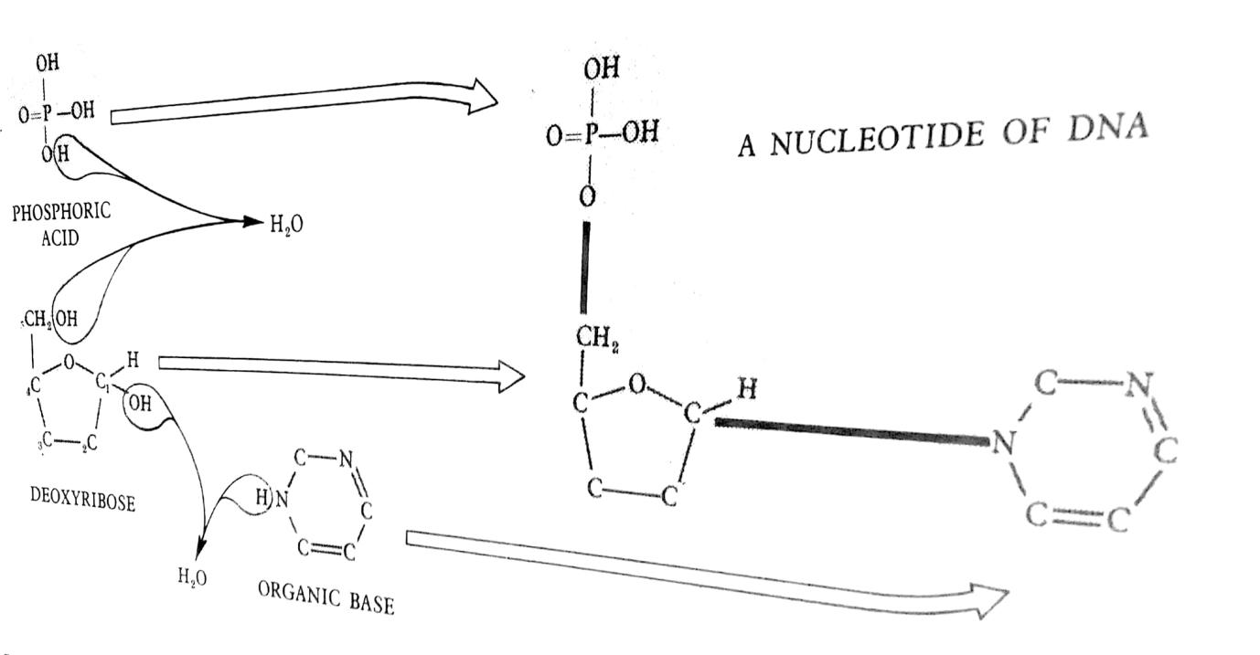
DNA consists of two polynucleotide chains coiled around each other to form a double helix. The double helix is held together by hydrogen bonds between pairs of bases in the two chains.
The pairing depends on the shape of the bases whereby a purine can only pair with a pyrimidine and depending on the ability of the bases to form hydrogen bonds. Adenine, a purine pairs with thymine, a pyrimidine forming two hydrogen bonds ie A = T. Guanine, a purine pairs with cytosine, a pyrimidine forming three hydrogen bonds.
COMPLEMENTARY BASE PAIRING IN THE DOUBLE HELIX
Complementary base pairs are the only ways the bases can bond and join the two polynucleotide chains. Thus the sequence of bases along one polynucleotide chain determines the sequence along the other ie adenine on one chain means that there must be a thymine on the other chain at that point and so on.
Complementary base pairing forms a basis of DNA replication and its ability to form messenger RNA during protein synthesis. Complementary base pairing can only happen if the two polynucleotide chains are ant parallel. Anti parallel chains run in opposite direction whereby one chain runs from 3’ – 5’ and the other runs from 5’- 3’.
The two polynucleotide chains twist to form a double helix cross liked at regular intervals whereby one complete turn of the double helix is 3.4nm and has 10 pairs of nucleotides.
Illustration of the double helix
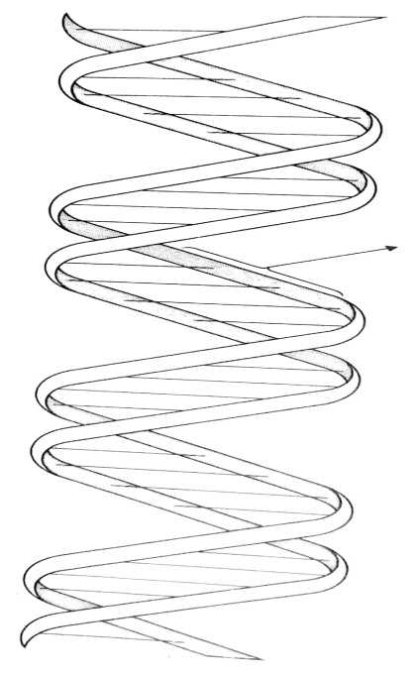
Illustration of the a short length of the double helix
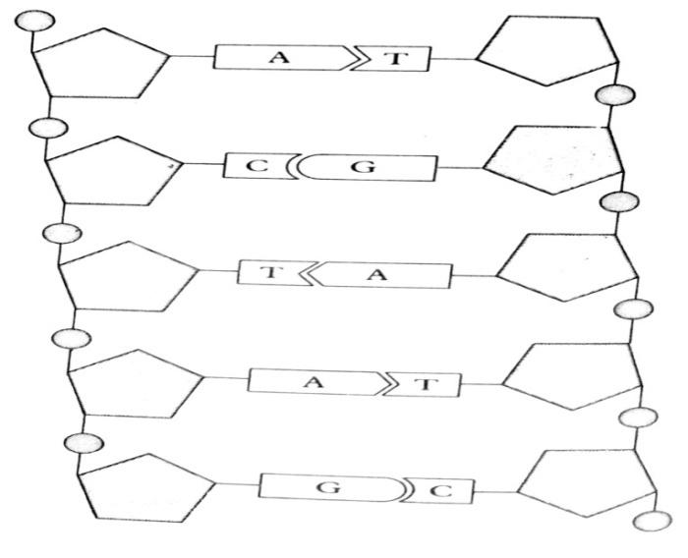
DNA REPLICATION (DNA DUPLICATION)
This is the process by which DNA makes exact copies of itself which is controlled by the enzymes helicase, DNA polymerase and DNA ligase. DNA replication involves the following steps.
The hydrogen bonds between the complementary bases of the two strands of the parent DNA molecule break. The breaking of the double helix is controlled by the enzyme helicase.
The two strands unwind/unzip, each strand acting as a template for the synthesis of a new strand, complementary to itself.
DNA polymerase enzyme moves down the two strands linking free nucleotides in the nucleoplasm to their complementary bases on the templates. Each time DNA polymerase meets the next base on the DNA template, free nucleotides approach the DNA strand, and the one with the correct complementary base hydrogen bonds to the base in the DNA. Thus adenine bonds with thymine and cytosine bonds with guanine.
The free nucleotide is then held in place by the enzyme until it binds with the preceding nucleotide, thus extending the new strand. The enzyme continues to move along one base at a time with new DNA strands growing until all the nucleotides on the templates have joined with appropriate free nucleotides and the two identical daughter molecules of DNA are formed.
The movement of DNA polymerase is 5’ to 3’ direction and an enzyme DNA ligase closes the gaps left by joining the 3’ end to the 5’ end.
Two molecules of DNA identical to each other and which are replicas of the original copy are formed and this is called the semi conservative hypothesis. This is because half of the original parent molecule is conserved in each of the new strands produced. This is important because the cell can provide identical copies of all its genetic instructions to be passed onto daughter cells during cell division.
Illustration of DNA replication
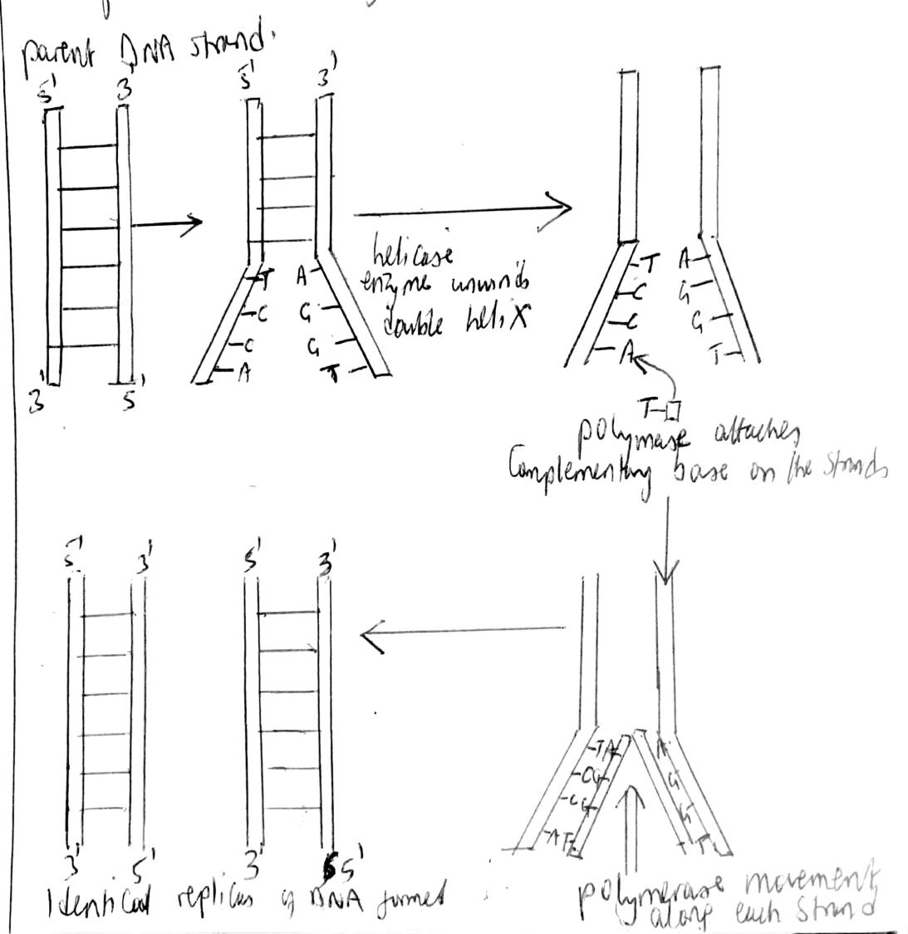
THE RIBONUCLEIC ACID (RNA)
RNA usually consists of a single polynucleotide chain that forms an alpha helix. The pentose sugar in the RNA molecule is a ribose sugar rather than deoxyribose that occurs in the DNA.
RNA nucleotides contain four types of bases adenine (A), guanine (G), cytosine (C) and uracil (U) which replaces thymine of DNA. There are several types of RNA which include: messenger RNA (mRNA), transfer RNA (tRNA), and ribosomal RNA (rRNA). Each differs in length and shape but all share the same basic structure.
Messenger RNA (mRNA)
Messenger RNA molecules are mobile templates of the protein coding part of the cistron. mRNA is a long single stranded molecule of up to 1000 of nucleotides which is formed into a helix.
It is manufactured in the nucleus. It is a mirror copy of part of one strand of the DNA helix. Messenger RNA is dispatched out of the nucleus after its synthesis through the nuclear pores into the cytoplasm. mRNA associates with ribosomes to form a polysome or polyribosome which directs protein synthesis.
Transfer RNA (tRNA)
Transfer RNA molecules transport specific amino acids to the polysome (ribosome on mRNA) during protein synthesis. There are 20 groups of tRNA, each specific for one kind of amino acid. They all have the same basic structure.
Transfer RNA molecules are 70 – 90 bases long. They have a ‘clover’ leaf structure. They consist of four major arms with an optional arm giving a total of 5 arms.
- The first arm (anticodon arm- It contains a sequence of three bases known as the anticodon and these are complementary to the bases on the mRNA. It is these bases on the mRNA which specify the amino acids.
- The acceptor arm- The amino acid to be transferred to the ribosome so that it is linked to the polypeptide chain or initiate translation is attached to the acceptor arm. The acceptor arm has the base sequence CCA.
- Third arm (pseudo uracil)- It contains a pseudo uracil surrounded by thymine and cytosine (T...C). it is at this arm that the tRNA binds with the ribosome.
- Dihydrouracil arm (DH...)/D- loop- It contains an unusual base dihydrouracil. This arm binds with the enzyme during translation.
- Optional arm- It is also known as the extra arm or variable arm. In some species, it is longer and in others, it is short.
Illustration of transfer RNA structure
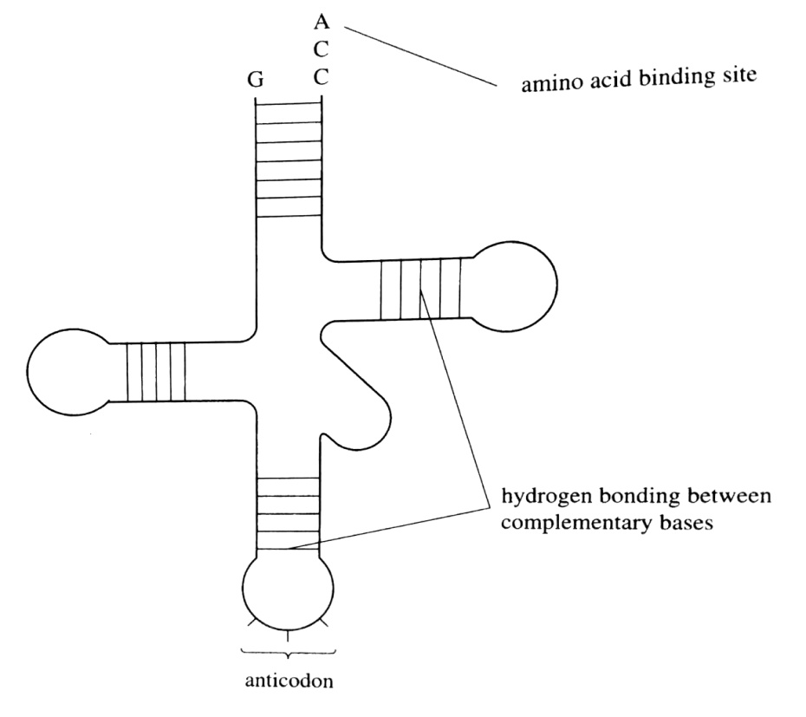
Ribosomal RNA (rRNA)
It consists of many nucleotides wound into a complex structure consisting of partly single and double helices. It is made in the nucleus under the control of the nucleolus. After being synthesised, rRNA moves to the cytoplasm where it binds with the protein molecules to become ribosomes. Over 80% of RNA consists of rRNA in the cell.

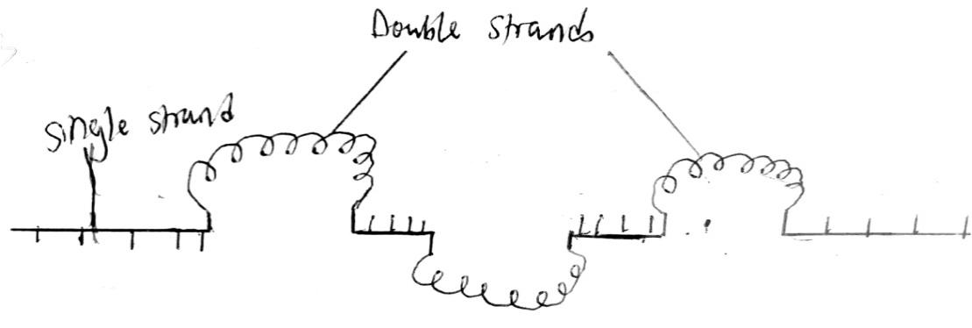
GENE
A gene is a segment of DNA that specifies the structure of a protein during protein synthesis. Thus a gene is a unit of heredity composed of DNA or it is a discrete particle forming part of a chromosome that determines a particular characteristic.
Differences between DNA and RNA
RNA | DNA
It is a single polynucleotide chain. | It is a double polynucleotide chain.
It has a smaller molecular mass ranging between 200000 – 2000000. | It has a larger molecular mass from 100000 to 150million.
It may be single or double helix. | It is always a double helix.
The pentose sugar is ribose. | The pentose sugar is deoxyribose.
Organic bases present are adenine, guanine, cytosine and uracil. | Organic bases present are adenine, guanine, cytosine and thymine.
RNA is manufactured in the nucleus but found throughout the cell. | DNA is found entirely in the nucleus.
RNA is chemically less stable. | DNA is chemically very stable
The ratio of adenine and uracil to cytosine and guanine varies. | The ratio of adenine and guanine to cytosine and guanine is one.
The amount of RNA varies from cell to cell in an organism and within a cell according to metabolic activity. | The amount of DNA is constant for all cells of a species except gametes and spores.
RNA may temporarily exist for short periods. | DNA exists permanently throughout the organism’s life.
There are three basic forms of RNA which include mRNA, tRNA, and rRNA. | Only one basic form of DNA exists but with an almost infinite variety within that form.

THE GENETIC CODE
All cells in an organism contain all the information required to determine the characteristics of that whole organism. This information is stored in DNA and it is known as the genetic code.
The genetic code is a means by which the genetic information in DNA controls the manufacture of specific proteins by the cell. The code takes the form of a series of triplets of bases in DNA from which it is transcribed a complementary sequence of codons in the mRNA. The sequence of these codons determines the sequence of amino acids during protein synthesis.
The genetic code is held in the order of bases along the DNA molecule. Sections of DNA called cistrons (commonly referred to as genes) contain the information needed to make a particular polypeptide.
When the DNA in the cistron is activated, the information is transferred to a molecule of messenger RNA which acts as a template for the synthesis of the polypeptide. A template is any molecule that acts as a pattern for the synthesis of anew molecule.
During transcription of protein synthesis, DNA acts as a template for making mRNA by complementary base pairing. Thus a short sequence of DNA may be transcribed as follows:
DNA base sequence: TAGGCTTGAT
mRNA base sequence: AUCCGAACUA
A triplet of nucleotides within a molecule of mRNA functions as a unit of genetic coding usually by specifying a particular amino acid during the synthesis of proteins; and this is called a codon.
NB: A codon is a triplet of bases represented in the mRNA that specify a particular amino acid.
An anticodon is a group of three bases next to each other on the transfer RNA molecule that pairs with a complementary codon of 3 bases on the messenger RNA molecule.
Features of the genetic code
- The code is a triplet code of three nucleotides in which each of the 20 amino acids used to make proteins is represented by a three letter abbreviation (a base triplet).
- The code is linear reading from a starting 5’ end to a finishing 3’ end point directions.
- The code is degenerate ie there are more codons than the amino acids, and as such, most of the amino acids are coded for by more than one codon. For example CCA, CCC, CCG and CCT all code for the same amino acid proline. The first two bases of the code are more important than the third base in specifying a particular amino acid.
NB: There are 64 possible codons out of the combination of four bases (4³) and there are 20 amino acids present in proteins in all living organisms.
- The start and end of the coding sequence in a cistron is determined by specific codons. Thus the genetic code is punctuated by the start codon which is AUG for methionine amino acid; and the three stop codons which are UAA, UAG and UGA.
NB: The stop codons cannot code for any amino acid and therefore there are no anticodons that complements them.
- The code is universal in that the same triplets code for the same amino acids in all organisms.
- The genetic code is non-overlapping in which each triplet in DNA specifies one amino acid and each base is part of only one triplet and therefore involved in specifying only one amino acid.
Table of genetic code showing the base sequences of the triplet code in mRNA and the amino acids for which they code
 | Second base in codon
First base in codon | U | C | A | G | Third base in the codon
U | UUU - Phe | UCU – Ser | UAU – Try | UGU - Cys | U
U | UUC - Phe | UCC – Ser | UAC – Try | UGC - Cys | C
U | UUA - Leu | UCA – Ser | UAA - Stop | UGA - Stop | A
U | UUG - Leu | UCG – Ser | UAG – Stop | UGG –Trp | G
C | CUU - Leu | CCU – Pro | CAU – His | CGU - Arg | U
C | CUC - Leu | CCC – Pro | CAC – His | CGC - Arg | C
C | CUA - Leu | CCA – Pro | CAA – Gln | CGA - Arg | A
C | CUG - Leu | CCG – Pro | CAG – Gln | CGG - Arg | G
A | AUU - Ileu | ACU – Thr | AAU – Asn | AGU - Ser | U
A | AUC - Ileu | ACC – Thr | AAC – Asn | AGC - Ser | C
A | AUA - Ileu | ACA – Thr | AAA – Lys | AGA - Arg | A
A | AUG - Met | ACG – Thr | AAG – Lys | AGG - Arg | G
G | GUU - Val | GCU – Ala | GAU – Asp | GGU- Gly | U
G | GUC - Val | GCC – Ala | GAC – Asp | GGC - Gly | C
G | GUA - Val | GCA – Ala | GAA – Glu | GGA - Gly | A
G | GUG - Val | GCG – Ala | GAG – Glu | GGG - Gly | G

Ala – Alanine Leu – Leucine
Arg – Arginine Lys – Lysine
Asn – Asparagine Met – Methionine
Asp – Aspartic acid Phe – Phenylamine
Cys – Cysteine Pro – Proline
Gln – Glutamine Ser – Serine
Glu – Glutamic acid Thr – Threonine
Gly – Glycine Trp – Tryptophan
His – Histidine Val – Valine
Ile – Isoleucine Try – Tyrosine
CENTRAL DOGMA OF MOLECLAR BIOLOGY
The relationship between DNA, mRNA and polypeptides in eukaryotic cells is called the central dogma of molecular biology, which states that: “The genetic information is transferred from DNA to DNA during transmission from generation to generation and from DNA to RNA for protein phenotypic expression in an organism”.
Thus mRNA is made is made on a DNA template in the nucleus in a process called transcription. The mRNA then moves into the cytoplasm where it combines with ribosomes to direct protein synthesis in a process called translation.
When the information in a cistron is used to make a functional polypeptide chain by transcription and translation, then gene expression (phenotypic expression) is said to have taken place.
PROTEIN SYNTHESIS
This is the process by which living cells manufacture proteins from their constituent amino acids in accordance with the genetic information carried in the DNA of the chromosomes. This information is encoded in the mRNA which is transcribed from DNA in the nucleus of the cell.
The sequence of amino acids in a particular protein is determined by the sequence of nucleotides in mRNA. At the ribosomes, the information carried by mRNA is translated into the sequence of amino acids of the protein in a process called translation.
DNA instructs protein synthesis on the basis of one gene one polypeptide hypothesis which states that each gene is responsible for the synthesis of a single polypeptide.
The process generally involves two stages including transcription and translation.
TRANSCRIPTION
This is the process by which a complementary mRNA copy is made from the specific region of DNA molecule which codes for a specific polypeptide. Transcription involves a specific region of DNA molecule called cistron unwinding, by which hydrogen bonds holding the double helix together are broken by the enzyme helicase, exposing the bases in the transcribing strand.
RNA polymerase enzyme attaches to the transcribing strand at a particular base sequence called the promoter site, initiating transcription.
RNA polymerase moves along the transcribing DNA strand adding one complementary RNA nucleotide at a time to the newly unwound portion of DNA in the direction of 5’ to 3’.
When the enzyme moves onto another region of the transcribing DNA strand, the double helix of DNA reforms behind it; thus DNA acts as a template against which mRNA is constructed.
On reaching a specific stop sequence called terminator, the enzyme detaches and the mRNA molecule peels away from the DNA.
Introns (a sequence of nucleotides between the cistrons which do not code for amino acids) are removed, and the remaining sections of mRNA called exons (sections of nucleotides that code for amino acids) are spliced together to form the final strand of mRNA. The mRNA molecule leaves the nucleus through the nuclear pores into the cytoplasm.
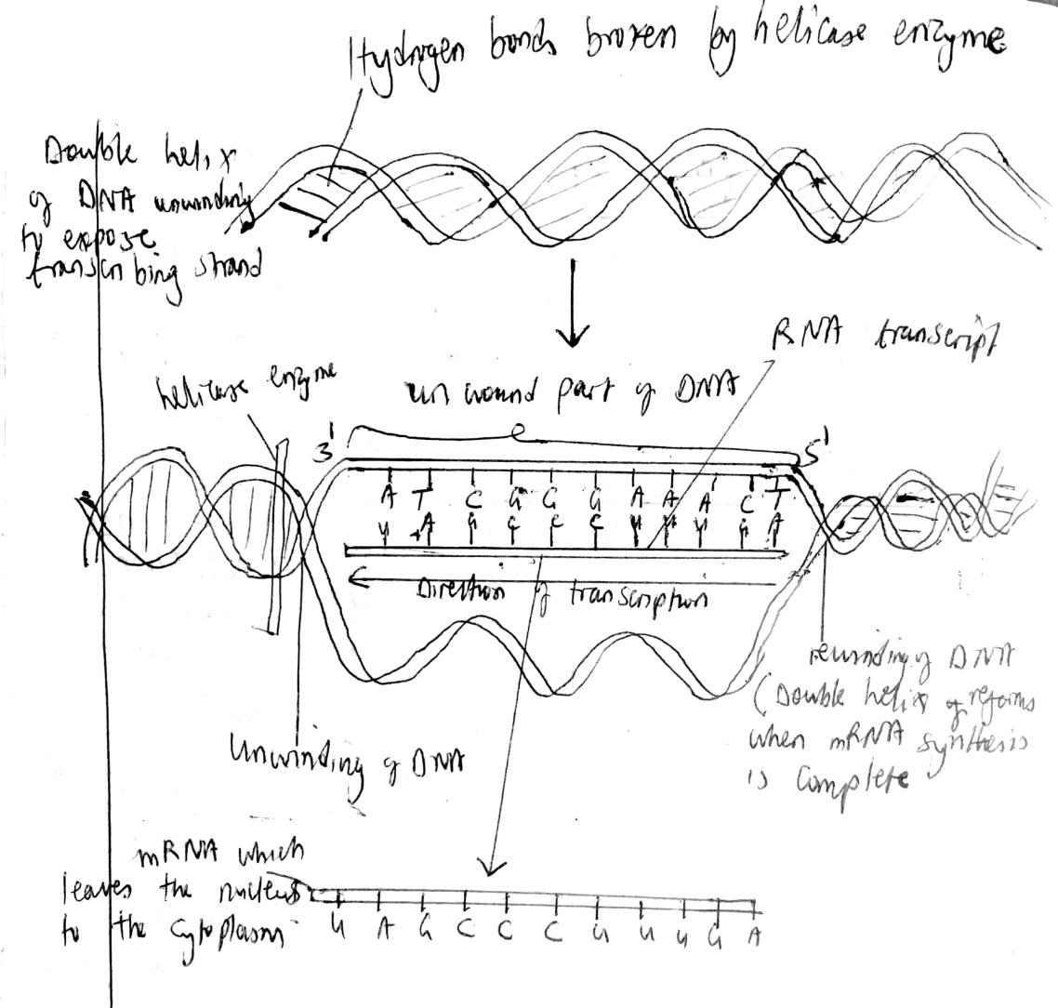
TRANSLATION
This is the process by which information encoded within the mRNA is used to make a specific polypeptide chain in the cytoplasm. a group of ribosomes become attached to mRNA to form a structure called a polyribosome or polysome.
Each ribosome has two tRNA binding sites ie the decoding site A (aminoacyl site) and the condensing site P (Peptidyl site). A site binds the incoming tRNA amino acid complex, and the P site binds to the tRNA to which the growing polypeptide is attached.
Translation process consists of the following steps
- Activation of amino acids.
- Transfer of activated amino acids to tRNAs.
- Initiation of polypeptide chain synthesis.
- Elongation of polypeptide chain.
- Termination of polypeptide chain.
The amino acids in the cytoplasm are activated by ATP in the presence of aminoacyl tRNA synthatase enzyme making them collide with specific tRNA molecules to form tRNA amino acid complexes called aminoacyl tRNA.
The complementary anticodon of a tRNA amino acid complex is attracted to the first codon of mRNA to initiate polypeptide chain synthesis. The start codon on mRNA is always AUG, so tRNA with anticodon UAC enters the A site carrying amino acid methionine which in many cases does not remain permanent part of the finished protein.
The second on mRNA likewise attracts its complementary anticodon on the second tRNA amino acid complex. When the second codon attracts the second tRNA amino acid complex, the methionine tRNA complex is moved and bound to the P site making the A site available for the second tRNA. This is known as translocation.
Translocation involves movement of tRNA molecules from the A to P sites and movement of the mRNA exactly three nucleotides or movement of the position of ribosomes so that the codon formerly located in the A site moves to the P site.
A peptide bond is then formed between methionine and the second amino acid, a reaction catalysed by peptidyl transferase or synthatase enzyme forming a dipeptide which detouches from tRNA₁ but remaining attached to tRNA₂ carrying the dipeptide.
tRNA₁ is released into the cytoplasm and tRNA₂ carrying the dipeptide moves shifts from the A site to the P site leaving the A site available for the third tRNA amino acid complex. A peptide bond is again formed between the dipeptide and the third amino acid to form a tripeptide and tRNA₂ is then released into the cytoplasm.
The process occurs until the termination codon or stop codon is reached, and the process is terminated with the polypeptide chain released in the cytoplasm to perform a functional role in the metabolism. The stop codons are always UAA, UAG and UGA.
The polypeptide formed undergoes several modifications in which the amino acid methionine is removed and the polypeptide processed further to achieve its native biological structure forming either a primary structure, secondary structure, tertiary structure, tertiary structure or quaternary structure.
NB: Animals usually obtain their amino acids from the food they ingest, although they have some capacity to synthesise their own non essential amino acids.
In plants, the formation of amino acids occurs in the mitochondria and chloroplasts in a series of stages:
- Absorption of nitrates from the soil.
- Reduction of these nitrates to the amino group (NH₂)
- Combination of these amino groups with a carbohydrate skeleton eg α-ketoglutarate from the Kreb’s cycle).
- Transfer of the amino groups from one carbohydrate skeleton to another by a process called transamination. In this way, all the 20 amino acids can be formed.

