NAME INDEX NUMBER
SCHOOL DATE

THE CELL
1. 1995 Q2 P1

Name the organelle that performs each of the following functions in a cell
(2 marks)
Proteins synthesis

…………………………………………………………………………………………..
Transport of cell secretions

………………………………………………………………………………………………….

2. 1996 Q8 P1
State two functions of cell sap (2 marks)

……………………………………………………………………………………………………………………………………………………………………………………

3. 1997 Q1 P1
State the functions of the following cell organelles
  - Golgi apparatus

…………………………………………………………………………………………
  - Ribosomes

………………………………………………………………………………………….

4. 1998 Q3 P1
Which organelle would be abundant in:
Skeletal muscle cell

………………………………………………………………………………………..
Palisade cell

…………………………………………………………………………………….

5. 2001 Q7 P1
Name the organelle in which protein synthesis takes place

…………………………………………………………………………………………………..

6. 2004 Q7 P1
State the function of the organelles:
  - Lysosomes (1 marks)

…………………………………………………………………………………………..

  - Golgi apparatus (2 marks)

………………………………………………………………………………………..
7. 2005 Q2 P1
The diagram below represents a cell.
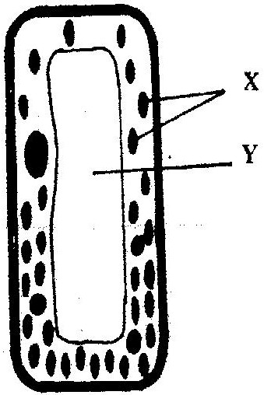

(a) Name the parts labelled X and Y (2 marks)

X………………………………………………………………………………
Y………………………………………………………………………………
(b) Suggest why the structures labelled X would be more on one side than the other. (1 mark)
……………………………………………………………………………………………………………………………………………………………………
8. 2006 Q1 P1
a) State the functions of cristae in mitochondria.

…………………………………………………………………………………

b) The diagram below represents a cell organelle.
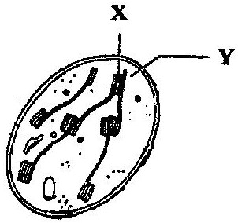

(i) Name the part labelled Y. (1 mark)

………………………………………………………………………………………….
(ii) State the functions of the part labelled X. (1 mark)

…………………………………………………………………………………………

9. 2007 Q2 P1
(a) What is the formula for calculating linear magnification of a specimen when
using a hand lens? (1 mark)

…………………………………………………………………………………………
(b) Give a reason why staining is necessary when preparing specimens for
observation under the microscope (1 mark)

……………………………………………………………………………………………………………………………………………………………………
10. 2007 Q4 P1
State three functions of Golgi apparatus (3 marks)

………………………………………………………………………………………………………………………………………………………………………………………………………………………………………………………………………………………………………

11. 2008 Q12 P1
State two functions of the endoplasmic reticulum (2 marks)

……………………………………………………………………………………………………………………………………………………………………………………………………

12. 2009 Q3 P1
State the functions of the following parts of a light microscope (2 marks)
  - Objective lens

………………………………………………………………………………………………………………………………………………………………………… Diaphragm
……………………………………………………………………………………………………………………………………………………………………
13. 2009 Q7 P1
State the function of the following cell organelles
- Ribosome (1 mark)

…………………………………………………………………………………
- Lysosomes (1 mark)

………………………………………………………………………………………………………………………………………………………………………………………………………………………………………………………………………………
14. 2009 Q15 P1
Name the type of movement that occurs within a plant cell (1 mark)

………………………………………………………………………………………
15. 2009 Q26 P1
How are the mitochondria adapted to their functions? (2 marks)

…………………………………………………………………………………………………

16. 2010 Q3 P1
State the function of:
- Ribosomes (1 mark)

…………………………………………………………………………………………
- Lysosomes (1 mark)

……………………………………………………………………………………….

17. 2010 Q9 P1
State two ways in which chloroplasts are adapted to their functions. (2 marks)

……………………………………………………………………………………………………………………………………………………………………………………
18. 2011 Q11 P1
State the functions of the following parts of a light microscope.
Fine adjustment knob.

……………………………………………………………………………………………………………………………………………………………………
Stage (2 marks)

……………………………………………………………………………………………………………………………………………………………………………………

19. 2011 Q15 P1
Give reasons for carrying out the following procedures when preparing temporary wet
mounts of plant tissues.
a) Making thin plant sections (1 mark)

…………………………………………………………………………………

b) Adding water on the plant section. (1 mark)

…………………………………………………………………………………..

c) Placing a cover slip over the plant section. (1 mark)

………………………………………………………………………………………….

20. 2012 Q3 P1
The figure below is a fine structure of a generalised animal cell as seen under an electron microscope.

- Name the parts labelled A and B (2 marks)
A…………………………………………………………………………….

B…………………………………………………………………………….

- How is the structure labelled B adapted to its functions (2 marks)
………………………………………………………………………………………………………………………………………………………………………………

21. 2012 Q12 P1
(a) Name the part of a light microscope used to bring an image of a specimen into sharp
focus. (1 mark)

………………………………………………………………………………………….
- Why is it recommended to keep the stage of the microscope dry? (1mark)
…………………………………………………………………………………..

- 2012 Q27, 30 P1
27. What is the function of contractile vacuoles in amoeba? (1 mark)

………………………………………………………………………………………………
30. Name the organelle that is involved in each of the following: (2 marks)
- Manufacture of lipids
…………………………………………………………………………………..
- Formation of Lysosomes
………………………………………………………………………………………….

