P530/2
BIOLOGY 2
BTES MOCKS
JULY/AUG 2019
2 ½ Hours
UGANDA ADVANCED CERTIFICATE OF EDUCATION

BTES MOCKS
BIOLOGY
(THEORY)
PAPER 2
2 Hours 30Minutes

INSTRUCTIONS;
This paper consists of six questions
Answer question one in section A plus three others from section B
Candidates are advised to read questions carefully, organize their answers and present them precisely, logically with well labeled illustrations where necessary.

SECTION A (40 MARKS)
- The graph below shows the variation in carbon dioxide uptake or release for two varieties of plants of same species grown under different condition, study the graph below and answer and the questions that follow;
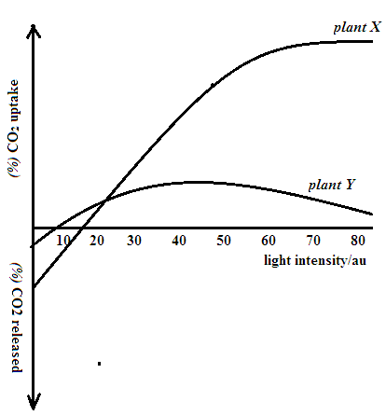
The table below shows the photosynthetic rates at different wavelengths of light;
Wave length/nm | 400 | 450 | 500 | 550 | 600 | 650 | 700 | 730
Photosynthetic rate/au | 5 | 9 | 6.7 | 7.9 | 8.5 | 8.2 | 3 | 00
- i) Identify the possible condition(s) in which plant X and Y where grown (01 MKS)
ii) Compare the relationship between X and Y with increasing intensity (10 MKS)
ii) Explain the relationship between carbon dioxide uptake and release with increasing light intensity (10 MKS)
- Plot a suitable graph to represent the results in the table above (08 MKS)
- i) What phenomenon is represented by the graph above (01 MK)
ii) From the graph state the optimum wave length for photosynthesis (01 MK)
- Explain the effect of varying wavelength of light to photosynthetic rate; (09 MKS)
SECTION B (60 MARKS)
2 a) Explain the role of plasma composition in resisting P^{H} fluctuation of blood (10 MKS)
b) How does the fluctuation in blood P^{H} relate to hemoglobin’s oxygen load? (06 MKS)
c) Explain the role of higher diameter of red blood cells than that of blood capillaries surrounding the alveoli of lungs; (04 MKS)
3 a) Account for the role played by a hydrostatic skeleton in achieving support and locomotion in annelids (10 MKS)
b) i) How does the antagonistic activity of skeletal muscles bring about displacement in bipeds
(06 MKS)
ii) Assess the role played by calcium ions in causing the displacements above; (04 MKS)
4 a) Outline the impacts of fire to a terrestrial ecosystem (08 MKS)
b) Explain;
- the role played by biological rhythms in survival of organisms (03 MKS)
- the role played by territorial behavior in courtship (02 MKS)
c) Compare biological rhythms with habituation in animals (07 MKS)
5. a i) Account for the role played by myelin sheath in neural impulse transmissions (05 MKS)
ii) Outline the factors that maintain a unidirectional impulse flow along neurons (06 MKS)
b) How does the simple facet of a compound eye function as a photoreceptor organ? (09 MKS)
6 a) Distinguish between cordominant and sex linked characters (04 MKS)
b) Given that blue eye colour blindness is controlled by a recessive gene on X chromosome and that sickle cell is a form of mutation that affects erythrocytes; If a cross between a carrier woman for sickle cell and blue eye colour blindness with a carrier man for sickle cell with normal eye sight in Uganda was done,
- Workout to show the resultant phenotypes of this cross (10 MKS)
- Calculate the percentage of their children with blue eye colour blindness (02 MKS)
- Explain the percentage of carriers for sickle cell may exceed that of carriers for colorblindness (04 MKS)
END

