612/3
IPS ART & CRAFTS
Paper 3
Jul / Aug 2019
3 hours

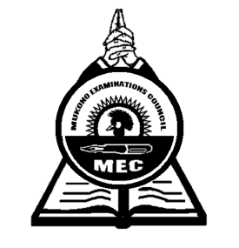

MUKONO EXAMINATION COUNCIL
Uganda Certificate of Education
IPS ART AND CRAFTS
DRAWING/PAINTING FROM HUMAN FIGURE
Paper 3
3hours

Alternative subjects
EITHER (Full figure)
- Candidates draw or paint a whole figure of a male with a straw hat standing holding a long walking stick (about 2 m high) with the right hand, close to his body. The stick touches the ground as his support.
The model wears a long sleeved robe (kanzu) tied with a string torn from another piece of cloth around his waist with a noose to make a knot.
The right foot should be thirty centimeters ahead of the left foot. The model faces the candidate directly and appears to be in a thoughtful mood.

OR (Portrait)
- A girl/ boy (about 18 years old), sits on a locker at a three quarter angle, and slightly bends down.
The model is dressed in pair of trousers and short sleeved T-Shirt. The model’s hair is uncombed and hides both his / her hands at the back.
Candidates draw or paint the upper part of the model from the waist.

End -

