P510/3
PHYSICS PRACTICAL
Paper 3
July/ Aug. 2014
3 ¼ hours

UGANDA TEACHERS’ EDUCATION CONSULT (UTEC)
MOCK EXAMINATIONS
Uganda Advanced Certificate of Education
PHYSICS
(PRINCIPAL SUBJECT)
Paper 3
3 hours 15 minutes

INSTRUCTIONS TO CANDIDATES:
Answer question 1 and one other question.
Candidates will not be allowed to handle the apparatus for the first fifteen minutes.
Graph papers may be provided.

Marks are awarded for the degree of accuracy of results obtained their suitability and for the use made of them.

Candidates may be required to give a brief report on the sources of errors during the experiment. However, candidates are not required to give a description of the apparatus used.

Candidates are expected to record on their scripts all their observations as these observations are made and to plan the presentation of the records so that it is not necessary to make a fair copy of them. The working of the answers should be handed in.

1. In this experiment, you will determine the moment of inertia of a meter rule X, about its center by two methods.
METHOD I
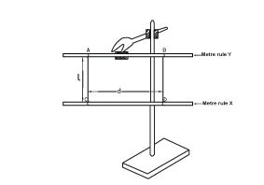
Fig. 1 a
(a) Read and record the mass, m, of the meter rule labeled X
(b) Clamp the meter rule labeled Y as shown in fig. 1 a.
(c) Tie threads AC and BD at 35.0 cm and 65.0 cm marks of meter rule X, such that they are at separation, d.
(d) Adjust the length, L, of each thread to 0.500 m.
(e) Displace the meter rule X, about the vertical through its center and release it to oscillate in the horizontal plane.
(f) Record the time for twenty oscillations.
(g) Calculate the period T.
(h) Find the moment of inertia I, from I = (mg/16 I)(Td)² Where g is acceleration due gravity g =10 ms⁻²)
METHOD II
(a) Dismantle the arrangement in fig. 1a
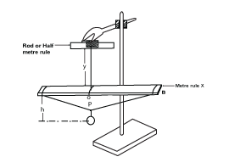
Fig.1 b
(b) Suspend the metre rule X, using a piece of thread such that the length y = 2.5 cm as shown in fig. 1 b
(c) Adjust the position of O such that the meter rule balances horizontally.
(d) Tie one end of the long thread provided at the 1.0 cm mark of meter rule X.
(e) Pass the other end of the thread through the hook of the pendulum bob provided and tie the free end of the thread at 99.0 cm mark.
(f) Adjust the height h, to 0.600 m.
(g) Adjust the position of the hook along the thread, so that the meter rule balances again.
(h) Displace the end A of the meter rule and release it to oscillate in a vertical plane.
(i) Record the time for 10 oscillations
(j) Calculate the period T₁
(k) Stop the oscillation of the meter rule
(l) Displace the pendulum bob towards you and release it to oscillate in a horizontal plane perpendicular to the plane APB
(m) Record the time for 10 oscillations
(n) Calculate the period T₂
(o) Repeat procedures (f) to (n) for values of h = 0.500, 0.400, 0.300 and 0.100 m
(p) Tabulate your results including the values of (T₁² – T₂²) and 1/h
(q) Plot a graph of (T₁² – T₂²) against 1/h
(r) Determine the slope, S, of the graph
(s) Find the moment of inertia, I, from; S = 4 I/gm
Where g = 10 ms⁻² and m is the mass of the pendulum.
2. In this experiment, you will determine the width, W of the glass block provided using two methods.
Part I
(a) Measure and record the radius, R, of the Rwenzori mineral water bottle.
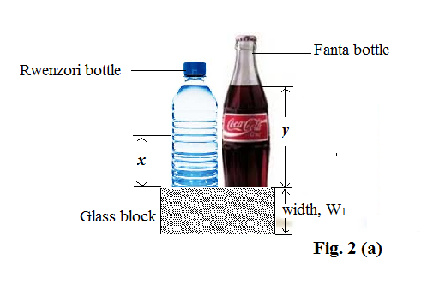
Fig. 2(a)
(b) Pour 250 ml of water in the Rwenzori mineral water bottle and 250 ml of water in the fanta glass bottle provided.
(c) Place a glass block besides the two bottles put together such that the largest face faces you as shown in figure 2 (a).
(d) Measure the heights of the water x and y from the glass block.
(e) Calculate the width, W₁ from the expression.
Part II
(a) Fix the plain sheet of paper provided on a soft board
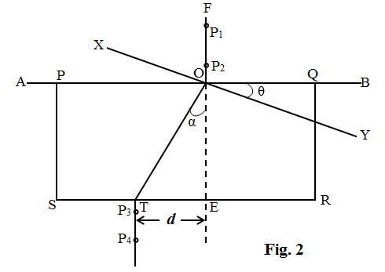
(b) Draw a line AB along the middle of the paper
(c) Place the glass block on the paper with the broadest face topmost and one of its longest side PQ along the line AB.
(d) Trace the outline of the block
(e) Remove the glass block and label the outline PQRS as shown in figure 2.
(f) Draw a line EF normal to PQ at O and intersecting SR at E.
(g) Fix pins P₁ and P₂ vertically a long FO.
(h) Draw a line XY through O at angle θ =10º to line AB.
(i) Place the glass block with its longest edge along XY.
(j) Looking through the block, stick P₃ and P₄, so that they appear to be in line with images of P₁ and P₂.
(k) Remove the glass block and pins P₃ and P₄
(l) Draw a line through points P₃ and P₄ so that it meets SR at T
(m) Join O and T
(n) Measure and record angle, α, and length TE = d.
(o) Repeat the procedures (h) to (n) for valves of θ =20, 30, 40, 50 and 60º.
(p) Record your results in a suitable table including values of tanα.
(q) Plot a graph of d against tan α
(r) Determine the slope, W₂, of your graph.
(s) Calculate the average width W, from.
Hand in the tracing paper together with your work

3. In this experiment, you will determine the resistivity of,$sρ$ of the material of the wire W
(a) Measure and record the diameter, d, of the wire W.
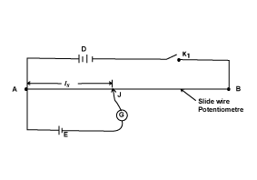
Fig. 3(a)
(b) Connect the circuit shown in fig. 3(a)
(c) Close switch K₁
(d) Move the sliding contact, J, along the slide wire AB until a point is reached where the galvanometer G shows no deflection.
(e) Measure and record the balance length l_{s.}
(f) Open switch K₁
(g) Disconnect cell E

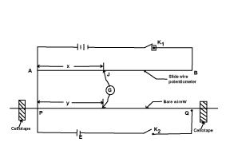
Fig. 3(b)
(h) Connect the circuit shown in fig. 3(b), starting with y = 0.200 m
(i) Close switches K₁ and K₂ and move the sliding contact, J, along AB until a point is reached when the galvanometer, G, shows no deflection.
(j) Measure and record the balance length x.
(k) Open switches K₁ and K₂
(l) Repeat the procedures in (h) to (k) for values of y = 0.300, 0.400, 0.500, 0.600 and 0.700 m.
(m) Tabulate your results.
(n) Disconnect the circuit in figure 3(b) and connect the circuit in figure 3(c).
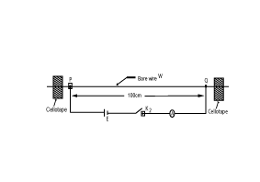
Fig. 3(c)
(o) Close the switch K₂
(p) Read and record the current I, in the circuit.
(q) Disconnect the circuit in the figure 3(c).
(r) Connect the voltmeter across cell E and note the reading V_{c} on it.
(s) Plot a graph of x against y.
(t) Find the slope, m, of the graph
(u) Calculate the value, R, from the expression: R = mV_{c}/ l_{s} I
(v) Calculate the resistivity, $ρ$, of the material of the wire from the expression:
$$ρ=\frac{πd^{2}R}{4}$$
END

