Name: …………………………………………….House ………………………………………

Signature: ……………………………..Stream……………………Combination………………

Form Five
Subsidiary ICT
Paper1,
S850/1
2 hours
^{th}/Nov/2013

KIIRA COLLEGE BUTIKI
Uganda Advanced Certificate of Education
INFORMATION AND COMMUNICATIONS TECHNOLOGY (ICT)
(Subsidiary Paper)
^{th} November 2013
Paper One (Theory)
S.5 E O T
2 Hours

Instructions:

- This paper is made up of twelve structured questions.
- Write your answers in the spaces provided.
- All questions are compulsory.

FOR OFFICIAL USE ONLY
1 |  | 7
2 |  | 8
3 |  | 9
4 |  | 10
5 |  | 11
6 |  | 12
SUB TOTAL |  | SUB TOTAL |  | TOTAL

1.(a) What is a keyboard? [1mark]
Dont write in this margin

……………………………………………………………………………………………..
……………………………………………………………………………………………..

(b) Name the parts of the computer system below: [3marks]



(c) What is the purpose of the cursor movement keys. [1 mark]

……………………………………………………………………………………………..
……………………………………………………………………………………………..
2. Assuming you have been appointed a laboratory technician for your school. After taking up your
job you find out that the computer laboratory lacks rules and regulations guiding
students. The system administrator requested you to design five guidelines for the
student. [5 marks]
……………………………………………………………………………………………..
……………………………………………………………………………………………..
……………………………………………………………………………………………..
……………………………………………………………………………………………..
……………………………………………………………………………………………..
……………………………………………………………………………………………..
……………………………………………………………………………………………..
……………………………………………………………………………………………..
3. (a) Expain the following terms/commands as applied in spreadsheet. (5marks)
(i) Workbook
………………………………………………………………………………………………………………………………………………………………………………………………………………………………………………………………………………………………………………………………………
(ii) Worksheet
……………………………………………………………………………………………………………………………………………………………………………………………………………………………………………………………………………………………………………………………………
(iii) freeze panes
………………………………………………………………………………………………………………………………………………………………………………………………………………………………………………………………………………………………………………………………

(iv) Cell address
……………………………………………………………………………………………………………………………………………………………………………………………………………………………………………………………………………………………………………………………………....
(v) Wrap text
……………………………………………………………………………………………………………………………………………………………………………………………………………………………………………………………………………………………………………………………................
4. Complete the table below by suggesting the different ways of selecting the stated cell(s) in a worksheet. (5marks)
Cells to select | Mouse action to be applied
One cell

Entire row
Entire column
Entire worksheet
Cluster of cells

5.(a) What is meant by the term Computer software? (1mark)

……………………………………………………………………………………………………………………………………………………………………………………………………………………………………………………………………………………………………………………................

(b) System software may be categorized into Operating systems, Utility programs and programming languages. Briefly explain, giving an example to each category
(i) Operating systems: (2 marks)
…………………………………………………………………………………………………………………………………………………………………………………………………………………………………………………………………………………………………………………………………………………………………………………………………………………………………………
(ii) Utility programs : (2marks)
…………………………………………………………………………………………………………………………………………………………………………………………………………………………………………………………………………………………………………………………………………………………………………………………………………………………………………..
(iii) Programming languages: (2 marks)
………………………………………………………………………………………………………………………………………………………………………………………………………………………………………………………………………………………………………………………………………………………………………………………………………………………………………….

6. Explain how the following tasks can be performed in a worksheet
- Adding a worksheet in a workbook (1mark)
……………………………………………………………………………………………………………………………………………………………………………………………………………………………………………………………………………………………….

- Renaming a worksheet (1mark)
………………………………………………………………………………………………………………………………………………………………………………………………………………………………………………………………………………………………
- Activating the cell’s content (1mark)
……………………………………………………………………………………………………………………………………………………………………………………………………………………………………………………………………………………………....
7. Form five students are required to create e-mails and send their assessments to the
teachers email. It was about Electronic mail which refers to as the sending and
receiving of digital messages on a network. Explain any five features of e-mail.
[5marks]
……………………………………………………………………………………………..
……………………………………………………………………………..………………
……………………………………………………………………………………………..
……………………………………………………………………………..………………
……………………………………………………………………………………………..
……………………………………………………………………………..………………
…………………………………………………………………………………………………
………………………………………………………………………………………………..
8. Your father has been working in the ministry of public service for the last twenty
years. At the beginning of this year the permanent secretary requested them to acquire
Computer skills. Last week when he went to his office he found a computer on his
desk ,being computer illiterate he does not know the application of information and
communication technology. You are tasked to advise him on the areas of application
of computers. Give any five areas. [5 marks]
……………………………………………………………………………………………..
……………………………………………………………………………..………………
……………………………………………………………………………………………..
……………………………………………………………………………………………..
……………………………………………………………………………………………..
……………………………………………………………………………..………………
……………………………………………………………………………………………..
……………………………………………………………………………………………..
9. Using the diagram below.
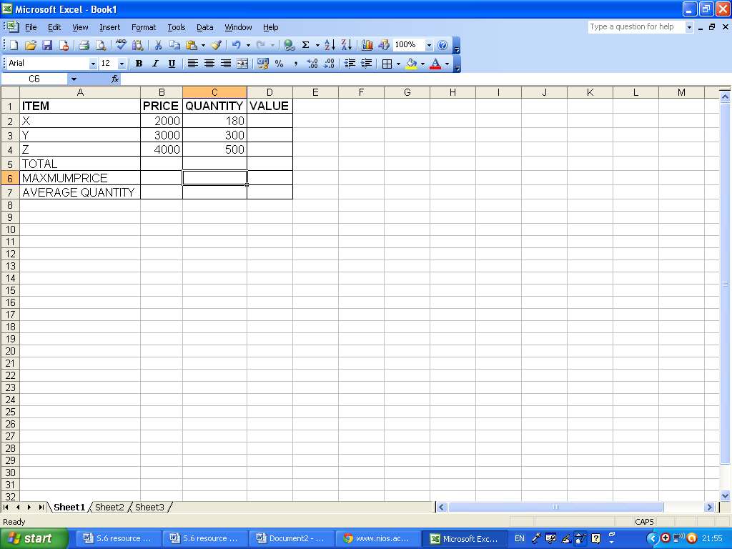
[1mark@]
- Write a formula to display the value (price by quantity) for each item in column D

……………………………………………………………………………………………..
……………………………………………………………………………..………………
- Calculate the total quantity in cell C5

……………………………………………………………………………………………..
……………………………………………………………………………..………………
- Write a formula to calculate the total value and display it in cell D5

……………………………………………………………………………………………..
……………………………………………………………………………..………………
- Write a formula to display the maximum price in cell B6.

……………………………………………………………………………………………..
……………………………………………………………………………..………………
- Write a formula to calculate the average quantity and display in Cell C7

……………………………………………………………………………………………..
……………………………………………………………………………..………………
10. (a) Identify any three types of crime that are associated with the widespread use of IT. (3mks)
……………………………………………………………………………………………………………………………………………………………………………………………………………………………………………………………………………………………………………………………………………………………………………………………………………………………………………………………………………………………………………

(b) Describe two pieces of advice that a bank can give to customers to help them avoid such dangers. (2mks)
……………………………………………………………………………………………………………………………………………………………………………………………………………………………………………………………………………………………………………………………………………………………………………………………………………………………………………………………………………………………………………
11. Identify five services that an ISP can provide to users. (5marks)
……………………………………………………………………………………………………………………………………………………………………………………………………………………………………………………………………………………………………………………………………………………………………………………………………………………………………………………………………………………………………………………………………………………………………………………………………………………………………………………………………………………………………………………………………………………………………………………………………………………
12. (a) A shopkeeper uses a stand-alone computer for producing.
- Order forms for sending to suppliers
- Records of sales and purchases as evidence for the taxation authorities
- Leaflets advertising special offers
The computer has a hard drive, a CD- RW drive and a DVD drive. State the different ways how the shopkeeper can use those three storage medias. In each case say why it’s appropriate for that use. [3 marks]
……………………………………………………………………………………………………………………………………………………………………………………………………………………………………………………………………………………………………………………………………………………………………………………………………………………………………………………………………………………………………………………………………………………………………………………………………………………………………………………………………………………………………………………………………………………………………………………………………………………
(b) Give a clear difference between primary memory and secondary memory of a computer.
(2marks) …………………………………………………………………………………………………………………………………………………………………………………………………………………………………………………………………………………………………………………………………………………………………………………………………………
$≈$END$≈$

