Name: ……………………………………………House ………………………………………

Signature: ……………………………..Stream…………………………………………………

Form Five
Subsidiary ICT
Paper1,
S850/1
2 hours 30 Minutes
28th/Sept/2013

KIIRA COLLEGE BUTIKI
Uganda Advanced Certificate of Education
INFORMATION AND COMMUNICATIONS TECHNOLOGY (ICT)
(Subsidiary Paper)
28th September 2013
Paper One (Theory)
S.5 Midterm
2 Hours 30 Minutes

Instructions:

- This paper is made up of twenty structured questions.
- Write your answers in the spaces provided.
- All questions are compulsory.
- All questions carry equal marks

FOR OFFICIAL USE ONLY
1 |  | 11
2 |  | 12
3 |  | 13
4 |  | 14
5 |  | 15
6 |  | 16
7 |  | 17
8 |  | 18
9 |  | 19
10 |  | 20
SUB TOTAL |  | SUB TOTAL |  | TOTAL

- (a) Define Information and Communication Technology. (1mark)

……………………………………………………………………………………………………………………………………………………………………………………………………………………………………………………………………….
(b) Assuming, you have been appointed as the head of ICT department in Kiira College Butiki. The school wishes to buy new computers to ease the work of teaching and learning ICT.
Explain four factors you would consider when buying computers. (4 marks)

……………………………………………………………………………………………………………………………………………………………………………………………………………………………………………………………………………………………………………………………………………………………………………………………………………………………………………………………………………………………………………………………………………………………………………………………………………………………………………………………………………………………………………………………………………………………………………………………………………………….
- Explain one specialized application ICTs can play in each of the following areas (5 marks)
- Education
……………………………………………………………………………………………………………………………………………………………………………………………………………………………………………………………….
- Health
……………………………………………………………………………………………………………………………………………………………………………………………………………………………………………………………….
- Entertainment
………………………………………………………………………………………………………………………………………………………………………………………………………………………………………………………………
- Security
……………………………………………………………………………………………………………………………………………………………………………………………………………………………………………………………….
- Industries
……………………………………………………………………………………………………………………………………………………………………………………………………………………………………………………………….
- Vicent is a lab assistant at Kibisi sec school. She was requested to present a list of items he would use in his computer lab. Among the items he listed included

- Blower
………………………………………………………………………………………………………………………………………………………………………………………………………………………………………………………
- Antiglare screens
………………………………………………………………………………………………………………………………………………………………………………………………………………………………………………………
- Water proof cover
………………………………………………………………………………………………………………………………………………………………………………………………………………………………………………………
- Gaseous fire extinguisher
………………………………………………………………………………………………………………………………………………………………………………………………………………………………………………………
- Surge protector
………………………………………………………………………………………………………………………………………………………………………………………………………………………………………………………

- (a) In reference to the following file path: C/user/desktop/mukolobe/letter.doc.
Identify the following; (5 marks)

- File name………………………………………………………………………
- File type………………………………………………………………….........
- Profile………………………………………………………………………….
- Folder………………………………………………………………………….
- Location………………………………………………………………….........

- Give the file extensions of the following file types. (5 marks)
File type file extension

- Ms Word ……………………………………………………
- Batch file ……………………………………………………
- Ms Excel ……………………………………………………
- Ms Access ……………………………………………………
- Ms PowerPoint ……………………………………………………

- Today internet is becoming almost part of man’s life. State any five positive effects of internet to the society.
………………………………………………………………………………………………………………………………………………………………………………………………………………………………………………………………………………………………………………………………………………………………………………………………………………………………………………………………………………………………………………………………………………………………………………………………………………………………………………………………………………………………………………………………………………………………………………………………………………………………………………………………………………………………………………
- Mobile telephones are used for accessing internet
- Give three advantages of using mobile telephones for internet access.(3mks)
…………………………………………………………………………………………………………………………………………………………………………………………………………………………………………………………………………………………………………………………………………………………………………………………………………………………………………
- Give two disadvantages of using mobile telephones for internet access. (2mks)
…………………………………………………………………………………………………………………………………………………………………………………………………………………………………………………………………………………………………………………………………………………….
- When opening an application program in a computer using command prompt, what should be typed in the run dialog box to open the following applications. (5mks)
- Microsoft word……………………………………………………………….
- Microsoft excel……………………………………………………………….
- Microsoft access………………………………………………………………
- Microsoft PowerPoint…………………………………………………………
- Microsoft publisher……………………………………………………………

- (a) What is a hardware device? (1mark)
………………………………………………………………………………………………………………………………………………………………………………………………………………………………………………………………………………………………………………………………………………………………..

(b) Name the output devices labeled A, B, C and D. (4 marks)

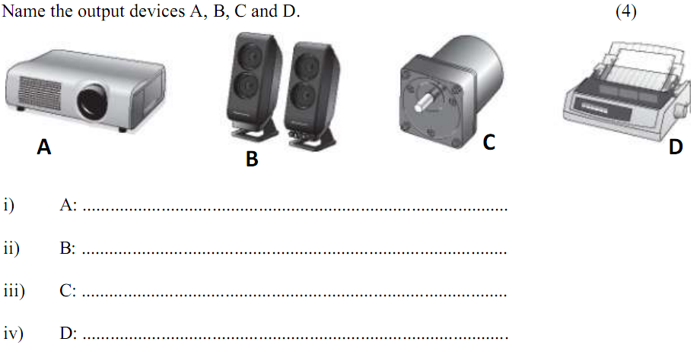

- Describe five advantages of using mobile phone to speak with other people rather than sending emails using a laptop.
………………………………………………………………………………………………………………………………………………………………………………………………………………………………………………………………………………………………………………………………………………………………………………………………………………………………………………………………………………………………………………………………………………………………………………………………………………………………………………………………………………………………………………………………………………………………………………………………………………………………………………………………………………………………………………..
- (a) Explain three advantages and two disadvantages of E-commerce and E-buziness. (5 marks)
Advantages.
……………………………………………………………………………………………………………………………………………………………………………………………………………………………………………………………………………………………………………………………………………………………………………………………………………………………………………………………………………………………………………………………………………….
Disadvantages.
………………………………………………………………………………………………………………………………………………………………………………………………………………………………………………………………………………………………………………………………………………………………..
- (a) Define a computer. (1mark)
……………………………………………………………………………………………………………………………………………………………………………………………………………………………………………………………………….
(b) Describe the characteristics of a modern computer. (4marks)
……………………………………………………………………………………………………………………………………………………………………………………………………………………………………………………………………………………………………………………………………………………………………………………………………………………………………………………………………………………………………………………………………………………………………………………………………………………………………………………………………………………………………………………………….
- (a) What is an Icon. (1mark)
……………………………………………………………………………………………………………………………………………………………………………………………………………………………………………………………………… (i) What is a desktop. (1mark)
………………………………………………………………………………………………………………………………………………………………………………………………………………………………………………………........................
(ii) Give the functions of My computer, Recycle Bin and internet explorer Icons found on the Desktop in a windows environment. (3marks)
………………………………………………………………………………………………………………………………………………………………………………………………………………………………………………………………………………………………………………………………………………………………………………………………………………………………………………………………………………………………………………………………

- Explain what is meant by the following terms.
- Double click (1mark)
……………………………………………………………………………………………………………………………………………………………………
- Right click (1mark)
……………………………………………………………………………………………………………………………………………………………………
- Left click (1mark)
……………………………………………………………………………………………………………………………………………………………………
- Drag and drop (2marks)
………………………………………………………………………………………………………………………………………………………………………………………………………………………………………………………
- Explain the factors that should be considered when preparing a computer laboratory. (5marks)
……………………………………………………………………………………………………………………………………………………………………………………………………………………………………………………………………………………………………………………………………………………………………………………………………………………………………………………………………………………………………………………………………………………………………………………………………………………………………………………………………………………………………………………………………………………………………………………………………………………………………………………………………………………………………………….
- (a) what is the difference between word processor and word processing. (1mark)
……………………………………………………………………………………………………………………………………………………………………………………………………………………………………………………………………………………………………………………………………………………………….
(b) Explain the features of a word processor. (4marks)
………………………………………………………………………………………………………………………………………………………………………………………………………………………………………………………………………………………………………………………………………………………………………………………………………………………………………………………………………………………………………………………………………………………………………………………………………………………………………………………………………………………………………………………………………………………………………………………………………………………

- Give five measures that protect users and computers in the computer laboratory. (5marks)
…………………………………………………………………………………………………………………………………………………………………………………………………………………………………………………………………………………………………………………………………………………………………………………………………………………………………………………………………………………………………………………………………………………………………………………………………………………………………………………………………………………………………………………………………………………………………………………………………………………………………………………………………………………………………………….....
- Give the advantages of using word processors. (5marks)
………………………………………………………………………………………………………………………………………………………………………………………………………………………………………………………………………………………………………………………………………………………………………………………………………………………………………………………………………………………………………………………………………………………………………………………………………………………………………………………………………………………………………………………………………………………………………………………………………………………………………………………………………………………………………………………………………………………………………………………………………………………………………………………………………………………………
- Give five functions of operating systems. (5marks)
……………………………………………………………………………………………………………………………………………………………………………………………………………………………………………………………………………………………………………………………………………………………………………………………………………………………………………………………………………………………………………………………………………………………………………………………………………………………………………………………………………………………………………………………………………………………………………………………………………………………………………………………………………………………………………………………………………………………………………………………………………………………………………………………………………………………………………………………………………………………………………………….
- (a) Give two indications for virus infection in a computer. (2marks)
………………………………………………………………………………………………………………………………………………………………………………………………………………………………………………………………………………………………………………………………………………………………
(b) Explain three ways of protecting the computer against viruses. (3marks)
……………………………………………………………………………………………………………………………………………………………………………………………………………………………………………………………………………………………………………………………………………………………………………………………………………………………………………………………………………………………………………………………………………………………………………………………………………………………………………………………………………………………………………………………………………………………………………………………………………………….

$≪$END$≫$

