UGANDA ADVANCED CERTIFICATE OF EDUCATION
MOCK EXAMINATIONS 2019
P250/1 PHYSICAL GEOGRAPHY
PAPER 1
TIME: 3 HOURS
Instructions to candidates:
- This paper consists of three sections A,B and C
- Answer four questions.
- Section A is compulsory
- Answer one question from section B and one question from section C
- Credit will be given for use of relevant diagrams and specific examples.
- Any additional questions attempted will not be marked.

SECTION A:
COMPULSORY MAPWORK QUESTION
- Study the 1:50,000 UGANDA map extract of MASINDI, sheet 39/3, series Y732, Edition 1 –U.S.D and answer the questions that follow.

- State the;
- Manmade feature found at grid reference 599851. (1 mark)
- Direction of flow of river Ibahe. (2 marks)

- Draw a cross section along northing 80 from Easting 48 to Easting 56, on it mark and name;
- A ridge
- A valley,
- Settlements,
- A road,
- Forest,
- Spur (10 marks)

- Calculate the;
- Vertical exaggeration of the cross section drawn. (2 marks)
- Vertical interval on the map extract. (2 marks)

- Describe the relationship between relief and landuse types shown on the map extract (6 marks)

- Study the photograph given and answer the questions that follow;
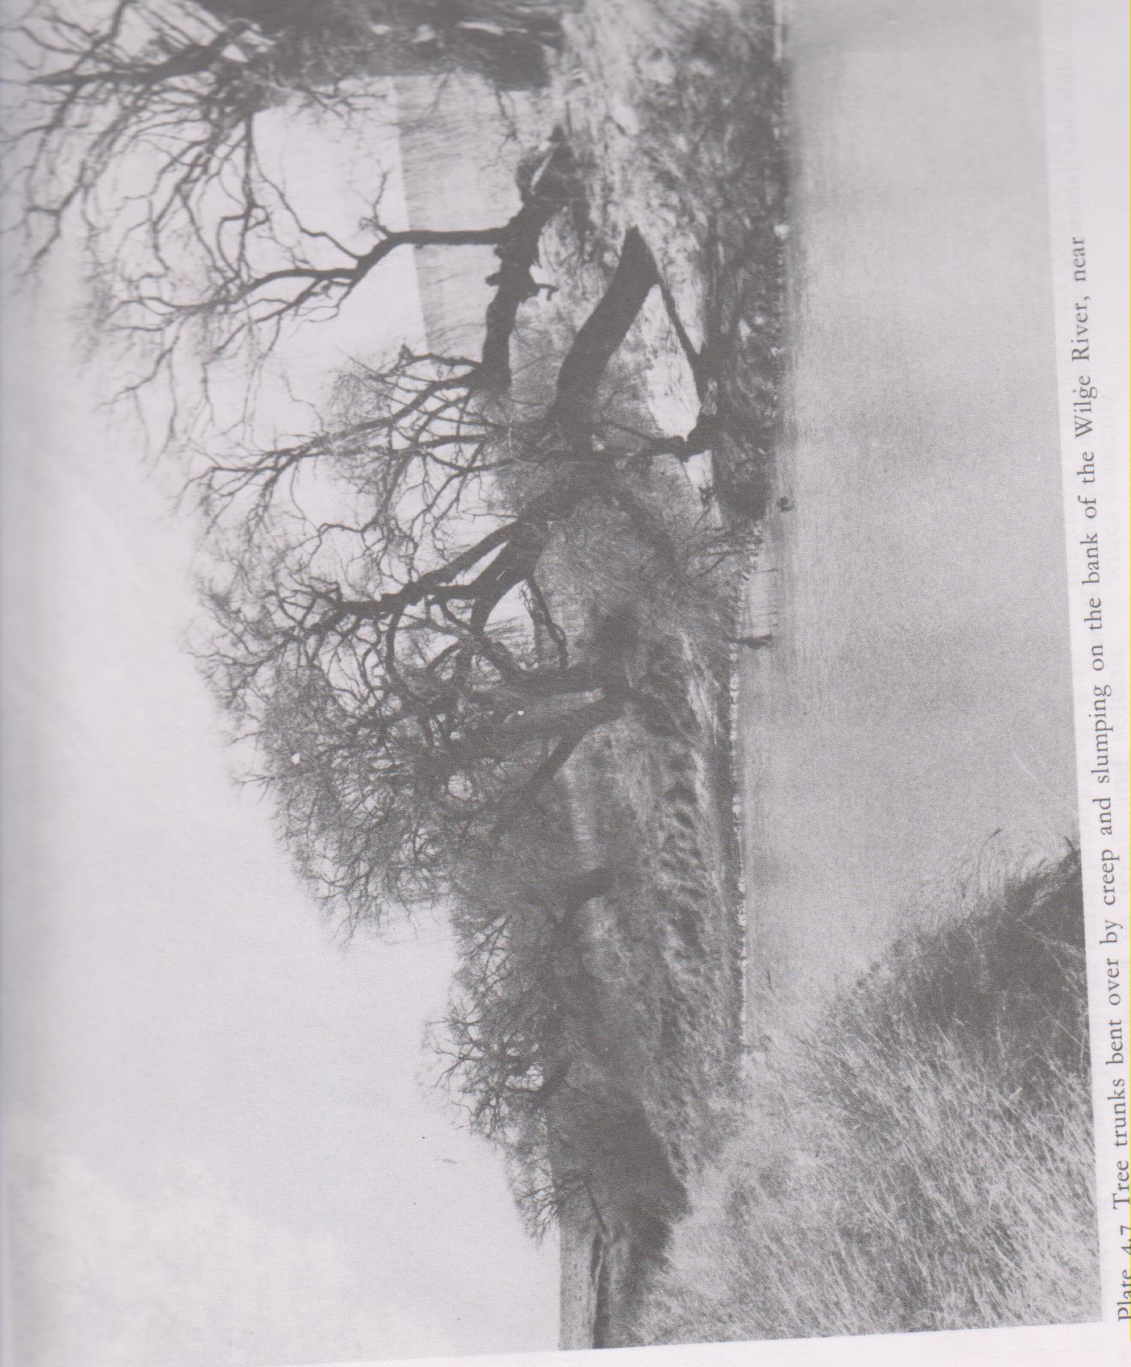
- Draw a landscape sketch of the area shown in the photograph given and on it mark and name any
- Two relief features
- Two vegetation types
- One drainage feature (8 marks)

- (i) Identify the geomorphic process taking place in the photograph (2 marks)
(ii) Account for the occurrence of the geomorphic process identified above. (8 marks)

- Explain the problems being faced by people living in the area. (6 marks)
- State the type of photograph shown (1 mark)

SECTION B:

- To what extent has faulting influenced the drainage of East Africa? (25 marks)
- Account for the formation of glacial erosional landforms in East Africa. (25 marks)
- Examine the influence of eustatic changes on the formation of landforms along the African coast.
(25 marks)

SECTION C:

- (a) What is meant by the term air mass? (10 marks)
(b) Describe the characteristics of air masses (15 marks)

- To what extent does climate influence forest growth in East Africa? (25 marks)
- To what extent does parent rock influence the formation of zonal soils in East Africa? (25 marks)

END

