P250/1
Geography
(Physical Geography)
Paper 1
July 2019
3 Hours

ACEITEKA MOCK EXAMINATIONS 2019
Uganda Advanced Certificate of Education

GEOGRAPHY

(PHYSICAL GEOGRAPHY)

Paper 1

3 Hours

INSTRUCTIONS TO CANDIDATES
- This paper consists of three sections: A, B and C.
- Answer FOUR questions.
- Section A is compulsory.
- At least ONE question should be answered from section B and ONE question from section C.
- Credit will be given for use of relevant sketch maps, diagrams and specific examples studied in the field.
- Any additional questions attempted will not be marked.

SECTION A
QUESTIONS 1 AND 2 ARE COMPULSORY
COMPULSORY MAPWORK QUESTION

      - Study the 1:50,000 East Africa (UGANDA) KATUNGURU Map extract part of sheet 76/1 series y732 Edition 4-U.S.D and answer the questions that follow:

- (i) State the grid reference of river confluence on river Rutanda. (1 mark)

(ii) Identify the man made feature found at grid reference 719753. (1 mark)

- (i) Reduce the area shown on the map extract by 2 ½.
Draw its sketch map and on it mark and label;
- Relief features
- Drainage features
- Vegetation types. (11 marks)

(ii) Calculate the new scale of sketch map drawn in (b) above. (2 marks)

- Explain the process for the formation of major relief feature above 3200ft above sea level. (4marks)
- Giving evidence from the map extract, explain the relationship between relief and vegetation in the area. (6 marks)

COMPULSORY PHOTOGRAPHIC INTERPRETATION QUESTION.
      - Study the photograph provided below and answer the questions that follow.

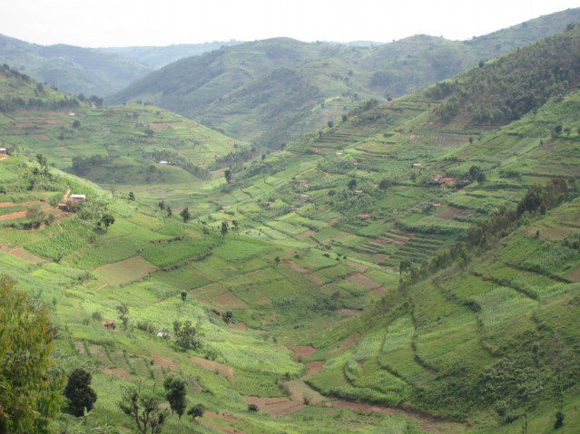

- Draw a land scape sketch of the area shown in the photograph and on it mark and name;
- relief features.
- land use types. (9 marks)
- Describe the characteristics of the relief of the area shown in the photograph. (4 marks)

- With evidence, explain the relationship between relief and land use in the area shown in the photograph. (6 marks)

- Explain the problems faced by people living in the area shown in the photograph. (4 marks)
- Giving reasons for your answer suggest an area in East Africa where this photograph could have been taken. (2 marks)

SECTION B

      - a) Examine the causes of eustatic changes. (8 marks)

b) Explain the formation of landforms resulting from submergence of highland coasts. (17 marks)

      - Describe the process for the formation of different types of rocks in East Africa. (25 marks)

      - Explain the influence of tectonic movements on the formation of lakes in East Africa. (25 marks)

SECTION C

      - To what extent are human activities responsible for the modification of Equatorial climate in East Africa? (25 marks)

      - To what extent has altitude been responsible for distribution of natural forest vegetation in East Africa? (25 marks)

      - a) What is soil catena? (5 marks)

b) Examine the influence of the parent rock on the formation of soil types in
East Africa. (20 marks)

END

