P250/1
GEOGRAPHY
(PHYSICAL
GEOGRAPHY)
PAPER 1
3 HOURS

GEOGRAPHY DEPARTMENT 2019

Uganda Advanced Certificate of Education
S.6 GEOGRAPHY INTERNAL MOCK

(PHYSICAL GEOGRAPHY)

PAPER 1

3 Hours

INSTRUCTIONS TO CANDIDATES:
- This paper consists of three sections A, B and C.
- Answer four questions.
- Section A is compulsory.
- Answer one question from section B and one question from section C.
- Credit will be given for use of relevant sketch maps, diagrams and specific examples studied in the field.
- Any additional question (s) attempted will not be marked.

SECTION A:
COMPULSORY MAP WORK QUESTION
1. Study the 1:50,000 (Uganda) KIGOROBYA MAP EXTRACT. Part of sheet 38 la:YT 32: Edition 2 U.S.D and answer the questions that follow.
- (i) find the grid reference of a borehole west of Kibugubya
(01 mark)
(ii) measure the distance of the Bulindi dry weather road from a junction of Mbarara (01 mark)
{b) Calculate the
i) height of Kiraira conical hill (02 marks)
ii) gradient of the all weather loose surface road in the area
(02 marks)
(c) Draw a relief transect of the area from grid reference 240660 to
grid reference 29O7OO, and on it, mark and label,
- Two physical regions
- Settlement
- Farming
- Two transport routes (10 marks)
(d) (i) Account for the Nature of population in the area (05 marks)
(ii) Describe the relationship between relief and agriculture in the area (04 marks)

- Study the photograph given and answer the questions that follow;
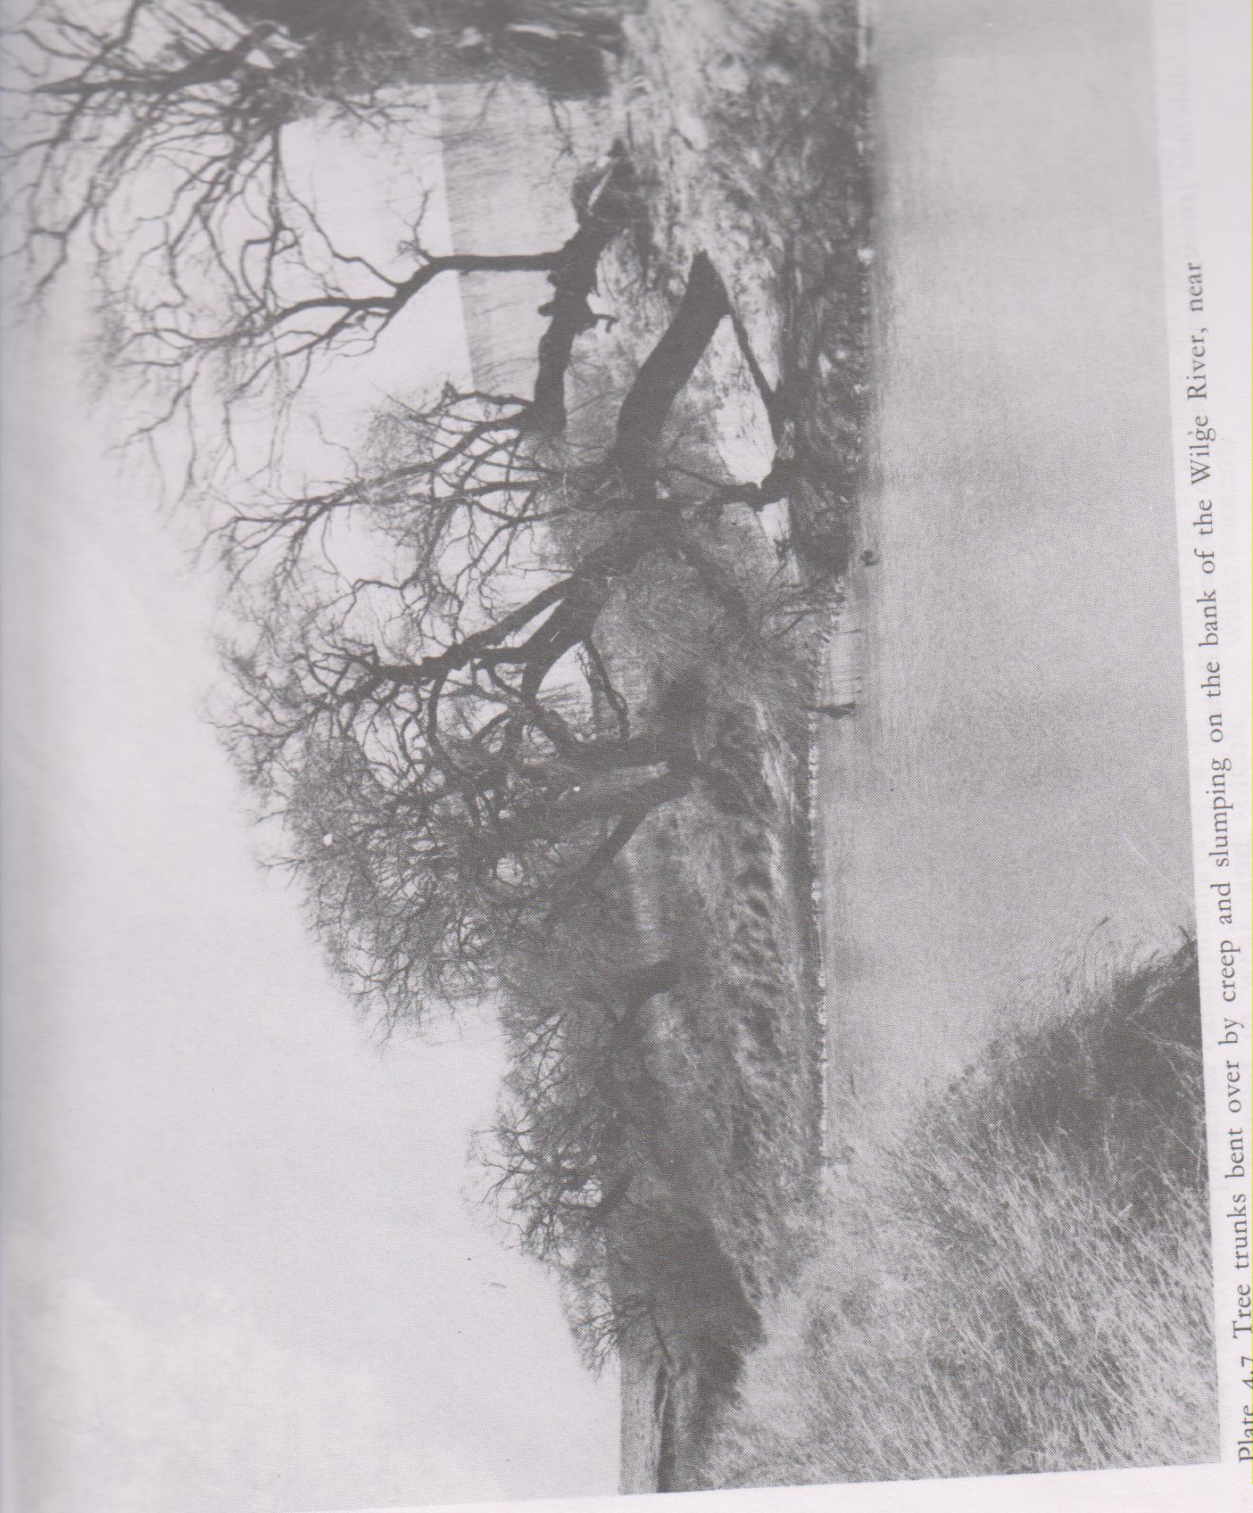
- Draw a landscape sketch of the area shown in the photograph given and on it mark and name any
- Two relief features
- Two vegetation types
- One drainage feature (8 marks)

- (i) Identify the geomorphic process taking place in the photograph (2 marks)
(ii) Account for the occurrence of the geomorphic process identified above. (8 marks)

- Explain the problems being faced by people living in the area. (6 marks)
- State the type of photograph shown (1 mark)

SECTION B
Answer one question from this section.
- Examine the relevance of Wegener’s theory on continental drifting. (25 marks)
- Account for the occurrence and effects of mass wasting in East
Africa. (25 marks)
- (a) Distinguish between a tilt block and a horst (6 marks)
(b) Examine the contribution of faulting to the development of East Africa (19 marks)

SECTION C
6 (a) Differentiate between desertification and global warming
(08 marks)
(b) Describe the effect of desertification in East Africa (17 marks)
7. Examine the effect of ocean currents on the climate of the adjacent coastal areas. (25 marks)
8. (a) Distinguish between Pedocals and Pedalfers (08 marks)
(b) Explain the conditions favoring the formation of zonal soils
(17 marks)

END

