P250/1
GEOGRAPHY
(Physical Geography)
Paper 1
Jul/Aug 2019
3 Hours



MUKONO EXAMINATION COUNCIL
Uganda Advanced Certificate of Education
GEOGRAPHY
(Physical Geography)
Paper 1
3 Hours

INSTRUCTIONS TO CANDIDATES
This paper consists of three sections A, B and C.
Answer only four questions in all.
Section A is compulsory.
Answer one question from section B and one from section C.
Any additional question(s) attempted will not be marked.
Credit will be given for the use of relevant diagrams and specific examples studied in the field.

SECTION A
Question 1 and 2 are Compulsory
- Compulsory Map work question.
Study the 1:50,000 EAST AFRICA (UGANDA) KATUNGURU Map extract part of sheet 76/1, series Y32, Edition 4 – USD and answer the questions that follow.
- (i) Giving reasons, state the hemisphere in which Katunguru is located (02 marks)
(ii) Calculate the trend of the Loose surface road from Ishasha and Rulshuru (700821) to Kahyoro (763767) (02 marks)
- Reduce the area East of Easting 76 and South of Northing 88 by 2 times and draw a sketch map on it, make and name;
- Two physiographic regions
- Two drainage features
- One vegetation type
- Two land use activities
(11 marks)
- (i) What evidence is there to suggest that the land use activities in the area covered by the
map extract are planned? (04 marks)
(ii) Explain the relationship between relief and communication. (routes 06 marks)

- Compulsory Photograph Interpretation Question
Study the photograph provided below and answer the questions that follow.
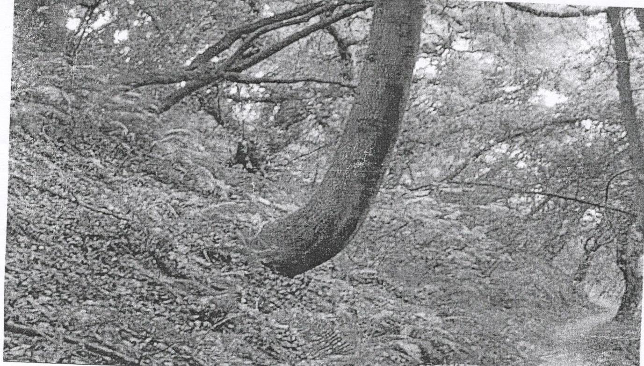

- Draw a land scape sketch of the area shown in the photograph and on it, mark and name
- two relief Features
- two vegetation types
- one land use type
(08 marks)
- Account for the geomorphic occurrence shown in the photograph above. (08 marks)
- Examine the control measures that can be adopted to overcome the geomorphic occurrence shown in Photograph above. (06 marks)
- Giving reasons for your answer, suggest one area in East Africa where the photograph could have been taken. (03 marks)

SECTION B
Answer one question from this section
- To what extent are high lands in East Africa a result of diastrophic movements? (25marks)

- (a) Distinguish between a Gorge and a Plunge Pool. (10 marks)
(b) Account for the development of a Gorge (15 marks)
- (a) Describe the characteristics of Coral land forms. (09 marks)
(b) Examine the relevance of Murry’s theory in the understanding of the origin and formation
of Coral landforms. (16 marks)
SECTION C
Answer one question from this section.

- (a) Distinguish between Relative and Absolute humidity. (08 marks)
(b) Account for the humidity variations in East Africa. (17 marks)

- To what extent does latitudinal location influence the distribution of Miombo Vegetation in East Africa? (25 marks)

- (a) Distinguish between Pedocals and Pedalfers. (08 marks)
(b) Examine the factors that influence the formation of Azonal soils in East Africa.
(17 marks)
End -

