MARKING GUIDE
P250/2
GEOGRAPHY
(World Problems and Development)
Paper 2
Jul / Aug
3 hours

UGANDA TEACHERS’ EDUCATION CONSULT (UTEC)
Uganda Advanced Certificate of Education
GEOGRAPHY
(WORLD PROBLEMS AND DEVELOPMENT)
Paper 2
3 hours

INSTRUCTIONS TO CANDIDATES:

Attempt FOUR questions in all.
Question 1 in section A is compulsory
The other three questions should be picked from section B
Credit will be given to use of relevant sketch maps, diagrams and specific examples
Any additional question attempted will not be marked
MARKING GUIDE

00 - irrelevant answer
00 - 06 Hopeless answer
07 - 09 Inadequate answer
10 - 11 Marginal answer
12 - Basic answer
13 - 16 Average answer
17 - 19 Good answer
20 + Very good answer

SECTION A

- The table below shows Kenya’s balance of visible trade (K£ million) 1982 – 1986.

Year | 1982 | 1983 | 1984 | 1985 | 1986
Imports | 900.3 | 905.6 | 1097.2 | 1196.0 | 1337.9
Exports | 568.6 | 652.2 | 776.9 | 811.4 | 986.9
Balance of trade

Source: Human and Economic Geography (M.Senior, F.N Wegulo) Page 265.

- Calculate the balance of trade for Kenya for each year. (05 marks)
Balance of trade = Exports – imports trade
Balance of trade = 568.6 – 900.3 trade for 1982
= -331.7. 1 mark

Balance of trade = 652.2 - 905.6
For 1983 = -253.4 1 mark
Balance of = 776.9 - 1097.2
Trade for 1984 = -320.3 1 mark

Balance of = 811.4 - 1196.0
Trade for 1985 = -384.6 1 mark

Balance of = 986.9 - 1337.9
Trade for 1986 = -351 1 mark
(05 marks)

Years | Balance of trade
1982  1983  1984  1985  1986 | -331.7 = -332  --253.4 = -253  -320.3 = -320  -384.6 = -385  -351.0 = -351

- Draw a divergence bar graph to portray Kenya’s balance of visible trade.
(08 marks)

A divergence bar graph showing Kenya’s balance of visible trade. (1982 – 1986)

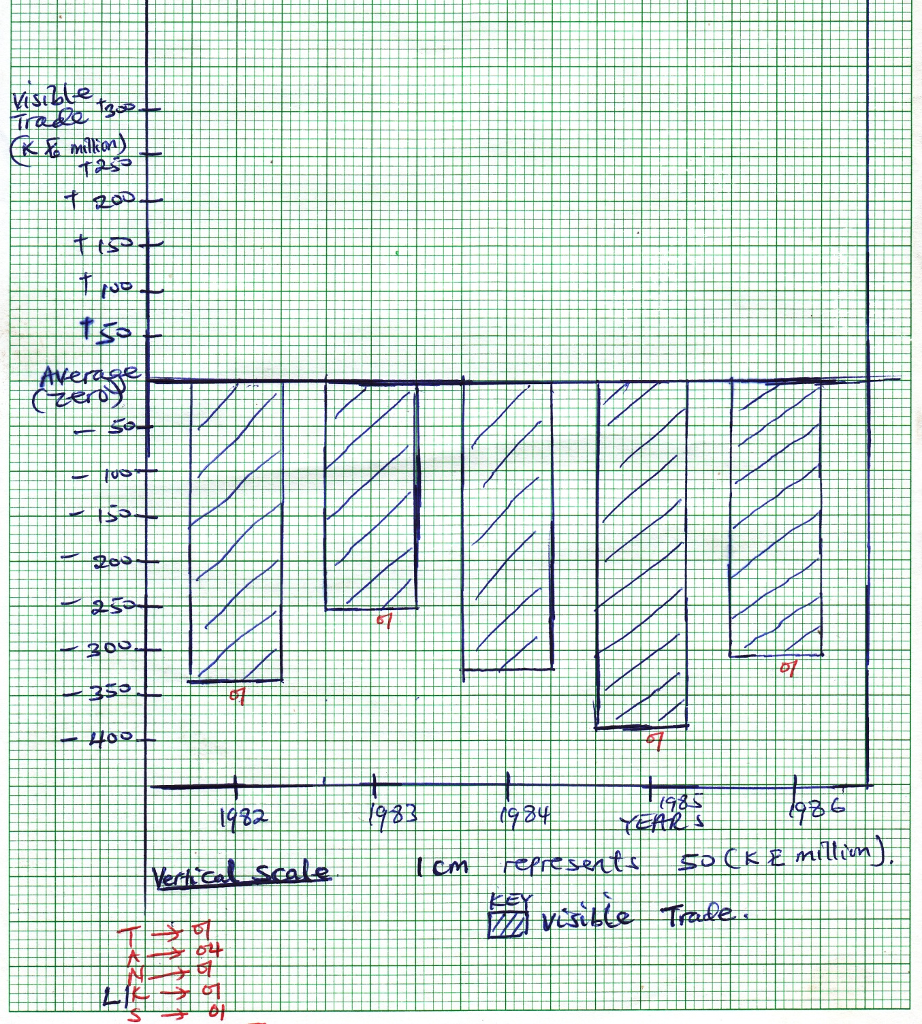

- Identify the years in which;
- Kenya’s balance of visible trade was:
- Unfavourable (03 marks)

The years in which Kenya’s balance of visible trade was unfavourable are 1982, 1983, 1984, 1985 and 1986.

Any 3 x 1 = 3 marks
- Favourable (01 mark)

There is no year in which Kenya’s balance of visible trade was favourable.
1 mark
(04 marks
- What are the demerits of a divergence bar graph? (02 marks)
- It involves many calculations
- Limited to only one commodity or item
- Does not show actual values / absolute values but portrays divergences
- Difficult to determine a suitable scale in case values have a wide amplitude
- Time consuming especially drawing bars of each item.
- It consumes large space

Any 2 x 1 = (02 marks)

- Examine the importance of such trade in the economy of Kenya.
(06 marks)

- It encourages technological development
- Utilization of country’s resources
- It diversifies the economy
- It promotes international relationships / mutual understandings / international cooperation among countries
- It is a source of foreign exchange to Kenya
- It is a source of government revenue to Kenya
- It encourages infrastructural development in form of roads
- It encourages research undertakings
- It provides employment opportunities
- It provides market
- It promotes industrial development in Kenya.

NB: Reward candidates who bring points in negative ways like it limits research undertakings.
It limits industrial developments since this trade was unfavourable.

Any 6 x 1 = 6 marks
Total = 25 marks

SECTION B

- Assess the impact of the Green Revolution to either India or U.S.A. (25 marks)

Candidates are required to define Green revolution, specify its characteristics and later give and explain the positive and negative impacts of Green revolution to either India or USA.

Green revolution is the agricultural development programme devised to improve or transform agriculture through use of modern farming techniques aiming at increasing production of both crops and animal yields.

Green revolution is used to describe the spectacular rise in cereals (Rice and wheat) production in highly populated countries.

This farming practice or programme originated from Mexico in the 1940s and spread world wide to Monsoon Asia especially to India, China, Bangladesh, Pakistan, Turkey and later to USA, Canada and South Africa

Green revolution in India or USA is characterized with:-
- Use of fertilizers to improve soil fertility
- Development of disease resistant crop varieties especially cereals like rice and wheat
- Development of high yielding crops or varieties especially cereal crops like rice and wheat. The traditional plants were crossed with varieties having shorter stems, better able to stand up if they bear great grains
- Development of quick maturing crop and animal varieties
- Application of pesticides to control pests and weed killers
- It involves use of machines like tractors hence reducing labour costs in India / USA

Positive effects
- Involves improvement in transport and communication
- Promoted diversification of agriculture / economy rather than lying on only industrialization in both USA and India.
- Solved the problem of famine as cereals in form of wheat and rice have been produced.
- Increased government revenue through taxing
- Source of foreign earnings through the export of prodcuts like wheat, rice
- It has helped to reduce price fluctuations, in India / USA through fixing prices for cereals especially rice and wheat

Negative impacts
- Green revolution led to increased mechanization which has greatly reduced the demand for manual labour worsening the problem of unemployment especially in the highly populated areas like India.
- The programme has led to improved crop varieties such as high yielding varieties are less palatable to eat like rice in India / USA
- Green revolution has also led to over production of cereals because of the application of fertilizers, increased, use of chemicals, pesticides and herbicides carrying out irrigation farming as well as mechanization over production ha resulted into fall in prices and shortage of storage facilities.
- Green revolution involves the development of high yielding varieties, these varieties need heavy application of fertilizers, herbicides and pesticides which have increased the cost of production, encouraged the growth of weeds and pollution of water supply like the Great lakes of U.S.A
- The land consolidation programmes under Green revolution have led to loss of land by farming landlords making the system very unpopular
- There has been salinization of the water and soils due to excessive evaporation which in turn has affected output.

(25 marks) impressional marking

- Introduction of land reforms Continuation of characteristics
- Use of irrigation farming

Importances of Green revolution to India / USA (continuation of positives)

- Green revolution has led to increase in quality and quantity of crops produced. This has been as a result of increased application of fertilizers, use of herbicides to kill the weeds, carrying out irrigation farming as well as use of machinery like tractors in India / USA
- Farmers are educated and acquire skills about modern, methods of cultivation and livestock rearing such as application of fertilizers , chemicals, artificial insemination and farm management
- Green revolution has led to development of crop varieties which can withstand the local conditions (draught resistant). New strains of wheat, rice and maize produced dwarf plants capable of withstanding strong winds, drought conditions, heavy rainfall and diseases. These have resulted into self-sufficiency in food production in India / USA
- Green revolution has led to generation of employment opportunities on the farms and then industries. People obtained employment in the following areas; research, cultivation, marketing, transport, processing hence earning income there by helping to improve on their standards of living
- Green revolution has led to land reforms especially the consolidation of farms. Small pieces of land were amalgamated which led to increased acrage under the growth of cereals like rice, barley, oats and wheat. This has given farmers incentives and they were able to borrow money from financial institutions.
- Promotes international relationships

- (a) Distinguish between tropical rainforest and coniferous forests. (10 marks)

Candidates should specify the differences between tropical rainforests and coniferous forests.

Tropical rainforests are also known as equatorial forests / selvas forests and they are mainly located between 0º – 10º N/S of equator while coniferous forests are temperate forests / boreal located in humid areas between 50ºN and 70ºN.

Tropical rainforests exist in countries like Nigeria, Angola, Ivory Coast, Gabon, Senegal, Central African Republic, Democratic Republic of congo, Brazil of South America, Uganda etc while coniferous forests exist in temperate area / countries like Sweden, Norway, Finland, Canada etc

Examples of Tropical rainforests include Green heart, Mahogany, rose wood, Iron wood, while pines, spruce. Etc. are coniferous.

Tropical rainforests | Coniferous forests
Yeild hard woods like Mahogany and Iron wood | Yeild soft woods like Pines, spruce
They grow impure stands (mixed) | They grow in impure stands not mixed one single spicies
Trees are very tall and straight to over 46 metres | Trees are tall and straight (i.e. have medium height) of 30m
They have climbing plants such as lianas and epiphytes | They don’t have climbing plants
They have canopies / umbrella shaped | Have no canopies
Broad leaves to help them during evaporation | Have tiny narrow leaves to reduce winter loss
Thick and luxuriant | Not thick and luxuriant
Long gestation | Short gestation
Possess buttress roots to support them in soil | Lack buttress roots

(b) Explain the significance of forestry industry to the development
of either Sweden or Swaziland. (15 marks)

Candidates should give and explain positive and negative contributions / significance / importances of forestry industry to either Sweden or Swaziland

Sweden
It produces coniferous / temperate forests that yield soft woods. Examples of tree species include:- pines, spruce, fir, larch, birch, red cedar etc.
Major lumbering areas / districts of Sweden include: Ume, Umea, Pitea, Trollhattan, Tule, Torne, Sundvaal, Nourkoping, Stockhoum and Karl standa

Swaziland
It mainly produces temperate / coniferous that yield soft woods. Examples of trees in Swaziland include; Ecalyptus, pines

Major lumbering areas include; great usutu pigs area.
Positive importances / significance are more less the same in Sweden or Swaziland. They include;
- Development of town and ports like Pitea swidvaal in Sweden, Bunya, Mbaine in Swaziland due to handling of forest products / urbanization
- Provision of employment opportunities to the people in Sweden / Swaziland like lumber jacks hence improving their standards of living.
- Source of foreign exchange through forest export products to countries like Britain, Germany.
- Promotes the development of tourism industry due to variety of tree species and the established industries act as tourist potentials.
- Source of energy in form of fuel wood.
- It promotes the diversification of the economy rather than lying on few sectors like finishing for the case of Sweden.
- It stimulates infrastructural development in form of roads, railways, that are used for transportation of forest products.
- It promotes research undertakings and technical advancements especially pests that affect the grown trees, mechanisms of harvesting
- Source of government revenue through taxes imposed and used in development of other sectors in the country like industrialization.
- International relationships
- Modification of climate
- Habitant of wild animals
- Conservation of soil
- Water catchment areas (15 marks)

Negative
- Urbanization and its associated negative problems like prostitution, increased crime rates, moral degeneration in areas like Pitea, Ume, in Sweden.
- Profit repatriation by the foreign lumbering companies for the case of Swaziland.
- Pollution especially water pollution and air pollution due to established industries and transportation of logs via water sources especially rivers and lakes like lake Vebern, river Tule in Sweden.
- Loss of lives due to accidents that occur during the process of tree felling
- Soil erosion
(25 marks) impressional marking

- To what extent have environmental factors led to the development of the fishing industry in either Morocco or Japan? (25 marks)

Candidates should state and explain the physical / environmental / geographical factors leading to the development of the fishing industry in either Morocco or Japan.

Morocco
African country that uses the North Atlantic and mediterrenean sea as the major fishing grounds. Fish species include; Tuna, Anchovies, Mackerel, Sardines, Crustaceans, Shell fish such as crysters, loberstar.
Major fishing ports include;
Agadier, Rabat, Essaquira, Cassablanca, Tetuan, El Jadig, Mella, Tefouan

Japan
Asiatic country in the north west pacific ocean, the sea of Okhotsk, yellow sea, East china sea, of Japan as the major fishing grounds.
It is endowed with fish species like, cuttle fish, cod, shellfish, salmon, mackerel, crustaceans like lobsters pond crabs. Major fishing ports include; Osaka, Tokyo, Nagoya, Yokohama, Hokkaido, Hokkodate, Nagasaki, Kobe

Environmental factors / geographical factors include:-
- The warm Kuroshio and cold oyashio that washes Japan and the cold canary current causing the waters to upwell creating favourable conditions for fish metabolism.
- Relief nature of the countries i.e. highly mountainous and rugged like Kuji and Fugi in Japan, Atlas mountains for Morocco.
- The long indented coastline that favours fish breeding and construction of landing sites like Hokadate for Japan and Melilla in North of Morocco
- Drainage systems in form of rivers like river Oumerbia in Morocco that deposits mineral salts in the ocean that encourage growth of planktons.
- Existence of commercial fish species like salmon that are highly demanded
- The existence of large and shallow continental shelf that allows large vessels to land and light to penetrate to the sea bed hence plankton formation.
- Relative smooth ocean floor that allows the use of modern techniques like trawling
- The influence of vegetation species or forests like Mediterranean forests for Morocco, coniferous forests for Japan that provide raw materials for boat construction, fish net floaters extracted from the bark of the cork tree in north of Morocco.

Others
- Adequate capital
- Large market for fish product both local and external market like in Britain, Denmark.
- Relative political stability
- Cooperative societies
- Intensive research
- Modern technology used like drifters, trawlers encourage high annual caught
- Supportive government politics
- Improved transport networks.
(25 marks)
Impressional marking

- Assess the factors limiting industrial growth in either East African countries
or South Africa. (25 marks)

candidates should give the factors that hinder or limit industrial growth in either East African countries or South Africa.
- Industrial centres and type of industries should also be mentioned.

East Africa
Major industrial centres of East Africa include:- Kampala, Jinja, Mbarara, Lira, Nairobi, Kisumum Mombasa in Kenya, Dar-es-Salaama, Tanga, Mwtara, Lindi, Dodoma, Bukoba in Tanzania

Major industries in East Africa include:- Fish processing industries, tea processing, industries, copper smelting industries, soap making industries, leather tanning industries, ship building industries, automatic assembling, cigarette manufacturing etc.

South Africa

Major industrial centres include; Durban, East London, port Elizabeth, Cape town, Pretoria, Johannesburg, Vereeninging, Springs.

Major industries
Leather tinning, textiles, paper making industries, automobiles, glass ware, cement oil refineries.

Factors limiting industrial development or growh are similar in both East African countries and South Africa include:-
- Limited energy for industrial use
- Political instabilities in most East African countries which creates threats to industrialists
- Limited transport networks with a lot of potholes limiting accessibility to markets
- Stiff competition due to production of similar commodities
- Limited capital to purchase machines
- Low level of technology characterized with breakdown of machines
- Inadequate market for industrial products
- Profit repatriation by foreign investors
- Limited land for industrial expansion
- Poor government policies such as over taxation
- Low levels of education

- Examine the significance of the mining industry on the environment in either
Ghana or U.S.A. (25 marks)

Candidates are required to give and explain the positive and negative / significances / importances of mining industry.

Ghana
Main minerals in Ghana include; Gold, diamonds, Bauxite, Manganese, Iron ore, salt, coal, natural gas, zinc.

Mining centres of Ghana include; Asante,Dunkwa, Obuasi, Kade, Awaso, Sokoto, Takoradi, Accra, Tema, Tamale.

U.S.A
Major / main minerals in USA include; iron ore, Gold , mercury, silver, mica, sulphurs, phosphates, oil, copper, lead, natural gas, tungsten etc.

The mining centres of USA include Pittsburg, Baltimore, Philadephia, Chicago, Detroit, Los Angeles, New Orleans, Houstan, St. Louis, Toronto, Dallas.

Positive significance to Ghana / USA
- Mining has led to development of industreis through provision of both raw materials and power to both mineral processing industires and other slike the iron and steel industries of Kade, Dunkwa in Ghana, Pittsburg, Detroit, oil refinaries.
- Mining has facilitated urbanization, i.e. towns and ports like Tena, Accra, Obwasi in Ghana have sprung up, Chicago, Dallas in USA as a result of handling mineral processing and exports.
- Source of government revenue through taxing those employed on mines and related mineral processing industries.
- It has stimulated infrastructural development, roads, railways and canals.
- Mining has encouraged the development of tourism based on mining directly and related activities.
- It has encouraged improved foreign relations between Ghana / USA and her trade pattern in mineral products like Britain, Germany.
- Provision of employment opportunities to those involved in mining of minerals and processing industries
- It has stimulated capital inflow from foreign investors especially in Ghana
- Source of foreign exchange through the exports of mineral products especially oil products in USA.
- Diversification of the economy

Negative contributions
- Pollution of the environment from the mines and established industries like iron and steel industries in Pittesburg of USA
- Mining leads to destruction of the landscape through creation of mine pits in Obwasi, Dunkwa of Ghana, Pittsburg mining areas of USA.
- It has encouraged profit repatriation or capital outflow especially in Ghana by foreign investors
- Mining has caused deforestation with negative impacts on flora and fauna.
- Loss of lives due to accidents in the mining centres involving collapse of mines, diseases such as silicosis.
- Urbanization with its associated negative evils such as congestion slum development, increased crime rates and moral degeneration in areas like Tema, Accra of Ghana, Detroit, Chicago of USA.

(25 marks)
Impressional marking.

- (a) Distinguish between;
Candidates are required to give the differences of the two with examples.

- Site and situation of a town

Site of a town is the exact piece of land upon which it is built while situation of a town is where the town is in relation to the surrounding area.
04 marks

- Conurbation and hinterland

Conurbation refers to a great aggregation or continuous network of urban communities. It is therefore a situation where one urban area swallows up others to form a continuous urban area. It is the merging of two or more of the neighbouring urban centres or towns into a single urban complex. Examples of conurbations include:- Ruhr conurbation in Germany with towns like Essen, Bochum Dortumund, Duisburg, Dusseldorf.

Rand cornubation in South Africa, made up of Johannesburg, springs, Pretoria, Germinston, Krugersdrop.
Randstad of Holland / Netherland, made up of Rotterndam, Amsterdam, the Hague, Utrecht.

While
Hinterland refers to an area influenced by a port or town. The hinterland therefore serves or is served by a port or town. Examples of hinterland include; Mombasa, Rotterdam. 04 marks

- Immigration and out migration. (12 marks)
Immigration refers to the movement of people into a country from another country like from Sudan into Uganda, Kenya into Uganda

While
Out migration is the movement of people from one area to another are of the same country like from Mubende to Kampala of Uganda. (04 marks)

(b) Account for the growth and development of either Lagos port or Rotterdam. (13 marks)

Candidates are required to give reasons that led to the growth of Lagos / Rotterdam.

Lagos
Located on the Gulf of Guinea in southern Nigeria, along the Atlantic Ocean. It used to be the capital city of Nigeria but today Abuja is the capital with a population of over 378,671 people.
It occupies Lagos Island, Ikoyi Island and Victoria Island, as well as a large area on the mainland.

Rotterdam
Located in Netherland / Holland at the mouth of river Rhine as it enters the North Sea, Rotterdam is the busiest and most important port in Europe.

The reasons that account for the growth of Lagos / Rotterdam are almost the same and include:-

Physical factors / reasons;
- Deep and well sheltered natural harbor
- At the mouth of river Rhine. This enables big or large ships or vessels to land here and carry out commercial activities
- Low fidal range of less than 2 metres that allows ships to use the port throughout the year.
- Relatively flat relief that favours the construction of high buildings; ware houses for storage of both imports and exports of merchandise.
- The rich and productive hinterland of Switzerland, Germany, France for Rotterdam, that provides adequate minerals like iron ore, silver and agricultural products such as wires, timber making the port busy throughout the year.
- The ice – free conditions as a result of the warm north Atlantic drift for Rotterdam. This rises the temperature making operations of the port throughout the year.
- Strategic location at the North Sea for Rotterdam, along the Atlantic Ocean from Lagos, making a major international trade routes to overseas.

Human factors
- High level of technology used in the construction of New waterway
- Presence of a large population which provided skilled labour in the establishment of manufacturing and services industries and provide market for the goods produces.
- Availability of a large capital to develop the port such as docking, loading and unloading.
- Supportive government policies of Netherland through developing port handling facilities, ware – houses.
- The efficient and modern transport networks that links to Rotterdam / Lagos in form of roads, railways and Canals.
- Abundant power in form of hydro electricity, natural gas and coal that has attracted many industries and settlements.
- Intensive research and education facilities that has attracted many people in this region leading to its growth
- The relative political stability of both Rotterdam in Netherland and Lagos in Nigeria has enabled the area to grow without revenges of wars that bring threats.
(13 marks)
Impressional marking

- “The famine crisis among countries in the Horn of Africa is initiated”. Discuss.
(25 marks)

Candidates are required to define famine, mention countries affected by famine in the horn of Africa and explain human factors that initiate famine. Later explain factors that bring famine in the region.

Famine refers to an acute shortage of food. It is a condition in which there is food scarcity or insufficiency in food supply for a relatively long period of time like 3 months and beyond.

Countries affected by famine in the horn of Africa include:- Somalia, Eriteria, Ethiopia, Djibouti.
Forms or categories of famine should be specified i.e. persistent famine and periodical famine.

Famine among countries in the horn of Africa is initiated by the following human factors:-

- Limited capital to buy farm inputs like fertilizers, improved seed varieties, machinery like tractors, set up irrigation schemes hence resulting into food shortage like in Ethiopia.
- The political instabilities in form of wars that create threats to farmers like in Ethiopia and Somalia.
- Rural – Urban migration leaving the old and energy less people to tilt the land.
- The unfavourable government policies like giving priority to industrial sector like in Ethiopia, Eritrea.
- The poor farming methods i.e. monoculture, bush burning.
- Poor storage facilities
- Inaccessibility or poor transport and communication facilities limiting dispatching of food from areas of excess to those lacking food.
- Land tenure systems like communal ownership discouraging intensive farming and thus affecting agricultural productivity
- Limited research
- Conservatism or illiteracy / cultural norms resulting into refusal to change from traditional / cultural systems to modernity.

Other factors
- Pests, diseases and wild animals e.g. cassava mosaic, stalk boerer in maize affecting crop production
- The rugged topography / relief like in Somalia, Ethiopia affecting use of agricultural modernization
- Poor seed breeds resulting into low yields.
- Absence of surface water e.g. in Somalia.
- Unfavourable climatic conditions like prolonged drought like in Ethiopia, Eritrea resulting into drying of crops.
- Natural vagaries like mass – wasting, eruptions like in Ethiopia.
- Detoriated and exhausted soils due to soil erosion leading to reduced yields.

(25 marks)
Impessional marking

END

