Marking guide
P 250/3 Geography
Standards:
- Marking is by impression unless otherwise stated
- Candidates should exhibit ability to discuss and illustrate the points raised with relevant local examples.
- A mere outline of points should not get more than half the marks allocated for that section.
AWARDS:
23 – 25 – Excellent answer
18 – 22 – A very good answer
15 – 17 – A good answer
12 – 14 – An average answer
8 – 11 – An “O” level answer
1 – 7 – A fail answer
00

SECTION A: FIELD WORK
1. For any one fieldwork study you have done either as an individual or a group:
a) State the;
(i) topic of the study.
Candidates are expected to state the topic of study. Which is researchable, bearing a geographical relationship and clearly bringing out
- What was studied
- Where the study took place
i.e. What – 01mk
Where – 01mk
Mx 02mks
(ii) objectives of the study.
Candidates are expected to come up with the objectives which are closely related to the topic.
These should be specific, measurable, achievable and time – bound.
Candidates should use phrases like:
- To find out…..
- To identify….
- To investigate….
Etc
Avoid phrases like;
- To know…….
- To appreciate…..
- To understand…..
Any 5x1 – 05mks

b) Draw a physiographic section of the area studied and on it, mark and name the different land use types.
Candidates are expected to draw a physiographic section/cross section/Line transect/relief section of the area studied.
This should have the following
- Title – showing the two points 01mk
- Direction from one point to another 01mk
- Shading the transect base 01mk
- Key/labelling 01mk
- Atleast four land uses 04mks
Total 08mks
NOTE: Land uses can be
- Settlements
- Transport routes
- Factories
- Docking areas
- Fish smoking
- Marketing
- Landing sites
- Trading centres
- Farming etc.
c) Describe the factors which have favored the development of the land use types named in (b) above.
Candidates are expected to come up with factors favouring the development of the land use types named above
Note: - These should be illustrated with place names or directions
- No place name or direction no mark at all
- These factors must varied i.e. physical and human

(a) Physical factors
- Fertile soils
- Favourable drainage
- Favourable climate
- Large pieces of land
- Vegedtation type
- Influence of relief etc.
Any three varied physical factors
03mks
(b) Human factors
- Adequate Capital
- Skilled and semi skilled labour
- Improved transport and communication
- Availability of market
- Adequate power etc.
Any three varied human factors
03mks
Mx 06mks

d) Outline the problems you faced during the field work study.
Candidates are expected to come up with problems faced during the field study.
These problems should be geographical in nature and closely related to the topic and objectives of the study.
Problems may include:
- Obstruction by hills, tall trees etc.
- Poor visibility due to fog/mist
- Language barrier
- Hiding of vital information
- Giving wrong information
- Inaccessibility
- Jungle environment
- Innaculate measuring devices
- Obsolete maps
- Sudden weather changes
- Poor drainage etc.
NOTE:
- Problems must be explained and illustrated with information missed.
- Without information missed no mark at all.
Any 4x1 Mx 04mks
Total 25marks

2. For any one field work study you have carried out on a plantation farm,
a) State the,
(i) topic. (02marks)
Candidates are expected to come up with a topic spelling out WHAT was studied and WHERE the study took place.
- The topic must constitute the name of the plantation and the place.
- No name of the plantation and place name the candidate losses. 01mark
for where the study took place.
- No evidence of plantation crop, the candidate gets Zero (0).
Mx 02mks
- objectives of the study. (05marks)
Candidates should come out with objectives closely, related to the topic of study which are measurement, achievable and realistic.
Any 5x1
b) Describe how you collected information during the field preparations? (09marks)
Candidates are expected to select any three methods and describe how they were used to collect data bringing out the tool used and the information got.
Awarding:
- Identification + Definition = 01mk
- Description with a tool = 01mk
- Information got(Evidence) = 01mk
Any 3x3 Mx 09mk
These methods include:
- Observation
- Recording
- Interviewing
- Sampling
- Measuring
- Map orientation
- Drawing/sketching/recording/Documentation etc.
c) What was involved in your pre-field preparations? (05marks)Candidates are expected to come up with the activities they had before going to the field,
The first four activities have to have this order.
- Pilot study
- Topic of study
- Objectives
- Methods used.
Them these others any come after i.e.
- Collection of materials to use
- Literature review
- Seeking permission
- Formation of groups
- Briefing
- Departure
NOTE: Candidate should illustrate their point with information related with the area of study.
Any 5x1 Mx 05mks
d) Explain the relationship between the plantation farm and the physical environment in the area studied. (04marks)
Candidates should come up with relationships which are well illustrated with place name or direction.
- No place name or direction, no mark at all.
- Relationship have to be categorized under positive and negative.
i.e. Postive:
- Source of income/employment/improved standard, of living.
- Development of infrastructures of roads, education etc.
- Growth of towns/urbanization
- Development of outgrowers schemes.
- Increased research/Education/tourism
- Source of food e.g. sugar, beverages etc.
- Development of industries
- Source of government revenues
- Development of skills by work.
Any 2x1= 02mks
Negative
- Deforestation/destruction of forests
- Soil exhaustion due to monoculture
- Encourage migration of labour/withdraw of labour from other sectors
- Displacement of people for more land.
- Competition for land leading to famine
- Regional imbalance due to setting up plantations compared to areas without.
- Profit repatriation because plantations are mainly owned by foreigners
- Urban related problems such as growth of slums, increased crimes etc.
Any 2x1=02mks
Mx04mks
Total 25 marks

SECTION B: UGANDA
3. (a) Examine the problems faced in the utilization of range lands in Uganda.
(15marks)
Candidates are expected to define, Range landsas generally. The Savanna and semi-arid areas of Uganda characterisitised by low rainfall amounts i.e. below 750mm and hot temperature.
Mx 02Mks
Examples of rangeland areas are:
- Areas of Kaabong, Kotido, Moroto:
- Lake Albert flat plains
- Parts of Masaka
- Kiruhura, Rakai, Sembabule, Isingiro.
- Parts of Luwero Nakasongola etc.
Candidates are expected to a draw sketch map of Uganda showing the range land areas
* Title – 01mk
* Key – 01mk
* Any three Rangeland areas - 03mks
Mx 05mks
NOTE:
- Mere outline of the range land area Mx 03mks
- Identification on a map Mx 03mks
- Map without districts Zero

(b) Describe the steps taken to overcome those problems. (10marks)
A sketch map of Uganda Showing the range land areas.

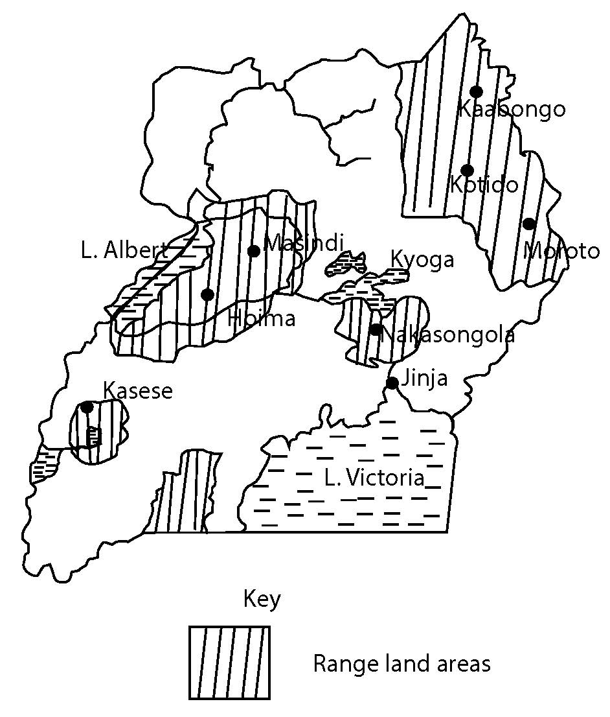

Candidates are expected to explain the problems faced in the utilization of Rangelands.
- Low and unreliable rainfall amounts affecting farming for example in Sembabule, Nakasongola etc.
- Scarcity of nutritious pastures for the licve stock for example in Kivuhura, Buliisa, Nakasongola etc.
- Pests and diseases affecting animals and plants in Sembabule, Moroto, Kotido Masindi etc.
- Scarcity of underground water affecting livestock rearing in Kotido, Buliisa, Moroto, Nakasongola etc.
- Remoteness of rangelands due to limited and poor transport for example in Kotido, Nakapiripiriti, etc.
- Poor and infertile soils limiting the growing of crops for example in Moroto, Masindi, Buliisa etc.
- Encroachment on gazette National parks by the Bahima in Lake Mbiiro in Kivuhura, Basongola in Queen Elizabeth in Kasese etc. This risks their animal form wild animal attack.
- There is inadequate capital to utilize the rangelands for example to buy modern tools in the mining of Gold in Kabong, Kotido etc.
- There is insecurity in some rangelands areas for example the cattle rustlers from North West Kenya attacking Ugandans in Kabong, Kotido etc.
- Limited skilled labour ie veterinary doctors
- Unfavorable government failure to construct and maintain transport routes
- Land wrangles – especially in Nakasongola
- Wild animals
NOTE: Points must be explained and illustrated with a Range land area.
Points without illustrations must not go beyond half the allocated mark.
Any 8x1
Mx 08mks.
b. Candidates can then describe the steps taken to overcome those problems. i.e.
- Digging of valley dams bore holes etc. to avail with water for example in Masha, Kiruhura, Nakasongola etc.
- Introductions of ranching to control overgrazing e.g. Kiruhura, Buliisa etc.
- Spraying of animals to kill pests which attack animals in Moroto, Kaabong.
- Introduction of irrigation farming to those dry areas like Moroto, Buliisa etc. to be able to grow crops.
- Establishing of wild animal parks where the places cannot enable enable crop, growing of Bokora corridor in Kotido, Moroto etc.
- Planting of trees to change the living conditions for example Agoro in Lamuto, Orom in Kitgum, Opili in Agago districts etc.
- Controlled hunting to reduce on the wild animals the animals and people in Kotido, Moroto, Kaabong etc.
- Alternative activities other than farming have been introduced for example mining of Gold in Kotido, Petroleum in the Wanseko – Semuliki basin etc.
- Apiculture or bee keeping has been done especially in areas, where trees are found e.g. in Moroto, Kasese, East Madi areas etc.
- The national environmental Management authority is carrying out public seminars and rallies for sustainable use of rangelands.
- Micro-finances institutions are offer loans and other non-governmental organization like “send a cow” Heifa international etc. e.g. Sembabule, Rakai, Masindi etc.
- The government has taken on the tarmacking of roads in those areas to enable the use of these areas e.g. in Nakapiripiriti, Kotido etc.
Any 10x1
Mx 10marks
NOTE: Points must be explained and illustrated with a range land area.
TOTAL 25 Marks
4. Discuss the extent to which physical factors have limited the exploitation of non-metallic minerals in Uganda. (25marks)
Candidates are expected to come up with the current status of the mining sectors in Uganda as.
- Quarrying sand and clay mining are on the increase through out the country.
- Actual mining of petroleum is soon beginning in Hoima.
- Phosphate processing stopped way back in the 1970s
- Vermiculite is one of the most selling minerals in Uganda.
- Most mining in Uganda is done using remote/crude tools e.g. lime in Kisor, Kasese etc.
- Limestone mining in Tororo and in Kisoro, Kasese etc.
- Limestone mining in Tororo and Hima is still at a low level .
- The processing of salt at Lake Katwe in Kasese stopped. Etc.
Accept any 2x1 02mks.
Candidates can identify the non metallic minerals in Uganda for example;
- Limestone in Kasese, Tororoetc
- Gypsum in Mbarara; Bundibujo
- Mica in Nebbi, Moroto, Kitgum etc.
- Salt in Lake Katwe in Kasese
- Asbestos in Arua, Tororo, Kaabong etc.
- Diatomite – Nebbi , Aura, Moyo
- Kaoiline- L .Victoria shore line
- Field spur in Kayunga.
- Phosphate in Tororo
- Sand and clay around lakes i.e. Victoria, Kyoga etc.
- Granite in Mubende, Nakasongola etc.
- Petroleum in Albertine rift
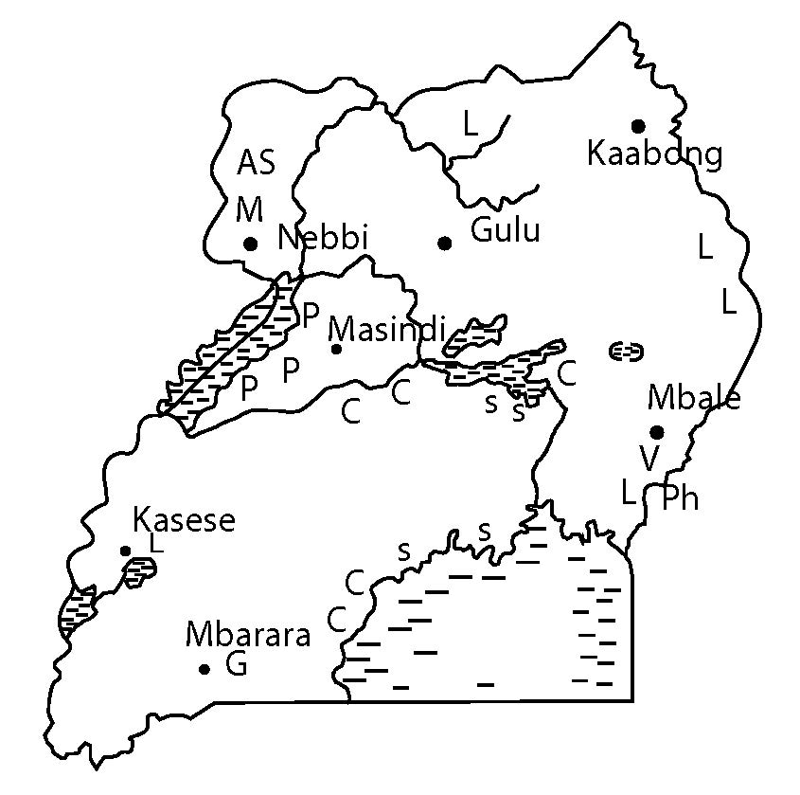
A sketchmap of Uganda showing the distribution of Non-mettalic minerals.

Key
V – Vermiculite
L – Limestone
M – Mica
Ph – Phosphate
P – Petroleum
G – Gypsum
S – Sand
As – Asbestos
C – Clay
Candidates should come up with the physical factors, limiting the exploitation of non metallic minerals for example.
- Minerals occur in small quantities which is uneconomical to the mine for example Gypsum in Mbarara , Bundibugyo etc.
- The quality and concetration of minerals is low, this reduces the demand for these minerals for example clay in Wakis, Mica in Nebbi etc.
- Minerals are buried under hard basements rocks which make them difficult to exploit for example Vermiculite in Mbal, lime stone in Tororo etc.
- Most minerals in Uaganda are scattered where they exist this limits their exploitation for example Limestone in Moroto, Kitgum etc.
- International territorial conflicts between Uganda and other counties for example D.R.C on petroleum in the Lansiko – Sumulinki basin.
- Unfavorable climatic conditions characterized by heavy rainfall amounts limit extraction of clay, sand
Any 3 physical factors well explained and the illustrated with a non-metallic mineral x2 04marks
Candidates can then bring up the other factors for example;
- Competition from other sectors, for example agriculture limit the mining for example clay, sand etc around lakes, tourism
- Repatriation of profits by Foreign companies doing mining e.g. Vermiculite in Mbale, Petroleum in Buliisa.
- The low level of techmology to prospect and exploit the minerals for example limestone in Kitgum, Mica in Nebbi.
- Limited capital to buy machines used in the mining of for example Mica in Nebbi, Limestone in Moroto etc.
- Remoteness of some mineral rich areas for example salt in Kasese, Gypsum in Mbarara etc./ Bundibugyo
- Inadequate market for some minerals for example rock salt in Kasese
- Limited power and energy needed to drive machines in the processing of the minerals like Vermiculite in Mbale etc.
- Exhaustion of some of the minerals for example limestone in Tororo, Mica in Nebbi etc.
- Environmental activism, these delay to give license to mineral exploiters on condition/ of environment protection e.g. in the mining of sand in Lwera.
- Hostility of some tribes in the mining areas for example limestone in Moroto by the Karamojongs.
- Inadequate skilled labour to carry on processing of minerals for example Limestone in Kasese, Mica in Nebbi etc.
- Insecurity in some areas with minerals for example Limestone inKasese etc.
- Unsupportive government policies for example the beaurocracy in the giving of licenses to mines e.g. sand in Lwera etc.
- Accidents in the mining process, scafre away the miners e.g. the mining of Granites in Mubende, Nakasongolaetc
- Corruption/embezzlement of funds for example petroleum in lake Albert region.
- Diseases and pests which attack miners for example clay and sand around lakes.
- The failing prices of some minerals on the world market have led to the closer mines e.g. phosphates in Tororo /Price fluctuation etc.
Any 12x1 12marks
NOTE: Candidate must stick to the question i.e. non metallic minerals.
TOTAL 25 marks
5. Assess the contribution of irrigation farming on the development of Uganda. (25marks)
Candidates are expected to define Irrigation farming as a form of farming where water is artificially applied to the field especially in areas which receive low and unreliable rainfall.
Mx 02Mks
Candidates can then bring up the major examples if irrigation farming scheme in Uganda for example.
- Mubuku irrigation scheme in Kasese
- Kiige irrigation scheme in Kamuli
- Labori irrigation scheme in Serere
- Ongoma irrigation scheme in Lira
- Atera irrigation scheme in Apac
- Agoro irrigation scheme in Kitgum
- Kibimba irrigation scheme in Bugiri
- Olwanyi irrigation scheme in Dokolo
- Doho irrigation scheme in Butaleja
- Kakira sugar plantation in Jinja
- Lugezisugar plantation in Buikwe
Etc
NOTE: Identification of the irrigation farms with a sketch map.
Mx 05marks
Identification without a sketch map
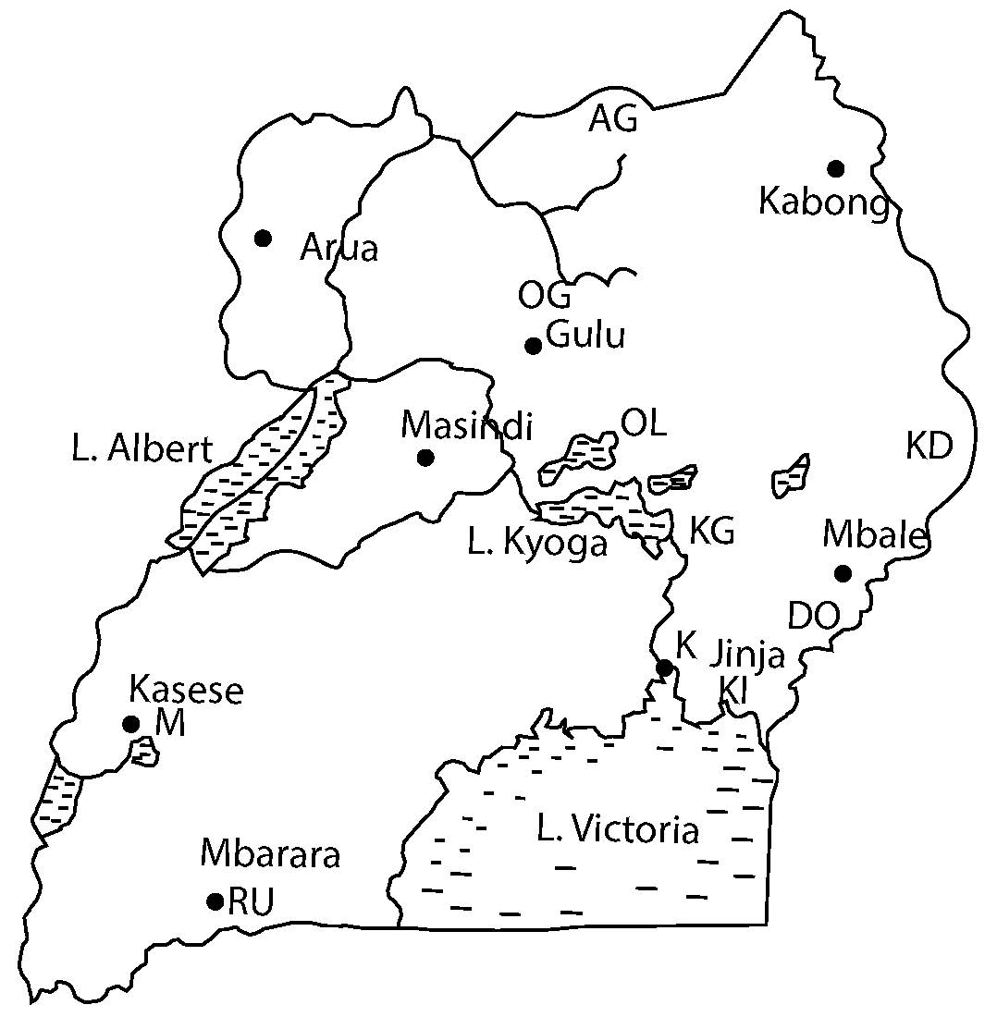
Mx 03marks
A Sketch map of Uganda Showing Irrigation farms.

Key
KI- KibimbiIrrigation scheme
K- Karira Plantation
DO- Doho Irrigation scheme
M-Mubuku Irrigation scheme
RU-RuhiraIrrigation scheme
KG- KiigeIrrigation scheme
KD- Kadam Irrigation scheme
AG - AgoroIrrigation scheme
OL- OlwenyiIrrigation scheme

Candidates expected to come up with the positive contributions of irrigation farming for example.
- Source of employment opportunities for example drivers seeders etc. on Doho irrigation scheme in Butalejja.
- Training skills for example at Olweny in Dokolo, Kiige in Kamuli etc.
- Avails food to the people for example Kakiraosugar plantation in Jinja etc.
- It is a source of foreign exchange i.e. when goods are sold to outside counties for example KIbimba in Bugiri etc.
- It supports the cultivation of cash crops like rice and fruits etc. for example Kibimba rice scheme in Bugiri etc.
- Facilitates the growth of industries that process agricultural products for example Kakira sugar plantation in Jinja etc.
- Reduces the risks of crop failure due to drought e.g. at Ongom irrigation scheme in Lira, Mubuku in Kasese etc.
- Creates market for irrigation equipment for example water pumps at Kiige irrigation scheme in Kamuli etc.
- Enables infrastructural odevelopemnt for example roads, schools, hospitals etc. at Kakira sugar plantation in Jinja, Kibimba rice scheme in Bugiri etc.
- Urbanization
- Promotes research/education/Terrorism for example at Kakira sugar plantation in Jinja, Mubuku in Kasese etc.
- Source of revenue i.e. taxes paid to the government by for example Doho scheme in Butalejja etc.
- Promotes international relationship especially with countries where goods are sold e.g. Kibinba via scheme in Bugiri, Olweny in Dokolo etc.
- Enables ithe diversification of the economy e.g. from tourism to agriculture by Mubuku scheme in Kasese etc.
- Makes use of land that would otherwise remain unutilized.
NOTE: Candidate must explain and illustrate their points with an irrigation scheme and place without he/she should not exceed half the mark.
Any 10x1 10marks
Candidates can then bring up the Negative contributions for example:
- Leads to displacement of people in the process of expanding of farms for example Kakira sugar plantation in Jinja
- Encourage the cutting down of trees in the process growing crops for example Doho Scheme in Butalejja.
- Increases the risks of disease spread especially the people who work in flooded water of Bilharzia, mosquitoes causing malaria e.g. in Kibimba rice scheme in Bugiri.
- Encourage rural-urban migration for people intending to get jobs up at Kakira sugar plantation in Jinja etc.
- Specialization in a particular crop is affected by price fluctuations on the world market for example Kibimba rice scheme in Bugiri etc.
- There is contamination of the water that is used by other people during the spraying of pests and diseases e.g. at Mubuku irrigation scheme in Kasese etc.
- Monoculture leads to soil deterioration for example at Doho scheme
- Has led to profit repatriation e.g. at Kakira sugar plantation in Jinja etc.
- Brings about urbanization and its problems e.g. Kakira in Jinja etc.
Any 8x1 08mks
TOTAL 25marks
6. Examine the causes and effects of land degradation in Uganda. (25marks)
Candidate are expected to define the term land degradation as the devaluation/ deterioration of the usefulness of land./The depreciation in soil fertility
Mx 02mks
Candidates can then come up with areas experiencing land degradation
i.e.
- Areas of Kaabong, Kiruhura, Buliisa etc. due to overgrazing
- Kampala, Jinja due dumping of industrial waste like plastics, glasses etc.
- Suta, Mukono, Kajjansi, due ro mining of sand, clay etc.
- Buikwe, Mukono etc. due to monoculture
- Bududa, Kapchorwa etc. due to land slides.
- Nakasongola, Moroto, Nakapiripiriti due to Bush burning etc.
Identification with a sketch map
Mx 05 marks
Identification without a map
Mx 03marks
A sketch map of Uganda showing areas experiencing land degradation.

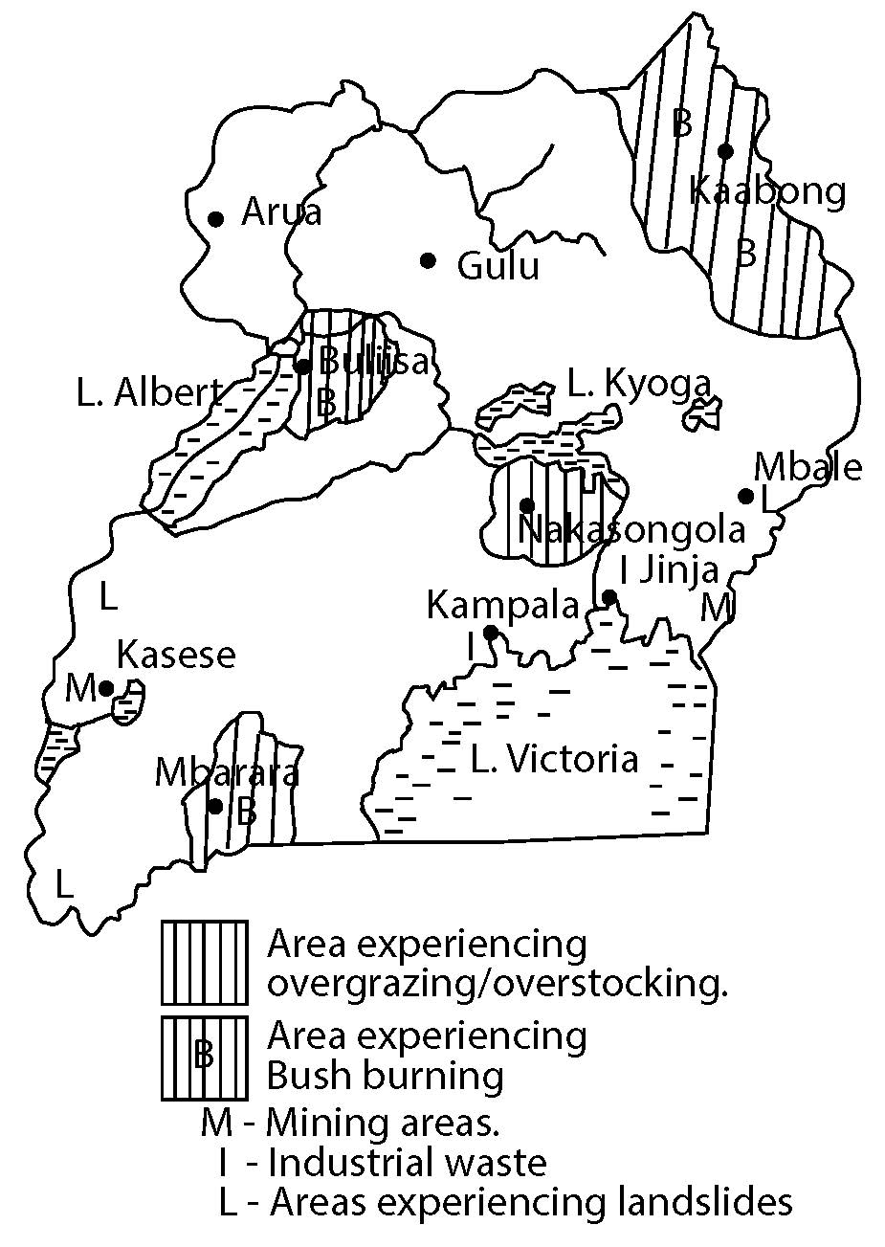

Candidates are expected to come up with the causes of land degradation in Uganda for example.
- Overstacking which leads to overgrazing exposing the fertile soils to agents of erosion e.g. in Kaabongetc.
- Monoculture i.e. growing of the same crop over and over depriving of the soil it’s nutrients weakening it for example in Buikwe, Jinja etc.
- Use of some fertilizers, Herbicides and pesticides with chemicals that kill the soil forming living organisms affecting the soil e.g. use of DDT in Masaka, Rakai etc.
- Digging along the steep hills, this creates channels for water taking away the fertile soils e.g. Kabale, Kisoro etc.
- Extensive cutting down of trees reducing rainfall amounts in an area, this reduces tfhe moisture in the soil e.g. around Mabira, Budongo forests etc.
- Bush burning, this exposes the top soils to agents of soil erosion and also kills soil forming organisms.
- Industrial effluents or waste disposal of plastics, polythene, papers/bags, glasses etc. these limit the penetration of water into soil e.g. in Kampala, Jinja etc.
- Mining/quarrying, this deforms the land/limiting it from being used for other services e.g. in Kajjansi, Seeta etc.
- Global warming
- Natural fires.
- Road construction, machines during construction cause vibrations which weakens the soil setting off mass wasting e.g. Kapchorwa – Nakapiripiriti road etc.
- Heavy rainfall, this increases the water run off taking away the fertile top soils e.g. Mukono, Kabale etc.
- Earth quakesdistracts the land making it hard to be used again e.g. Kabarole, Bundibujo etc.
- Volcanicity, the explosions create young soils which is in use e.g. in Kisoro, Mbale etc.
- Floods etc.
- Pests like locusts
- Drought (prolonged)
NOTE: Points must be explained and illustrated with a placement where land degradation is taking place.
Any 10x1 Mx 10mrks
Candidates can then come up with the effects of hand degradation for example;
- Reduced food production due to the reduced soil nutients e.g. in Masaka etc.
- Weakening of the soil strata due vibrations during road construction sitting off mass wasting e.g. in Kapchorwa
- Increased rates of landslides for example in Bududa, Sironko etc.
- Loss of soil fertility due to dumped polythene bags e.g. in Wakiso, Kampala etc.
- Creation of gullies/trenches affecting transport of Moroto, Kotidoetc
- Slowing down the soil forming process due to bush burning the soil living organism e.g. in Kaabong, Buliisa etc.
- Reducing rainfall due to bush burning and cutting down the forests which reduce water in the soil of Masindi, Moroto etc.
- Famine due to food shortage e.g. recently in Soroti people were eating leaves of trees.
- There is increased soil erosion due to the way soils are managed e.g. in Moroto, Kitgum etc.
Any 8 well explained and illustrated
Mx 08mks
TOTAL 25marks
7. To what extent has the low level of technology hindered the exploitation of forests in the lower altitudes of Uganda? (25marks)
Candidates are expected to come up with the current status of the forestry sector in Uganda i.e.
- There is a high rate of deforestation.
- Afforestation and re-afforestation programs are on in different areas.
- Much of the destruction of forests is due to the need for charcoal and fire wood.
- Equatorial lowland forests are heavily encroached by settlers.
- The government of Uganda has incorporated by settlers.
- The government of Uganda is encouraging the use for sustainable exploitation of forestry.
- Some forests have been redemacated and other gazetted.
- Most of the low land forests are hard wood trees
- Forest cover stands at around 4.9 million hectares.
- Etc.
Any 2x1 02 marks
Example soffporests in the lower altitudes of Uganda include.
- Budongo in Buikwe
- Bugoma in Hoima
- Malabigambo in Rakai
- Bwindi impenetrable in Kanungu
- Kalinzu in Bushenyi
- Sumuliki in Bundibugyo
- Echnya in Kisoro
- Maramagambo in Rubirizi
- KashokaKitomi in Buhweju
- Mpanga in Mpigi
- Lutaboka in Kalangala
- Kibaale in Kabarole
- Etc.
Riverine forest katonga, Nile kufu forest
Planted forest: Bugamba Katugo Zombo
Savana woodland, Mt kei, Morongole, Otze
NOTE: Identification of forests in lower altitudes with a map
05 marks

Mere identification of these forests without a map
03 marks
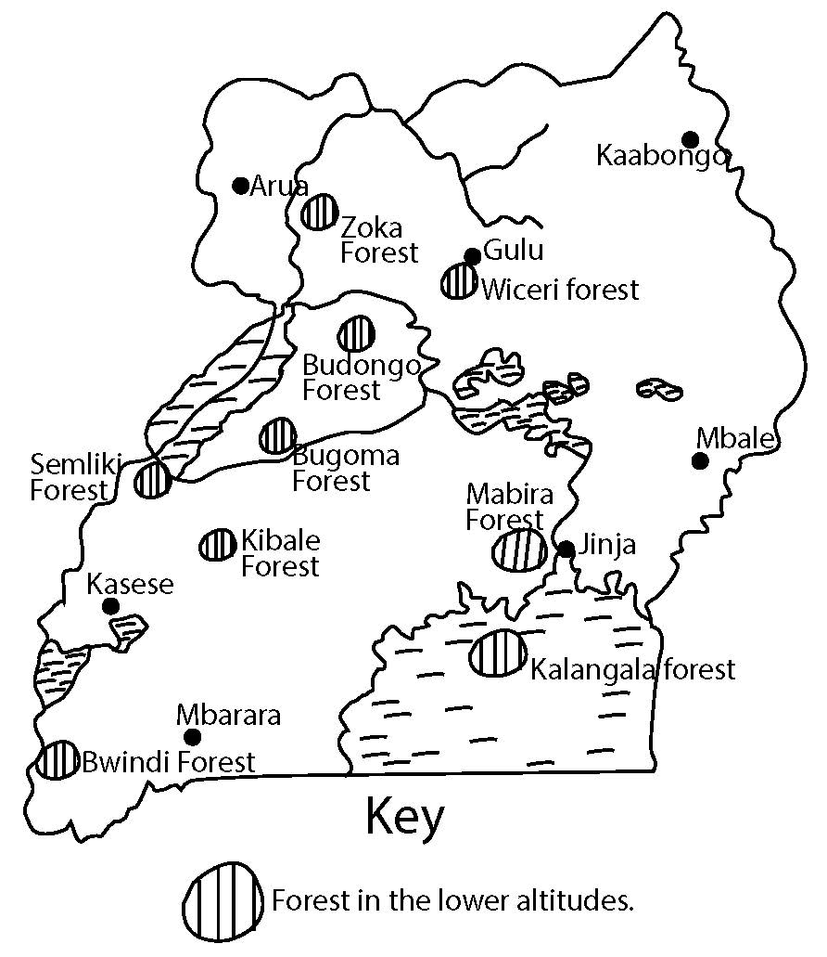
A Sketch map of Uganda showing forest found in lower attitudes

Tile -01 marks
Any 3 named forest 03 marks
Key/labelling -01mark
05 marks
Candidates are expected to come up with the extent of low levels of technology hindering forest exploitation in lower attitudes of Uganda ie.
- Uses of local tools to cut down the trees for example the hand saw, pangs axesetc which is tiresome to put the tree down e,gBudongo, Weceri, Zoka etc.
- The technology used to predict the illegal encroaches is very remote. This has costed the fillers life through fight eg in Bugoma, Kalangala forest etc.
- The use of ropes to drug 10gs of trees to processing plant is tiresome to those doing it in Kalinju forests.
- Very local processing plants that can not even change the saw dust into ply wood etc in Masindi for Budongo forest
- The technology used in the filling of trees has created losses through destroying the young one leg in Mabira, Kicerietc
- Any 3 well explained and illustrated with a forest name x 2 marks
- Mx 06 marks
- Candies can the bring the other factors hindering the exploitation of forest in the lower altitudes of Uganda ie.
- The scattered valuable species of trees making exploitation hard in Mabira, Budongo forest etc,
- Presence of wild animals like lion, leopards, snakes etc that scare away the exploiters eg. In kibale forest e6tc.
- National barriers eg water falls, wetlands etc that cut off areas with forest a egBwindi forest etc.
- Pest and diseases which scare away the exploiters e.g Mosquitoes, Teste flies etc in Bwindi, Kibale forest etc.
- Inadequate capital needed to buy modern tools to use e.gMabira forest.
- Un controllable fires that destroy large areas of forest egBugoma forest etc.
- Competition from other lad users e g agriculturalist , settlers, tourist etceg in Mabira, Kibale forest etc.
- Government policy of gazetting forest limiting exploiters egMabira, Kibale forest.
- Limited markets for the hard wood tree species in Budongo, Bugoma forest etc
- Limited government support to train skills, funding research etceg at Nyabyeya forest college into exploit forest likeMabira.
- Insecurity in some areas with forest potentials egsemuliki forest.
- Land tenure systems/ culture many limit forest exploit6ationeg land lords with big chanks of land in MabiraKibale forest etc.
- Dampness of the environment ie cold and dark limit exploitation eg in Bwindi forest
- Profit repatriation where investors fails to pay workers and instead go away with all the money eg in Kibale forest etc.
- Corruption and embezzlement of funds by officers in forestry department eg for mabirra forest etc.
- Remote location of some forest limit their assessment and transportation of forest products eg in Bwindi forest
- Inadequate power supply needed for the processing of wood ie got from semuliki forest etc
Any 12 well explained and illustrated with a name of a forest x 1 mark
Mx 12 marks
Total 25 marks
- Nature of forest
- Long gestation period
- Climbing plants
- Buttress roots
- Hard wood timber
- No pure stands
8. Study the table below showing Ugandan’s projected mid ten year age group (2014) and answer the questions that follow:
Age | Male (‘000s) | Female(‘000s) | Total (000s)
0-9  10-19  20-29  30-39  40-49  50-59  60-69  70-79  80+ | 6,078  4,342  2,570  1,706  938  534  413  225  126 | 6,135  4,461  3,063  1,778  1,027  633  437  240  145 | 12,213  8,803  5,633  3,484  1,966  1167  850  465  217

Source: Uganda bureau of statistics report 2015.

a) Draw a population pyramid to represent Uganda’s population structure. (13marks)
A population pyramid representing Uganda population structure in 2014 in ‘000s
PERCENTAGES
Age years | MALE | FEMALE % | TOTAL % Age
0-9 | 17.43 | 17.60 | 35.04
10-19 | 12.45 | 12.79 | 25.25
20-29 | 7.37 | 8.78 | 16.16
30-39 | 4.89 | 5.10 | 9.99
40-49 | 2.69 | 2.94 | 5.64
50-59 | 1.53 | 1.81 | 3.34
60-69 | 1.18 | 1.25 | 2.43
70-79 | 0.64 | 0.68 | 1.33
80+ | 0.36 | 0.41 | 0.77

Ie No of male x 1000 = % age
Total population
No of female x 100 = %age
Total population
Fore example
6078 x 100
34852
=17. 43%
Note no mark for calculations
Exchange of sides of male and female means no mark for accurancy but gets for marginal.

b) Describe the characteristics of Uganda’s population. (02marks)
- Children of age group 0-9 are very many compared to others
- women appear to be more than men.
- Many people in Uganda die at the age of 60+
- There are more people at the retirement age ie 60+
- The difference in age between male and female is small
- There is a high birth rate in Uganda
- It has a triangular shape
Any 2 x 1 -02 marks

c) Assess the impact of the above population structure on the development of Uganda.
(10 marks)
The population is big in the lower age group and it goes on increasing the age groups rise.
Negative impact
- High dependence burden
- Limited savings due to more to look after
- High government expenditure.
- Few people in the working age
- Easy spread of diseases/.
- High crime rates
- High poverty rates
Any 3 x 2 = 06 marks
Positive impacts
- Room for future employment
- Chances are there for exploitation of resources.
- Market for goods in young children.
Any 2 x 2 = 04marks.

