Making Guide
P530/3 Biology
No.1.You are provided with freshly killed specimen labeled R
- Open the specimen to expose its Coelum.
- Basing on the features exposed, with a reason state the class of the specimen.
(2 marks)
- It is amammalia;
- It bears a diaphragm
(ii) Without displacement draw and label the structures for food storage, flow of materials and immunity. (13 marks)
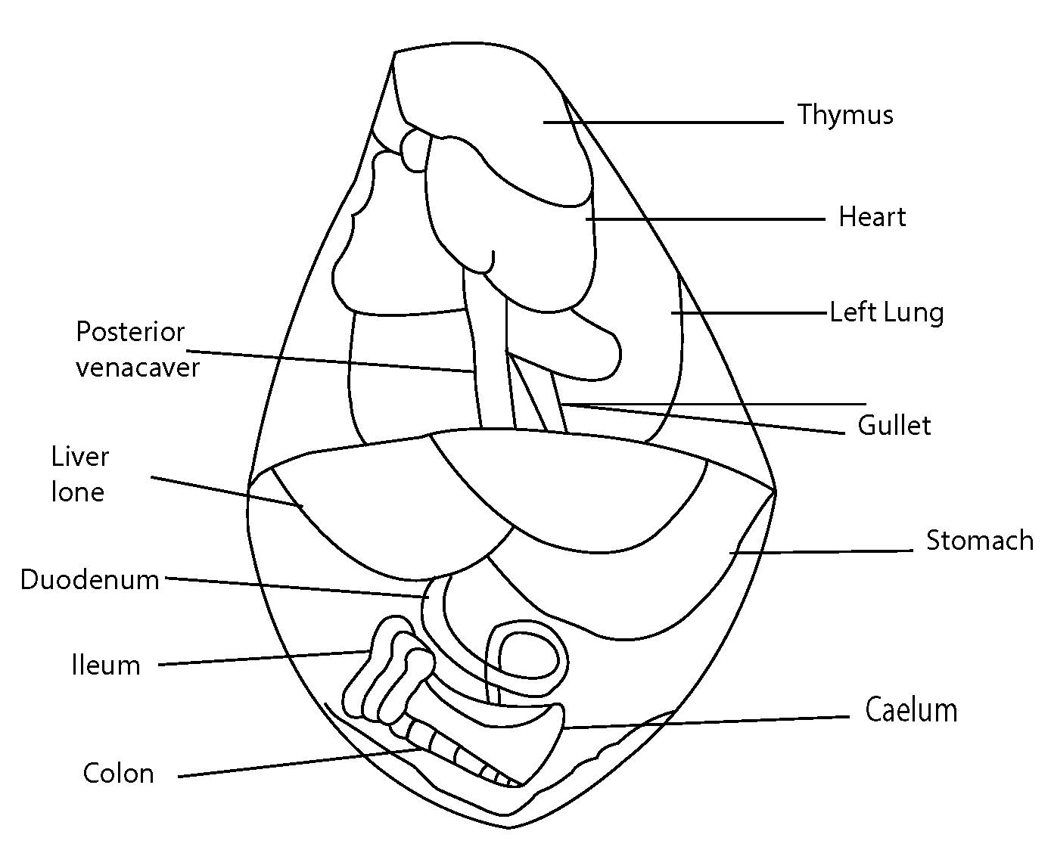
The drawing of coelum structures of specimen R used for flow of materials, Immunity and storage of food;

NA-abdominal if any other feature and labeled
- Ignore
NA –Theraac any other feature draw and leballed
Award any one luglobe for drawing Habeling

- Display vessels that:
- Supply right side of the head.
- Drain left side of the head, intestines and right side of the pelvic region.
With the heart displaced to its right draw, and label your dissection. (27 marks)
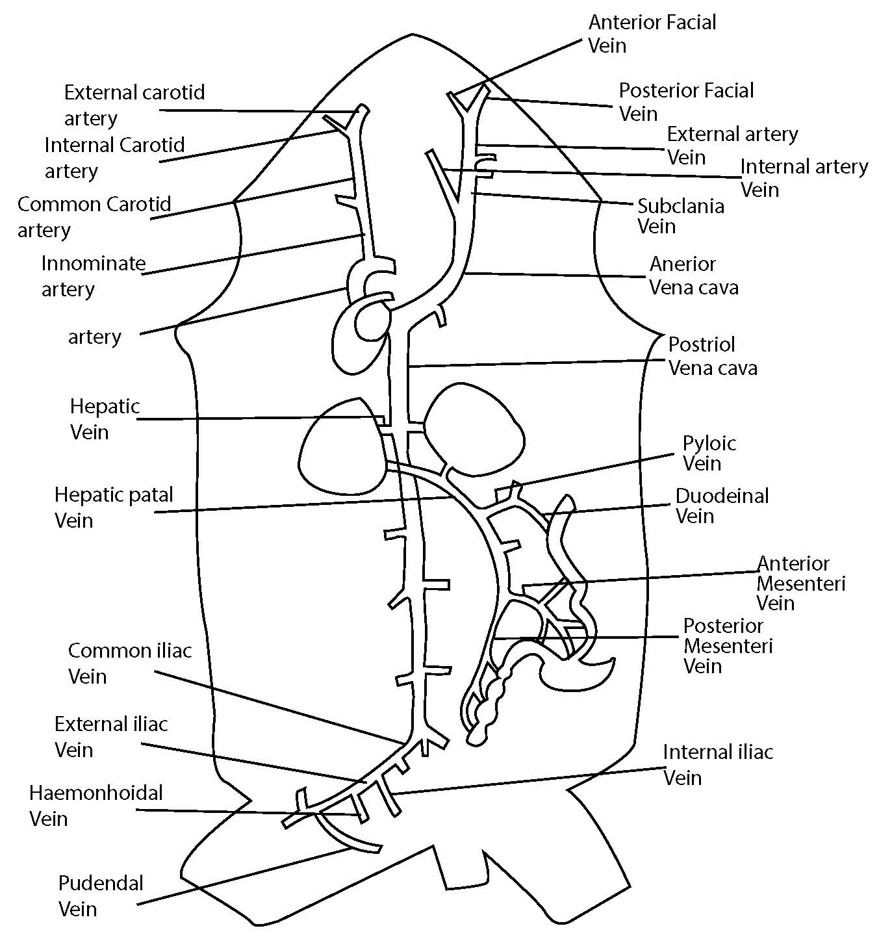
The drawing of vessels supplying the right side of the head and drawing the left side of the head, intestines and right side of pelvic region with heart displaced to the right of specimen R.

No. 2. You are provided with solution S, H and W.
- Write and carry out the tests in the table 1 below to confirm the chemical composition of solution S. (12 marks)
TABLE I
Tests | Observation | Conclusion
Iodine test  To 2cm³ of solution S add 2 drops of iodine solution | The colorless solution turns to pale brown solution | Starch absent
Benedict’s test  To 2cm³ of solution S add 2cm³ of Benedict’s solution and boil | The colorless solution turned blue and remained blue solution | Reducing sugars absent
Biuret test  To 2cm³ of solution S add 1cm³ of NaoH(aq) followed by 2 drops of copper II suphates | The colorless solution turns to blue precipitate | Proteins absent
06 + 03 + 03 = 12
Note: wrong test no mark for observation and conclusion.
Reject; Warm or heat without time duration for Benedict’s test.
Iodine solution
Brown alene
Blue solution for observation of Burret test

b) Obtain six test tubes and label five of them 1, 2, 3, 4 and 5.
- Obtain six test tubes and label five of them 1, 2, 3, 4 and 5.
Cut 60cm long of anterior part of ileum of specimen R. Cut it into 4 equal parts and dip them into a beaker of water. Gently squeeze out the ileum content. With dry sand and pestle crush all pieces of ileum in a mortar into a paste. Add 14cm³ of water then decant a clear solution into a test tube and label the extract as E.
Pour 2cm³ of solution S into the labelled test tubes then to test tube;
1 + 1cm³ of E.
2 + 1cm³ of H + 1cm³ of E.
3 + 1cm³ of W + 1cm³ of E.
4 + 5 drops of E.
5 + 1cm³ of boiled E.
Incubate all test tubes at 35 – 40⁰C for 6 minutes.
Carry out Benedict’s test on all test tubes 1 – 5 and record your observations and conclusions in table II below. (10 marks)
b) TABLE II
Benedict’s test | T.T | Observation | Conclusion
To 2cm³ of the mixture add 2cm³ of Benedict’s solution and boil. | 1 | The turbid solution turned blue solution to green and then yellow precipitate | Moderate reducing sugar present
 | 2 | The turbid solution turned blue and remained blue | Reducing sugars absent
 | 3 | The turbid solution turned blue solution and then green solution | Little reducing sugar present
 | 4 | The turbid solution turned to blue solution then to green solution | Little reducing sugar present
 | 5 | The turbid solution turned blue solution and then remained blue solution | Reducing sugar absent
05 + 05 10

(c) Explain the observations in table II above.
(c) Test tube 1
High concentration of enzyme molecules E;
Faster collision of substrate with enzyme molecules; faster break dawn of substrate S; no breakdown of substrate S into reducing sugars. 03 marks
Test tube 2
Medium H inhibits activity of enzyme in Extract E; no breakdown of substrate S into reducing sugars. 02 marks
Test tube 3
Medium W lowers activity of E; hence slow break down of S; into little reducing sugars.
02 marks
Test tube 4
Low concentration of E; low chances of collision between substrate S with enzyme molecule; slow rate of breakdown of S; into reducing sugars. 03 marks
Test tube 5
Boiling/high temperature denatures enzyme molecules E; hence no breakdown of substrate S; into reducing sugars. 02 marks
(12)
(d)i) With a reason suggest the nature of Extract E. (2 marks)
(i) An enzyme/ biological/ organism catalyst
It catalyzes the breakdown of substrate S into reducing sugars; 02

(ii) State four properties of Extract E. (4 marks)
- Its activity increases with increases with increase in its concentrations;
- It catalyzes the breakdown of substrate S into reducing sugars;
- It is denatured by High temperature/boiling;
- Its activity is reduced by medium W;
- Its activity is stopped by medium H;
3+1=04
(06)
NB: No student should suggest the named/nature of solution S because it is not identified. If she/he does, should lose the marks for No.2 (39) – sign of prior knowledge
No.3. You are provided with specimens A, B, C, D and F. Cut specimens A, B, and D transversely and specimen C longitudinally.
a) (i) Examine the endocarp of B and state how it increases the chances of dispersal of the specimen. (2 marks)
- Juicy endo carp to attract animals;
- Numerous seeds to increase chances of dispersals;
- Seeds covered by oily fluid to protect the seeds from animal digestion. Any2x1=02
(ii) With a hand lens examine and describe the differences between seeds of specimen
A and D. (2 marks)
Seeds of H | Seeds of D
- Round seeds  - Short funicle  - Larger seeds  - Seed reduce project | Flattered seeds  Long funicle  Smaller seeds  Seeds radiate inwards
Any 2x1=02

(b) Use a hand lens to observe and state descriptive features in a locule of the following specimens. A, B, C, D and F.
Specimen H
Numerous; tapering; closely packed juicy hairs and a small, smooth; with short funicle;
4x$\frac{1}{2}$ =02
Specimen B
Fluid/ juice filled; with flattened; smooth; small numerous seeds; oval shaped; seeds with short funicle;
any 4x$\frac{1}{2}$ =02
Specimen c
A; very large; smooth; round; seed with very long; thick funicle; any 4x$\frac{1}{2}$ =02
(10)
Specimen D
Many; flattened; oval shaped; small seeds with thin; long funicle and fleshy funicle;
4x$\frac{1}{2}$ =02
Specimen F
Many; wrinked/rough; round; small seeds with long; thick/fleshy; funicle
4x$\frac{1}{2}$ =02

c) Use descriptive features in (b), above to construct a dichotomous key for specimens in order of F, B, D, C, and A.
Dichotomous key for specimens in of F, B, D, C and A.
1 a) wrinked/rough seeds| thick funicle
b) smooth seeds|thin funicle 2
2 a) flattered seeds ……………………………... 3
b) found seeds………………………………… 4
3 a) Juicy/short funicle/seeds covered by oily fluid ……………….. B
b) Fleshy/long funicle/ no oily fluid ……………………………… A
4 a) Very large seed/ no juicy hair ………………………………….. C
b) Small seed/juicy hairs …………………………………………. A
8x$\frac{1}{2}$ =04
OR
Only 3 & 4 re
3 a) Juicy/seeds covered by oily fluid ……………………………… B
b) Fleshy/no juicy fluid …………………………………………… D
4 a) Very large seed/ very funicle/ no juicy air ……………………. C
b) Small seed/short funicle/Juicy hair …………………………….. A
(08)

(d) Observe the cut surface of specimen A. By excluding structures that are exterior to locules draw and label half of it. (4marks)
The drawing of halt of the art surface of specimen A with structures anterior to locules excluded.
