P235/1
Islamic Religious Education
(The Glorious Quran)
Paper 1
July/August 2019

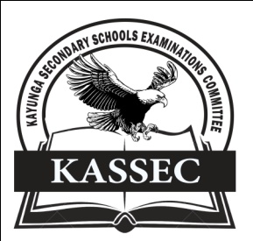

KAYUNGA SECONDARY SCHOOLS EXAMINATION COMMITTEE
Uganda Advanced Certificate of Education
JOINT MOCT EXAMS 2019
ISLAMIC RELIGIOUS EDUCATION
(The Glorious Quran)
PAPER ONE

INSTRUCTIONS TO CANDIDATES
- Answer four questions only
- All questions carry equal marks.

1. Examine the modes of revelation according to the Quran. (25 marks)

2. Account for the authenticity of the Holy Quran (25 marks)

3. Discuss the Quranic teachings on the soul. (25 marks)

4. (a) Discuss the conditions the dead experience in the grave. (13 marks)
(b) How does the above experience benefit the living Muslims? (12 marks)

5. Analyse the Quranic teachings on the status of a woman in Islam (25 marks)
6. (a) Discuss the Quranic teachings on brotherhood (13 marks)
(b) What is the significance of Islamic brotherhood to society? (12 marks)

7. Examine the guidance offered by the Quran in business transactions.(25 marks)

8. (a) Analyse the Quranic teachings on Zakah (13 marks)
(b) Explain the significance of Zakah to Muslims (12 marks)

9. Discuss the features of political system according to the teachings of the Quran (25 marks)
10. (a) Explain the conditions under which a Muslim is permitted to engage in
Jihad. (13 marks) (b) Analyse the significance of Jihad to Muslims (12 marks)

11. (a) Examine the themes of surat inshirah (13 marks)
(b) What lessons can be learnt from the surah? (12 marks)

12. (a) Discuss the content of surat al Asr (103) (15 marks)
(b) Analyse the lessons learnt from this surah by Muslims. (10 marks)

END

