P235/2
Islamic Religious Education
(Hadith and Fiqh)
Paper 2
July/August 2019
2 ½ HOURS

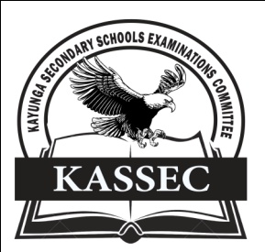
KAYUNGA SECONDARY SCHOOLS EXAMINATION COMMITTEE
Uganda Advanced Certificate of Education
JOINT MOCT EXAMS 2019
ISLAMIC RELIGIOUS EDUCATION
(HADITH AND FIQH)
PAPER TWO
2 HOURS 30 MINUTES

INSTRUCTIONS TO CANDIDATES
- This paper is divided into two sections A and B
- Answer any four questions, taking at least one from each section.
- All questions carry equal marks
- Any additional question(s) answered will not be marked.

SECTION A
HADITH (TRADITONS OF THE PROPHET)
1. Examine the role of Imam Malik bin Anas to the development of Hadith literature. (25 marks)

2. Discuss the contribution of Al –Bukhar to the compilation of Hadith. (25 marks)

3. In judging al – Misal’s works, he was included among the sound compilers. Analyse the criteria he used in compiling authentic traditions. (25 marks)

4. The practice of forging Hadith was detrimental but at the same time meritorious to Muslim practice. Discuss (25 marks)

5. (a) Account for the inclusion of Dhaif among the classes of Hadith (13 marks)
(b) Explain the impact of classification of the study of Hadith. (12 marks)

6. Analyse the characteristics of Hadith al – Qudsi. (25 marks)

SECTION B
FIQH (PRACTICE)
7. Account for the development of Islamic law up to 850AD. (25 mark)

8. Compare the Qur’an and Hadith as sources of Islamic law. (25 marks)

9. Discuss the origin of the legal classification of acts in Islam. (25 marks)

10. Discuss the biography and contribution of Imam Hanbal to the study of Islamic jurisprudence. (25 marks)

11. Explain the teachings of Islam on dignity of a woman. (25 marks)

12. (a) Discuss the struggle to apply sharia in Algeria (13 marks)
(b) Explain the challenges they faced in the struggle to apply sharia. (12 marks)
END

