P210/6
HISTORY
(African History)
Paper 6
Jul/Aug 2019
3 Hours

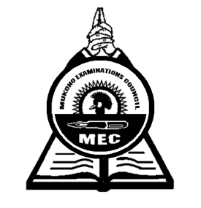

MUKONO EXAMINATION COUNCIL
Uganda Advanced Certificate of Education
HISTORY
(African History)
Paper 6
3 Hours

INSTRUCTIONS TO CANDIDATES
Answer any four questions only
All questions carry equal marks.
Any additional question(s) attempted will not be marked.

- Assess the role of the military sector in the survival and maintenance of the pre-colonial African states by the end of the 19th century. (25 marks)

- To what extent was the Berlin colonial congress of 1884 – 1885 responsible for the scramble and partition of Africa? (25 marks)

- Examine the impacts of the Abolition of slave trade in West Africa. (25 marks)

- How did the Portuguese rule affect the people of Angola by the end of the 19th century?
(25 marks)
- Explain the challenges that undermined the work of Ajaji Crowther as a missionary in West Africa. (25 marks)
- Account for the adoption and success of indirect rule in Northern Nigeria. (25 marks)

- Justify the causes and consequences of the Temne- Mende rebellion of 1898. (25 marks)

- Examine the impact of the mineral revolution to the peoples of South Africa between 1867 and 1910. (25 marks)

- How did the British exploit African land upto 1914? (25 marks)

- Why was Omukama Kabalega able to resist the British for long? (25 marks)

End -

