Name: ………………………………………………... Index No. ……………
Sign: …………………
P 510/2
PHYSICS
Paper 2
June /July 2017
2 ½ hours

S.6 INTERNAL MOCK EXAMINATION
Uganda Advance Certificate of Education
PHYSICS
Paper 2
2hours 30 minutes

Instructions to Candidates:
- Answer five questions including one from section A, one from section B and not more than two from C and D.
- Assume where necessary.
Acceleration due to gravity g = 9.81ms⁻²
Speed of light in vacuum, C = 3.0x10⁸ms⁻¹
Election charge, e = 1.6 x10⁻¹⁹C
Election mass, = 9.11x 10⁻³¹ Kg
Permeability of free space = 4πx10⁻⁷ Hm⁻¹
Permittivity of free space, = 8.85x10⁻¹² Hm⁻¹
The constant $\frac{1}{4πε_{0}}$ = 9.0x10⁹ F⁻¹m
Resistivity of Nichrome wire at 25⁰C = 1.2x10⁻⁶ Ωm
Specific heat capacity of water = 4.2x10³JKg⁻¹K^{-1.}

SECTION A
- a) Define the following terms applied to concave lens.
- principal focus (1mk)
(ii) Radii of curvature. (1mk)
b) A point object is placed at distance, U in front of a diverging lens of focal length, f to form an image at a distance, V from the lens. Derive an expression that relates U, V, f. (4mks)
c) Describe an experiment to determine the focal length of concave lens using a plane mirror, converging lens and an illuminated object. (4mks)
d) What is meant by a;
(i) Visual angle (1mk)
(ii) near point. (1mk)
e) A person with a normal near point distance of 25cm wears spectacles with a diverging lens of focal length 200cm in order to correct the far point distance to infinity. Calculate the near point distance when viewing using spectacles. (3mks)
f) (i) Draw a ray diagram to show the formation of an image of a distant object in a terrestrial telescope in normal adjustment. (3mks)
(ii) State two disadvantages of the terrestrial telescope. (2mks)

2. a) Define refractive index. (1mk)
b) (i) Describe with the aid of a diagram how the refractive index of a liquid can be determined using an air cell. (5mks)
(ii) Derive the expression used to obtain the refractive index of the liquid in b(i) above. (3mks)
c) A prism of refracting angle 60⁰ has refractive indices 1.515 and 1.529 for red and violet lights respectively. When white light is incident on one face of the prism, red light undergoes minimum deviation. Calculate;
(i) incidence angle for the white light. (4mks)
ii) emergence angle for violet light (3mks)
d) Describe the adjustments that have to be made before a spectrometer can be used. (4mks)

SECTION B
3. a) What is meant by the following as applied to wave motion?
i) wave length (1mk)
ii) wave front (1mk)
b) i) Define resonance. (1mk)
ii) Describe how velocity of sound in air can be determined using a resonance tube. (5mks)
c) i) Explain how stationary waves are formed. (3mks)
ii) A turning fork of 760Hz is sounded near the open end of a closed pipe of length 40cm. If air in the tube resonates with the turning fork, Determine the mode of vibration and its end correction. (Velocity of sound in air is 330ms⁻¹). (5mks)
d) i) Explain reverberation as applied to sound waves. (2mks)
ii) Explain how reverberation can be minimized in large halls. (2mks)
4 a) i) State two conditions necessary for interference patterns to be formed. (2mks)
ii) With the aid of a diagram, describe how interference can be produced by division of wave front. (4mks)
b) In young’s double slit experiment, the slits are 0.5mm apart and interference is observed on the screen placed at a distance of 100cm from the slits .It is found that the 9th bright fringe is at a distance of 8.84cm from the second dark fringe from the centre of the fringe pattern. Find the wave length of light used. (5mks)
c) Explain what is observed on the interference fringes in young’s double slit experiment when the monochromatic source of light is replaced by a source of white light. (5mks)
d) Describe how interference fringes are formed in a wedge –shaped film. (4mks)

SECTION C
5. a) i) Distinguish between root mean square value and peak value of an alternating current. (2mks)
ii) What is peak value of the voltage from a 240V a.c mains. (2mks)
b)
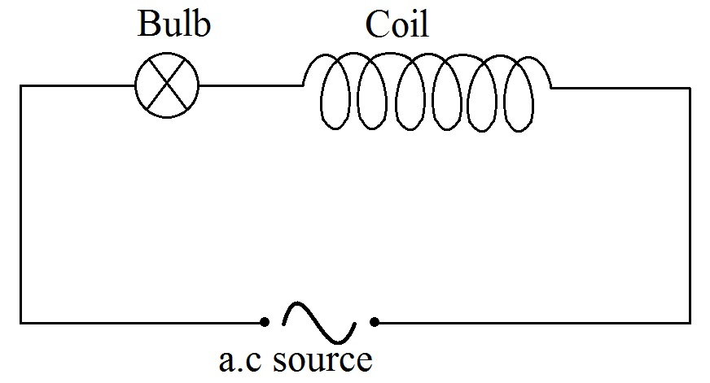
An air cored coil, a bulb and a.c source are connected as shown in fig 3 .When a solid iron core is introduced into the cool, the bulb becomes dimmer and the core hot. Explain the observation. (6mks)
c) i) What is meant by the term inductive reactance . (1mk)
ii) Derive an expression for the reactance of an inductor of inductance, L when a sinusoidal varying a.c of frequency,f passes through it. (5mks)
(iii) A sinusoidal alternating voltage of 6V_{rms} and frequency 1KHZ is applied to a coil of inductance 0.5H. Assuming that the coil has negligible resistance calculate the root mean square value of the current. (3mks)
d) State one advantage of a.c over d.c. (1mk)
6. a) Define
i) the tesla (1mk)
ii) Magnetic flix. (1mk)
b) Two infinitely long straight wires carrying currents, I₁ and I₂ respectively are placed parallel to each other in a vacuum at distance, d metres apart .Derive an expression for the force per metre between the wires. (05 marks)
c) i) Sketch the magnetic field pattern due to a current flowing in a circular cool. (02mks)
ii) Write down an expression for magnetic flux density at the centre of a circular coil of N turns each of radius r and carrying a current I. (01mk)
- A wire of length 7.85m is wound into a circular coil of radius 0.05m. If a current of 2A passes though the coil, find the magnetic flix density at the centre of the coil. (4mks)
d) With aid of a labeled diagram describe the structure and mode of operation of a d.c motor. (06mks)
7. a) i) Describe an experiment to demonstrate the damping effect of eddy current. (4mks)
ii) Give two practical applications of this effect. (01mk)
b) What is meant by;
i) Self induction (1mk)
ii) Mutual induction (1mk)
c) Discuss the factors which determine the maximum emf generated by a dynamo. (4mks)
d) A transformer has 2000 turns in the primary coil. The primary coil is connected to a 240V mains. A 12V, 36W lamp is connected to the secondary coil. If the efficiency of the transformer is 90% determine,
i) The number of turns in the primary coil. (2mks)
ii) Current flowing in the primary coil. (3mks)
e) Explain any two factors which lead to energy losses in the transformer. (4mks)

SECTION D
8. a) i) Define the following; electric field intensity and electric potential at a point. (02mks)
ii) Show that electric field intensity at appoint is equal to the negative potential gradient. (4mks)
b) i) Explain with the aid of a diagram ,how an insulated metal sphere can be charged by induction using a negatively charged rod. (3mks)
ii) Describe how a gold leaf electro scope can be used to detect the presence of charge on a body. (2mks)
c) i) Write down the equation for electrostatic force between two isolated point charges in a vacuum. (1mk)
ii) Sketch the electric field lines between two negatively changed spheres carrying unequal charges and use the sketch to explain a neutral point. (2mks).
d) A charged polystyrene sphere of mass 2g is suspended by a fine nylon thread between two plates 5cm apart as shown in the figure below.
+2000V
Plate
Plate
0V
5cm
Sphere

When a p.d of 2000V is applied across the plates, the thread attached to the square defeats through an angle of 30º .Calculate the charge on the sphere. (6mks)
9 a) i) Define the term dielectric constant. (1mk)
ii) State two uses of a die electric in a capacitor. (2mks)
b) i) Define capacitance of a capacitor. (1mk)
ii) Explain the effect of placing an insulator between the plates of a charged capacitor. (5mks)

c)
6.0 V
0.7µF
2.0µF
0.3 µF

Three capacitors of capacitances 0.7µF, 2.0µF and 0.3µF are connected as shown in the figure above. Calculate the energy stored in the 2.0µF capacitor when fully charged. (6mrks)
d) Explain with aid of a suitable graph the function of a capacitor in a full wave rectifier. (5mks)
10 a) i) Define electrical resistivity and state its units. (2mks)
ii) What is meant by emf and internal resistance of a battery. (2mks)
b) Explain why the resistance of a metal increases when the temperature of the metal is increased. (2mks)
c) Describe with the aid of labeled diagram,how a slide wire potentiometer may be used to determine the emf of a battery. (6mks)
10 Ω
3V
5Ω
K₂
E
D
B
A
d)
K₁

The circuit in the figure above shows a uniform slide wire AB of length 100cm and resistance 15 Ω. The wire is connected in series with a resistor of resistance 5Ω across a 3.0V battery of negligible Internal resistance. A cell of emf, E and internal resistance,r is connected as shown. With switches K₁ and k₂ open, the galvanometer ,G shows no deflection when AD is 75.0cm. With K₁ and k₂ closed, the galvanometer shows no deflection when AD is 65.0 cm. Find the;
- Value of emf E. (3mks)
- Internal resistance ,r (3mks)
- Balance length when k₁ is closed and k₂ is open. (2mks)

END

