P235/3
Islamic Religious Education
Paper 3
July/August 2019

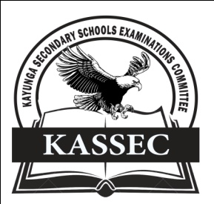
KAYUNGA SECONDARY SCHOOLS EXAMINATION COMMITTEE
Uganda Advanced Certificate of Education
JOINT MOCT EXAMS 2019
ISLAMIC RELIGIOUS EDUCATION
PAPER THREE

INSTRUCTIONS TO CANDIDATES
- Answer four questions.
- All questions carry equal marks.

1. Assess the contribution of Qusayy to the foundation and prosperity of Mecca as the great “Commercial city” of Arabia in the 16th century. (25marks)

2. Muhammad (P.B.U.H) was undoubtedly a religious leader, but for him, religion was the total responsibility of his personality to the situation in which he found himself. Support the above statement with evidence. (25marks)

3. “The Sabites were responsible for the challenges faced by the caliphate of Uthuman bin Affan”. Discuss (25marks)

4. When Yazid I assumed the reign of power, the opposition which his father had kept in check rose against him.
(a) Give an account of the rise (12marks)
(b) Explain the way Yazid dealt with opposition. (13marks)

5. Discuss the social and political organisation during the Umayyad era. (25marks)

6. To what extent was the Abbasid period of governance a new era? (25marks)

7. To what extent was the invasion of the Mongols in Persia a death blow to the existence of the Abbasids dynasty? (25marks)

8. “It was the excellent preparation for the invasion of Egypt that enabled the Fatmids to rise”. Discuss (25marks)

9. How justifiable is the claim that al Azhar is the most outstanding Fatimid cultural institution. (25marks)

10. To what extent did Salah Din contribution of Muslim success against the crusaders? (25marks)

11. Assess the impact of the Moghuls on the development of Islam in central Asia and India. (25marks)

12. Analyse the system of administration under the Ottomans. (25marks)

END

