S.6 BIOLOGY PAPER 1
TIME:2¹/₂HOURS

NAME……………………………………………………………………………………… STREAM…………………
Instructions:
- Answer all questions in section A and B
- Put the alternative showing the most correct answer in the box on the right of each question
SECTION A (40 MARKS)
- Which of the following statements concerning human red blood corpuscles is false?
- Contain the red pigment hemoglobin
- Are destroyed by the liver
- Lack a nucleus when mature
- Are spherical in shape
- A trio –ventricular and semi lunar valves
- Ensure supply of blood to the heart muscle cells
- Keep blood moving in one direction in the heart
- Separate the left from the right ventricles and atria
- Ensure supply of blood to skeletal muscle
- The more variation in a population, the greater its potential to
- Give rise to gene flow
- Adapt to new changes in its environment
- Produce more males
- Be wiped away by an epidemic
- In phototropism
- Auxin is inactivated on the lightened side
- More auxin is synthesized on the darkened side
- Light initiates a redistribution of auxin in the zone of elongation
- Light initiates a redistribution of auxin in the apical meristem
- Which of the following is an adaptation to aquatic environment?
- Long roots
- Lack of stomata
- Large cortex with closely packed cells
- Well-developed xylem
- In photosynthesizing plant cells, the light dependent and the light-independent reactions take place in the …………………respectively.
- Nucleoplasm and cytoplasm
- Cytoplasm and stroma
- Plasma membrane and grana
- Grana and stomata
- Most mutations in organisms are;
- Recessive and advantageous
- Recessive and of no advantage
- Dominant and advantageous
- Dominant and of no advantage
- Control of breathing rate in mammals
- Largely according to the level of carbon dioxide in the blood
- Under entirely voluntary control
- According to the blood pressure in the arteries
- Largely according to the level of the oxygen in the blood
- Which series of steps best describes the path of a reflex arc?
- Sensory neurone, stimulus, synapse, motor neurone
- Stimulus, receptor, sensory neuron, synapse, motor neuron, effector
- Stimulus, receptor, sensory nuerone, motor nuerone, synapse, effector,
- Stimulus, receptor, sensory nuerone, synapse, effector, motor nuerone
- Plant cells which are thin-walled, can photosynthesis, store food and secrete substances belong to
- Parenchyma
- Collenchyma
- Cambium
- Xylem
- The change of colours in a chameleon is an example of
- Cryptic coloration
- Mimetic coloration
- Flash coloration
- Warning coloration
- Which of the following play no defense roles in mammals?
- Lymph nodes
- T cells(lymphocytes)
- Platelets
- Erythrocytes
- The primary connection between the nervous system and the endocrine system is
- The hypothalamus
- The brain
- Adrenal gland
- Thyroid gland
- The pigment responsible for detecting the present or absence of light in plants
- Photoflorin
- Chlorophyll
- Florigen
- Photochrome
- Stomatal closure is normally caused by.
- Rising turgor of the
- Increasing pH of the guard cell sap
- Conversion of starch to sugar in the guard cells
- Loss of guard cell turgor
- Water flowing over the gills of a bony fish
- Flows in the same direction as blood in the gills
- Flows more slowly than the blood
- Flows in the opposite direction to that of the blood
- Loses only 0.5% of its dissolved oxygen to the blood
- Hormones and enzymes are similar in that both
- Are always secreted directly into the digestive system
- Affect the rate of physiological processes
- Are secreted only by endocrine glands
- Convert carbohydrate to amino acids
- Of the following activities which is the second event to occur in the depolarization of a nerve cell?
- Na⁺ channels open and Na⁺ rushes inside
- K⁺ channels open and K⁺ rushes outside
- Negatively charged ions rush outside
- K⁺ channels open and K⁺ rushes inside
- During flight in big-sized insects, upstroke is brought about by
- Contraction of direct flight muscles
- Relaxation of indirect flight muscles
- Contraction of indirect flight muscles
- Sudden up thrust of the body
- Which one of the following pairs of events occur together to increase the oxygen concentration in the alveoli of the lungs?
- Contraction of diaphragm muscles and internal intercostal muscles
- Relaxation of diaphragm muscles and internal intercostal muscles
- Contraction of diaphragm muscles and external intercostal muscles
- Relaxation of the diaphragm muscles and external intercostal muscles

- The figure below shows changes in potentials in an axon membrane when an impulse is transmitted.
Direction of impulse
B
+ve

0 A
C

-ve D
At which stage of the electrical potential marked, is the axon most permeable to sodium ions?
- The type of learning that involves the immediate understanding and responding is
- Imprinting
- Associative learning
- Insight learning
- Habituation
- Starch, glycogen and cellulose are all composed of
- Alpha- glucose
- Beta- glucose
- Monosaccharides
- Polysaccharides
- Which one of the following applies to the cones of the retina? They
- Show visual acuity
- Perceive dim light
- Show much retinal convergence
- Contain rhodopsin pigment
- Which one of the following parasites is intercellular?
- Taenia
- Plasmodium
- Ascari
- Trypanosome
- Which one of the following is the correct formula of a polysaccharide?
- (C₆H₁₀O₅)_{n}
- (CH₂O) _{n}
- (C₆H₁₂O₆) _{n}
- (C₁₂H₂₂O₁₁) _{n}
- Myoglobin is more abundant in active muscles because it
- Easily give up its oxygen to the muscles
- Gives the colour of the muscles
- Slowly releases oxygen to the muscles
- Has a low affinity for oxygen
- Which one of the following hereditary characteristics is known to be limited?
- Hemophilia
- Albinism
- Baldness
- Colour-blindness
- In order to survive in the sea, a marine bony fish
- Loses water by osmosis and absorbs salts
- Swallows water and absorbs salts
- Swallows water and extracts salts
- Grains water by osmosis and extrudes salts
- Which one of the following characteristics of a parasite would increase its chances of survival?
- Being highly specific
- Inflicting severe effects on the host
- Parasiting more than one type of horst
- Employing no vectors
- Pancreatic juice contains the enzymes;
- Lipase, amylase, pepsin
- Lipase, amylase, trypsinogen
- Amylase, pepsin, trypsinogen
- Amylase, pepsin, trypsinogen
- The end product of glycolysis is
- Glucose diphosphate
- Lactic acid
- Citric acid
- Pyruvic acid
- The figure below represents a tetrapod in motion

2 1-a

5
3 4

If the animal limb a during its movement, in which position would it shift its Centre of gravity in order to remain most stable?
- 2
- 3
- 4
- 5
- The camel family is found only in North Africa, Asia and South America. This is an example of
- Adaptive radiation
- Convergent radiation
- Discontinuous distribution
- Divergent distribution
- Which one of the following structures is responsible for initiating the contractions of the heart?
- Purkinje tissue
- A trio- ventricular node
- Sino atrial node
- Heart muscle
- In which one of the following does anaerobic respiration not occur?
- Skeletal muscle
- Yeast cell
- Bacteria
- Smooth muscle
- Which one of the following is the MRNA strands that corresponds to the DNA strand TAGGCT?
- AUCCGU
- UUCCGU
- CGAAUC
- UAGGCU
- Which one of the following is the correct route taken by blood on leaving the heart, in a single circulatory system?
- Body heart gills
- gills heart body
- body gills heart
- gills body heart
- Termites are able to eat wood because they
- Contain fungi in the gut
- Contain cellulose digesting bacteria in the gut
- Possess strong mandibles
- Produce cellulose
- The wave length from the light spectrum is mostly by absorbed by green plants?
- Red
- Green
- Blue
- Yellow
SECTION B
41.(a) Distinguish between anaerobiosis in plants and animals. (02 marks)
……………………………………………………………………………………………………………………………………………………………………………………………………………………………………………………………………………………………………………………………………………………………………………………………………………………………………………………………………………………………………………………………………………………………………………………………………………………..
b) Describe the fate of lactic acid in respiratory metabolism (02 marks)
……………………………………………………………………………………………………………………………………………………………………………………………………………………………………………………………………………………………………………………………………………………………………………………………………………………………………………………………………………………………………………………………………………………………………………………………………………………..
c) Explain the advantage of lactic acid accumulation in muscles during exercise. (02 marks)
……………………………………………………………………………………………………………………………………………………………………………………………………………………………………………………………………………………………………………………………………………………………………………………………………………………………………………………………………………………………………………………………………………………………………………………………………………………..
d) (i) Explain why very few plants can be complete anaerobes. (03 marks)
……………………………………………………………………………………………………………………………………………………………………………………………………………………………………………………………………………………………………………………………………………………………………………………………………………………………………………………………………………………………………………………………………………………………………………………………………………………..
ii) State one situation when plants carry out anaerobiosis. (01 mark)
……………………………………………………………………………………………………………………………………………………………………………………………………………………………………………………………………………………………………………………………………………………………………………………………………………………………………………………………………………………………………………………………………………………………………………………………………………………..
42. Figure 2 shows the metabolic rate of a resting dog at different environmental temperatures.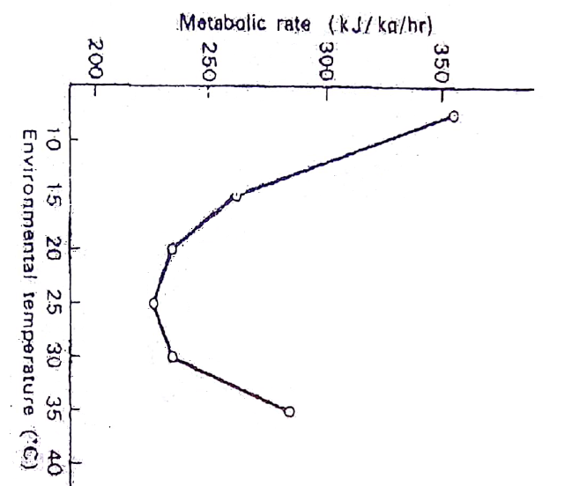
- Describe the effect of increasing environmental temperature on metabolic rate. (04 marks)
……………………………………………………………………………………………………………………………………………………………………………………………………………………………………………………………………………………………………………………………………………………………………………………………………………………………………………………………………………………………………………………………………………………………………………………………………………………………………………………………………………………………………………………
- Explain the change in metabolic rate between
- 20º c and 30ºc (02 marks)
……………………………………………………………………………………………………………………………………………………………………………………………………………………………………………………………………………………………………………………………………………………………………………………………………………………………………………………………………………………………………………………………………………………………………………………………………………………………………………………………………………………………………………………
- Above 30ºc (02 marks)
………………………………………………………………………………………………………………………………………………………………………………………………………………………………………………………………………………………………………………………………………………………………………………………………………………………………………………………………………………………………………………………………………………………………………………………………………………………………………………………………………………………………………………………………………………………………………………
- Explain how the Carmel a desert mammal is specialized to meet the problems of overheating and water stress in its habitat. (02 marks)
……………………………………………………………………………………………………………………………………………………………………………………………………………………………………………………………………………………………………………………………………………………………………………………………………………………………………………………………………………………………………………………………………………………………………………………………………………………………………………………………………………………………………………………
43. Figure3 shows the comparative photosynthetic response of $C_{3}$ and $C_{4}$ plants to increasing light intensity and temperature.
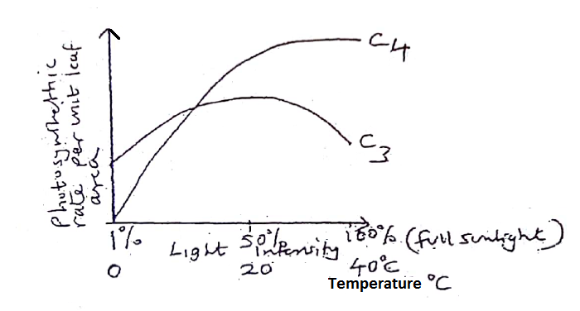
- Compare the combined effect of light intensity and temperature on the photosynthetic rate. (03 marks)
………………………………………………………………………………………………………………………………………………………………………………………………………………………………………………………………………………………………………………………………………………………………………………………………………………………………………………………………………………………………………………………………………………………………………………………………………………………………………………………………………………………………………………………………………………………………………………………………………………………………
- State the advantage of;
- $C_{4}$ photosynthesis over $C_{3}$ photosynthesis (03 marks)
……………………………………………………………………………………………………………………………………………………………………………………………………………………………………………………………………………………………………………………………………………………………………………………………………………………………………………………………………………………………………………………………………………………………………………………………………………………………………………………………………………………………………………………………………………….
- $C_{3}$ photosynthesis over $C_{4}$ photosynthesis (02 marks)
……………………………………………………………………………………………………………………………………………………………………………………………………………………………………………………………………………………………………………………………………………………………………………………………………………………………………………………………………………………………………………………………………………………………………………………………………………………………………………………………………………………………………………………………………………….
- State the likely location of
- $C_{3 }$plants (01 mark)
……………………………………………………………………………………………………………………………………………………………………………………………………………………………………………………………………………………………………………………………………………………………………….
- $C_{4}$plants (01 mark)
………………………………………………………………………………………………………………………………………………………………………………………………………………………………………………………………………………………………………………………………………………………………………
44. Figure 4 shows a motor end plate together with associated muscle.
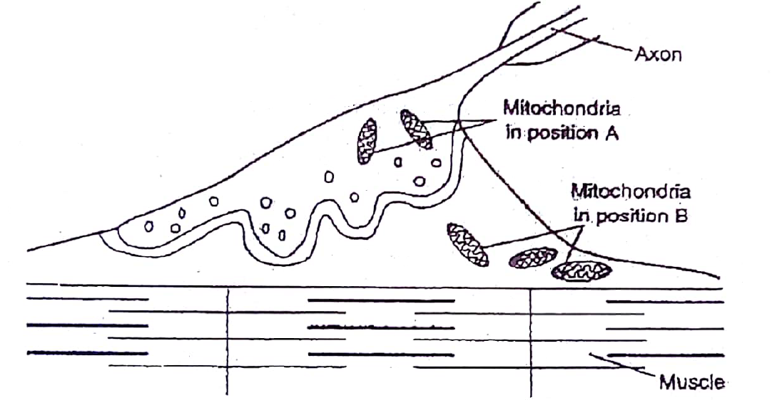

- Describe how transmission of information occurs across the nerve muscle junction when an impulse arrives at the pre synaptic membrane (05marks)
………………………………………………………………………………………………………………………………………………………………………………………………………………………………………………………………………………………………………………………………………………………………………………………………………………………………………………………………………………………………………………………………………………………………………………………………………………………………………………………………………………………………………………
- (i) What causes the banding pattern seen in the muscle fibril? (02marks)
………………………………………………………………………………………………………………………………………………………………………………………………………………………………………………………………………………………………………………………………………………………………………………………………………………………………………………………………………………………………………………………………………………………………………………………………………………………………………………………………………………………………………………
- Explain the likely change in the banding pattern when the muscle fibril?
(03marks)
………………………………………………………………………………………………………………………………………………………………………………………………………………………………………………………………………………………………………………………………………………………………………………………………………………………………………………………………………………………………………………………………………………………………………………………………………………………………………………………………………………………………………………………………………………
45. (a) Explain what is meant by green house effect. (03marks)
………………………………………………………………………………………………………………………………………………………………………………………………………………………………………………………………………………………………………………………………………………………………………………………………………………………………………………………………………………………………………………………………………………………………………………………………………………………………………………………………………………………………………………………………………………
(b) State the harmful consequences of the following
- Ozone layer depletion (03 marks)
………………………………………………………………………………………………………………………………………………………………………………………………………………………………………………………………………………………………………………………………………………………………………………………………………………………………………………………………………………………………………………………………………………………………………………………………………………………………………………………………………………………………………………………………………………………
- Discharge of smoke in air from industries (03marks)
………………………………………………………………………………………………………………………………………………………………………………………………………………………………………………………………………………………………………………………………………………………………………………………………………………………………………………………………………………………………………………………………………………………………………………………………………………………………………………………………………………………………………………………………………………………
- Suggest one way how ozone layer depletion has been minimized (01mark)
………………………………………………………………………………………………………………………………………………………………………………………………………………………………………………………………………………………………………………………………………………………………………………………………………………………………………………………………………………………………………………………………………………………………………………………………………………………………………………………………………………………………………………
46. (a) What is meant by polymorphism? (01mark)
…………………………………………………………………………………………………………………………………………………………………………………………………………………………………………………………………………………………………………………………………………………………………………………………………………………………………………………………………………………………………………………………………………………………………………………………………………………………………………………………………………………………………………………………………………………………………………
b) Biston betularia the peppered moth is light coloured and mottled. In 1848 a dark (melanic) mutant form was captured in Manchester by 1895 98% of these months in Manchester were melanic forms. The dark two forms are morphs, the normal form being Biston betularia typica and the dark form Biston betularia carbonifera
Table 1 shows the observed frequency of the two morphs of Biston betularia
Habitat | typica | Carbonifera
Rural woodland | 94.6% | 9.4%
Industrial woodland | 10.1% | 89.9%

Table 2 shows the observed frequency of predation of Biston betularia by woodland birds

Habitat | Typical | Carbonifera
Rural woodland | 13.6% | 86.3%
Industrial woodland | 74.2% | 89.9%

- Comment on the distribution of the two forms of month as shown in table 1 (03 marks)
………………………………………………………………………………………………………………………………………………………………………………………………………………………………………………………………………………………………………………………………………………………………………………………………………………………………………………………………………………………………………………………………………………………………………………………………………………………………………………………………………………………………………………………………………………………………………………………………………………………………
- How does the data in table 2 support the natural selection? (04marks)
……………………………………………………………………………………………………………………………………………………………………………………………………………………………………………………………………………………………………………………………………………………………………………………………………………………………………………………………………………………………………………………………………………………………………………………………………………………………………………………………………………………………………………………………………………………………………………………………………………………………...
- Given that the data shown in table 2 was collected in the 1950s, would you predict similar figures if the investigation was to be repeated this year. (02marks)
…………………………………………………………………………………………………………………………………………………………………………………………………………………………………………………………………………………………………………………………………………………………………………………………………………………………………………………………………………………………………………………………………………………………………………………………………………………………………………………………………………………………………………………………………………………………………………………………………………………………………………………………………………………………………………………………………………………………………………………………………………………………………………………………………………………………………………………………………………………………………………………………………………………………………………………………………………………………………………………………………………………………………………………………………………………………………………………………………………………………………………………………
END
I wish you the best!

