NAME ……………………………………………………………………………………………………………………………………

RANDOM/PERSONAL No. ……………………………../……………….. SIGNATURE ………………………………
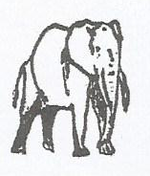
P530/1
BIOLOGY THEORY
Paper 1
MONDAY, 13th August 2018 (Morning)
2 hours 30 minutes

ACHOLI SECONDARY SCHOOLS EXAMINATIONS COMMITTEE
Uganda Advanced Certificate of Education
Joint Mock Examinations, 2018
BIOLOGY THEORY
Paper 1
2 hours 30 minutes
INSTRUCTIONS TO CANDIDATES:
- Answer ALL the questions in both Sections A and B.
- SECTION A – Indicate the correct answer by circling the correct alternative.
- SECTION B – Answers should be written in the spaces provided.

For Examiner’s Use Only
Questions |  | Marks
Section A: 1 – 40
Section B | 41
Section B | 42
Section B | 43
Section B | 44
Section B | 45
Section B | 46
TOTAL

SECTION A
- The following events occur in a seedling during germination:
(i). Rapid cell division and cell enlargement.
(ii). Production of hydrolytic enzymes.
(iii). Secretion of gibberellic acid.
(iv). Reduction in dry mass of endosperm.

The correct sequence of occurrence is:
A. (i) (ii) (iii) (iv) B. (iii) (ii) (iv) (i)
C. (iii) (ii) (i) (iv) D. (i) (ii) (iv) (iii)

- The ability of a police dog to trace accurately the route taken by a suspect is an example of …………………
A. habituation. B. latent learning.
C. imprinting. D. insight learning.

- A person’s blood group is type B if her / his …………….
A. red blood cells carry only A antigens.
B. blood plasma contains only antibody a.
C. blood plasma contains only antigen B.
D. blood plasma contains neither antibody a nor b.

- When the shoot apex of the growing plant is removed, lateral growth is encouraged because ………….
A. auxins are activated in buds.
B. growth of lateral buds is stimulated by gibberellins.
C. more abscisic acid is produced to promote lateral growth.
D. cytokinins are activated in absence of auxins from apex.

- The process of ripening in unripe fruits is enhanced when they are enclosed with ripe ones because………………..
A. IAA is produced by the ripe fruits to initiate ripening of others.
B. ripe fruits produce ethene, which facilitates ripening of other fruits.
C. the unripe fruits absorb heat from the ripe fruits which speed up ripening.
D. the unripe fruits absorb moisture from the ripe fruits which speed up ripening.

- Plant species R has a diploid number of 10. Plant species Q has an haploid number of 10. A new species S arises as an alloploidy hybridization of R and Q. The diploid number of S would be ………

A. 10 B. 20 C. 30 D. 40

- The unwinding of DNA helix during transcription process requires the enzyme called …………….
A. DNA ligase. B. DNA polymerase.
C. Helicase. D. RNA polymerase.

- In HIV virus, the role of enzyme “reverse transcriptase” is to ………
A. unite viral DNA with host’s DNA.
B. release viral RNA to make proteins.
C. transfer DNA from the host into the virus.
D. make DNA from virus RNA.

- In ferns, gametes are produced by the ….………
A. gametophytes through mitosis. B. sporophytes through mitosis.
C. sporophytes through meiosis. D. gametophytes through meiosis.

- Which one of the following is the best way of comparing the metabolic rate of mammals of different body sizes? By relating ……………….
A. the percentage increase in body mass.
B. the amount of food consumed per day.
C. the oxygen consumed per unit body mass per unit time.
D. the carbon dioxide released per unit body mass per unit time.

- Which one of the following processes in the body does NOTinvolve a cascade of reactions?
A. Blood clotting.
B. Conversion of glycogen to glucose by adrenaline.
C. Regulation of blood sugar level by cortisol hormone.
D. Conduction of an impulse along the nerve fibre.

- A plant cell is magnified x2000 and the length of one chloroplast is 16mm. What is the actual length of the chloroplast in micrometres?

A. 16 B. 8 C. 1600 D. 32000
- Which one of the following is NOT compatible with Darwin’s theory?
- Evolution occurs in individuals rather than in groups.
- Natural selection eliminates unsuccessful variations.
- Evolution has diversified and altered the ancestral species.
- All organisms have arisen by descent with modifications.

- One of the roles of the glycoprotein and glycolipids on the surface of the cell membrane is to ……………..
A. increase the absorbing surface area.
B. provide receptor site for recognition of stimuli.
C. provides site for various reaction pathways.
D. separated the contents of the cell from surrounding environment.

- A shark (fish) and a porpoise (mammal) are both adapted to swimming. This is an example of ………….
A. adaptive radiation. B. divergent evolution.
C. convergent evolution. D. speciation.

- Which of the following sets of hormones is produced from the pituitary gland?
A. ACTH, TSH, FSH and LH. B. ADH, GH, TSH and FSH.
C. ADH, FSH, TSH and LH.
D. ACTH, GH, Oxytocin and Thyroxine

- An almost universal cost of ‘group living” in animals is …………….
A. higher exposure to disease and parasites.
B. increased risks of predation.
C. reduced access to mates. D. interference with foraging.

- Facilitated diffusion and active transport both require ………..
- ATP B. Unidirectional movements of S
- Protein carriers D. Lipid soluble solute

- Which one of the following theories does NOT offer a mechanism to account for origin of life?
- Steady state theory B. Spontaneous generation
C. Special creation D. Cosmozoan theory
- Carangiform locomotion occurs only in ……….…….
A. bony fish and tuna fish. B. eels and dog fish.
C. dog fish and bony fish. D. tuna fish and eels.

- In commensalism, the relationship of species A and species B is such that ...
A. A and B both benefit. B. A benefits and B is harmed.
C. A benefits and B is not affected. D. A and B are both harmed.

- In the mammalian menstrual cycle, the decline in the level of progesterone is due to……………
- successful conception. B. formation of corpus luteum.
C. degeneration of corpus luteum. D. maturation of graafian follicle.

- Which type of mutation is caused by the presence of a nucleotide in the wrong position in a DNA chain?

A. Inversion. B. Insertion. C. Deletion. D. Substitution.

- The genetic condition of spores produced in the sporophyte capsule of bryophyte is …..……..
A. polyploid. B. tetraploid. C. haploid. D. diploid.

- During excretion in insects, which of the following enter malphigian tubules passively?
- uric acid and ammonia. B. salt and water.
C. carbondioxide and water. D. K⁺ ions and Na⁺ ions.

- Which one of the following is the ovum developed from?
A. Primary oocyte. B. Secondary oocyte.
C. Oogonium. D. Primordial germ cell.

- Which part of the Weinberg equation represents individuals who have at least one allele for sickle cell anaemia?
A. 2pq B. p² + 2pq C. p² + q² D. q² + 2pq

- Release of milk in lactating mother is aided by ………

A. prolactin only. B. both prolactin and oxytocin.
C. oxytocin only. D. oestrogen.

- Which one of the following features characterises the omnivore gut?
A. Large divided stomach.
B. Poorly developed appendix and caecum.
C. Short ileum and colon. D. Long pouched colon.

- In insects, the pupa moults into an adult when …………
- only ecdysone is released.
- only juvenile hormone is released.
- both ecdysone and high levels of juvenile hormone are released
- both ecdysone and low level of juvenile hormone are released.

- Seeds exposed to red light are able to germinate because …….
A. Pr absorbs red light and is converted to Pfr that promotes germination.
B. Pr absorbs far red light and is converted to Pfr that promotes germination.
C. Red light is converted into far red light to promote germination.
D. Pr absorbs red light to promote germination.

- Which one of the following best refers to a boom and bust population?
A. The birth rate is always equal to the death rate.
B. The birth rate is always greater than the death rate.
C. It never exceeds the carrying capacity.
D. Increases very rapidly and overshoots the carrying capacity.

- Three counts of 80, 75 and 67 of a plant species using a quadrat of 20cm³. The density of the plant per m² is ……..

A. 40.000 B. 74 C. 36.667 D. 222

- Which one of the following organisms exhibit intracellular digestion?

A. Fungi. B. Insects. C. Hydra. D. Mammals.

- The function of adductor muscle of the limb is to………..
A. draw femur forwards. B. draw femur backwards.
C. draw femur outwards. D. draw femur inwards.

- During water stress, photosynthesis reduces in plants mainly due to the shortage of ………..
A. water. B. sunlight. C. carbondioxide. D. mineral salts.
- The function of abscission layer is …………
A. instruction information of absorption layer.
B. stimulates disintegration of the middle lamellas.
C. stimulates production of calcium pectate.
D. decrease the sensitivity of the leaves to auxin.

- Which of the following zones in the root provides force required to penetrate the soil?
- Root cap. B. Zone of cell division.
C. Zone of cell elongation. D. Zone of cell differentiation.

- The similarities of insect wings to bat wings lead to a conclusion that ……
A. they belong to the same class.
B. they descended from a common ancestor.
C. originated from the same environment.
D. evolved in the same environmental condition.

- A female human being was supplied with radioactive uracil. At what process will the uracil be used?
A. DNA replication B. t RNA formation.
C. mRNA formation. D. during transcription.

SECTION B
Question 41:
(a) (i) Distinguish between physical and chemical digestion. (02 marks)

………………………………………………………………………………………………………………………………………………………………………………………………………………………………………………………………………………………………………………………………………………………………………………………………………………………………
(ii) State three ways in which physical digestion occurs in humans. (1½ marks)
………………………………………………………………………………………………………………………………………………………………………………………………………………………………………………………………………………………………………………………………………………………………
(b) Explain the nervous and chemical (hormonal) control of secretion of digestive juices during digestion in human.
- In the stomach: (04 marks)

………………………………………………………………………………………………………………………………………………………………………………………………………………………………………………………………………………………………………………………………………………………………………………………………………………………………………………………………………………………………………………………………………………………………………………………………………………………………………………
- In the duodenum: (03 marks)

……………………………………………………………………………………………………………………………………………………………………………………………………………………………………………………………………………………………………………………………………………………………………………………………………………………………………………………………………………………………………………………………………..
Question 42:
(a) (i) What is meant by the term ‘natural selection’? (01 mark)

………………………………………………………………………………………………………………………………………………………………………………………………………………
(ii) Some years ago, it was thought that the use of antibiotics would result into total eradication of bacterial strains. However, bacteria are now more widely spread than ever and in forms more resistant to the antibiotics used. Explain the role of natural selection in the evolution of resistance to antibiotics in bacteria. (03)

………………………………………………………………………………………………………………………………………………………………………………………………………………………………………………………………………………………………………………………………………………………………………………………………………………………………………………………………………………………………………………………………………………………………………………………………………………………………………………
(b) Night blind people have difficulty in seeing in dim light. The allele for night blindness, n, is recessive to the allele for normal vision, N. These alleles are not sex-linked. The diagram below shows part of a family tree showing inheritance of night blindness.

1 2

12

3 4 5 6 7 8 9 10 11

13 14
KEY:
–Female with night blindness. – Male with night blindness.

– Female with normal sight. – Male with normal sight.

(i) What is the most likely genotype of individual 2? Give reasons / evidence for your answer. (02 marks)

Genotype…………………………………………………………………………………………
Reasons……………………………………………………………………………………………………………………………………………………………………………………………………………………………………………………………………………………………………………
(ii) What is the probability that the next child born to individuals 10 and 11 will be a girl with night blindness? Show your working. (02 marks)

…………………………………………………………………………………………………………………………………………………………………………………………………………………………………………………………………………………………………………………….………………………………………………………………………………………………………………………………………………………………………………………………………………
(iii) The cross between individuals 12and 14 would represent a mating between first cousins. Based on this, comment why a marriage between close relatives may be risky. (02 marks)

…………………………………………………………………………………………………………………………………………………………………………………………………………………………………………………………………………………………………………………….………………………………………………………………………………………………………………………………………………………………………………………………………………

Question 43:
The table below shows: number of chromosomes, amount of DNA in arbitrary units and number of chromatids in a human cell at different stages of the cell cycle. (07 marks)
 | Stage | Number of Chromosomes | Amount of DNA (AU) | Number of Chromatids
i | End of mitosis | 46 | 500
ii | Interphase
iii | Beginning of mitosis / meiosis
iv | End of meiosis
v | After fertilisation

(a) If at the end of mitosis the cell had 46 chromosomes and 500AU of DNA; complete the table above by indicating the number of chromosomes, DNA amount and number of chromatids in the human cell at each stage of the division.

(b) Describe how the arrangement of chromosomes during metaphase of mitosis differs from the arrangement of chromosomes during metaphase of meiosis.
(03 marks)
………………………………………………………………………………………………………………………………………………………………………………………………………………………………………………………………………………………………………………………………………………………………………………………………………………………………
………………………………………………………………………………………………………………………………………………………………………………………………………………………………………………………………………………………………………………………

Question 44:
The graph below shows the effect of light intensity on carbondioxide exchange by leaves of plants growing in shades and sunny areas.

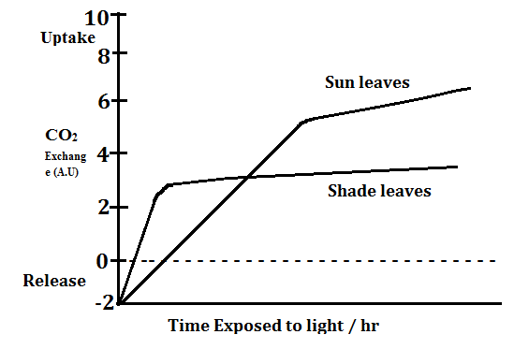

(a) (i) Represent the compensation points for the two types of leaves on the
graph and explain the meaning of compensation point. (03 marks)

………………………………………………………………………………………………………………………………………………………………………………………………………………………………………………………………………………………………………………………………………………………………………………………………………………………………………………………………………………………………………………………………………
(ii) Explain why shade leaves reach compensation point at different times from that of sun leaves. (02 marks)

………………………………………………………………………………………………………………………………………………………………………………………………………………………………………………………………………………………………………………………………………………………………………………………………………………………………
(b) (i) Compare the uptake of carbon dioxide for the two leaves. (03 marks)

………………………………………………………………………………………………………………………………………………………………………………………………………………………………………………………………………………………………………………………………………………………………………………………………………………………………………………………………………………………………………………………………………
- Suggest what would happen to the curve of sun leaves if the plant was placed in a higher carbon dioxide concentration. (02 marks)

………………………………………………………………………………………………………………………………………………………………………………………………………………………………………………………………………………………………………………………………………………………………………………………………………………………………

Question 45:
The figure below shows the detailed structure of a cell of proximal convulated tube and adjacent to a capillary.
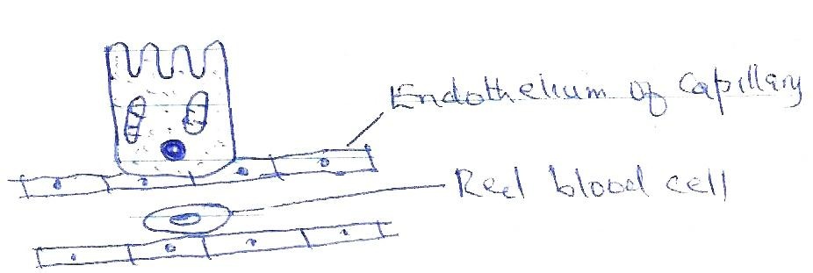

(a) (i) Outline how the cell of the proximal convulated tubule is adapted to
its function. (02 marks)

………………………………………………………………………………………………………………………………………………………………………………………………………………………………………………………………………………………………………………………
(ii) Describe how the molecules of glucose and water are moved from the filtrate into the capillary. (03 marks)

............................................................................................................................................................

...........................................................................................................................................................

………………………………………………………………………………………………………………………………………………………………………………………………………………………………………………………………………………………………………………………
(b) Antidiuratic Hormone (ADH) is involved in controlling blood water potential. Outline how ADH operates by negative feedback in regulation of water potential of blood. (05 marks)

………………………………………………………………………………………………………………………………………………………………………………………………………………………………………………………………………………………………………………………………………………………………………………………………………………………………………………………………………………………………………………………………………………………………………………………………………………………………………………
………………………………………………………………………………………………………
Question 46:
(a) Explain briefly some of the problems which may arise from excessive use of chemicals to control pests. (04 marks)

………………………………………………………………………………………………………

………………………………………………………………………………………………………

………………………………………………………………………………………………………

………………………………………………………………………………………………………

……………………………………………………………………………………………………

(b) Biological pest control avoids some of the problems of chemical control.
(i) Explain what is meant by the term :biological pest control”. (01 mark)

………………………………………………………………………………………………………

………………………………………………………………………………………………………

(ii) Suggest two of the possible risks of biological pest control. (02 marks)

………………………………………………………………………………………………………

………………………………………………………………………………………………………

………………………………………………………………………………………………………

(c) Explain how the release of chlorofluorocarbons (CFCs) into the atmosphere can damage ecosystems. (03 marks)

………………………………………………………………………………………………………

………………………………………………………………………………………………………

………………………………………………………………………………………………………

………………………………………………………………………………………………………

………………………………………………………………………………………………………

*THE END*
The End.

