P235/4
Islamic Religious Education
Paper 4
July/August 2019

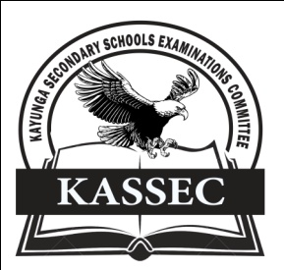
KAYUNGA SECONDARY SCHOOLS EXAMINATION COMMITTEE
Uganda Advanced Certificate of Education
JOINT MOCT EXAMS 2019
ISLAMIC RELIGIOUS EDUCATION
PAPER FOUR

INSTRUCTIONS TO CANDIDATES
- Answer four questions, taking at least one question from each section

SECTION A
1. (a) Why did the Arabs establish their early settlements along the coast of East
Africa? (13 marks)
(b) How did Arab settlement facilitate the spread of Islam? (12 marks)

2. (a) Account for the growth and development of the East African Coastal
market. (13 marks)
(b) How did it contribute to the spread of Islam along the coast of East
Africa? (12 marks)
3. ‘Islam in the interior of East Africa owes it’s spread to the establishment of the interior trade routes? Discuss (25 marks)

4. (a) Analyse Muteesa I’s role in the spread of Islam in Buganda. (13 marks)
(b) What were the obstacles to the spread of Islam in Buganda during his
reign? (12 marks)

5. To what extent did British colonial rule benefit the Muslim community in Kenya? (25 marks)
6. Without the role of the Nyamwezi, the spread of Islam in the interior of Tanzania would have been a waste. Discuss (25 marks)

SECTION B
7. To what extent did the Berbers contribute to the spread of Islam in West Africa? (25 marks)
8. Assess the impact of the Trans – Saharan trade in the spread of Islam in West Africa. (25 marks)
9. (a) Account for the rise of Almoravid movement (13 marks)
(b) How did the Almoravids affect the spread of Islam? (12 marks)

10. To what extent did Mansa Sulaiman’s administration facilitate the spread of Islam in Mali kingdom? (25 marks)

11. (a) Analyse the teachings of Qadiriyya brotherhood (10 marks)
(b) How did the teachings of this brotherhood promote Islam in West Africa? (15 marks)
12. Assess the impact of colonialism on the spread of Islam in West Africa. (25 marks)
END

