P245/3
CHRISTIAN RELIGIOUS
EDUCATION
(Christianity in the east African
Environment)
Paper 3
Jul/Aug 2019
2 ½ Hours

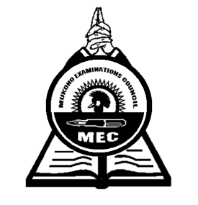

MUKONO EXAMINATION COUNCIL
Uganda Advanced Certificate of Education
CHRISTIAN RELIGIOUS EDUCATION
(Christianity in the east African Environment)
Paper 3
2 Hours 30 Minutes

INSTRUCTIONS TO CANDIDATES
Answer any four questions choosing one from section A, two from section B and one from section C.

SECTION A
DESCRIPTION OF AFRICAN RELIGIOUS EXPERIENCE AROUND 1844
- a) Discuss the different initiation rituals as they were carried out in African Traditional
Society. (13 marks)
b) Explain the relevance of the above rituals to the traditional Africans. (12 marks)

- a) How was the education about sex provided in African Traditional Society? (13 marks)
b) How is the same education provided today? (12 marks)

- a) “Death was a transition from the physical state to the spiritual state.” Justify the
statement basing on the African Traditional Society. (13 marks)
b) How are dead bodies treated in modern times? (12 marks)

SECTION B
THE COMING OF CHRISTIANITY, ITS IMPACT AND INTERACTION

- To what extent did the ex-slaves contribute to the expansion of the church in East Africa?
(25 marks)
- To what extent did the trade in human beings hinder the spread of Christianity in East Africa? (25 marks)

- a) Explain the contribution of Kabaka Mwanga in the outbreak of the religious wars in
Buganda. (13 marks)
b) How did the wars affect the church in East Africa? (12 marks)

- a) Discuss the major features of the missionary formal Education in East Africa.
(13 marks)
b) How did this education pave way to the spread of Christianity? (12 marks)

- a) Discuss the values that are attached to Christian marriage. (13 marks)
b) Why are modern marriages breaking up so fast? (12 marks)

SECTION C
CHRISTIANITY IN THE CONTEMPORARY RELIGIOUS ENVIRONMENT

- To what extent has the Uganda Joint Christian Council (UJCC) achieved the objectives of its founders? (25 marks)

- Compare the Islamic religious faith with the Bahai Religious faith. (25 marks)

- a) Explain the causes of Child sacrifice today. (13 marks)
b) How can the church address the above challenge? (12 marks)

- a) “The Church is responsible for the spread of HIV/AIDS in East Africa today.” Discuss.
(15 marks)
b) Advise the government on how it can control the spread of HIV/ AIDS. (10 marks)

- End -

