P510/3
Physics Practical
Paper 3
July /August 2019
3 ¼ hours

KAYUNGA SECONDARY SCHOOLS EXAMINATIONS COMMITTEE (KASSEC)
JOINT MOCK EXAMINATIONS 2019
Uganda Advanced Certificate of Education
PHYSICS PRACTICAL
PAPER 3
3 HOURS 15 MINUTES

INSTRUCTIONS TO CANDIDATES
- Answer question 1 and one other question.
- Candidates are not allowed to use the apparatus for the first fifteen minutes.
- Graph papers are provided.
- Mathematical tables and non programmable scientific calculators may be used.
- Write on one side of the paper only
- Candidates are expected to record on their scripts all their observations as these observations are made and to plan the presentation of the records so that it is not necessary to make a fair copy of them. The working of the answer is to be handed in.
- Details on the question paper should not be repeated in the answer nor is the theory of the experiment required unless specifically asked for. Candidates should however record any special precautions they have taken and any particular feature of their method of going about the experiment.
- Marks are given mainly for a clear record of the observations actually made, for their suitability and accuracy and for the use made of them.

1. In this experiment, you will determine Young’s modulus, E, for a metre rule using two methods. (40marks)
Method I:
- Measure and record the breadth, b, and thickness, d, of the metre rule labelled Z.
- Clamp the metre rule Z on the table with a length, l = 0.900m from the free end. Attach a pointer at the free end of the metre rule
- Suspend a mass of 0.100kg at a distance 3.0cm from the free end of the metre rule Z as shown below.
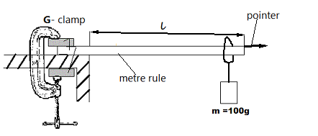
- Displace the mass slightly downwards and set the metre rule into vertical vibration.
- Measure the time for 20 oscillations
- Calculate the period, T, of the oscillation
- Calculate Young’s modulus, E, from the expression

E =$\frac{16π^{2}l^{3}}{ {10T}^{2}{bd}^{3}}$
Method II
- Using the set up in method I clamp a metre rule vertically beside the metre rule Z with a pointer, without the mass M = 100g .clamp the metre rule Z on the table with length l= 0.900m free.
- Read and record the initial pointer reading on the metre rule.
- Suspend a mass m= 0.100kg at a distance 2.0 cm from the free end of the metre rule Z as shown below.

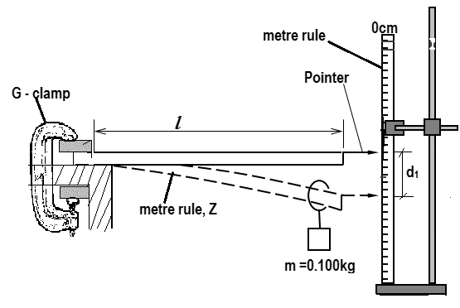
- Read and record the final pointer reading on the metre rule.
- Determine the depression, d₁ in metres of metre rule Z.
- Repeat procedures (a) to (e) with values of $l$ = 0.800, 0.700, 0.600, 0.500, 0.400 and 0.300m respectively.
- Tabulate your results including values of $\log_{10}{d_{1}}$ and $\log_{10}{l_{}}$
- Plot a graph of $\log_{10}{d_{1}}$ against $\log_{10}{l}$
- Read and record the intercept, C, on the $\log_{10}{d_{1}}$ axis
- Calculate Young’s Modulus, E, from the expression.
C = $\log_{10}{}\left(\frac{0.4g}{{Ebd}^{3}}\right)$ where g = 9.81ms ⁻²
2. In this experiment, you will determine the constant $β$ , of the glass block provided using two methods. (40 marks)
Method 1
- Fix a plain sheet of paper on the soft board using drawing pins.
- Place the glass block with its broad face on the paper and trace its outline ABCD.
- Remove the glass block from its outline and mark the mid-point O, on side BC.
- Replace the glass block on its outline and fix an optical pin P₁ vertically and very close to side BC at O as shown in the figure below.
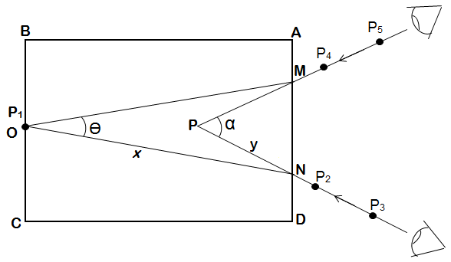
$$∝$$
$$θ$$
- While looking through the glass block from side AD, fix pins P₂ and P₃ such that they appear to be in line with the image of pin, P₁. Mark the positions of P₂ and P₃.
- Remove pins P₂ and P₃.
- While looking from AD again, fix pins P₄ and P₅ such that they are also in line with the image of P₁ as shown in the figure above mark the positions of P₄ and P₅.
- Remove pins P₄ and P₅
- Remove the glass block and draw lines through P₃, P₂ and through P₅, P₄ to their point of linter section, P.
- Join O to M and also O to N.
- Measure and record angles $∝$ and $θ$
- Measure and record distances ON= x and PN = y.
(m) Calculate the constant,$β$, of the glass block from the expression.
$β=$ $\frac{x cos\left(\frac{θ}{2}\right)}{y cos\left(\frac{∝}{2}\right)}$
Method II
- Measure and record the width, w, of the glass block.
- Fix a plain sheet of paper on the soft board using drawing pins.
- Place the glass block on the paper with its broad face uppermost and trace its outline ABCD.
- Remove the glass block from its outline and draw a normal NM at O such that AO= 2.0cm.
- Draw a normal WZ at Y such that YO = 5.0cm and WY = 10.0 cm
- Draw a line XO such that d= 2.0cm where d = XY.
- Replace the glass on its outline
- Fix pins, P₁ and P₂ along XO.
- While looking through the glass block from side DC, fix pins P₃ and P₄ such that they appear to be in line with the images of P₁ and P₂ as shown in the figure below.
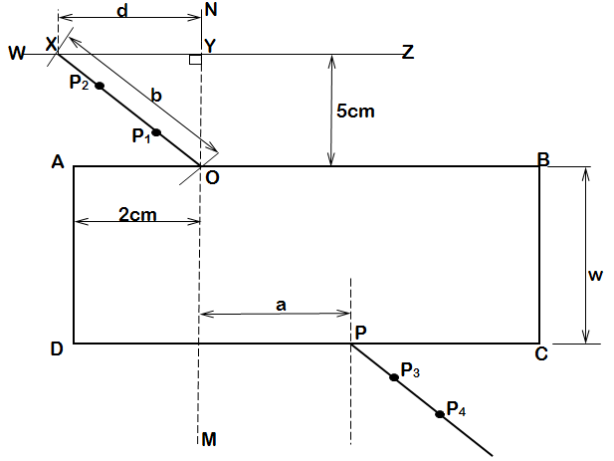
- Remove the glass block and the pins
- Draw a line through P₃ and P₄ to meet side DC at P
- Measure and record distances a and b ,where b =XO
- Repeat procedures (f) to (l) for values of d = 2.5, 3.0, 4.0, 6.0 and 8.0cm respectively.
- Record your results in a suitable table including values of $\frac{1}{a^{2}}$ and $\frac{b^{2}}{d^{2}}$
- Plot a graph of $\frac{b^{2}}{d^{2}}$ against $\frac{1}{a^{2}}$
- Find the slope, S, of the graph
- Calculate the constant, $β$, of the glass block from the expression.
S=$\left(\frac{W}{β}\right)$ ²
NB: HAND IN YOUR TRACING PAPER TOGETHER WITH YOUR SCRIPT.

3. In this experiment, you will determine the resistance per metre r of the wire provided. (40 marks)
PART I
- Connect the dry cell, a rheostat, Q, a switch, K, ammeter A, and resistor of 5$Ω$ in series as shown in the figure below.
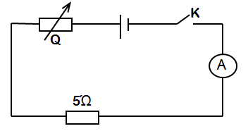
- Close switch K
- Adjust the rheostat until the ammeter reading registers a current, I = 0.08A.
- Disconnect the circuit, but keep the setting of the rheostat unaltered.
- Connect the circuit as shown below.
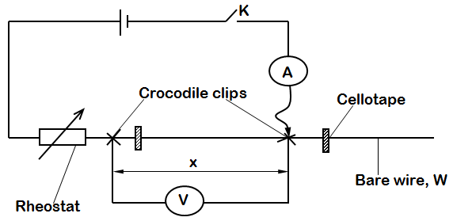
o
- Close switch K
- Without altering the setting of the rheostat, adjust the position of the crocodile clips until the reading of the ammeter, I= 0.08A.
- Read and record the length, x_{O} , of the barewire, W, between the two crocodile clips
- Open switch K
- Calculate the resistance per metre length, r_{o} from the expression r_{o} = $\frac{5}{x}$
₀
- Close switch K
- Adjust the length of the barewire, W, between the crocodile clips such that x = 0. 200m.
- Adjust the rheostat until the current registered by the ammeter, I = 0.08A
- Read and record the voltmeter reading, V.
- Repeat procedures (i) to (n) for values of x = 0.300, 0.400, 0.500, 0.600 and 0.700m respectively.
- Disconnect the circuit.
- Tabulate your results including values of $\frac{1}{V}$ against $\frac{1}{x}$
- Plot a graph of $\frac{1}{x}$ against $\frac{1}{V}$
- Determine the slope, r₁, of the graph

PART II
m
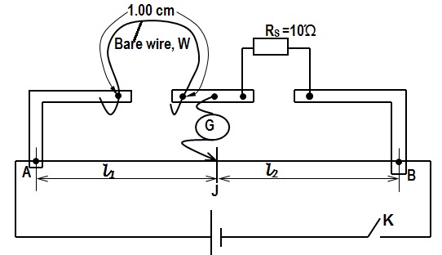
- Connect the circuit shown in the figure above, with 1.00m length of the bare wire, W, connected in the left hand gap of the metre bridge.
- Connect the standard resistor, R_{s} = 10$Ω$, in the right hand gap of the metre bridge.
- Close switch K
- Move the sliding contact, J, along the metrebridge wire AB to locate a point for which the galvanometer shows no deflection.
- Read and record the balance length, l₁ and l₂
- Open switch, K
- Calculate the resistance per metre, r₂, of bare wire ,W, from r₂ = R_{s} $\frac{l_{1}}{ l_{2}}$
- Repeat procedures (b) to (f) with R_{s} = 5.0 $Ω$
- Calculate the resistance per metre, r₃ of the barewire ,W, from r₃ = Rs$\frac{l_{1}}{l_{2}}$
- Calculate the average of r_{o}, r₁, r₂ and r₃.

END

