SUB ICT FACILITATION 2016
TERM III 2016
- GENERAL KNOWLEDGE
- What is IT?
- Distinguish between I.T. and ICT.
- In the world of ICT, explain, stating the ICT gadget needed, the role of ICT’s in the following areas.
  - Education
  - Health
  - Communication
  - Transport
  - Mass Media
- What is a computer laboratory?
- Distinguish (by definition) between physical and Data securities as used in laboratories.
- State six (6) tools and explain their roles/functions in the computer laboratory.
- What do you understand by the following terms?
  - Maintenance of computers
  - Servicing of computers
  - Troubleshooting
  - Ergonometry
- Explain the roles of the following computer professionals:
  - Network administrator
  - Systems Administrator
  - Systems analyst
  - Laboratory Technician/Attendant
  - Programmer
  - System designer
  - Computer scientist
  - Web master
  - Database manager/analyst
  - Computer Engineer
- What is computer literacy?
- Explain the importance of being computer literate.
- Distinguish between a computer and a computer system.
- Give reasons why a computing system can be restarted.
- Give the difference between the following:
  - Log off and Log in
  - Reset and Shut Down
  - Sleep and Hibernation
- Why do frequent computer users need glare glasses?
- COMPUTER HARDWARE
- Define the term computer hardware.
- State and explain the two categories of computer hardware.
- State and explain the role of six (6) hardware components found within (3) and without (3) the system unit.
- What is the importance of the hard drive to a computer system?
- Distinguish between the following:
  - Input and input device
  - Output and output device.
- State and explain six (6) input devices that you know.
- A printer is now a must-have hardware for computer users. State and explain two types of printers and for each give three (3) examples.
- Define the following terms as used in VDU’s.
  - Resolution
  - Pixel
  - Passive LCD
  - TFT LCD
- State or outline the four modes of monitor displays.
- A barcode reader also called wand is an important ICT tool in the area of business. State and explain how it works at P.O.S. in trading and shopping centers.
- The CPU is referred to as the brain of any computing device. Explain the various components of the CPU and how each functions.
- Why is the back-end of a desktop PC having the following?
  - Fans
  - Ports
  - Expansion Slots
- Distinguish between the following:
  - parallel port and serial port
  - VGA card and Sound card
- State and explain the five major functions of the CPU.
- State three (3) components that affect the speed of a computing system.

- MEMORY
- Define the following terms:
  - Memory
  - Storage device
  - Primary storage/memory
  - Auxiliary storage/memory
  - Removable storage
  - Sneaking
- Distinguish between ROM and RAM giving two (2) types of each of the memory.
- Data and information can be stored on a device in three major forms, that is, electronic, magnetic and optical. Define each form and give three examples of each form.
- Compare and contrast the following storage devices:
  - Hard disk and Flash disk (STICK MEMORY)
  - Floppy diskette and VCD
- Define the following as used in digital storage.
  - Bit
  - Byte
  - Nibble
- How many songs will Peter store on a flash stick labeled 4.2GB if each song is 512KB of size?
- How many bits are in a CD of 702MB?
- Distinguish (by definition) between a buffer memory, cache, and a flash memory.
- COMMUNICATION
- Define the following terms as used in data transmission
  - Data communication
  - Protocol
  - Network
  - Communication
  - Channel
  - Topology
- State and explain the three major components/elements of a data communication system.
- Distinguish between the following transmission modes:
  - Half duplex and Full Duplex
  - Simplex and Packet switched Transmission.
- What do you understand by the terms guided and unguided transmission?
- Give three examples of guided and unguided transmission channels that you know.
- Explain how two friends will share a music file on a single phone. (Indicate all the steps).
- What is internet?
- Describe eight (8) services offered by the internet.
- Discuss the effects of the presence of the internet in a school like MABSS.
- State two (2) ISP’s that you know in Uganda.
- What are the four major requirements for one to connect to the internet?
- What is WWW?
- Define the following terms as used online:
  - Web browser
  - URL
  - Website
  - Webpage
  - Phishing
  - Hypertext
  - Spamming
  - Hyperlink
  - Hypermedia
- Why is a website necessary for a school like MABSS?
- What is cyber-crime?
- State and explain four (4) cyber-crimes you know.
- What is a computer network?
- Why do we need a school network?
- What does one require to setup a network?
- What factors does one consider when choosing a network topology?
- State and explain three advantages and three disadvantages of a network to an organization.
- Explain the following types of computer networks:
  - Peer To Peer
  - Client-To – Server Network
- Outline the various categories of computer networks and give an example where possible.
- Define the following terms as used in computer networks:
  - Ethernet
  - Extranet
  - Intranet
  - Node
  - Workstation
  - Terminal
  - Dumb terminal
  - Smart terminal
- Give two (2) advantages of using an extranet over an intranet in an organization.
- Why are internetworks important?
- For video conferencing and other services like Telecommuting required some specialized devices other than the computing system or phone. Outline four (4) devices needed to run such services.
- Below is a capture of an email window. Study it carefully and answer the questions that follow:
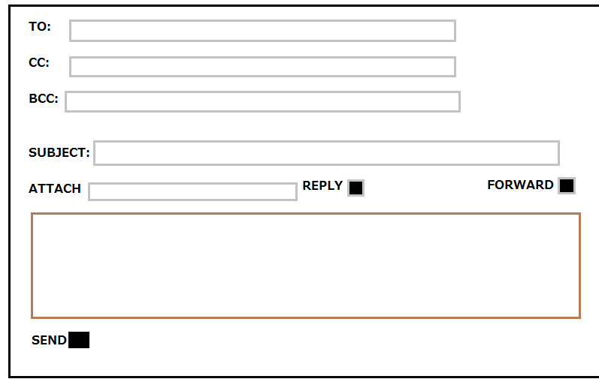
  - State the purpose of the following:
    - Attach:
    - To:
    - BCC:
    - Subject:
  - What is CC in full?
  - Give four etiquettes an email user should display while planning to compose an email.
- Whataspp, Skype, Facebook and intagram are the most current web 2.0 communication tools that show both features of real-time and non-real-time computing. Distinguish between the two features and give examples other than the above.
- What do you understand by cloud computing and green computing?
  - What are the advantages of green computing today?
  - Discuss the advantages and disadvantages of cloud computing.
- What is telecommunication?
  - Why is telecommunication a vital part of today’s communication world?
- SOFTWARE
- Define a computer program.
- Outline five computer programs you know.
- What is a device driver?
- State and explain the two major types of computer software and for each type give four examples.
- Explain the following classes of software and give one example of each:
  - Freeware
  - Shareware
  - Proprietary
  - Open-source
  - Suite applications
  - Demoware
- What do you understand by the term “malware”?
  - Give four examples of malware programs that you know.
  - Outline five symptoms of computer malware as seen on a computer system.
  - Explain five ways through which computing systems catch malware.
  - State four ways to prevent/guard a system against malware infections.
- What is a word processor?
  - Give four examples of word processor programs.
  - State and explain four features of word processors.
  - Distinguish between text editors and word processors.
- What is a spreadsheet?
  - Give three examples of spreadsheet programs.
  - State and explain four features of spreadsheets.
  - Outline five uses of spreadsheets.
  - Give four (4) advantages of using manual spreadsheets over electronic spreadsheets.
- What is a database management system (DBMS)?
  - Give three (3) examples of database management systems?
  - Distinguish between relational and non-relational databases and give an example of each.
- Define the following as used in DBMS:
  - Database
  - Object
  - Record
  - Data type
  - Primary key
  - Field Name
  - State uses of data bases.
  - Distinguish between manual and electronic databases.
- Write D.T.P. in full.
  - Distinguish between presentation and publication software.
  - Give three examples of each the software above.
- Define the following terms as used in presentation programs such as PowerPoint:
  - Slide
  - Slideshow
  - Slide transition
  - Template
  - Master slide
  - Animation
  - Speaker Notes
- State five uses of a publication program such as page maker or MS. Publisher.
- What is a utility program?
  - State and explain four functional utility programs that you know.
- What is an operating system?
  - State six (6) examples of operating systems.
  - State and explain six (6) functions played by an operating system.
  - Write D.O.S. in full.
  - Distinguish between GUI and CLI and give two (2) examples of each.
- Define the following:
  - Software upgrade
  - Software update
  - Program bug
  - Program installer
  - Troubleshooting
  - Executable file
  - Software installation
- Why is the screen saver necessary?
- What is booting?
  - Explain the stages of booting sequence.
  - Why do users reset computer systems sometimes?
- FILE MANAGEMENT SYSTEM
- Define the following as used in the file management system.
  - File
  - File name
  - File path
  - Windows explorer
  - Directory
  - File extension
- State and explain three (3) activities/roles carried out in the file management system.
- Given the path below, determine the required. F:/Document_&_Settings/Users/User1/Nakayiwa/box.rtf. Find:
  - Drive letter
  - File name
  - File Extension
  - System Folder
  - Profile Name
  - Folder Name
  - State any three programs that can be used to open the file above.
  - Write down five file extensions that you know and their corresponding programs to open them.
- Using windows operating system, outline the steps taken to:
  - Create a folder in MYDOCUMENTS called Dativa
  - Rename the above folder with a new name Musoke.
  - Saving a music file onto a portable/removable drive such as a flash disk named DAVE16.
- Write down the error that is likely to show up when;
  - One tries to save a file with a file names similar to one that already exists in the folder being saved into.
  - One tries to open a file that was either moved to a new location or deleted.
  - One tries to move a minimized file on the task bar to a new storage location say flash memory.
  - One tries to delete an open file into the recycle bin.

- PROGRAMING:
  - Define the term programing.
  - State any two types of programming methodologies that you know.
  - Explain the following terms as used in programming:
    - Pseudo code
    - Programming language
    - Code
    - Flow chart
    - Object Oriented programming
    - Inheritance
    - Polymorphism
  - List any three advantages and three disadvantages of High-level languages.
  - Distinguish between a source program and object code
  - Below is a flow chart. Study it well and tell the purpose.
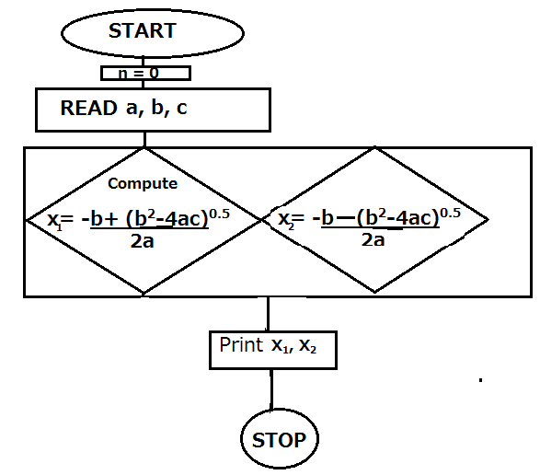
  - If a = 1, b =2 and c =1, print the values of x₁ and x₂.

