Name: ………………………..……………………… Centre/Index No:..…………..…..
Signature:………………………………………..................................................................

S850/1
Subsidiary Information and Communication Technology
Paper 1
July/August, 2019
2¹/₂ hours

LANGO SECONDARY SCHOOLS MOCK EXAMINATION ASSOCIATION
Uganda Advanced Certificate of Education
SUBSIDIARY ICT
Paper 1
2 hours 30 minutes

INSTRUCTIONS TO CANDIDATES:
Attempt all questions in this paper.
The paper is made up of twenty equally weighted questions.
All answers should be written in blue or black ink in the spaces provided on the question paper.
No additional materials (answer sheets) are provided.

FOR OFFICIAL USE ONLY
1 | 2 | 3 | 4 | 5 | 6 | 7 | 8 | 9 | 10 | 11 | 12 | 13 | 14 | 15 | 16 | 17 | 18 | 19 | 20 | TOT
- (a) What is a device driver? (01 mark)
………………………………………………………………………………………........…………………………………………………………………………………………...………………………………………………………………………………...................
(b) State two peripheral devices that may require installation of a device driver.
(02 marks)
- ...………………………………………………………………………………….....
- …………………………………………………………………………………........
(c) Outline two examples of windows operating system. (02 marks)
- …………………………………………………………………………………......
- …………………………………………………………………………………......
- A problem with some computers in the computer lab was reported to a lab technician. Two of the technician’s recommendations were for the school to install gadgets to
regulate temperatures, and also buy a woolen carpet for the computer laboratory.
- Suggest the gadget that they can buy in order to regulate room temperature.
(01 mark)
..........................................................................................................................................
- Give two reasons to explain why the gadget suggested in 14(a) above is required in a computer room. (02 marks)

- ....................................................................................................................................
- ....................................................................................................................................
(c) State two benefits of a woollen carpet in a computer laboratory. (02 marks)
- ...................................................................................................................................
- ...................................................................................................................................
- State five activities that can be performed on a computer using a mouse. (05 marks)
- ................................................................................................................................
- ................................................................................................................................
- ................................................................................................................................
- ................................................................................................................................
- ..............................................................................................................................
- a) Give the function of the following keyboard keys. (05 marks)
Caps Lock key .............................................................................................................................................
Shift key .............................................................................................................................................
Tab key .............................................................................................................................................
Ctrl key .............................................................................................................................................
Alt key .............................................................................................................................................
- State whether the following are TRUE or FALSE. (05 marks)
 | Statement | TRUE/FALSE
1. | A slot is found on the motherboard of a computer
2. | Winrar is a utility software
3. | POST helps to check if hardware is properly functioning and  connected
4. | System clock speed records the current data and time speed on the  monitor
5. | Primary key in a database table causes data redundancy

- (a) There are various forms of data communication which includes the both guided and
unguided transmission.
(i) What is a guided transmission? (01 mark)
………………………………………………………………………………………………
………………………………………………………………………………………………
(ii) Give any two examples of unguided transmission. (02 marks)
- ………………………………………………………………………………………
- ………………………………………………………………………………………
(b) Distinguish between modulation and demodulation as applied to data transmission.
(01 mark)
………………………………………………………………………………………………
………………………………………………………………………………………………
………………………………………………………………………………………………
………………………………………………………………………………………………
(c) Identify the device that can carry out both activities in (b) above. (01 mark)
………………………………………………………………………………………………
- (a) Distinguish between mail merge and word wrap word processing concepts.
(02 marks)
...................................................................................................................................................................................................................................................................................

(b) State any three advantages of using electronic word processors. (03marks)
..........................................................................................................................................
.........................................................................................................................................
..........................................................................................................................................
- (a) What is an e-mail? (02marks)
..........................................................................................................................................
..........................................................................................................................................
(b) Below is a capture of an email window. Study it carefully and answer the questions
that follow.

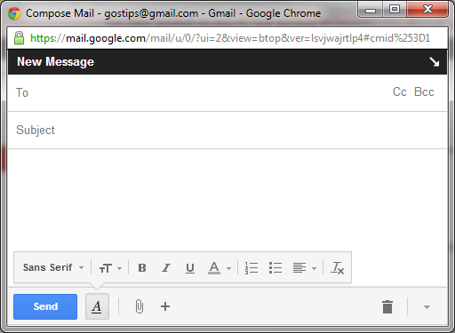

State the purpose of the following (03marks)
- To: ...........................................................................................................................
- Subject: ...................................................................................................................
- 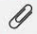........................................................................................................................

- (a) Distinguish between synchronous and asynchronous data communication modes
(02marks)
...................................................................................................................................................................................................................................................................................................................................................................................................................................................................................................................................................................................
(b) State one area in each case, where the following data transmission modes can be used.
(03 marks)
Mode of transmission | Area of application
Full duplex
Half duplex
Simplex

- (a) Define the term computer servicing (01 mark)
………………………………………………………………………………………………………………………………………………………………………………………………
(b) Give any two items/materials that can be used to service computers in a computer
laboratory. (02 marks)
………………………………………………………………………………………………………………………………………………………………………………………………

(c) Explain any two importance of servicing computers. (02 marks)
................................................................................................................................................ ………………………………………………………………………………………………………………………………………………………………………………………………
- Mr. Odil, a computer illiterate teacher was informed of the new ICT equipment and among these were the biometric devices which he had no idea about. He later seeks
your help. As an ICT student,
- What are biometric devices? (01 mark)
………………………………………………………………………………………………………………………………………………………………………………………………………………………………………………………………………………………………
(b) Mention any three biometric devices that they might have informed him about.
(03 marks)
- ………………………………………………………………………………………
- ………………………………………………………………………………………
- ………………………………………………………………………………………
(c) Explain any one disadvantage of using biometric devices (01 mark)
………………………………………………………………………………………………………………………………………………………………………………………………
- (a) Define the following terms; (03 marks)
Wiki
………………………………………………………………………………………………………………………………………………………………………………………………
Web portal
………………………………………………………………………………………………………………………………………………………………………………………………
Blog
………………………………………………………………………………………………………………………………………………………………………………………………
(b) State the type of organizations with the following top level domains. (02 marks)
.mil
.ac
- (a) Distinguish between a transfer rate and access time as applied to secondary storage
devices (02 marks)
………………………………………………………………………………………………………………………………………………………………………………………………
……………………………………………………………………………………………… (b) Explain any three ways of caring for CDs and DVDs. (03 marks)
- ………………………………………………………………………………………
- ………………………………………………………………………………………
- ………………………………………………………………………………………
- (a) What is a software version? (01 mark) ………………………………………………………………………………………………………………………………………………………………………………………….............................................................................................................................................
(b) Software is easily known to be affected by computer viruses which corrupt almost all
files and other software to hinder their functionality. Define a computer virus?
(01 mark)
………………………………………………………………………………………………………………………………………………………………………………………………
(c) Describe any two symptoms of computer viruses to software and hardware. (02 marks)
- ………………………………………………………………………………………
- ………………………………………………………………………………………
(d) State any one antivirus program you know (01 mark)
………………………………………………………………………………………………
- Identify the following devices and state the function of each.

DEVICE | NAME | FUNCTION

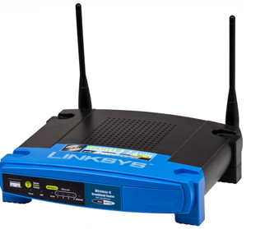
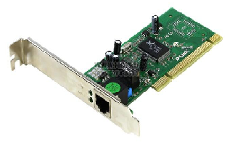
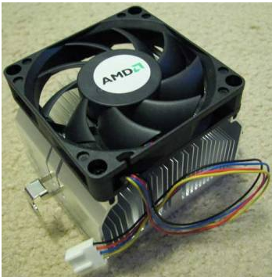
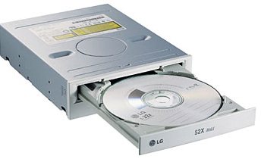

- What is recent in the minds of most Ugandans in IT world is digital migration
- Briefly describe the concepts of
- Digital divide. (01 mark)
.........................................................................................................................................
.........................................................................................................................................
- Digital migration. (01 mark)
..........................................................................................................................................
..........................................................................................................................................
(b) State three benefits Uganda has drawn from digital migration. (03 marks)
- ....................................................................................................................................
- ....................................................................................................................................
- ....................................................................................................................................
- (a) Differentiate between a server and a client computer. (02 marks)
………………………………………………………………………………………………………………………………………………………………………………………………………………………………………………………………………………………
(b) What is the function of each of the following network devices? (03 marks)
- Switch
………………………………………………………………………………………….………………………………………………………………………………………….
- Router
………………………………………………………………………………………….………………………………………………………………………………………….
- Bridge
………………………………………………………………………………………….…………………………………………………………………………………………
- Use the term below to complete the sentences that follow in (a)-(e). (05marks)
Slides transition. Animation effects. Slide layout.
Slide design. Slide show. Slide master.
Handouts.
- The visual movement from one slide to another slide is………………………………..
- The …………………………………………..set up the way text/objects appear on a
slide during presentation.
- The presentation of slides in a sequence on a projection screen is referred to …………………………………………………………………………………………..
- The ……………………………………………………defines the arrangement of all
items that makes up a slide.
- A user can print the entire presentation on one page by printing the…………………...

- (a) Define the following as used in the file management system. (02 marks)
- File path.
………………………………………………………………………………………..
………………………………………………………………………………………..
- File extension.
………………………………………………………………………………………...
…………………………………………………………………………………….......
- Using Windows 7 Operating System, outline the steps taken to create a folder in
DOCUMENTS called pre- mocks. (03 marks)
…………………………………………………………………………………………..
………………………………………………………………………………………….
………………………………………………………………………………………………………………………………………………………………………………………………………………………………………………………………………………
- (a) Briefly describe the concept of computer ethics. (02 marks)
…………………………………………………………………………………………..
…………………………………………………………………………………………..
(b) State three unethical practices usually engaged in by ICT users. (03 marks)
- ………………………………………………………………………………………
- ………………………………………………………………………………………
- ………………………………………………………………………………………

END.

