Name: ………………………...........................................................RegNo...............................
Signature: ………………………
S850/1Subsidiary ICT
Paper 1
June/July, 2019
2 ½ hours

ACEITEKA MOCK EXAMINATIONS 2019
Uganda Advanced Certificate of Education
S850/1 Subsidiary ICT
Theory Paper
2 Hours 30 Minutes

INSTRUCTIONS TO CANDIDATES:
This paper is made up of 20 compulsory and equally weighted questions
Write all your responses in dark blue or black ink in the spaces provided.
All answers should be written in the spaces provided. No additional material will be provided to the candidate.
Attempt ALL questions in this paper.

FOR OFFICIAL USE ONLY
1 |  |  | 11
2 |  |  | 12
3 |  |  | 13
4 |  |  | 14
5 |  |  | 15
6 |  |  | 16
7 |  |  | 17
8 |  |  | 18
9 |  |  | 19
10 |  |  | 20 |  | Total

Question 1
- State any three positive impact of using ICT in Music Industry today.
- ...........................................................................................................................................................................................................................................(01 mark)
- ..........................................................................................................................................................................................................................................( 01 mark)
- .......................................................................................................................................................................................................................................( 01 mark)
- Identify any two tasks a computer system cannot do.
- ........................................................................................................................................................................................................................... ................(01 mark)
- ........................................................................................................................................................................................................................................... (01 mark)
Question 2
- Study the parts of the computer system exhibited. Use it to answer the following questions:
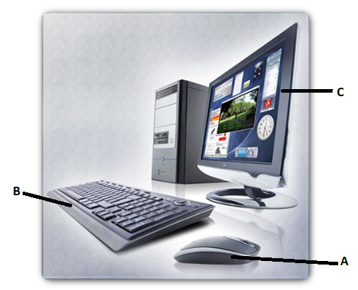
  - State the part labelled
- A…………………………………………...............….......(01 mark)
- B..........................................................................................(01 mark)
- C.........................................................................................(01 mark)
  - State one similarity between devices A and B (01 mark)
............................................................................................................................................................................................................................................................
  - What type of output is provided by the device labelled C? (01 mark)
.....................................................................................................................
Question 3
- The computer does not recognize a removable external drive.
  - Suggest one Probable cause.
.......................................................................................................................................................................................................................................................(02 mark)
  - What is the possible solution to the cause suggested in (a) i ?
............................................................................................................................................................................................................................................(02 mark)
- If an application does not install in a computer system, what could be the probable cause.
…………………………………………………………………………………………………………………………………………………………………..
……………………………………………………………………….(01 mark)

Question 4
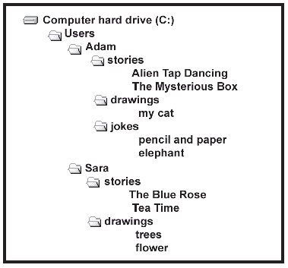
- Study the exhibit, identify and write the file path of the following files:
  - The Blue Rose (02 marks)
..............................................................................................................................
  - pencil and paper (02 marks)
..............................................................................................................................
- How many folders are seen in the exhibit
......................................................................................................................... (01 mark)

Question 5
Outline the uses of the following hardware components of the computer system:
  - Central Processing Unit (CPU)
............................................................................................................................................................................................................................................(01 mark)
  - Motherboard
………………………………………………………………………………………………………………………………………………................(01 mark)
  - Power Supply
………………………………………………………………………………………………………………………………………….................. (01 mark)
  - Video Array Graphics Card
.........................................................................................................................................................................................................................................(01 mark)
  - Adapter Cards
………………………………………………………………………………………………………………………………………………………….(01 mark)

Question 6
- State any two auxiliary / Secondary Storage Devices you know
- ..................................................................................................... (01 mark)
- .................................................................................................... (01 mark)
- Name any one auxiliary /Secondary Storage Medium you know.
  - ................................................................................................... (01 mark).
- What is use of cache memory found within the Central Processing Unit (CPU)
............................................................................................................... (02 marks)
Question 7
- Study the statements and tick the YES or NO only against each. (05 marks)
Statement | YES | NO
- You can only print one copy of a selected message
- You cannot preview a message before you print it.
- When you print a message, it is automatically deleted from your Inbox
- There is only one way to print a message.
- A folder can store more files than a briefcase

Question 8
Study the table and tick the appropriate match based on each memory. (05 marks)
Memory | Volatile | Non-volatile
- RAM
- CMOS
- ROM
- Punched Card
- Magnetic Tape

Question 9
What are the purposes of using the following devices? (05 marks)
INPUT DEVICES | Purposes
- Bar Code Reader
- MICR
- OCR
- Plotter
- Biometric System

Question 10
Toto College is organising a reunion for its teachers who have left or retired. A systems analyst is creating a database for the college to store the details of its past teachers. A three-letter code is used for the department. Part of the design of this database will involve the identification of suitable validation checks.
Below is a list of some of the data to be included in the database.
TeachName | CoName | Contact | DOB | YrLeft | Department
James | CEDAT | 0782458678 | 1/8/1980 | 2008 | Engineering
Monica | CoNS | 0702345687 | 26/7/1988 | 2009 | Mathematics
Paul | CoCIS | 0772678950 | 4/5/1972 | 2019 | Networks

- For the following fields write down the most appropriate validation check. Each validation check must be different.
  - Department....................................................................................................................................................................................................................................(01 mark)
  - DOB..............................................................................................................................................................................................................................................(01 mark)
  - YrLeft.............................................................................................................................................................................................................................................(01 mark)
- The systems analyst has set the data type for the contact field as text. Explain why this field has been set for a text data type rather than a numeric data type.
................................................................................................................................................................................................................................................................(02 marks)
Question 11
A teacher has created a spreadsheet of students’ test marks. She has written a function
= HLOOKUP(B4, D1: L2, 2, TRUE) in cell C4 in the spreadsheet.
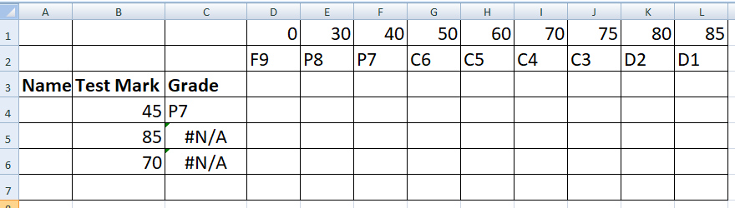
- Explain what the function in cell C4 does.
.............................................................................................................................................................................................................................................................. (02 marks)
- When the teacher copies the formula down column C an error occurs
- Explain why the error has occurred.
.................................................................................................................................................................................................................................................................................................................................................. (02 marks)
- Indicate what the teacher has to do to stop the error from happening.
..............................................................................................................................................................................................................................(01 mark)

Question 12
- State any two types of system software used in a computer system.
  - ..............................................................................................................(01 mark)
  - ..............................................................................................................(01 mark)
- With examples, differentiate between shareware and freeware application software
................................................................................................................................................................................................................................................................(02 marks)
- Name any application software suite that is commonly used.
........................................................................................................................ (01 mark)
Question 13
Indicate TRUE and FALSE for any correct and incorrect statements respectively.
- Our e-mail address must be unique........................................................................(01 mark)
- Web-based e-mail accounts do not required passwords.......................................(01 mark)
- You can sign up for Web-based e-mail without accepting the Web site's terms and conditions...............................................................................................................(01 mark)
- You can store Web-based e-mail messages in online folders................................(01 mark)
- You can delete e-mails from a Web-based e-mail account....................................(01 mark)

Question 14
- The use of computers has had an effect on the health of employees. For each of the statements below, identify one health problem most likely to be associated with them and two possible solutions to the problem. (03 marks)
Action | Health Problem | Possible Solution
Looking at a monitor for a long period of time | (i) | (i)
Looking at a monitor for a long period of time | (i) | (ii)

- Outline any two Internet Services you know
- .............................................................................................................(01 mark)
- .............................................................................................................(01 mark)
Question 15
To be transmitted, data must be transformed to electromagnetic signals. Where data can be analog or digital:
- What is a digital Signal?
.....................................................................................................................................................................................................................................................................................................................................................(02 marks)
- Explain the term “ analog signal” ?
......................................................................................................................................................................................................................................................................................................................................................(02 marks)
- Draw a sketch graph representing digital signal. (01 mark)

Question 16
- In data communication, a protocol is defined as a set of rules that governs data communication. Explain the three key elements of protocols.
  - ...............................................................................................................................................................................................................................................................................................................................................................(01 mark)
  - ...................................................................................................................................................................................................................................................................................................................................................................(01 mark)
  - ........................................................................................................................ ..........................................................................................................................................................................................................................................(01 mark).
- Explain why the following protocols are important in networking:
- HTTP.........................................................................................................................................................................................................................................................................................................................................................(01 mark)
- .SMTP............................................................................................................................................................................................................................................................................................................................................................(01 mark)
Question 17
Communication between two devices can be simplex, half-duplex, or full-duplex..
- Identify and name any two devices that operate under a simplex mode:
  - ....................................................................................................(01 mark)
  - ...................................................................................................(01 mark)
- State one difference between half-duplex and full-duplex modes of transmission.
.............................................................................................................................................................................................................................................................................................................................................................................................................................................................................................................................(02 mark)
- The effectiveness of a data communications system depends on four fundamental characteristics. Explain any one characteristic you know.
................................................................................................................................................................................................................................................................................................................................................................................................... (01 mark)
Question 18
- A company is setting up a Local Area Network. Name any three network devices she can use
- .............................................................................................................(01 mark)
- ..........................................................................................................(01 mark)
- ............................................................................................................ (01 mark)
- Propose any two cheaper transmission media this company can use.
- ........................................................................................................(01 mark)
- .........................................................................................................(01 mark)

Question 19
- What are cybercrimes?
.................................................................................................................................................................................................................................................................(02 marks)
- Suggest any two ways of minimizing cybercrimes in society.
  - ............................................................................................................................................................................................................................................(01 mark)
  - ............................................................................................................................................................................................................................................(01 mark)
  - ............................................................................................................................................................................................................................................(01 mark)
Question 20
- Indicate the word or phrase that matches the statement below. No repeat of word is required in any case: worm, Viruses, Trajan Horse, spoofing, and Phishing.
  - ........................................................................................ is the act of disguising one computer to, electronically “look” like another computer, in order to gain access to a system that would be normally is restricted.. (01 mark)
  - ....................................................................... is an unauthorized program which runs from inside, what seems to be an authorized. It in reality conceals what it is actually doing. (01 mark)
  - .............................................................................. is a program that attaches itself to a computer or a file and then circulate itself to other files and to other computers on a network. (01 mark)
  - ............................................................. do not require the host to attach themselves to. They make runable copies of themselves and do this repeatedly till they eat up all the available space on a computer's memory (01 mark)
  - ...................................... is a criminally fraudulent process of acquiring sensitive information such as username, passwords and credit card details by disguising as a trustworthy entity in an electronic communication.. (01 mark)

END

