Name………………………………………….......................

Signature……..…….......……................................ School: ...................................
S850/1
SUBSIDIARY ICT
Paper 1
July/Aug. 2014
2 ½ hours
S850/1
SUBSIDIARY
Information and
Computer tech

UGANDA TEACHERS’ EDUCATION CONSULT (UTEC)

MOCK EXAMINATIONS

Uganda Advanced Certificate of Education

SUBSIDIARY ICT

Paper 1

THEORY PAPER

2 hours 30 minutes

INSTRUCTIONS TO CANDIDATES:
Answer all questions in this paper.
All answers should be written in the spaces provided.
No additional materials (Answer sheets) are required.

For Examiners’ Use Only
1 | 2 | 3 | 4 | 5 | 6 | 7 | 8 | 9 | 10 | 11 | 12 | 13 | 14 | 15 | 16 | 17 | 18 | 19 | 20 | Total

1. (a) Your school has received a donation in form of a computer with the following specifications:

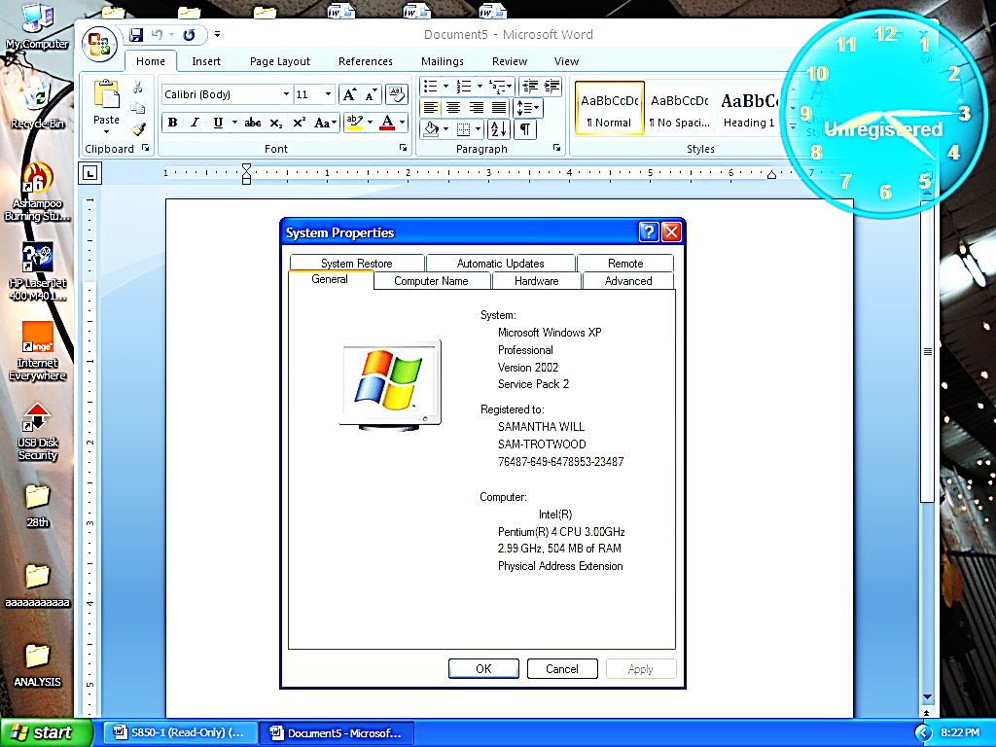

(i) State this computers processor speed. (01 mark)
....................................................................................................................................
(ii) State the name of the operating system supplied with this computer (01 mark)
....................................................................................................................................
(iii) Comment on the amount of RAM supplied on this computer in terms of capacity (01 mark)
....................................................................................................................................
(b) State any three factors considered when choosing an operating system to install on personal computer. (03 marks)
.................................................................................................................................... ....................................................................................................................................
....................................................................................................................................

2. Student X stored a file on a computer a few days ago but forgot to locate it.
(a) Identify any two search tools student X would employ to recover the file.
(02 marks)
.................................................................................................................................... ....................................................................................................................................
....................................................................................................................................
(b) If the file was stored at the following file path: C:\Documents and Settings\User\My Documents\computer practical\caleb.xls
(i) State the primary folder where it is located. (01 mark)
.................................................................................................................................... ....................................................................................................................................
(ii) Account name one can log on to access the file. (01 mark)
.................................................................................................................................... ....................................................................................................................................
(iii) The file type student X created. (01 mark)
.................................................................................................................................... ....................................................................................................................................

3. (a) Below is a list of some hardware components of a computer, choose which one best suits each of the scenarios presented in 3 (i) – (iii)
A Touch screen, A touch Pad, A Video Card, Plotters
(i) ………………………………….. Converts digital output from the computer into an analog video signal that is sent through a cable to the display device. (01 mark)
(ii) ………………………………….is an electronic visual display that can detect the presence and location of a touch within the display area. (01 mark)
(iii) ………………………………….use mechanical, ink jet, or thermal technology to create large-format images for architectural or engineering uses. (01 mark)

(b) State any two differences between Hard copy and Softcopy output. (02 marks)
..............................................................................................................................................
.............................................................................................................................................. .............................................................................................................................................
..............................................................................................................................................
4. (a) Distinguish difference between a browser and a search engine. (02 marks)
..............................................................................................................................................
.............................................................................................................................................. .............................................................................................................................................
..............................................................................................................................................
(b) A Students sent an e-mail to a friend with an attachment of a file containing a video 40 GB. How long will it take to download the file on a 128 kbps modem? (03 marks)
..............................................................................................................................................
.............................................................................................................................................. .............................................................................................................................................
..............................................................................................................................................
5. (a) How is system software different from application software? (01 mark)
..............................................................................................................................................
..............................................................................................................................................
(b) Outline the four basic components of system software (04 marks)
..............................................................................................................................................
.............................................................................................................................................. .............................................................................................................................................
..............................................................................................................................................

6. While working on a computer, Student Y’s computer had a power surge.
(a) Identify any three possible causes of power surge in a computer. (03 marks)
..............................................................................................................................................
.............................................................................................................................................. .............................................................................................................................................
(b) How can the above problem be controlled in a computer laboratory.(02 marks)
..............................................................................................................................................
.............................................................................................................................................. .............................................................................................................................................
..............................................................................................................................................

7. (a) Explain the difference between copying a document and moving a document. (02 marks)
..............................................................................................................................................
.............................................................................................................................................. .............................................................................................................................................
..............................................................................................................................................

(b) Write the keyboard shortcuts used to perform the following operation during word processing.
(i) Copy a block of selected text......................................................................... (01 mark)
(ii) Check spelling and grammar in the entire document
(01 mark)
..............................................................................................................................................
(iii) Increase font size. ..............................................................(01 mark)
8. A microprocessor contains many different types of registers, and each performs a specific function.
(a) What are registers? (01 mark)
..............................................................................................................................................
.............................................................................................................................................. (b) Below is a list showing the different kinds of registers, choose which one best suits each of the scenarios presented in 5 b (i) – (iv)
Program counter, Instruction register, Accumulator,
Instruction decoder
(i) …………………………. …………. holds the address of the next instruction to be fetched from the memory. (01 mark)
(ii) …………………………………..... holds the current instruction fetched from the memory. (01 mark)
(iii) ……………………………………. interprets, or decode, the instruction currently held in the instruction register. (01 mark)
(iv) ………..………………………….. holds the data item to be processed and the results of arithmetic and logical operations. (01 mark)
9. (a) State any two security threats delivered via e-mail. (02 marks)
..............................................................................................................................................
..............................................................................................................................................
..............................................................................................................................................
(b) Give two guidelines for creating a secure password. (02 marks)
..............................................................................................................................................
..............................................................................................................................................
..............................................................................................................................................
(c) A part from Microsoft outlook express, state one other example of e-mail software available for use today. (01 mark)
..............................................................................................................................................
..............................................................................................................................................
10. Tick TRUE or FALSE next to each of these statements. TRUE FALSE
File extension for power point program is .doc
DTP software is used to create magazines
A working knowledge of HTML is helpful when creating web pages
WORM is characterised by its self-propagating behaviour
A Graphical User Interface uses icons to represent applications

(05 marks)

11. (a) Explain the meaning of Attenuation as applied in data communication.
(01 mark)
..............................................................................................................................................
..............................................................................................................................................
(b) Give two causes that may bring about attenuation in communication systems. (02 marks)
..............................................................................................................................................
..............................................................................................................................................
..............................................................................................................................................
(c) State the difference between a simplex and a full duplex channel. (02marks) ..............................................................................................................................................
..............................................................................................................................................
..............................................................................................................................................
12. (a) Explain what is meant by data communication tools. (01 mark)
………………………………………………………………………………………..........
………………………………………………………………………………………............

(b) State the difference between analog and digital signalling. (02 marks)
............………………………………………………………………………………………
………............………………………………………………………………………………
(c) Give two examples of data communication tools. (02 marks)
………..........………………………………………………………………………………
...........………………………………………………………………………………………13. (a) Outline any three benefits of networking a set of computers for an organisation. (03 marks) ………..........………………………………………………………………………………
...........……………………………………………………………………………………… ………..........………………………………………………………………………………
...........………………………………………………………………………………………

(b) List down two examples of network operating systems. (02 marks) ………..........………………………………………………………………………………
...........……………………………………………………………………………………… ………..........………………………………………………………………………………
14. (a) Distinguish between a storage device and storage media. (02 marks) ………..........………………………………………………………………………………
...........……………………………………………………………………………………… ………..........………………………………………………………………………………
(b) Outline any three examples of solid state storage. (03 marks) ………..........………………………………………………………………………………
...........……………………………………………………………………………………… ………..........………………………………………………………………………………
...........………………………………………………………………………………………
15. (a) Below is a list of utility programs that enhances the performance of the exiting functions of an operating system and provides services that are not provided by other system software. Choose from the list below to complete the sentences Disk scanner, disk defragmenter, File viewer, File compressor
(i) ….………………………………. utility program detects and corrects physical and logical problems on a hard disk. (01 mark)
(ii) ….……………………………. utility program compresses data in order to create more storage area of a hard disk or floppy. (01 mark)
(iii) …………………………….utility collects contents of the file scattered in different portions and collects it together for easy accessibility and retrieval. (01 mark)
(b) List down two examples of utilities applied in 15 (a) (ii) above. (02 marks) ………..........………………………………………………………………………………
...........……………………………………………………………………………………… ………..........……………………………………………………………………………… 16. (a) Explain what is meant by cloud computing. (02 marks) ………..........………………………………………………………………………………
...........………………………………………………………………………………………
(b) Outline any two benefits of cloud computing. (02 marks) ………..........………………………………………………………………………………
...........……………………………………………………………………………………… ………..........………………………………………………………………………………
...........………………………………………………………………………………………
(c) State any one limitation of cloud computing services. (01 mark) ………..........………………………………………………………………………………
...........……………………………………………………………………………………… 17. (a) Give two advantages of e-commerce over traditional transactions. (02 marks) ………..........………………………………………………………………………………
...........……………………………………………………………………………………… ………..........………………………………………………………………………………
...........………………………………………………………………………………………
(b) Give one examples of e-commerce transactions. (01 mark) ………..........………………………………………………………………………………
...........………………………………………………………………………………………
(c) Outline two services that are normally supported by online banking.(02 marks) ………..........………………………………………………………………………………
...........……………………………………………………………………………………… ………..........………………………………………………………………………………
...........………………………………………………………………………………………18. (a) Explain the meaning of intellectual property rights. (02 marks) ………..........………………………………………………………………………………
...........……………………………………………………………………………………… ………..........………………………………………………………………………………
(b) Outline any three ways of protecting intellectual property rights of software developers. (03 marks) ………..........………………………………………………………………………………
...........……………………………………………………………………………………… ………..........………………………………………………………………………………
19. The manager of a bookshop uses a database to store data about the books she sells. The table below shows part of the database.

Title of Book | Rating | Number in stock | Order No | Next order due
Shake spear | G | 15 | B1-2001 | 20/12/2014
Vanity Fair | E | 25 | B2-2002 | 14/10/2014
Sandition | G | 21 | B3-2003 | 15/25/2014
Matrix | E | 05 | B4-2004 | 12/02/2014

(a) (i) Suggest an appropriate field for the primary key. (01 mark) ………..........………………………………………………………………………………
...........………………………………………………………………………………………
(ii) Suggest the appropriate data types for
Title of the book ………………………………………. (01 mark)
Rating …………………………………………………. (01 mark)
(iii) Suggest the appropriate field size for
“Number in stock” field (01 mark)
......................................................................................................................................
“Order number” field (01 mark)
.......................................................................................................................................

20. The worksheet below is used to compute the total hours and wages of employees working in a certain company. Use it to answer the questions that follow.
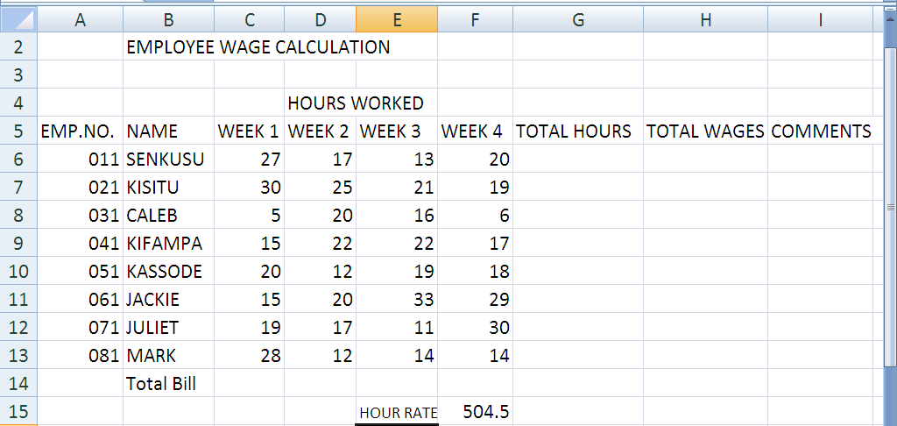
(a) Write down the formulas that shall be used to compute
(i) Total hours in cell G6 (01 mark) ………..........………………………………………………………………………………
...........………………………………………………………………………………………. (ii) Total wages (H5) basing on the hour rate in cell F15. (01 mark)
………..........………………………………………………………………………………
(iii) Comments in cell I6 to return “Hard worker “ or “Lazy worker” basing on number of hours worked in week 1 greater than or equal to 20.
(01 mark) ………..........………………………………………………………………………………
...........………………………………………………………………………………………
(iv) Total bill payable in cell H15. (01 mark) ………..........………………………………………………………………………………
(b) State the value that will be intersected as a result of highlighting cells in this reference: = (D6:D13 A10:H10) (01 mark) ………..........………………………………………………………………………………
...........………………………………………………………………………………….....
END

