S850/2
ICT
Paper 2
July 2019
2 hours

MADINAH ISLAMIC SECONDARY SCHOOL, NSANGI
PRE-MOCK EXAMINATIONS – 2019
UGANDA ADVANCED CERTIFICATE OF EDUCATION
ICT PRACTICAL
PAPER 2
2Hours

INSTRUCTIONS TO CANDIDATES
- Attempt only three questions.
- You are provided with the support files
- Each candidate will provided with a new CD-R or CD-RW.
- All numbers attempted should be saved in one folder with students Names and index number.
- Each candidate must produce a hard copy for each of their work to accompany the CD-R or CD-RW.

NOTE: Flash disks are not accepted

1. Using a suitable software package, load the file PROJECT.RTF and save it as
NEWSLETTER_YOUR NAME.
- Set the page size to A4, page orientation to portrait and all margins to 2cm. [2mark]
- Place in the footer the automated file name right aligned (including the file path) [1mark]
- Insert a blank line at the start of the document and enter the title: LAMUDAHK CONSTRUCTION NEWS [1mark]
- Below the title, add the subtitle: Report by: and add your name [1mark]
- Format the title and subtitle as follows;
- Font face Algerian, size 18.5 and colour blue for the title [1mark]
- Font face Constantia, size 14 and colour red for the sub-title [1mark]
- After the subtitle text, format the rest of the document into two equally spaced columns with a 2 cm gap. [1mark]
- In the left column, before the first paragraph, enter the subheading: The Company and use a format painter to apply the same formats of the sub heading “The project”. [1mark]
- Import the image LOG.JPG, place it on the first page below the sub title and resize it to 4.2cm height maintaining the aspect ratio.
[2marks]
- Format all text after the main title and subtitle except the sub headings to left alignment and font size 12. [1mark]
- Format the table so that;
  - it fits within the column width, no text is wrapped within a cell [1mark]
  - only the top row of the table has a light grey (10–20%) shading [1mark]
- Change the line spacing to 1.15 for all the text below the titles [1mark]
- Import the image ROAD.JPG after the sub-heading “Theproject”.
[1mark]

- Format the image as follows;
  - Resize the image to 5 cm high and maintain the aspect ratio.
[1mark]
  - Rotate the image 180°.
[1mark]
  - Crop the image to remove 50% from the right and make sure the text wraps round the image.
[1mark]
- Spell check and proofread the document and the produce a print out
[1mark]

2. You are required to create a short presentation. All slides must have a consistent layout and formatting. Unless otherwise instructed, each slide must display a title and bulleted list.
- Create a presentation of 5 slides using the file CONSTRUCTION.RTF for the literature of the presentation called your name_Workshop
- Display the following features on all slides:
  - The company logo LOG.JPG positioned in the top right corner, appropriately sized with aspect ratio maintained.
[2marks]
  - Your name and candidate number in the bottom left corner.
[1mark]
  - Automatic slide numbers in the top left corner.
[1mark]
- Change the layout of slide 1 to a Title Slide layout so it contains a title and subtitle centered in the middle of the slide.
[3marks]
  - Insert a title LAMUDAHK CONSTRUCTION COMPANY
  - Insert your name after the text Guide produced by:

- On slide 2 with the title CONSTRUCTION MANAGER AS AGENT, draw the following diagram: [3marks]
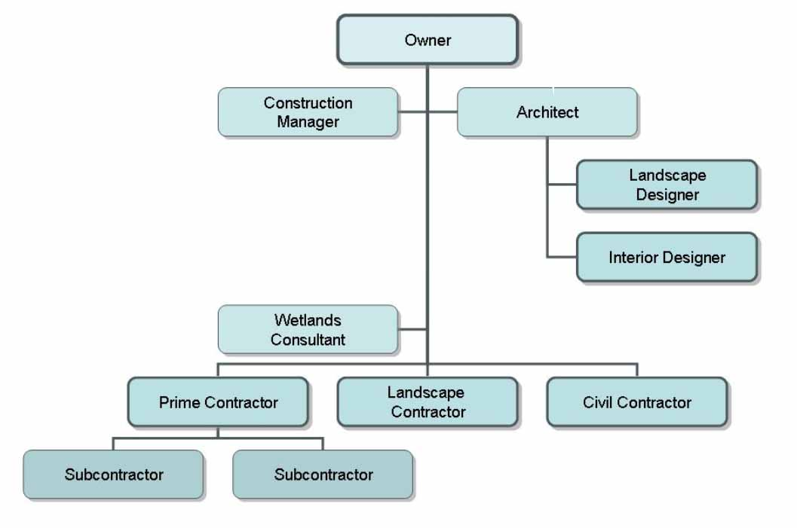
- On slide 3, enter the title Types of Construction Contracts. In the click to add text textbox enter a bulleted list of contracts.
[2marks]
- On slide 4, enter the different reasons for contractor failure. It should look like this
[3marks]
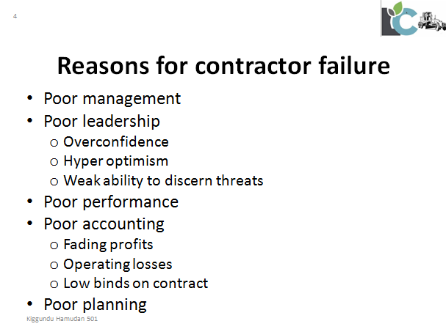

- The conclusion of the presentation should be on slide 5.
[2marks]
- Use rehearse timing feature to determine the amount of time each slide will spend on the screen while the presenter is presenting
[2marks]
- Print all your slides on one page [1mark]
3. a) Using a suitable software load a file STUDENTS MARKS and save it as your Firstname_Results [1Mark]
b) Use an appropriate function and computer the following;
- Total Marks in cellG2. Copy the formula to a range of cells G3:G13
[2Marks]
- AverageMarks in cell F2. Copy the formula to a range of cells F3:F13
[2Marks]
c) Use an appropriate function to position the students in COLUMN Iaccording to average marks. Ensure that, a student with the least average mark is in the first position. [2Marks]
d) Use a COUNTIF function to return the number of students who missed the CHEMISTRY exam in cell B15. [2Marks]
e) In cell B16, use a suitable function to return the model mark in PHYSICS.
[2Marks]
f) In cell D15, uses a suitable function to count the number of students have chemistry marks [2Marks]
g) Insert a column after PHYSICS, CHEMESTRY, MATH, and SUB-ICT. Enter column labels every after a every subject column as PHY Grade, CHEM Grade, MATH Grade, and ICT Grade. Use Wrap text feature so as text look like this;
[1Marks]
NAME | CLASS | PHYSICS | PHY Grade | CHEMISTRY | CHEM Grade | MATH | MATH Grade | SUB-ICT | ICT Grade | TOTAL | AVERAGE | POSITION

h) Use H-LOOKUP function to grade marks in all subjects. Refer to the grading scales below. [3Marks]
GRADING SCALE FOR PRINCIPLE SUBJECTS
0 | 1-39 | 40-44 | 45-49 | 50-59 | 60-69 | 70-79 | 80-100
X | F | O | E | D | C | B | A
GRADING SCALE FOR SUBSIDIARY SUBJECT
0 | 1-49 | 50-100
X | F | O

i) Select the range F2:F13 and use conditional formatting feature to apply a light red fill colour to the cell bearing X grade [2Marks]
j) Save changes and produce a print out. Make sure all your work fits on one page.
[1Mark]
4. a) Load a file Library Info Sys.accdb using suitable application software on your computer as it as Lib Management Info Sys
[1Mark]

b) Import a data from a fileRECORDS.xlsx to create another table called BORROWERS
[3marks]

c) Change the data types of the different fields as follows
[1Mark]
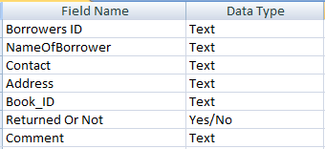

d) Create a relationship between the Books table and Borrowers table
[2Marks]
e) Create a query to display Name Of Borrower, Book,_Title, Author, Contact, and Addressfields only of those Borrowers who have not returned the book save as “Borrowers with books” [5marks]
f) Create another query to display names borrowers beginning with letter N from Kampala. Save it as “People from Kampala” [2Marks]
g) Create a form from borrowers table and enter the record below
[3marks]

Borrowers ID | NameOf Borrower | Contact | Address | Book_ID | Returned Or Not | Comment
KSS-011 | Mutaasa Kamada | 0754121356 | P.O BOX 145 Wakiso |  | Not | None

h) Create a report for only Science and Technology. Include Book ID, Book_Title, Book_Type , Author and Name Of Borrower [2marks]
i) Print out your form [1mark]

5. Use any desktop publishing software and design an advert for a construction company and it should look like this;


UseCall.jpg,image1.jpg and image2.jpg for the lower section of the advert and background.jpg for the background of the advert, the literature about the advert is provide in a file called publication.docx from the support file folder.
You are required to;
a) Use a blank page A4 size. [2marks]
b) Change the all margins to 0.4 inches. [2marks]
c) Import text to your publication [3marks]
d) Import images in their right positions as seen from the image. [3marks]
e) Save your publication as Marketing Advert [1Mark]
f) Save another copy of the publication as an image with a name Advert in your work folder. [2marks]
g) Create another publication file called Final Advert with a blank page A4 size and insert the image Advert.jpg. [2marks]
h) Change the image size height to 4.5 inches and maintain the aspect ratio.
[2marks]
i) Duplicate the image so that four of them fit on the page [2marks]
j) Produce a hard copy of the Final Advert [1mark]

END

