3. Shown in the figure below is an orthographic drawing of the intersection of two square prisms. Draw the given views showing the lines of interpenetration.

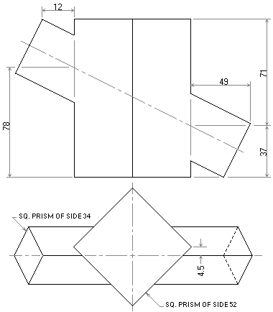

The next figure shows two views of a right cone and a sphere intersection. Copy the given views and complete them with the curves of interpenetration. All construction lines must be clearly shown.

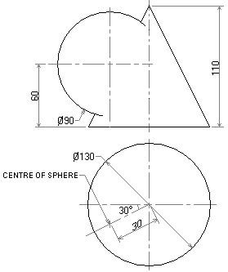

The figure below shows an incomplete view of a right cone intersected by a right cylinder. Draw the given view and complete it with a curve of intersection. All point centres on the curve must be clearly shown.

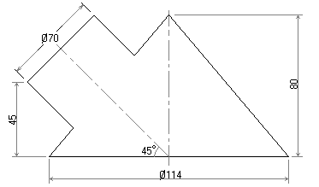 Shown in the figure below are two incomplete views of a square pyramid in intersection with a sphere. Draw full size both views, and complete them with the curves of intersection.

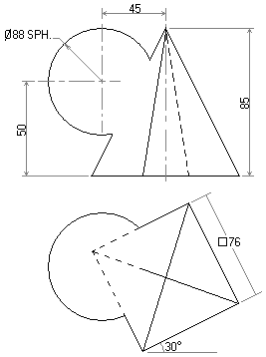

Shown in the figure below is an incomplete elevation of a component to be made from sheet metal. Draw full size the following views of the component in first angle projection;
(a) A complete front elevation.
(b) An end elevation in the direction of arrow P.

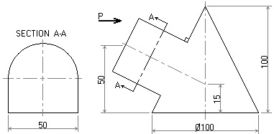

A hemispherical cap and a cylinder branch pipe intersect as shown incomplete in the figure below.
(a) Draw the elevation showing the curve of intersection accurately projected.
(b) Draw a development of one half of the branch pipe, assuming a butt joint along the line x-x.

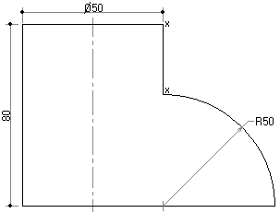

The figure below shows two views of a hexagonal prism piercing through a cone. Determine the curve of interpenetration between the cone and the prism.

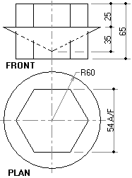

The figure below shows a cone and a cylinder intersecting each other.
(a) Determine the curve of interpenetration between the cone and cylinder.
All hidden details must clearly be shown.
(b) Draw the development of the cone to show the true shape of the holes made by the cylinder in the in the cone.

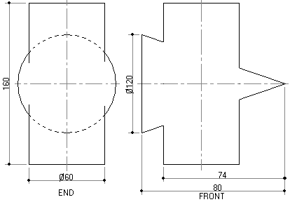

The figure below shows the front view of a cylinder intersecting with a cone.
(a) Project the end view in the direction of the arrow shown.
(b) Complete the curves of interpenetration between the cone and the
cylinder in both views.

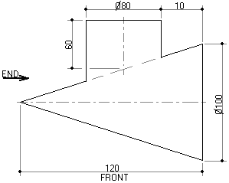

A hemispherical cap and a cylinder branch pipe intersect as shown incomplete in the figure below.
(a) Draw the elevation showing the curve of intersection accurately projected.
(b) Draw a development of one half of the branch pipe, assuming a butt joint along the line x-x.

figure below shows a cone and a cylinder intersecting each other.
(a) Determine the curve of interpenetration between the cone and cylinder.
All hidden details must clearly be shown.
(b) Draw the development of the cone to show the true shape of the holes made by the cylinder in the in the cone.

The elevation and incomplete plan views of two intersecting roofs are given in the figure below.
(a) Draw the given views.
(b) Complete the plan view showing:-
(i) The curve of intersection.
(ii) Other missing details.

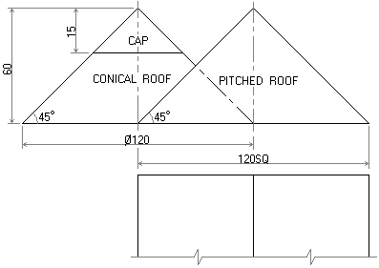

Two incomplete views of a cylinder intersecting with a square based pyramid are given in the figure below.
(a) Draw and complete them with the lines of intersection.
(b) Project the complete plan view of the cylinder and pyramid.

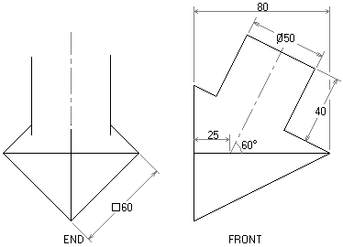

The figure below shows two views of a hexagonal based pyramid intersecting with a triangular prism.
(a) Complete the two given views by showing the lines of intersection
between them.
- Project the complete end view showing all the hidden details in the
direction of arrow E.

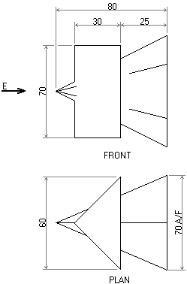

The front view of on octagonal prism intersecting with a roof is given in the figure below.
(a) Project its plan view in third angle projection.
(b) Determine the true shape of section of the roof.
(c) Develop the octagonal prism surfaces.

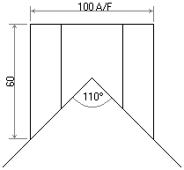

. The figure below shows a sphere interpenetrated by a right cylinder.
Draw the given views and complete the elevation with a curve of intersection.

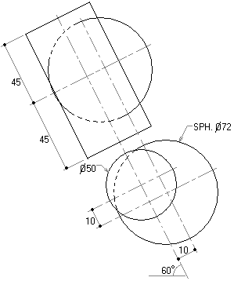

6. The figure below shows the elevation of an elliptical duct passing through the roof ridge. The duct has a major axis of 900mm and a minor axis of 600mm.
Using a scale of 1 : 10, draw:
- The given elevation.
- The plan.
- The end elevation in the direction of arrow P.

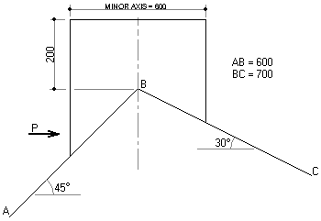

7. The figure below shows a right circular cone interpenetrated by a right cylinder. Draw and complete the given views showing the curves of intersection.

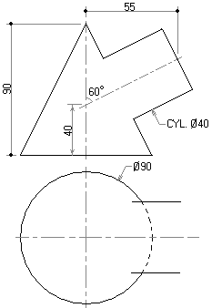

5. The figure below shows a right circular cone interpenetrated by a hexagonal prism.
(a) Draw;
(i) The given plan.
(ii) A complete elevation showing the curve of intersection.
- Make a compete development of the hexagonal prism with the seam as
shown.

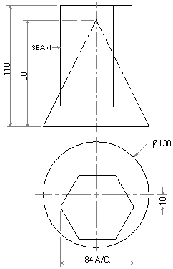

7. The figure below shows orthographic views of an offset interpenetration between two unequal cylinders.
(a) Draw the given views and the curve of intersection.
(b) Add an end elevation in the direction of arrow X.

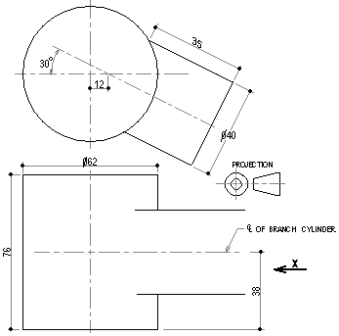

6. The figure below shows an incomplete elevation of three pieces of sheet metal piping. Draw to full size;

(a) a complete elevation showing curves of intersection, (12 marks)

(b) a complete plan. (08 marks)

