Name ……………………………………………………Signature………………………..
Index No
P515/1
Principles and
Practices of Agriculture
August 2019
2 ½ hours

MOCK EXAMINATIONS 2019
UGANDA ADVANCED CERTIFICATE OF EDUCATION
PRINCIPLES AND PRACTICES OF AGRICULTURE
Theory paper
Paper 1
TIME: 2 ½ HOURS

Instructions
- This paper consists of section A and B
- Answer all questions in both sections A and B
- Write the answers to section A in the boxes provided
- Write answer to section B in the spaces provided.
For Examiners use only
Section
A1 – 30
B 31
32
33
34
35
36
37
Total

SECTION A:
- Which of the following soil types is determine mainly by climate?
A: zonal soils
B: Azonal soils
C: Intra zonal
D: Molisols

- In preparation of silage, molasses are added to silage in order to
A: aid bacterial action
B: act as a catalyst
C: to increase carbohydrate content
D: increase temperature.

- Which one of the following pairs of hormones is responsible for milk- let down?
A: Oestrogen and progesterone
B:; oxytocin and prolactin
C: prolactin and oestrogen
D: oxytocin and progesteron

- Which one of the following factors may make crop rotation ineffective in controlling crop diseases?
A: there may be loss of soil fertility
B: Absence of resistant crop varieties
C: Late planting of crops
D: presence of pathogen spores from previous crop

- Wrought iron is preferred in the manufacture of chains because of its
A: Malleability
B: ductility
C: Hardness
D: toughness

- The predominant flowering plants in the neighbourhood of a bee hive influences the
A: timing of the harvesting of honey
B: ease with which colonies multiply
C: amount of honey produced I in the hive
D: distinct flavor of honey
- Which one of the following practices prolongs the life of semen after extraction from a bull?
A: adding glucose
B: keeping it in liquid nitrogen
C: diluting it
D: Adding antibiotics

- Gender oppression hinders agricultural production through the following except
A: denying some individuals opportunities available
B: unequal sharing of agricultural resources basing on sex.
C: denying some individuals the opportunity to make decisions
D: division of labour during the production process.

- Which of the following is not a characteristic of a good agro forestry tree species?
A: having light canopy to allow sunlight penetration
B: being easy to establish
C: being deep rooted
D: being able to compete with crops

- When the price of meat was 1500 Ugandan shillings per kilogram, a family consumed 20kg. When the price of meat changed to 2064, the family readjusted to 10kg per month. What was the elasticity of demand of the meat?
A: 1.33
B: 0.4
C: 0.67
D: 0.75

- The advantage of machine milking is that
A: it ensures complete milking
B: milk does not come in contact with contaminants
C: Milk is insulated from outside temperature
D: the milk man does not get tired.

- Which of the following explains why cotyledons are brought out of he ground in epigeal germination?
A: rapid elongation of epicotyls
B: rapid elongation of hypocotyls
C: cotyledons are stuck on the plumule
D: cotyledons rapidly increases in size during germination

- Digestible crude protein of a feed is a measure of the
A: nitrogen in the feed consumed which retained in the body
B: total nitrogen in a feed
C: total amount of protein in a feed
D: total amount of protein in the feed consumed which is defeacated

- When a super-phosphate fertilizer is applied to a clay soil, crops may not show positive response mainly because
A: phosphates get fixed into soluble minerals once in the soil
B: clay sols are usually water-logged and so dissolve in the phosphate
C: phosphate uptake by the crops is antagonized by the presence of other clay
minerals
D: clay soils encourages leaching of phosphates.

- The following results were obtained from selfing of F₁ generation of pure breeding pea. Parent plants for round and wrinkled seeds. Dominant trait round seeds: Recessive trait winkled seeds: Number of F2 offspring 7524. What would be the actual number of F₂ offsprings with round seeds?
A: 1881
B: 2508
C: 3762
D: 5643

- Which of the following is not a method of breaking seed dormancy?
A: treatment of seeds with 0.1% lindane dust before storage
B: mechanical scarification of seeds
C: soaking seeds in cold water for some time before planting
D: briefly immersing seeds in concentrated sulphuric acid

- The tough and horny layer covering the inner part of the gizzard does the function of
A: crushing the solid particles of food against the muscular wall
B: protecting the delicate muscles from damage by action of grit
C: grinding solid food materials into a fine consistency with the help of small stones
D: providing the grinding force to the grit to break down the solid food materials.

- The severe nitrogen deficiency in the soil which follows the addition of fresh plant residues with high C:N ratio is brought about by
A: less nitrogen content in the plant residues
B: immobilization of nitrogen in the soil by soil micro-organisms
C: less decomposition due to low moisture content in the plant residues
D: inability of soil organisms to fix nitrogen in the soil from the organic residues.

- The osmotic potential of a cell is at par with wall pressure when
A: at partial plasmolysis
B: at total plasmolysis
C: at full turgidity
D: when DPD is nil

- Which one of the following explains positive and negative geotropism in roots and shoots respectively?
A: high auxin concentration accelerates growth in roots but retards it in shoots
B: low auxin concentration accelerates growth in roots but retards it in shoots
C: high auxin concentration accelerates growth in both roots and shoots
D: low auxin concentration accelerates growth in both roots and shoots

- A driving wheel of 12 teeth drives another wheel of 25 teeth which has a load of 120N. If the effort used is 80N, what is the efficiency of the machine during its operation?
A: 2.1%
B: 1.5%
C: 72%
D: 2.08%

- Which of the following least effectively measures the efficiency of a farm?
A: comparison of actual yield with expected yields
B: comparison of net profit with capital invested.
C: comparing yields of one enterprise with yields of the same enterprise on a different farm
D: comparing fixed costs and gross income on the farm.

- Which of the following best explains why plants of the same species may respond differently to deficiency of the same nutrient?
A: uneven distribution of the nutrient in the soil
B: Genetic variation of the plants
C: uneven distribution of water in the soil
D: different photosynthetic mechanisms of plants

- Which one of the following is a characteristic of plants growing in highly watered soils?
A: stunted growth
B: early maturity
C: wilting
D: poor root development

- Agricultural products have an inelastic demand because they
A: are produced seasonally
B: are complemented by synthetics
C: cannot be stored for too long
D: are a necessity

- Which one of the following is a limitation of using a spray race on the farm?
A: it is not suitable for sick animals
B: it requires large volume of wash
C: the animal’s body may not be well covered by the wash
D: certain virus diseases can accumulate in the wash

- Which of the following workshop tools is used for smoothening curved edges of wood?
A: Tenon saw
B: Jack plane
C: Bow saw
D: Spoke shave

- Seeds from hybrid crops in maize are not good for use in the second generation because
A: they are expensive
B: they take long to mature than parents
C: they do not breed true to the parent quality
D: they are prone to pests and disease attack

- One way in which air seasoning of wood is better than Kiln seasoning is that it
A: requires less staking space
B: is a cheaper
C: makes timber more resistant to insect and fungal attack.
D: can decrease moisture content of timber to desired level.

- Fixed costs are not used to determine the profitability of a farm enterprise because they
A: do not vary with the amount of production
B: are not easily determined
C: are shared by several enterprises
D: are met once in production
SECTION B

- A test was carried out on 256 dried maize seeds using tetrazolium salt in an agricultural research station. The seeds were soaked in water for 2 hours and latter cut longitudinally through their embryos into two halves to expose the endosperm S. Thereafter halves were immersed in a solution of tetrazolium salt for 30 minutes. After the scheduled time, the endosperms of 396 halves were found not have changed while those of the remaining halves had turned to pink colour.
- (i) What was the purpose of soaking the seeds? (1 marks)
………………………………………………………………………………………………………………………………………………………………………………
(ii) Explain the reaction in the experiment above (2 marks)
………………………………………………………………………………………………………………………………………………………………………………

- From the results of the test above, calculate the germinability of the maize seeds
(3 marks)
……………………………………………………………………………………………………………………………………………………………………………………………………………………………………………………………………………………………………………………………………………………………………………………………………………………………………………………………………

- With a reason state the suitability of the maize seeds for planting (2 marks)

……………………………………………………………………………………………………………………………………………………………………………………………………………………………………………………………………………………………………………………………………………………………………………………………………………………………………………………………………

- Why should a farmer test for the germinability of seeds before planting (2 marks)
- ………………………………………………………………………………………………………………………………………………………………
- ……………………………………………………………………………………………………………………………………………………………….

- The figure below shows the result of an experiment to find out the effect of Indole Acetic Acid ( IAA) and gibberellic (GA) on elongation of the stem segments from the stem internodes of condition except for treatments outlined below

Culture 1 – control, no plant growth substance added
Culture 2 – GA only added
Culture 3 – IAA only added
Culture 4 – GA and IAA added
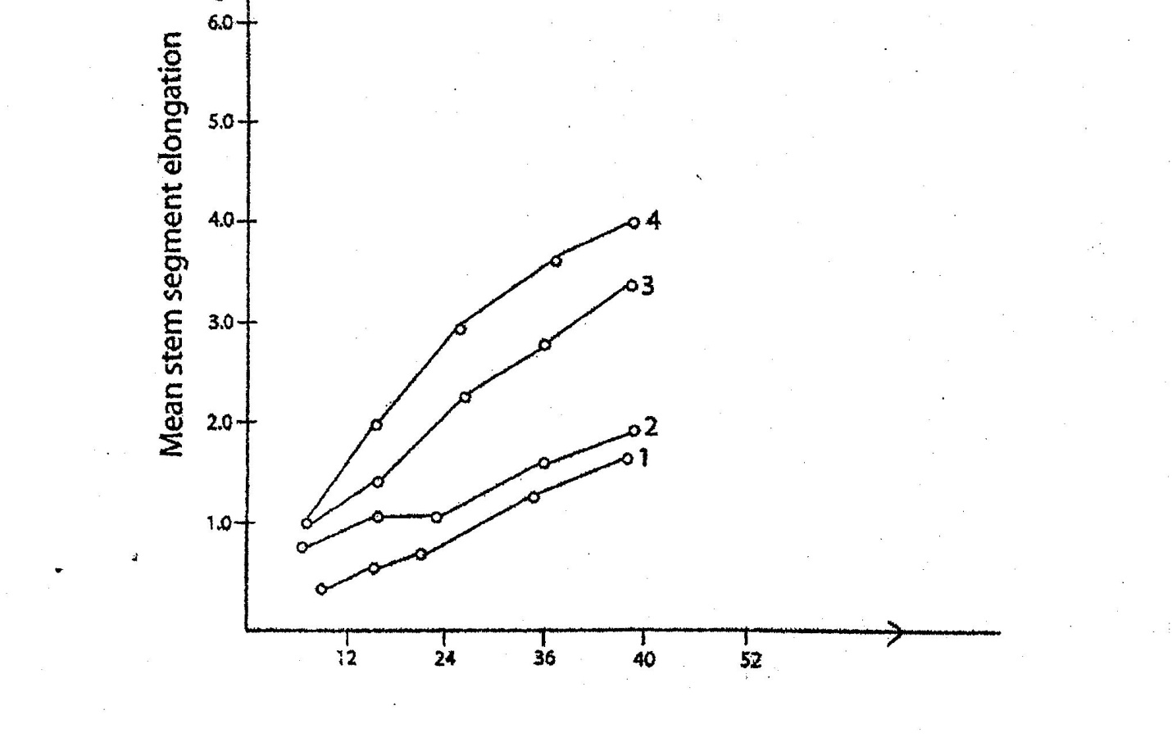
Incubation time

(a) What is the effect on elongation of the same segments of
- GA and IAA separately (4 marks)
……………………………………………………………………………………………………………………………………………………………………………………………………………………………………………………………………………………………………………………………………………………………………………………………………………………………………………………………………
- GA and IAA combined. (1 mark)

………………………………………………………………………………………………………………………………………………………………………………………………………………………………………………………………………………

(b) What type of interaction is shown by the two growth substance? (1 mark)
……………………………………………………………………………………………………………………………………………………………………………………
- State two other effects of IAA in plants other than stem elongation. (2 marks)
- ………………………………………………………………………………………………………………………………………………………………
- ………………………………………………………………………………………………………………………………………………………………

- State four commercial application of plant hormones. (2 marks)
- ………………………………………………………………………………
- ……………………………………………………………………………….
- ………………………………………………………………………………
- ………………………………………………………………………………

- A broiler bird consumed a total of (6) six kgs of a feed during its 10 week life from hatching to slaughter. Its hatching weight of approximately 6gm was ignored. While at slaughter, it weighed 2 kg
- Calculate its feed conversion ratio (3 marks)
…………………………………………………………………………………………………………………………………………………………………………………………………………………………………………………………………………………………………………………………………………………………………………………………………………………………………………………………………………………………………………………………………………………………………………………………………………………………………………………………
- Explain the meaning of feed conversion ratio. (2 marks)
……………………………………………………………………………………………………………………………………………………………………………………………………………………………………………………………………………………………………………………………………………………………………………………………………………………………………………………………………
- Outline five factors that may influence the feed conversion ratio of farm animals
(5 marks)
- ………………………………………………………………………………………………………………………………………………………………………………………………………………………………………………………
- ………………………………………………………………………………………………………………………………………………………………………………………………………………………………………………………
- ………………………………………………………………………………………………………………………………………………………………………………………………………………………………………………………
- ……………………………………………………………………………………………………………………………………………………………………
- ……………………………………………………………………………………………………………………………………………………………………

- (a) A wheel with a diameter of 400cm and an axle of diameter 80cm were used to lift a load on the farm. The machine has an efficiency of 65%. Calculate
- Velocity ratio of the machine (3 marks)
……………………………………………………………………………………………………………………………………………………………………………………………………………………………………………………………………………………………………………………………………………………………………………………………………………………………

- Mechanical advantage of the machine (3 marks)
……………………………………………………………………………………………………………………………………………………………………………………………………………………………………………………………………………………………………………………………………………………………………………………………………………………………………………………………………
(b) Mention two reasons why pulleys used to lift loads on the farm are not 100% efficient (2 marks)
(i) …………………………………………………………………………………
……………………………………………………………………………………..
(ii) ………………………………………………………………………………….
……………………………………………………………………………………..

- (a) Give five considerations that should be made in the construction of a maize crib
(5 marks)
……………………………………………………………………………………………………………………………………………………………………………………………………………………………………………………………………………………………………………………………………………………………………………………………………………………………………………………………………………………………………………………………………………………………………………………………………………………………………………………………………………………………………………………………………………………
(b) What precautions should be made before putting maize grain in the store?
(5 marks)
……………………………………………………………………………………………………………………………………………………………………………………………………………………………………………………………………………………………………………………………………………………………………………………………………………………………………………………………………………………………………………………………………………………………………………………………………………………………………………………………………………………………………………………………………………………
- (a) Explain four constraints of communal land ownership. (4 marks)
………………………………………………………………………………………………………………………………………………………………………………………………………………………………………………………………………………………………………………………………………………………………………………………………………………………………………………………………………………………………………………………………………………………………………………………………………………………………………………………………………………………………………………………………………………………………………………………………………………………………………………………………………………………………………………………………………………………………………………………………………………………………………………………………………………………………………………………………………………………………………………………………………………………………………………………………………………………………………………………………………………………………………………………………………………
(b) How does land consolidation as a land reform measure help to raise agricultural production? (6 marks)

…………………………………………………………………………………………………………………………………………………………………………………………………………………………………………………………………………………………………………………………………………………………………………………………………………………………………………………………………………………………………………………………………………………………………………………………………………………………………………………………………………………………………………………………………………………………………………………………………………………………………………………………………………………………………………………………………………
- (a) Describe five effects of soil temperature on soil fertility. (5 marks)
- ……………………………………………………………………………………………………………………………………………………………………………………………………………………………………………………..
- ………………………………………………………………………………………………………………………………………………………………………………………………………………………………………………………
- ……………………………………………………………………………………………………………………………………………………………………………………………………………………………………………………
- ………………………………………………………………………………………………………………………………………………………………….
- ………………………………………………………………………………………………………………………………………………………………………………………………………………………………………………………..

(b) Explain five factors affecting availability of plant nutrients (5 marks)

- ……………………………………………………………………………………………………………………………………………………………………..
- ……………………………………………………………………………………………………………………………………………………………………..
- ……………………………………………………………………………………………………………………………………………………………………...
- …………………………………………………………………………………………………………………………………………………………………….
- ……………………………………………………………………………………………………………………………………………………………………

END

