SUCCESS INTEGRATED NURSERY SCHOOL
Internal End of First Term Examinations 2020
Intelligence 5-6 years

Name _____________________________Stream____________
1. Study the pictures and fill in the right number.

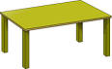

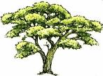
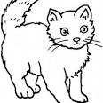

a) There are ________________trees.
b) There are ______________ boxes.
c) I can see ______________ balls.
d) I can see _______________ cats.
e) There are ______________ tables.

2. Count the apples and circle the correct number.
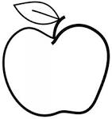 | 1, 2, 3, 4, 5, 6, 7
 | 1, 2, 3, 4, 5, 6, 7
 | 1, 2, 3, 4, 5, 6, 7
 | 1, 2, 3, 4, 5, 6, 7
 | 1, 2, 3, 4, 5, 6, 7

3. Form words.
rul ____________ too ___________
flow er ____________ th
teach ____________ clo ___________

ch n ______________
ai
ch r ______________

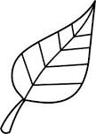
4. Match pictures to words.
t
h u

oo
m n

l s t
o o
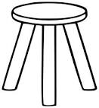
c k a b r
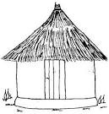
b o a l d

f e l a


5. Circle a picture for the word.
son sun
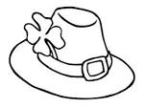
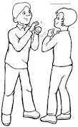
hat hut

man men

pot pond
6. Form six words from the puzzle.
b | o | y | t | r | e | e
o | x | g | i | g | a | g
o | n | a | n | l | c | g
k | s | i | m | h | a | t
c | h | a | i | r | t | i

1. _______________________ 2. ____________________
3. _______________________ 4. ____________________
5. _______________________ 6. _____________________
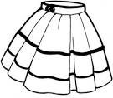
7. Match the belonging.

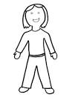
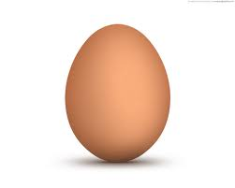

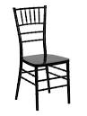
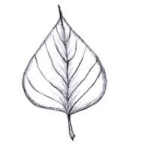

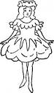
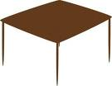

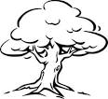
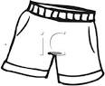

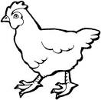

8. Ring the oddman out.

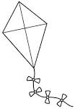

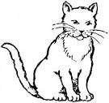
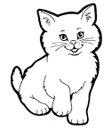

9. Join the dots in number order and name the picture.
1 2
0
4 3
11
7 8 _____________

5 6 9 10

