SUCCESS INTEGRATED NURSERY SCHOOL
Internal End of First Term Examinations 2020
Reading5-6 years

Name _____________________________Stream____________
1. Listen and write.
a) _____________________ b) ___________________
c) _____________________ d) ___________________
e) ____________________________
2. Fill in the missing sounds.
a) a, e, ____ o, u
b) ____, se, si, so, su
c) za, ze, zi, zo, ____
d) ga, ge, ___, go, gu
3. Form words.
st ___________ s u
pa _________
n ___________ n
pe ____________
ra ck ____________
su ____________

4. Match syllables to words and draw.
fa bed _____________
ma rug _____________
bo fan _____________
ru mat _____________
be box _____________
5. Tick only consonants in the words.
at in ox
6. Read and draw.
stool | two men | a bag and a banana
7. Circle a word for the given sound.
a) st: sand stool ship
b) oo: broom beef basket
c) ck stone duck desk
d) ma: men mix man
e) ee: feel fan fat
8. Fill in the missing sounds.
f __ __ t h __ t t r __ __
__ pple ca__ b__x
9. Circle the correct sound for the picture.
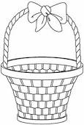
b c
s t
t r

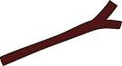

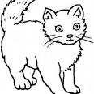
b m p
m c s
s o o

10. Read and draw good pictures.
I can see six eggs. | This is a big tree.
I have an apple. | Here is a story book.
Tom has a toy car.

11. Complete the story.
My name is ____________________. I am ________ years old. I have ___________fingers.I use my _________ to see.

