

Top class: Holiday Work

Name: ____________________________________________________
- Read, match and copy these action words
walk write ________________________
eat speak _______________________
read come ________________________
write jump ________________________
stand walk ________________________
dance sweep ________________________
come eat ________________________
speak greet ________________________
jump read ________________________
sweep stand ________________________
laugh wash ________________________
kneel cook ________________________
greet laugh ________________________
cook kneel ________________________
wash dance _________________________

- Match sounds to words and write.
ie toy____________
ng cream_________
ai spoon___________
ch pie______________
ck swing___________
sm air______________
ay chin____________
gi deck___________
sp smile___________
cr pay____________
ay glimp___________

- Name the source of sound
baa:___________________
sss:____________________
quack:_________________
woof:___________________
aaa:____________________
zzz:_____________________

- Make sentences using “and”.
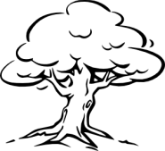 a tree and a stone
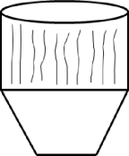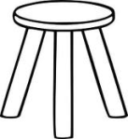 ____________________________________________
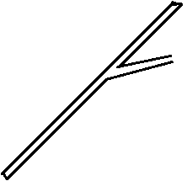 ____________________________________________
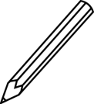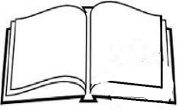_________________________________________
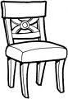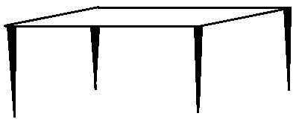_______________________________________
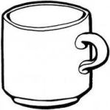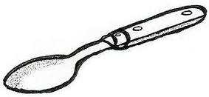______________________________________
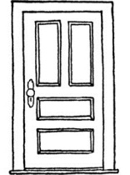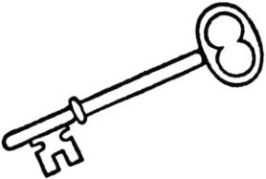______________________________________
- Draw these fruits

Pineapple | Watermelon | banana | mango | Orange

- Make sentences using the given words
- annoy: ______________________________
- coin: ________________________________
- spoil: ________________________________
- how: ______________________________
- flower pot: _________________________
- now: _______________________________
- loud: _______________________________
- mouth: ______________________________
- our: ________________________________
- enjoy: _______________________________
- Make sentences using the table

I  They  She | can | write  dance | well  happily  nicely

______________________________________________

_______________________________________________

_______________________________________________

_______________________________________________

________________________________________________

- Match the word to its starting sound
black gr
frost sw
brush bl
grant kn
strain tr
swift sl
spoil br
wrong str
kneel dr
treat fr
drink wr
slumber sp
- Name these shapes

- Write the next number

0 __________ 6 _________ 3 __________
8 __________ 5 _________ 8 __________
11 __________ 9 _________ 14 _________
13 __________ 2 _________ 7 __________
1 ___________ 10 ________ 4 __________
18 __________ 12 ________ 15 _________
- _________ 17 ________ 19 _________

- Name these pictures
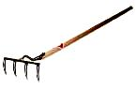
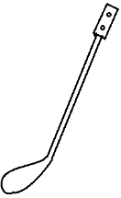
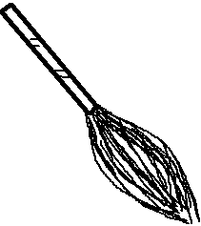
Broom, rake, mop slasher

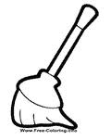
- Read and draw dangerous this
fire
stone

needle
pin

razorblade
Safety pin

nail
stick

- Read the story and answer questions
One day, Pocha went to his farm. It had very many animals such as Cows, Goats, sheep and rabbits.
As he was moving around the farm, he saw a big snake near the rabbits. Pocha was so scared thinking that the snake might bite his rabbits. So he ran very fast with a big stick and killed it

Answer questions about the story
- What is the name of the man in the story?
_____________________________________

- Write four animals found at pocha’s farm.
- _______________ (ii) ____________

- ________________ (iv)____________

- As pocha was moving he saw a __________

- What did he use to kill the snake?
Pocha used _____________________
- Draw and name any dangerous animal you know

- Make sentences from the given table
She  He | is | running  playing  carrying  sleeping  sitting
They | are | running  playing  carrying  sleeping  sitting

She ___________________________________
_______________________________________
_______________________________________
_______________________________________
_______________________________________

He ______________________________________
________________________________________
________________________________________
________________________________________
________________________________________

They _____________________________________
________________________________________
________________________________________
________________________________________
________________________________________

- Add these numbers
6 3 = 5 5 =
7 1 = 3 2 =
2 2 = 9 1 =
1 1 = 3 3 =
9 0 = 6 4 =
4 4 = 8 1 =
6 1 = 7 3 =

- Read and match these
20 twenty nine
21 thirty
26 twenty
29 twenty six
30 twenty one
19 twenty seven
3 fifteen
27 thirteen
15 three
13 nineteen

- Write numbers (1-30)
1

- END -

