SUCCESS INTEGRATED NURSERY SCHOOL
Internal End of First Term Examinations 2020
English 5-6 years

Name _____________________________Stream____________
1. Listen and write.
a) ______________________ b) ___________________
c) ______________________ d) ____________________
e) __________________________
2. Fill in the missing letters.

a b ____d e f ____h i
j k l ___ n o ___ q r
____ t u v ___ x y z

3. Name the pictures.
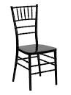 | 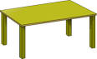 | 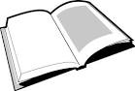 | 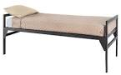 | 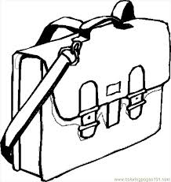

4. Write in capital letters.
d u c k b e d f a n

5. Write words correctly.
lgir ___________________ lstoo _________________
tma __________________ obko ________________
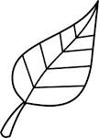
6. Underline the correct word for the picture.
lfea leaf fael
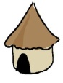
hut hat htu

pincel pecnil pencil
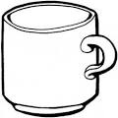
mug umg mgu
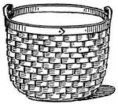
beskat basket bskeat

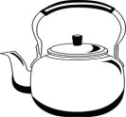
7. Match pictures to words.
boxes
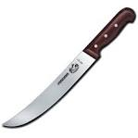
bucket
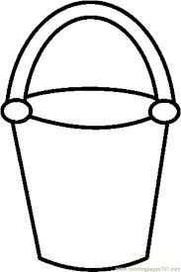
kettle

knife
8. Fill in the missing letters.
cl___ck dres___ t___n
9. Read and draw.
Here is a mat. |  | I can see a ball. |  | I can see two boys.
television | flower |  | trees |  | cat
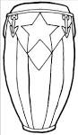
10. Make sentences.
a) It is a drum.

b) _____________________________________________

c) _____________________________________________
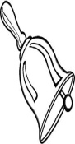
d) _____________________________________________
e) _____________________________________________

11. Complete the sentences.
a) I have _______________ eyes.
b) I am _____________ years old.
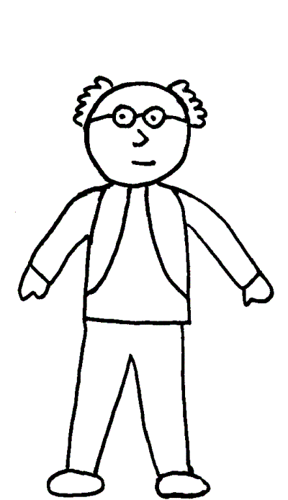
c) Tom and Sam have _________________ legs.
d) I can see six ____________

